Name:-Anurag Haldey

Class:-TY CC-1

Roll No:-2215055

Enrolment No:-MITU21BTIT0010

Lab Expreiment Number :-3

A] Write a JavaScript code to take inputs from user and display that inputs in

following pattern

“Hello ......... Welcome To World of JavaScript”.

JavaScript Code:-

const readline = require('readline');

const rl = readline.createInterface({

  input: process.stdin,

  output: process.stdout

});

rl.question("Enter your name: ", function(userInput) {

  const output = `Hello ${userInput} Welcome To World of JavaScript`;

  console.log(output);

  rl.close();

});

Explaination:-

1. It uses the **readline** module from Node.js to interact with the user in a command-line environment.
2. A **readline** interface (**rl**) is created to manage input and output.
3. The program prompts the user to enter their name using **rl.question()**.
4. The user's input is captured in the provided callback function as **userInput**.
5. A welcome message is constructed using the user's input and a static message.
6. The constructed message is displayed using **console.log()**.
7. The **rl.close()** method is called to close the readline interface when interaction is complete.

Output:-

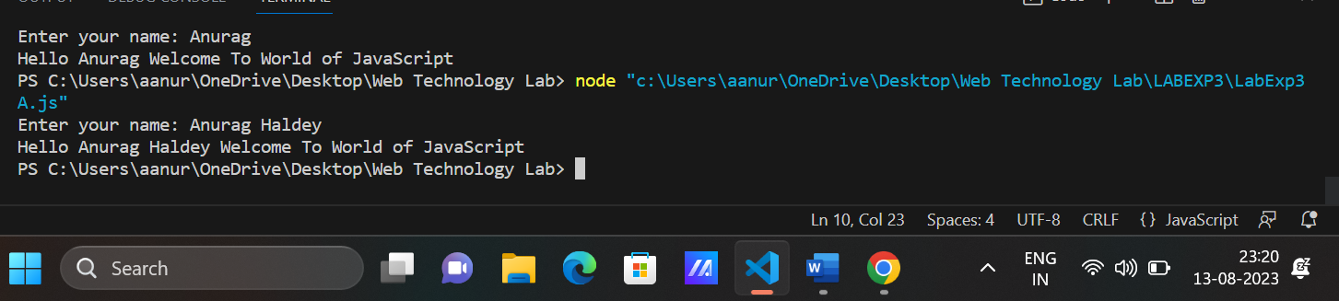

B] Write a JavaScript code to perform arithmetic operation by taking values from

users (Add,Sub, Mul,Div)(1. 4 Button, 2.Dropdown).

HTML Code:-

<!DOCTYPE html>

<html>

<head>

  <title>Arithmetic Operations</title>

</head>

<body>

  <h1>Arithmetic Operations</h1>

  <input type="number" id="num1" placeholder="Enter number 1">

  <input type="number" id="num2" placeholder="Enter number 2">

  <button id="add">Add</button>

  <button id="subtract">Subtract</button>

  <button id="multiply">Multiply</button>

  <button id="divide">Divide</button>

  <p id="result"></p>

  <script>

    const num1Input = document.getElementById('num1');

    const num2Input = document.getElementById('num2');

    const addButton = document.getElementById('add');

    const subtractButton = document.getElementById('subtract');

    const multiplyButton = document.getElementById('multiply');

    const divideButton = document.getElementById('divide');

    const resultElement = document.getElementById('result');

    addButton.addEventListener('click', () => performOperation('+'));

    subtractButton.addEventListener('click', () => performOperation('-'));

    multiplyButton.addEventListener('click', () => performOperation('*'));

    divideButton.addEventListener('click', () => performOperation('/'));

    function performOperation(operator) {

      const num1 = parseFloat(num1Input.value);

      const num2 = parseFloat(num2Input.value);

      let result;

      switch (operator) {

        case '+':

          result = num1 + num2;

          break;

        case '-':

          result = num1 - num2;

          break;

        case '*':

          result = num1 * num2;

          break;

        case '/':

          if (num2 !== 0) {

            result = num1 / num2;

          } else {

            result = 'Cannot divide by zero';

          }

          break;

        default:

          result = 'Invalid operator';

      }

      resultElement.textContent = `Result: ${result}`;

    }

  </script>

</body>

</html>

Explaination:-

HTML:

1. Basic HTML structure with title, headings, input fields, buttons, and a result display area.
2. Input fields for users to enter two numbers.
3. Buttons for addition, subtraction, multiplication, and division operations.
4. A paragraph element to show the result.

JavaScript:

1. Retrieves references to HTML elements (input fields, buttons, and result paragraph).
2. Attaches event listeners to operation buttons to trigger calculation.
3. **performOperation** function:
   * Extracts input numbers from input fields.
   * Uses a **switch** statement to perform the selected operation.
   * Handles division by zero error.
   * Updates the result display with the calculated result or an error message.

Output:-

