Name:-Anurag Haldey

Class:-TY CC1

Roll Number:-2215055

Enrolment Number:-MITU21BTIT0010

Subject:-Web Technology Laboratory

Lab Experiment No :-7

A] Write a PHP script to take number from user and print the table of that

number.

Code:-

<!DOCTYPE html>

<html>

<head>

    <title>Multiplication Table</title>

</head>

<body>

    <h1>Multiplication Table Generator</h1>

    <form method="post">

        <label for="number">Enter a number:</label>

        <input type="number" id="number" name="number" required>

        <input type="submit" value="Generate Table">

    </form>

    <?php

    if ($_SERVER["REQUEST_METHOD"] == "POST") {

        $number = $_POST["number"];

        if (is_numeric($number)) {

            echo "<h2>Multiplication Table for $number:</h2>";

            echo "<table>";

            for ($i = 1; $i <= 10; $i++) {

                $result = $number * $i;

                echo "<tr><td>$number x $i</td><td>=</td><td>$result</td></tr>";

            }

            echo "</table>";

        } else {

            echo "<p>Please enter a valid number.</p>";

        }

    }

    ?>

</body>

</html>

Output:-

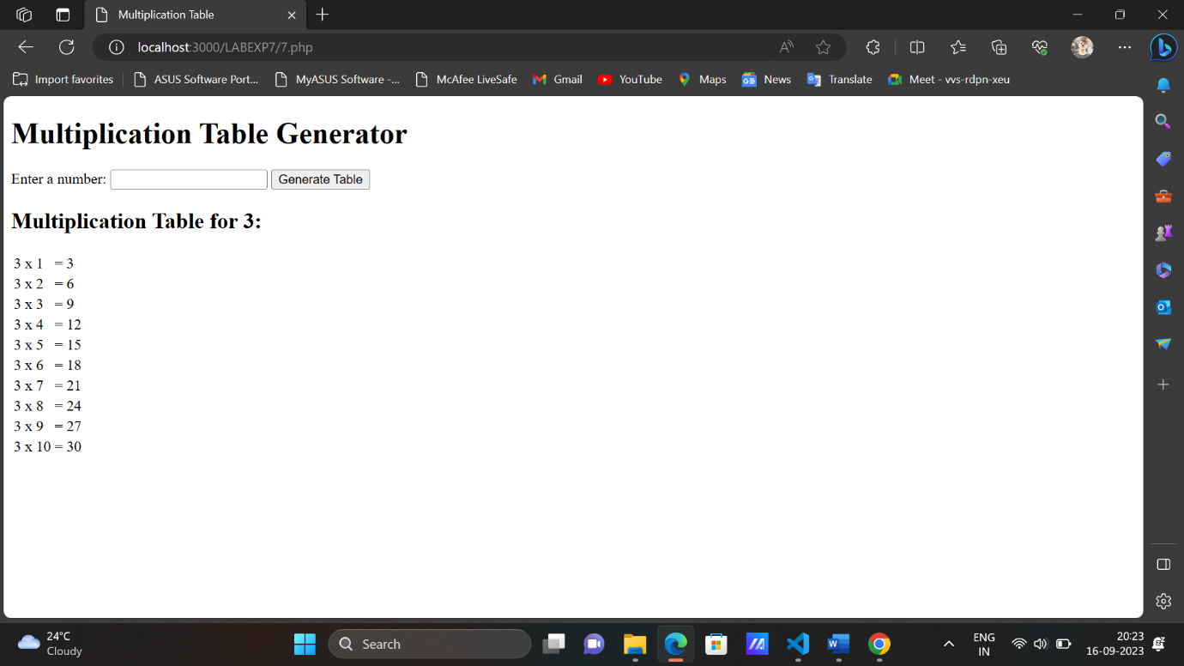

B]Write a PHP script to display numeric, associative and multidimensional

array with for each loop.

Code:-

<!DOCTYPE html>

<html>

<head>

    <title>PHP Array Display with User Input</title>

</head>

<body>

<h2>Array Display:</h2>

<form method="POST">

    Enter values for numeric array (comma-separated): <input type="text" name="numeric_input"><br>

    Enter key-value pairs for associative array (key1:value1,key2:value2,...): <input type="text" name="assoc_input"><br>

    Enter values for multidimensional array (comma-separated, format: name1,age1;name2,age2;...): <input type="text" name="multi_input"><br>

    <input type="submit" value="Submit">

</form>

<?php

if ($_SERVER["REQUEST_METHOD"] === "POST") {

    // Process the numeric array input

    $numericInput = $_POST['numeric_input'];

    $numericArray = explode(',', $numericInput);

    // Process the associative array input

    $assocInput = $_POST['assoc_input'];

    $assocArray = [];

    $pairs = explode(',', $assocInput);

    foreach ($pairs as $pair) {

        $keyValue = explode(':', $pair);

        $assocArray[$keyValue[0]] = $keyValue[1];

    }

    // Process the multidimensional array input

    $multiInput = $_POST['multi_input'];

    $persons = explode(';', $multiInput);

    $multidimensionalArray = [];

    foreach ($persons as $person) {

        list($name, $age) = explode(',', $person);

        $multidimensionalArray[] = ['name' => $name, 'age' => $age];

    }

    echo "<h3>Numeric Array:</h3>";

    echo "<ul>";

    foreach ($numericArray as $value) {

        echo "<li>$value</li>";

    }

    echo "</ul>";

    echo "<h3>Associative Array:</h3>";

    echo "<ul>";

    foreach ($assocArray as $key => $value) {

        echo "<li>$key: $value</li>";

    }

    echo "</ul>";

    echo "<h3>Multidimensional Array:</h3>";

    echo "<ul>";

    foreach ($multidimensionalArray as $index => $person) {

        echo "<li>Person " . ($index + 1) . ": <ul>";

        foreach ($person as $key => $value) {

            echo "<li>$key: $value</li>";

        }

        echo "</ul></li>";

    }

    echo "</ul>";

}

?>

</body>

</html>

Output:-

