**QA Observation**

Website : <https://www.tomsguide.com/>

***Home page***

* Search bar suggestions overlapping with top navbar
* PRODUCT REVIEWS

<https://www.tomsguide.com/us/lists/gift-ideas> : NAVbar section cartech,travelers,audio section images are dislocated.

***Forum page***

* Usernames listed after loading : <http://www.tomsguide.com/forum/forum-123.html>

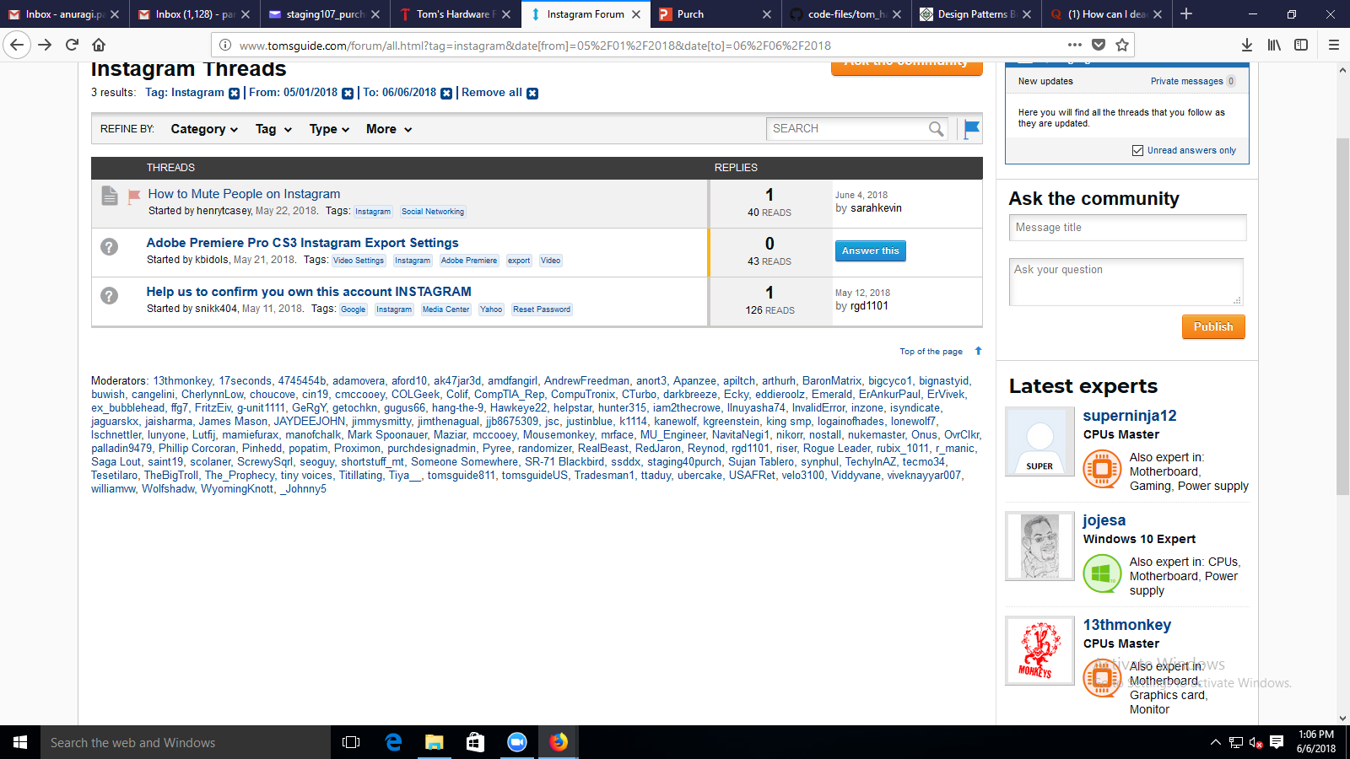

* Bottom

<http://www.tomsguide.com/forum/> : email error on out focus

***Subscribe :***

* Only checking the ‘@’ in the string given as input .