**Design normalized schema**

CREATE TABLE users (

user_id INT AUTO_INCREMENT PRIMARY KEY,

username VARCHAR(50) NOT NULL UNIQUE,

password_hash VARCHAR(255) NOT NULL,

role VARCHAR(20) NOT NULL,

email VARCHAR(100) UNIQUE,

created_at TIMESTAMP DEFAULT CURRENT_TIMESTAMP

);

CREATE TABLE departments (

dept_id INT AUTO_INCREMENT PRIMARY KEY,

dept_name VARCHAR(100) NOT NULL,

description TEXT

);

CREATE TABLE categories (

category_id INT AUTO_INCREMENT PRIMARY KEY,

category_name VARCHAR(100) NOT NULL,

description TEXT

);

CREATE TABLE complaints (

complaint_id INT AUTO_INCREMENT PRIMARY KEY,

user_id INT NOT NULL,

dept_id INT NOT NULL,

category_id INT NOT NULL,

title VARCHAR(200) NOT NULL,

description TEXT,

status VARCHAR(20) DEFAULT 'OPEN',

created_at TIMESTAMP DEFAULT CURRENT_TIMESTAMP,

updated_at TIMESTAMP DEFAULT CURRENT_TIMESTAMP ON UPDATE CURRENT_TIMESTAMP,

FOREIGN KEY (user_id) REFERENCES users(user_id) ON DELETE CASCADE,

FOREIGN KEY (dept_id) REFERENCES departments(dept_id),

FOREIGN KEY (category_id) REFERENCES categories(category_id)

);

CREATE TABLE responses (

response_id INT AUTO_INCREMENT PRIMARY KEY,

complaint_id INT NOT NULL,

user_id INT NOT NULL,

comment TEXT,

created_at TIMESTAMP DEFAULT CURRENT_TIMESTAMP,

FOREIGN KEY (complaint_id) REFERENCES complaints(complaint_id) ON DELETE CASCADE,

FOREIGN KEY (user_id) REFERENCES users(user_id) ON DELETE CASCADE

);

--Add indexes for performance

CREATE INDEX idx_complaints_user_id ON complaints(user_id);

CREATE INDEX idx_complaints_dept_id ON complaints(dept_id);

CREATE INDEX idx_complaints_category_id ON complaints(category_id);

CREATE INDEX idx_complaints_status ON complaints(status);

CREATE INDEX idx_responses_complaint_id ON responses(complaint_id);

CREATE INDEX idx_responses_user_id ON responses(user_id);

**ER Diagram:**

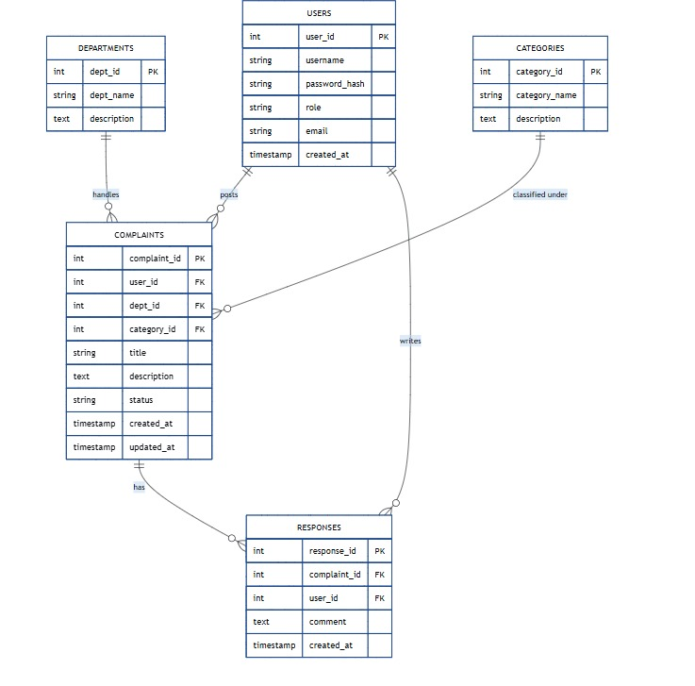

**SQL Queries Implementation**

**A. DML – Insert, Update, Delete**

**1. Insert Sample Users**

INSERT INTO users (username, password_hash, role, email)

VALUES

('alice', 'pass1hash', 'citizen', 'alice@mail.com'),

('bob', 'pass2hash', 'employee', 'bob@mail.com'),

('admin', 'pass3hash', 'admin', 'admin@mail.com');

**2. Insert Departments**

INSERT INTO departments (dept_name, description)

VALUES

('IT', 'Handles technical issues'),

('HR', 'Human resources'),

('Admin', 'Administrative tasks');

**3. Insert Categories**

INSERT INTO categories (category_name, description)

VALUES

('Network Issue', 'Problems with internet and WiFi'),

('Salary', 'Payroll-related issues'),

('Cleanliness', 'Hygiene and sanitation');

**4. Insert a Complaint**

INSERT INTO complaints (user_id, dept_id, category_id, title, description)

VALUES (1, 1, 1, 'WiFi not working', 'The internet is down in the main building.');

**5. Insert a Response**

INSERT INTO responses (complaint_id, user_id, comment)

VALUES (1, 2, 'We have informed the network team. Will be resolved soon.');

**🔹 B. DQL – Select Queries**

**1. View All Complaints**

SELECT * FROM complaints;

**2. Get Complaints with User, Department, and Category**

SELECT

c.complaint_id,

u.username AS user,

d.dept_name AS department,

cat.category_name AS category,

c.title,

c.status,

c.created_at

FROM complaints c

JOIN users u ON c.user_id = u.user_id

JOIN departments d ON c.dept_id = d.dept_id

JOIN categories cat ON c.category_id = cat.category_id;

**3. All Responses to a Complaint**

SELECT

r.response_id,

r.comment,

r.created_at,

u.username AS responded_by

FROM responses r

JOIN users u ON r.user_id = u.user_id

WHERE r.complaint_id = 1;

**🔹 C. JOINS – Combine Data Across Tables**

**1. Join Complaints and Responses**

SELECT

c.title,

r.comment,

r.created_at,

responder.username AS responded_by

FROM complaints c

JOIN responses r ON c.complaint_id = r.complaint_id

JOIN users responder ON r.user_id = responder.user_id;

**🔹 D. Subqueries**

**1. Complaints Submitted to HR Department**

SELECT * FROM complaints

WHERE dept_id = (

SELECT dept_id FROM departments WHERE dept_name = 'HR'

);

**2. Users with Multiple Complaints**

SELECT u.username, COUNT(c.complaint_id) AS total_complaints

FROM users u

JOIN complaints c ON u.user_id = c.user_id

GROUP BY u.user_id

HAVING COUNT(c.complaint_id) > 1;

**3. Most Recent Complaint per User**

SELECT * FROM complaints c

WHERE created_at = (

SELECT MAX(created_at)

FROM complaints

WHERE user_id = c.user_id

);

**🔹 E. Rollback and Transaction Example**

**Use when modifying data cautiously:**

START TRANSACTION;

-- Mistakenly updating the wrong complaint

UPDATE complaints

SET status = 'Resolved'

WHERE complaint_id = 100;

-- Realize the mistake

ROLLBACK;

-- Correct update

START TRANSACTION;

UPDATE complaints

SET status = 'Resolved'

WHERE complaint_id = 1;

COMMIT;