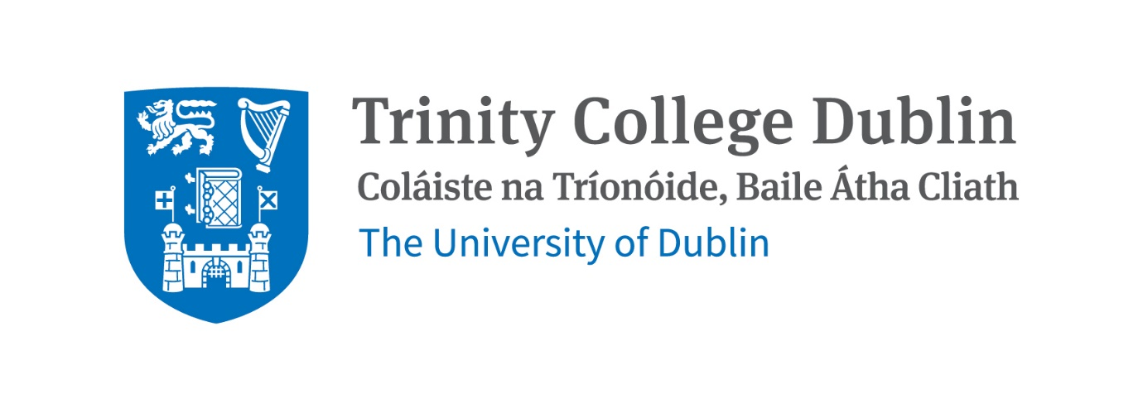

**3D3 COMPUTER NETWORKS**

**PROJECT ZERO REPORT**

Name – Anurag Janghala

Student ID – 19324037

**Design and key concept of decentralised system with features, requirements and constraints:**

A decentralised system that will work on blockchain as I call it, ***Proto-life***, is a system which is based on the data collected from activities that students do with each and every day, and at the end to provide them with ***T-CASH***(basically e-money which works inside trinity campus only) as a reward of being truthful to themselves by hustling with the busy schedule of college which also benefits their fitness. The idea is to create a platform for students in which they track their day by day activities like attending lectures, participating in activities like sports, societies or using gym inside campus and even exploring and accessing the buildings inside campus which will also benefits teachers as well as they get to know each student’s activity status which will also work as feedback for teachers as well. Being decentralised platform, students can see others activity feed which will be divided in two ways, first being ***classroom feed*** of each student(which will rank the students according to their activity record) and other is ***global activity* *feed***(which will sort those students who are existing toppers in their classroom feed, basically creates competitive environment in good way).

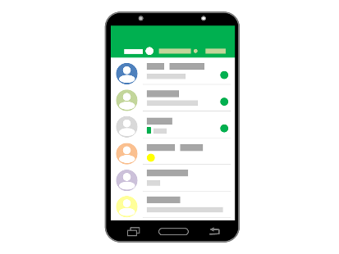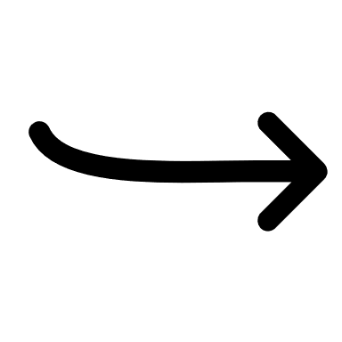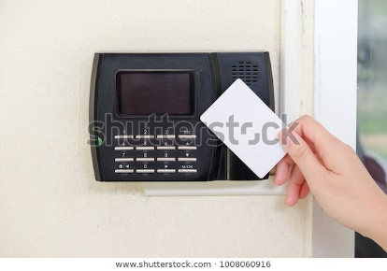

All activities of students will measured by an ***IOT device*** which keeps track of that student either by tapping it with student’s T-card or by using directly through proto-life app by sacnning mobile screen. That IOT device will be directly connected to the network database which will keep a log of transactions of T-CASH and a log of students with most activity points to sort out the students in classroom feed and global activity feed.

**Protocol overview:**

Protocols when student scan through mobile app either to get their activity points or to redeem T-CASH

TCP/IP (Transmission Control Protocol/Internet Protocol) – which will be used to communicate over the network using internet for sending the updated information of student’s activity feed which will update the user block in the network.

FTP (File Transfer Protocol) – which will be used to allow users to send T-CASH either to other users or to redeem them at stores inside campus.

As for a network, Hyperledger fabric technology will be used so for that network management it will be having -

Gossip data dissemination protocol – which is used to manage peer discovery in the system and also manages the channel membership by identifying the available peers and checking peers that if they are online or offline.

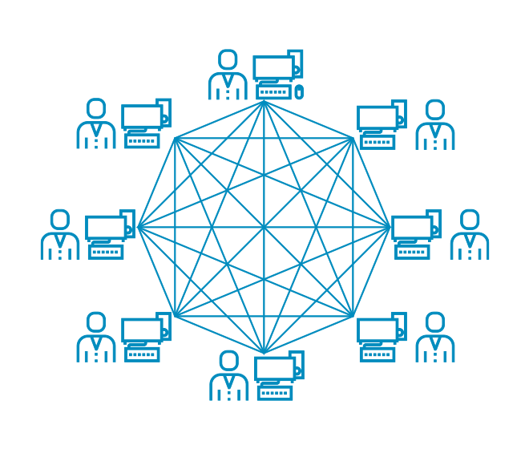

**Communication Model:**

In the model, mobile application used to communicate with IOT device which will send the message to connect with IOT device and then IoT device will send the response to connect with the app and then data will be transferred to the IoT device through scanning unique ID from mobile screen or else through T-card. Then the IoT device which is connected to the network database through the same Wi-Fi network of entire college, will send the information to network block to change the information by verifying it with only two node (those students who were used IoT device before the targeting node and after the targeting node) which will happen simultaneously for each student node which will also cover proof of work algorithm but by checking with only two node instead of every node which will make this fast and more efficient. Now, information containing unique id and T-CASH value stored in student’s block will be shared with the vendors (stores inside College) which are connected to the same distributed network. So whenever the student wants to redeem the T-CASH then IOT device gathers information while connecting with database after scanning the unique through mobile app or T-card during that time communication between mobile and IoT device is same as for that we used during getting T-CASH, but two more messages have been sent for verifying the purchase and sending the feedback. Here it works mostly on requests and response.

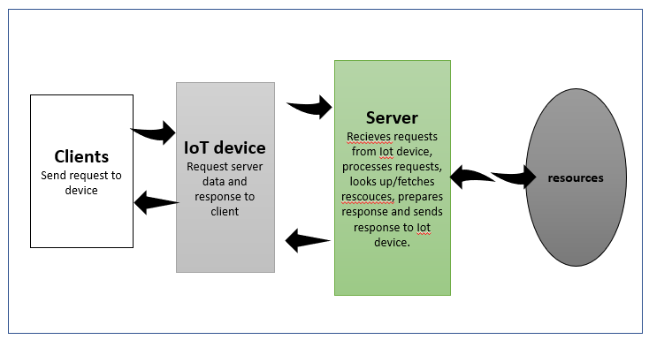

**Module Descriptions:**

This network model works on an asset which will be T-CASH in this case, as the state of the T-CASH changes recorded transactions in the block of a user with a unique hash value which defines the uniqueness to each user that are connected in chain.

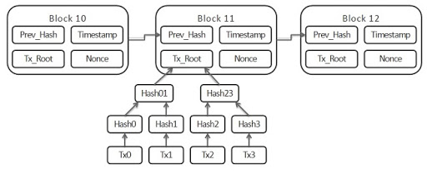

By using the Hyperledger data fabric which has ability to modify an asset(T-CASH) using chaincode and permissions. Chaincode is a software which defines an asset or assets for modifying them. Smart Charts are also deployed by the system to execute chaincodes.

For changing the value of the asset(T-CASH) relative to the real currency to get the price of the goods so that students can redeem, can’t be change until the main members like college and stores inside college , all does not agree on changes, if they do then the changes will be reflected in the system which all will be interacted by using the chaincodes.

For security purposes, only college has the access to the identification of the student according to which it will be having some protocols that will help to maintain the privacy of students. Although it will give vendors some details of purchaser but it will provide only T-CASH value and unique id which will change every time if there is updating in value of T-CASH and activity points which will make this system hard to breach as this data is also changes tags of other nodes as well and saves that in other’s block as well.

**Summary of Algorithms:**

It works on proof of work algorithm as the college will act as leader in this network for which student’s block in the chain will be trusted, as the student will join the network through college permission.

Types of algorithms used in this network:

- PoW (proof of work) algorithm

- sorting algorithm is applied

Which checks the activity feed of each students and then sorts them in order to get high to low rankers in activity feed.