**Anurag A**

**S6 MCA Regular**

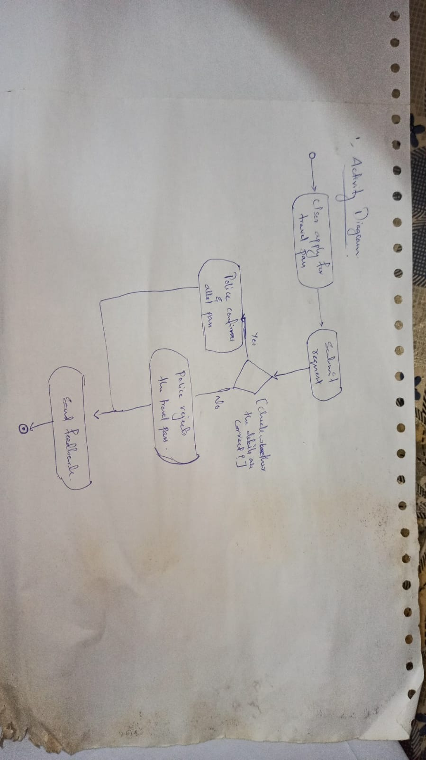**Activity Diagram [ User applying for travel passs ]**

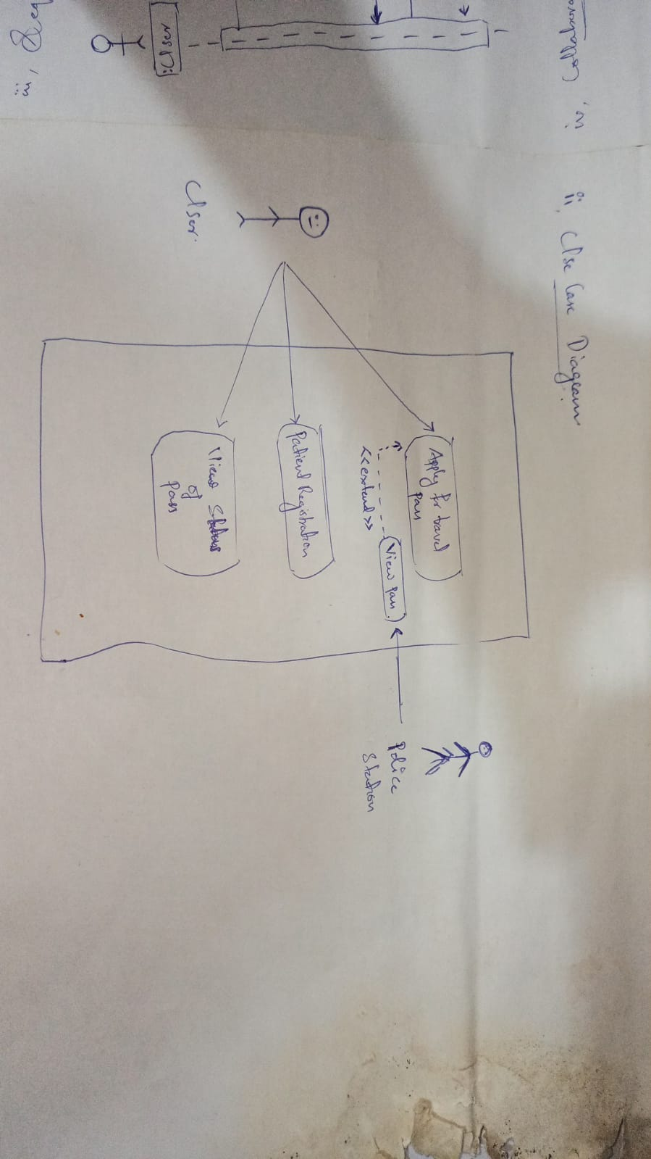**Use Case Diagram [ User applying for travel pass ]**

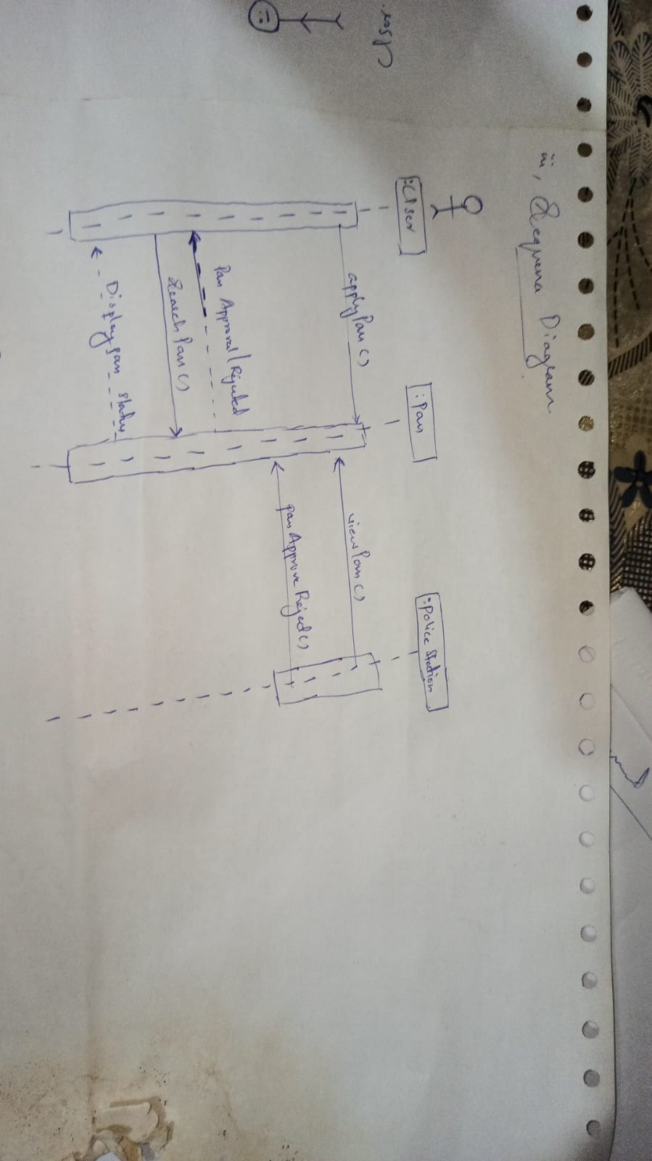**Sequence Diagram [ User applying for travel pass ]**

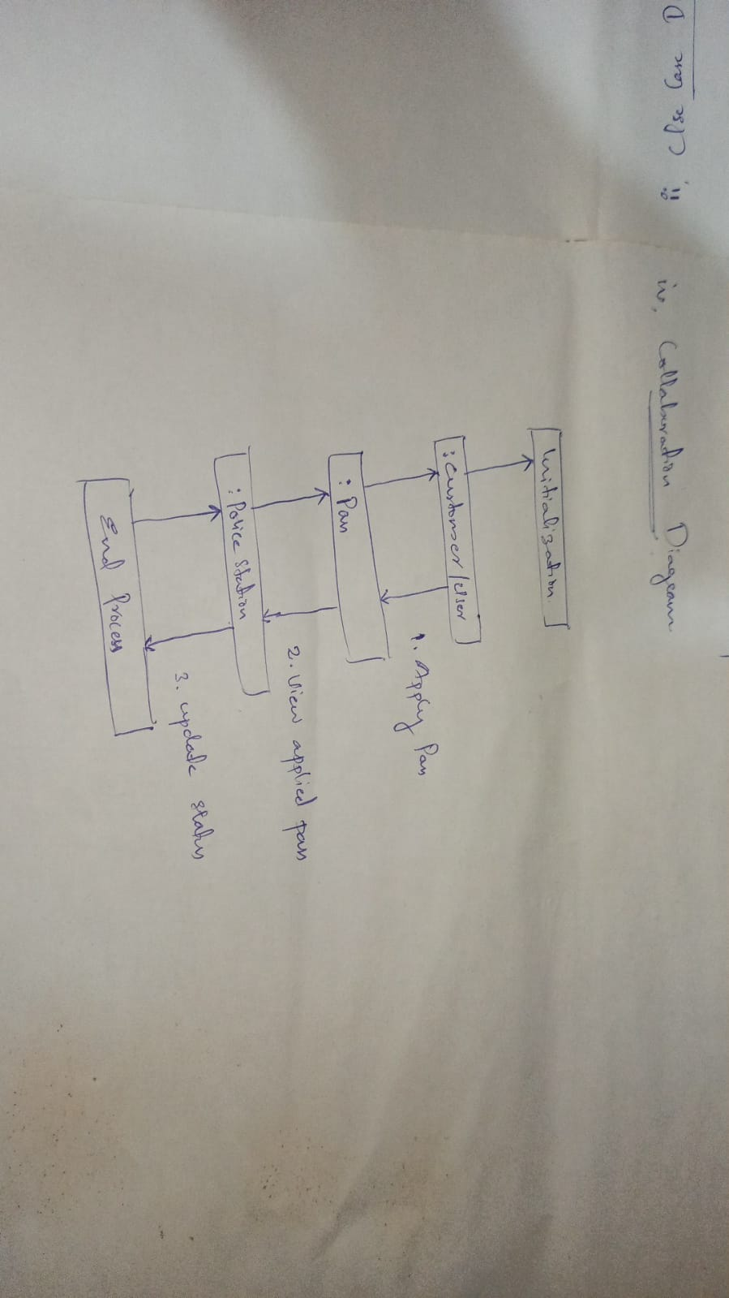**Collaboration Diagram**

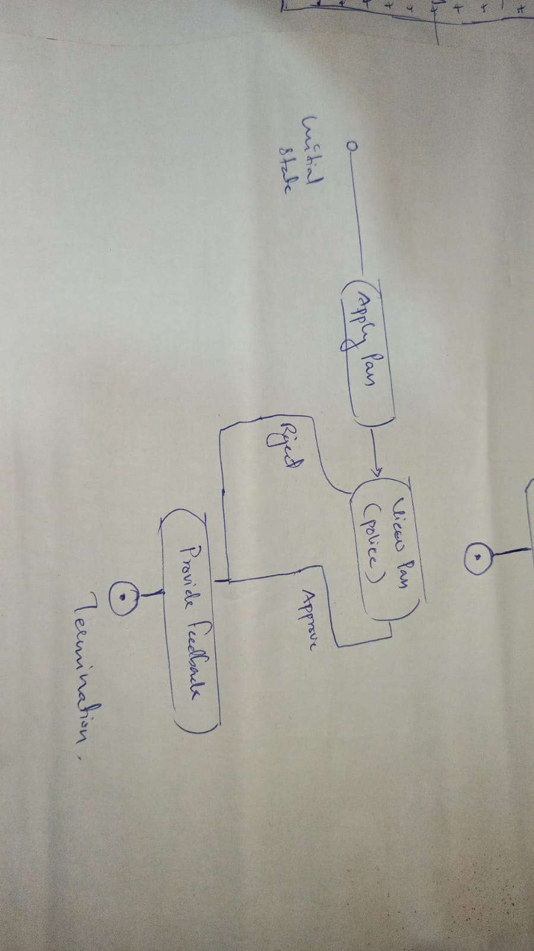**State Chart Diagram [ User applying for travel pass ]**

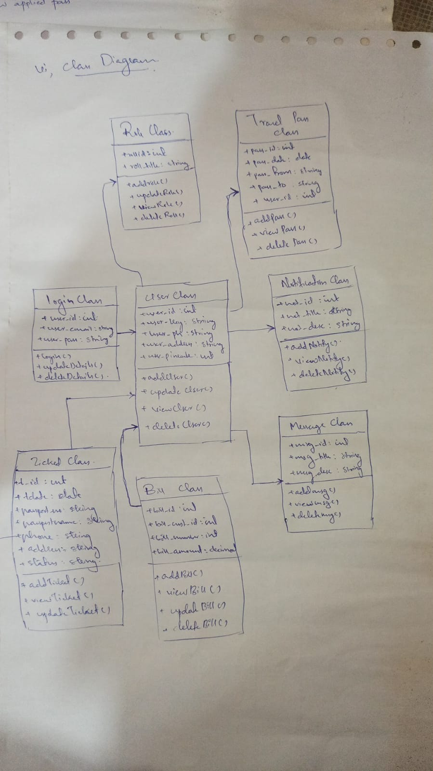**Class Diagram**

**Object Diagram**

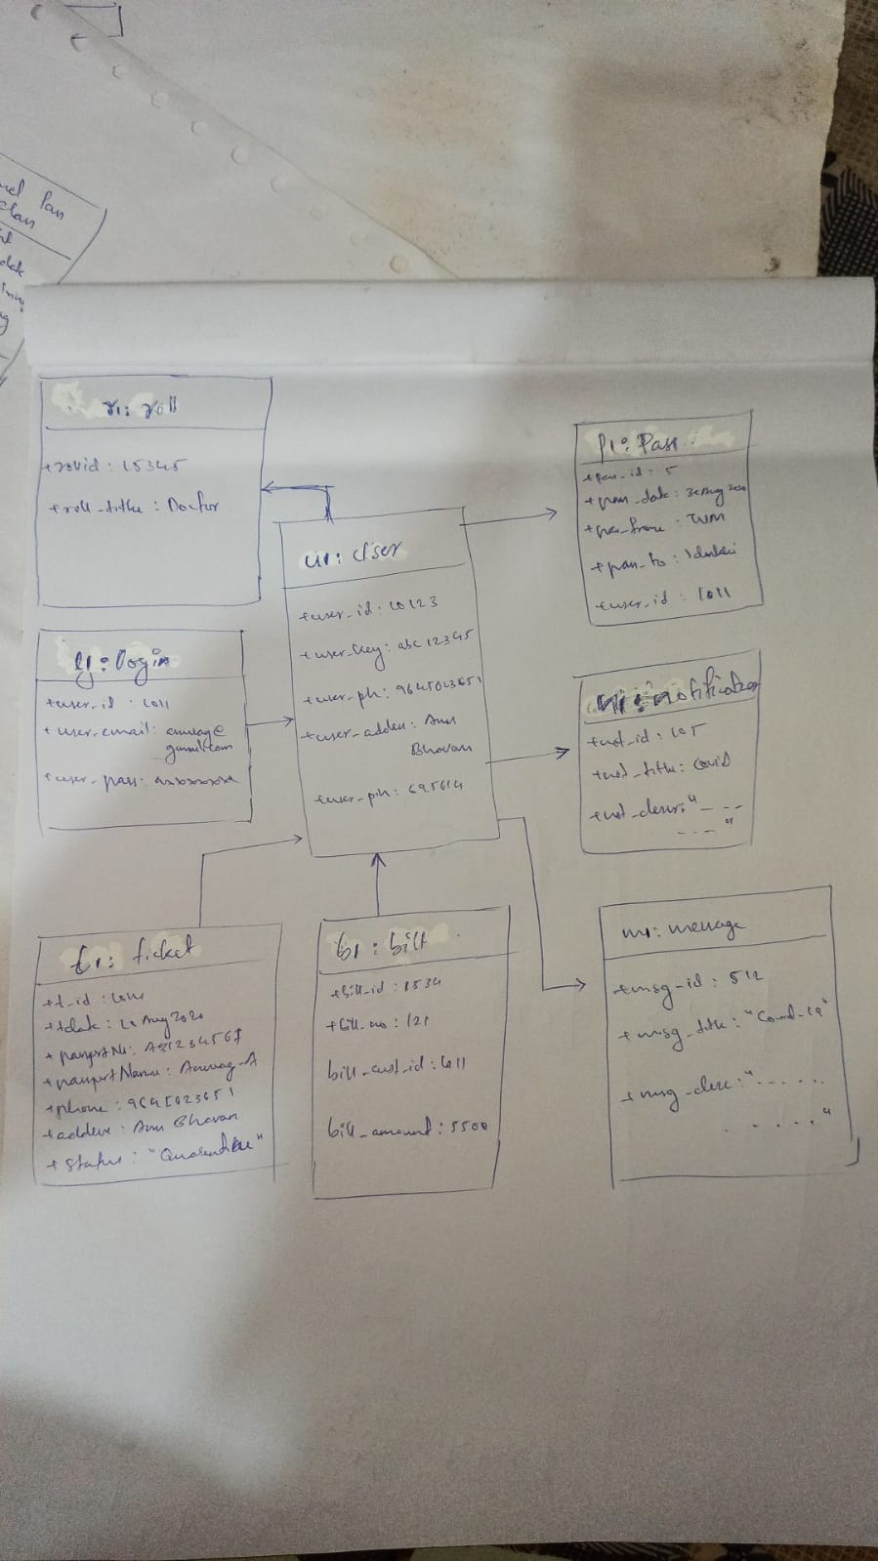

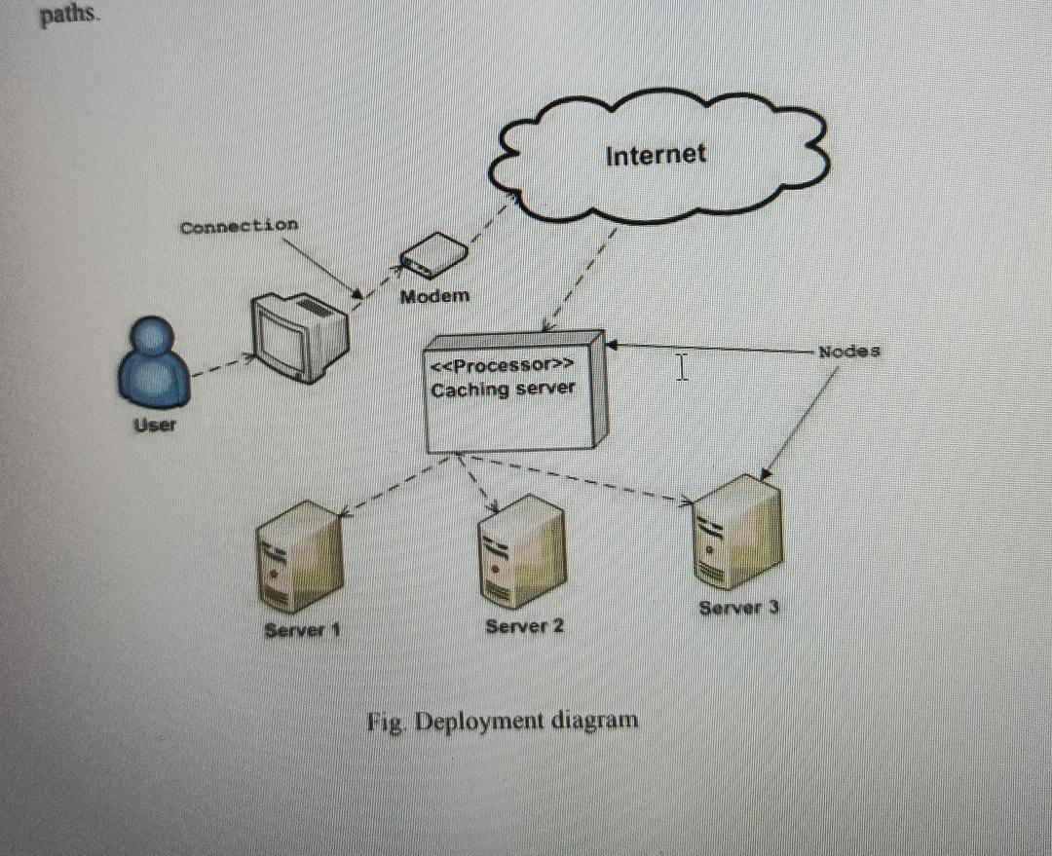**Deployment Diagram**

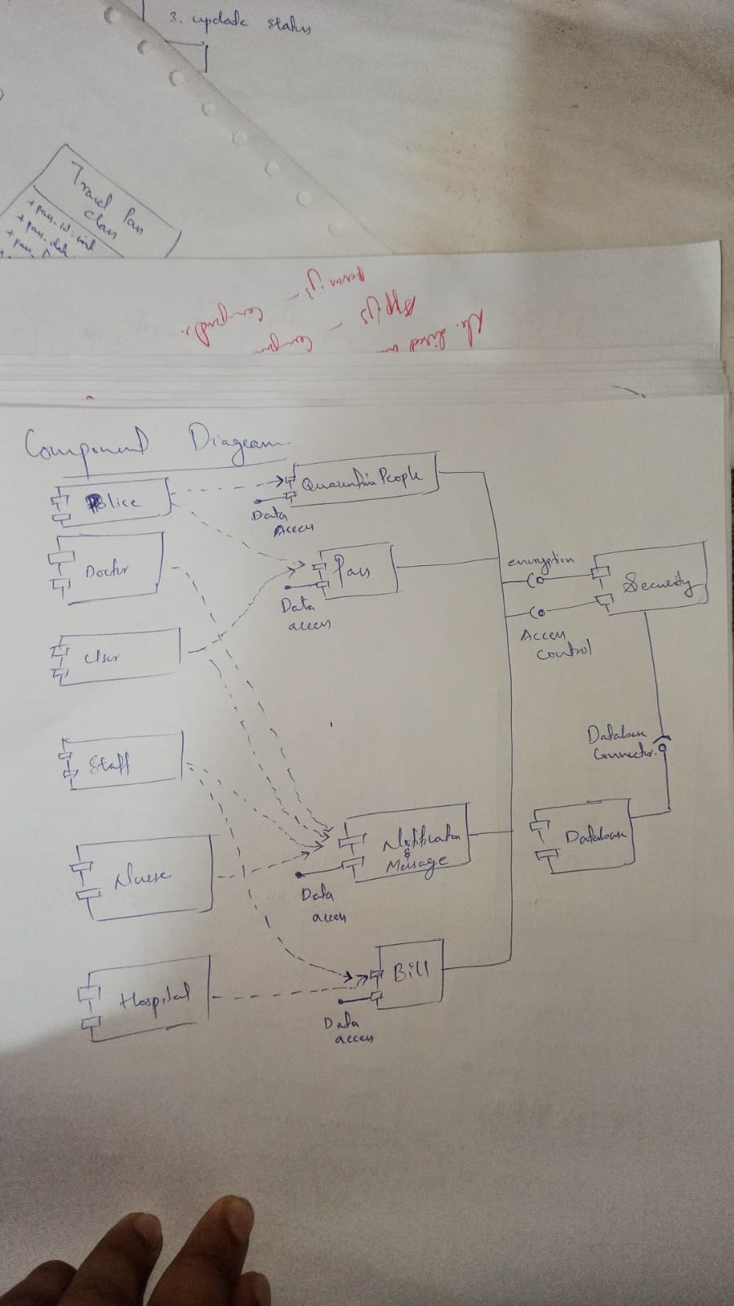**Component Diagram**