Internal Client Handover
RECPL Admin Panel Manual
Detailed guide for website administrators to update content, verify public pages, review contact enquiries, and use the protected admin panel.
Item | Detail
Website | radiantconsultant.com
Admin Area | /admin
Prepared On | 9 June 2026
Document Type | Manual / Handover Report
Keep this document private because it contains admin login details.

RECPL Admin Panel Manual
Internal use only. This manual is for RECPL website administrators who need to update website content and review contact enquiries.

Website Pages
Page | Title | URL
Home | Radiant Engineering Consultancy Pvt. Ltd. | https://radiantconsultant.com/
About | About RECPL | https://radiantconsultant.com/about
Gallery | RECPL Gallery | https://radiantconsultant.com/gallery
Contact | Contact RECPL | https://radiantconsultant.com/contact
Consultancy | Structure Design, Drawing & Structural Stability Audit | https://radiantconsultant.com/services/consultancy
NDT Services | NDT Testing Services | https://radiantconsultant.com/services/ndt
Material Testing | Material Testing Services | https://radiantconsultant.com/services/material-testing
Supply | Material Testing Equipment & Instrument Supply | https://radiantconsultant.com/supply
TPI Services | Third Party Inspection Services | https://radiantconsultant.com/services/tpi
Note: The TPI Services page currently redirects visitors to the Material Testing page.

Admin Access
Item | Value
Admin Panel URL | https://radiantconsultant.com/admin
Email ID | admin@radiantconsultant.com
Password | REAdmin@2025
Keep these login details private. Do not share them outside the authorized RECPL admin team.

What The Admin Panel Does
- Lets admins update website content from a protected panel.
- Lets admins edit text, links, images, SEO fields, page sections, buttons, and labels.
- Keeps the website design, layout, alignment, typography, and formatting fixed.
- Stores contact form enquiries in the connected database.
- Lets admins review submitted enquiries from the admin panel.

1. Login To The Admin Panel
Open https://radiantconsultant.com/admin. If you are not logged in, the website will show the sign-in screen.
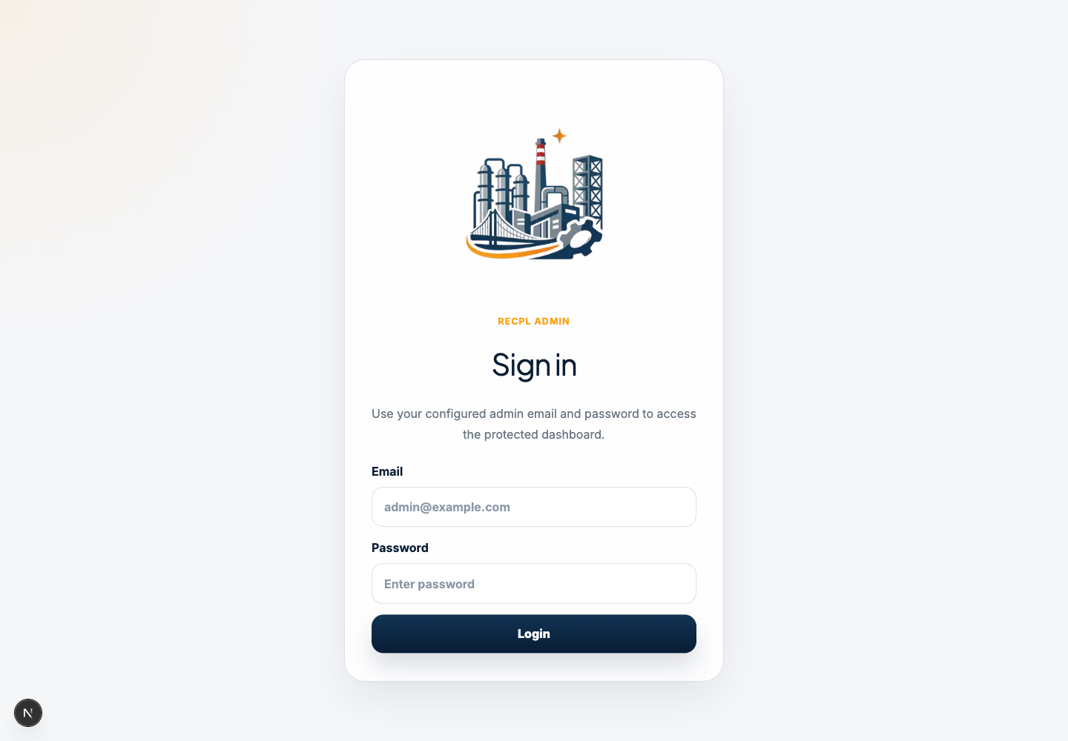
Pointers:
- Enter the admin email ID in the Email field.
- Enter the admin password in the Password field.
- Click Login to open the admin dashboard.
- If login fails, check that the email and password are typed exactly.

2. Understand The Admin Dashboard
After login, the dashboard shows the main admin areas.
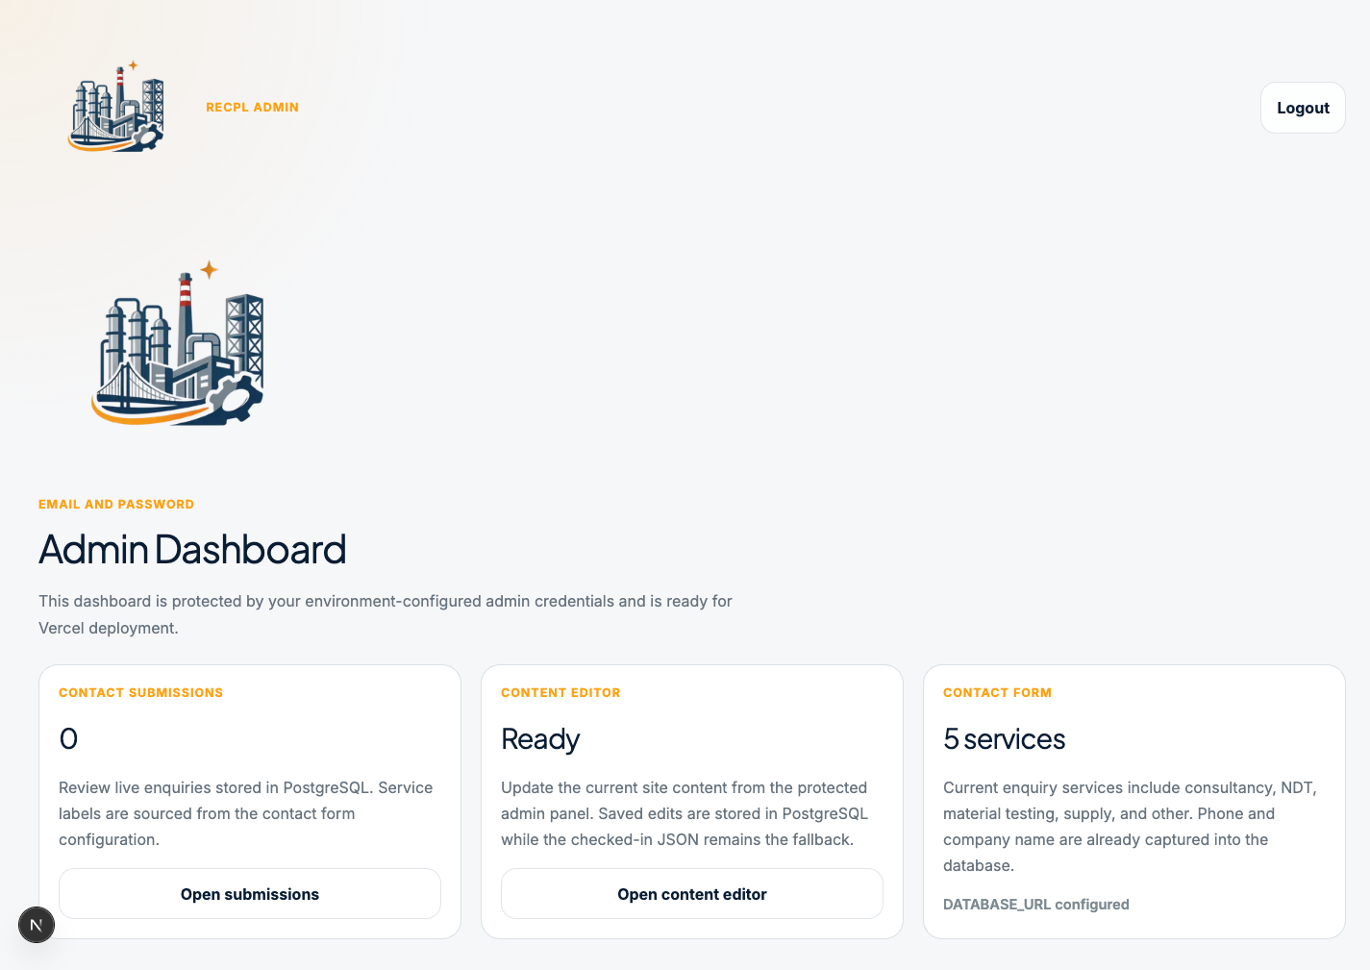
Pointers:
- Contact Submissions opens the enquiry list received from the contact form.
- Content Editor opens the website content editing area.
- Contact Form shows whether the database is connected and how many service options are configured.
- Use Logout after finishing admin work.

3. Open The Content Editor
Click Open content editor from the dashboard, or open https://radiantconsultant.com/admin/content.
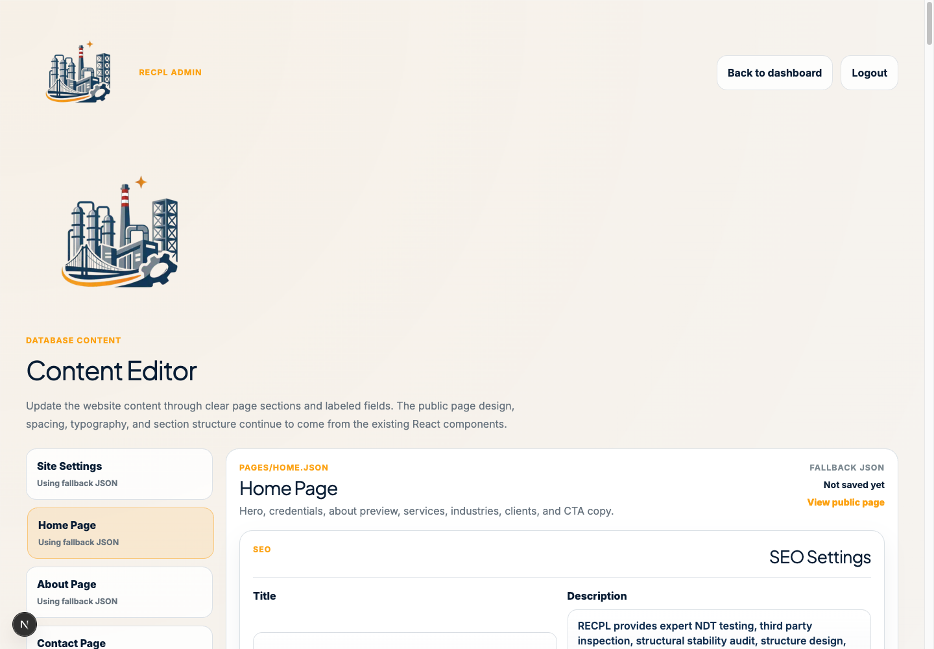
Pointers:
- The left side lists the editable website areas.
- Select a page such as Home Page, About Page, Contact Page, Gallery, or Site Settings.
- The right side shows editable sections and fields for the selected page.
- Using fallback JSON means the page is still using the original website content until an admin saves changes.

4. Update Website Content
Each page is split into clear sections such as SEO Settings, Hero Section, Services, Industries, Clients, CTA, and similar page-specific groups.
Pointers:
- Update normal text in single-line fields.
- Update longer paragraphs in larger text boxes.
- Update image links in Image URL fields.
- Use dropdowns for controlled choices such as icons or enabled/disabled settings.
- Do not change public page routes unless the website link itself is intentionally changing.

5. Save And Verify Changes
After editing, click Save content. The admin panel will show a saved confirmation message.
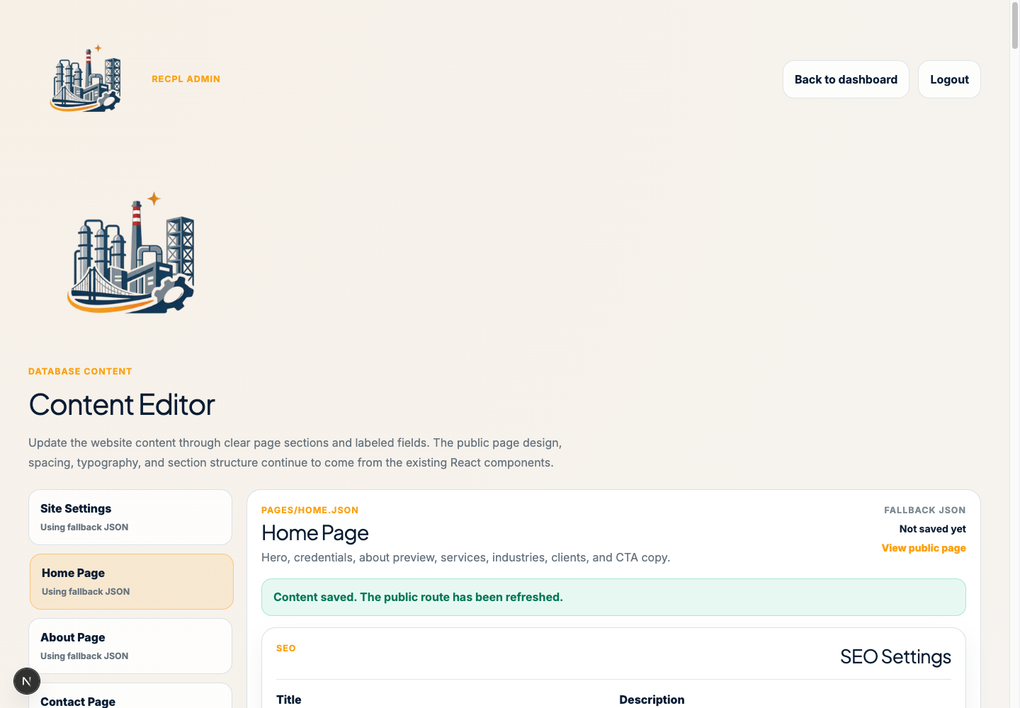
Pointers:
- Wait for the saved message before leaving the page.
- Click View public page to check the updated page.
- Review the public page for spelling, image quality, and link correctness.
- If something looks wrong, return to the same admin page, fix the field, and save again.

6. Review Contact Form Submissions
Open https://radiantconsultant.com/admin/submissions, or click Open submissions from the dashboard.
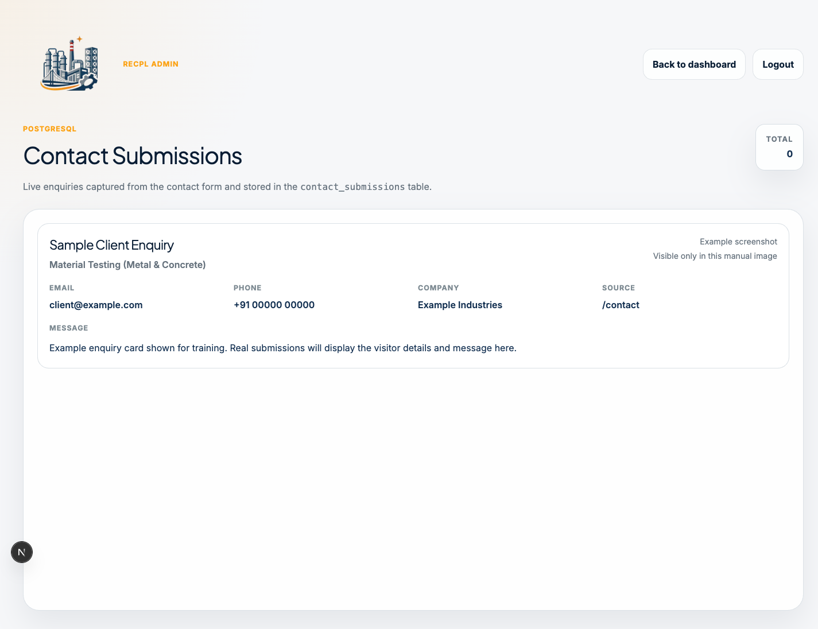
Pointers:
- Each enquiry card shows the visitor name, selected service, email, phone, company, source page, and message.
- Use the email and phone details to follow up with the visitor.
- New submissions appear after visitors send the public contact form.
- If no enquiries are available, the page will show an empty-state message.

7. Logout
Click Logout from the top-right area of the admin panel.
Pointers:
- Logout after every admin session.
- Do not leave the admin panel open on a shared computer.
- Log in again only when you need to update content or review enquiries.

Quick Admin Checklist
- Open the correct website page from the table at the top.
- Login to the admin panel.
- Choose Content Editor for website updates.
- Choose Contact Submissions for enquiries.
- Save content changes and verify the public page.
- Logout after finishing.

