**SQL Queries**

**1). How can you find the details of volunteer who is available on 25th Oct’22 for first half of the morning?**

**Ans.** Firstly we will manually search the day of given date, in our case its **‘tuesday’.** Once we find the day we will put this day in below sql query.

select `volunteers`.`id` as `volunteerId`, `volunteers`.`given_name` as `volunteerName`, `volunteers`.`family_name` as `volunteerFamilyname`, `volunteers`.`mobile` as `volunteerMobile`, `volunteers`.`email` as `volunteerEmail`, `volunteers`.`address` as `volunteerAddress` from `availability` inner join `volunteers` on `availability`.`volunteer_id` = `volunteers`.`id` where `availability`.`**half_day_morning**` = 1 and `availability`.`**tuesday**` = 1;

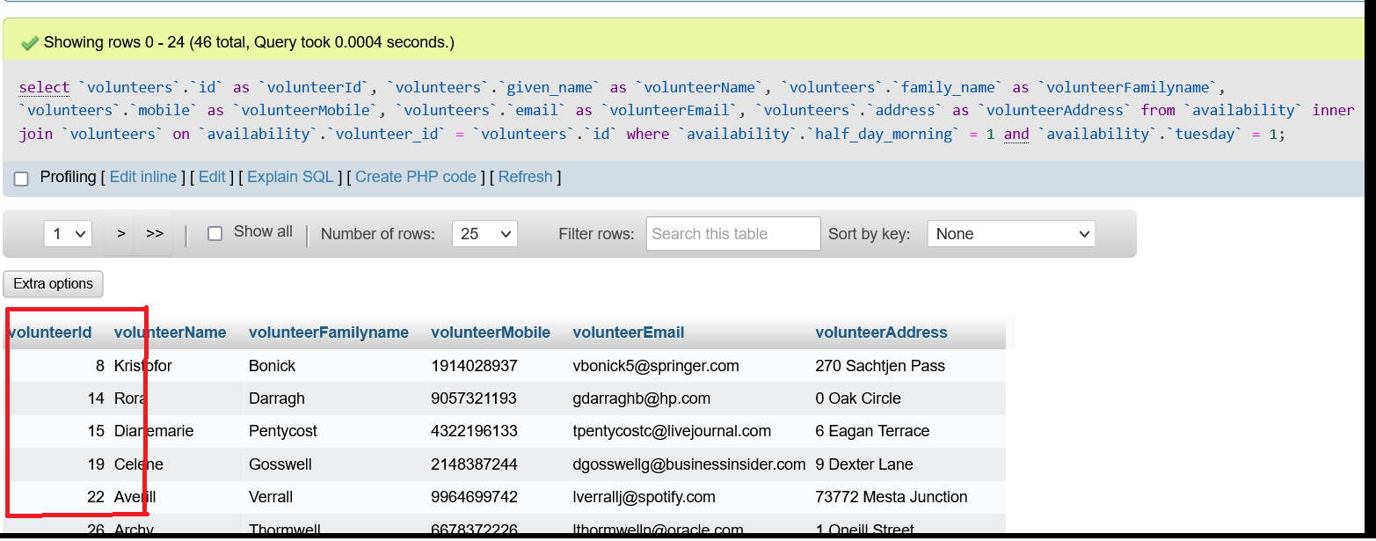

**2). How will you make a team of the available volunteers for the same case as mentioned above?**

**Ans.** Once we have the list of available volunteers on Tuesday first half of the morning, we will run a insert query in “teams” table with volunteer id whom you want to add in team with name of new team.

INSERT INTO `teams` (`team_name`, `volunteers`, `updated_at`, `created_at`) VALUES (**'Team B'**, **'14,15,19,22'**, current_timestamp(), current_timestamp());



**3). How can you assign the team to any client with the above newly formed team?**

**Ans.** For assigning team to required client we have run a query which will add volunteers to the clients. For example we want assign our Team A(team id : 21) to client id: 40. Also you have to mention start and end date.

INSERT INTO `team_client` (`**client_id**`, `**team_id**`, `**volunteers**`, `start_date`, `end_date`, `updated_at`, `created_at`) VALUES (**'43'**, **'23'**, **'14,15,19,22',** '2022-09-27', '2022-09-28', current_timestamp(), current_timestamp());

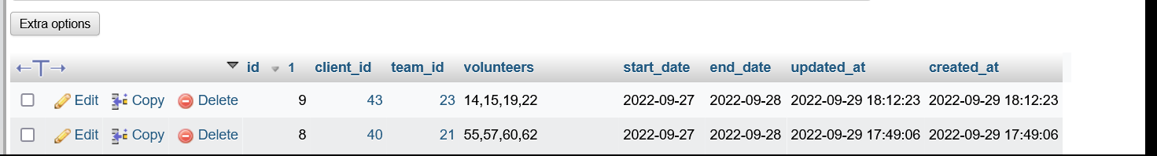

**4) How can you get list all the registered volunteers?**

**Ans.** For getting the list of all registered volunteers we have to run the following query :

SELECT `volunteers`.`id` as `volunteerId`, `volunteers`.`given_name` as `volunteerName`, `volunteers`.`family_name` as `volunteerFamilyName`, `volunteers`.`address` as `volunteerAddress`, `volunteers`.`mobile` as `volunteerMobile`, `volunteers`.`email` as `volunteerEmail` FROM `volunteers`;

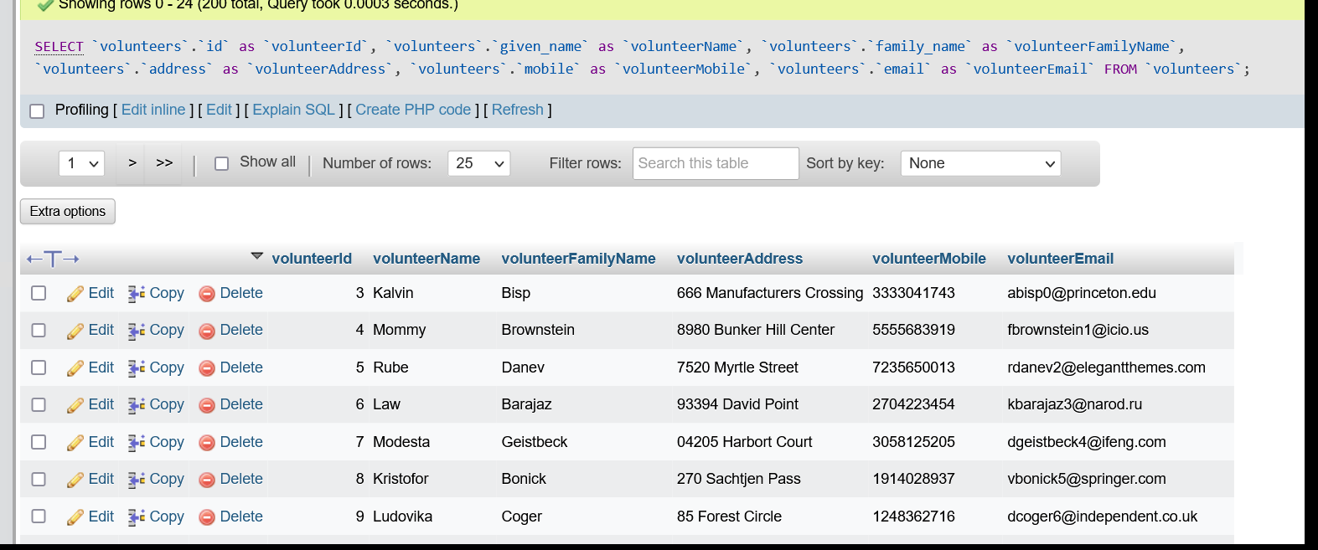

**5). How will you show the name of volunteers assigned in the team?**

**Ans.** For getting the list of all teams with their team id, team name and volunteer id, we can run this below mentioned query:

select `teams`.`id` as `teamId`, `teams`.`team_name` as `teamName`, `teams`.`volunteers` as `VolunteersIDs`, GROUP_CONCAT(volunteers.given_name) as volunteerName from `teams` left join `volunteers` on FIND_IN_SET(volunteers.id,teams.volunteers) > '0' group by `teams`.`id`;

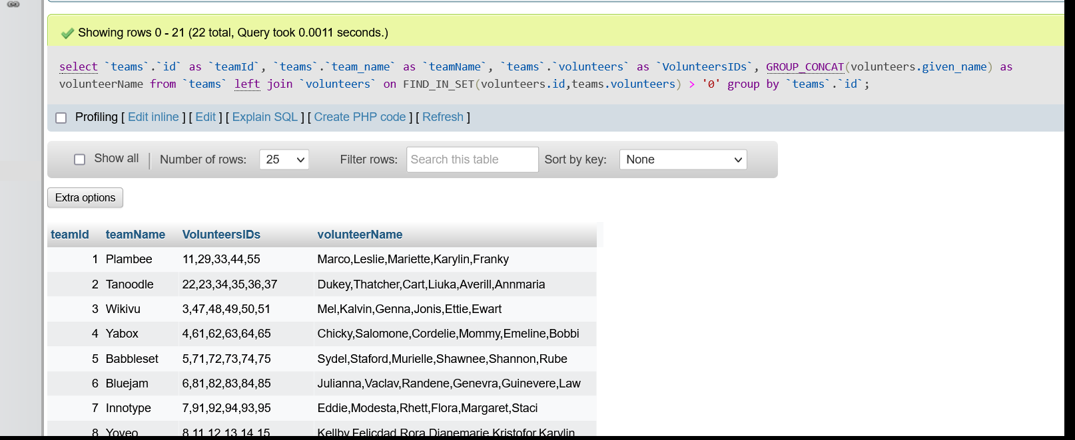

**6). How do I check the availabilities of all the volunteers?**

**Ans.** For getting the list of availabilities we have to run this query:

select `volunteers`.`id` as `volunteerId`, `volunteers`.`given_name` as `volunteerName`, REPLACE(REPLACE(monthly, 2, 'No'), 1, 'Yes') as monthy_availibility, REPLACE(REPLACE(weekly, 2, 'No'), 1, 'Yes') as weeklyAvailibility, REPLACE(REPLACE(fortnightly, 2, 'No'), 1, 'Yes') as fortnightlyAvailibility, REPLACE(REPLACE(full_day, 2, 'No'), 1, 'Yes') as fullDayAvailibility, REPLACE(REPLACE(half_day_morning, 2, 'No'), 1, 'Yes') as halfDayMorningAvailibility, REPLACE(REPLACE(half_day_afternoon, 2, 'No'), 1, 'Yes') as halfDayAfternoonAvailibility, REPLACE(REPLACE(monday, 2, 'No'), 1, 'Yes') as mondayAvailibility, REPLACE(REPLACE(tuesday, 2, 'No'), 1, 'Yes') as tuesdayAvailibility, REPLACE(REPLACE(wednesday, 2, 'No'), 1, 'Yes') as wednesdayAvailibility, REPLACE(REPLACE(thursday, 2, 'No'), 1, 'Yes') as thursdayAvailibility, REPLACE(REPLACE(friday, 2, 'No'), 1, 'Yes') as fridayAvailibility from `volunteers` inner join `availability` on `volunteers`.`id` = `availability`.`volunteer_id`;

