**WebAPI_HandsOn-2**

1. **Web Api using .Net core with Swagger:**

File Structure:

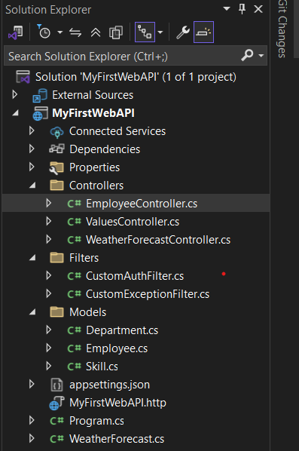

**//Program.cs**

**Code:**

using Microsoft.OpenApi.Models;

using MyFirstWebAPI.Filters;

var builder = WebApplication.CreateBuilder(args);

builder.Services.AddControllers(options =>

{

options.Filters.Add<CustomExceptionFilter>();

});

builder.Services.AddEndpointsApiExplorer();

builder.Services.AddSwaggerGen(c =>

{

c.SwaggerDoc("v1", new Microsoft.OpenApi.Models.OpenApiInfo

{

Title = "Swagger Demo",

Version = "v1",

Description = "TBD",

TermsOfService = new Uri("https://example.com"),

Contact = new Microsoft.OpenApi.Models.OpenApiContact

{

Name = "John Doe",

Email = "john@xyzmail.com",

Url = new Uri("https://example.com")

},

License = new Microsoft.OpenApi.Models.OpenApiLicense

{

Name = "License Terms",

Url = new Uri("https://example.com")

}

});

});

var app = builder.Build();

if (app.Environment.IsDevelopment())

{

app.UseSwagger();

app.UseSwaggerUI(c =>

{

c.SwaggerEndpoint("/swagger/v1/swagger.json", "Swagger Demo");

});

}

app.UseAuthorization();

app.MapControllers();

app.MapGet("/", () => Results.Redirect("/swagger"));

app.Run();

1. **Use POSTMAN tool, to point to the local Web API that was created with Employee controller:**

**//EmployeeController.cs**

**Code:**

using Microsoft.AspNetCore.Authorization;

using Microsoft.AspNetCore.Mvc;

using MyFirstWebAPI.Models;

using MyFirstWebAPI.Filters;

namespace MyFirstWebAPI.Controllers

{

[ApiController]

[Route("api")]

[AllowAnonymous]

[CustomAuthFilter]

public class EmployeeController : ControllerBase

{

// GET: api

[HttpGet]

[ProducesResponseType(typeof(List<Employee>), 200)]

public ActionResult<List<Employee>> GetStandard()

{

//throw new Exception("Something bad happened!");

return GetStandardEmployeeList();

}

// POST: api

[HttpPost]

public IActionResult Post([FromBody] Employee emp)

{

return Ok($"Employee {emp.Name} received successfully");

}

private List<Employee> GetStandardEmployeeList()

{

return new List<Employee>

{

new Employee

{

Id = 1,

Name = "Anurag",

Salary = 50000,

Permanent = true,

DateOfBirth = new DateTime(2004, 3, 27),

Department = new Department { Id = 101, Name = "IT" },

Skills = new List<Skill>

{

new Skill { Id = 1, Name = "C#" },

new Skill { Id = 2, Name = "SQL" }

}

}

};

}

}

}

1. **Modify the Controller name in the Route attribute of the Employee controller to ‘Emp’ and check its access thru POSTMAN:**

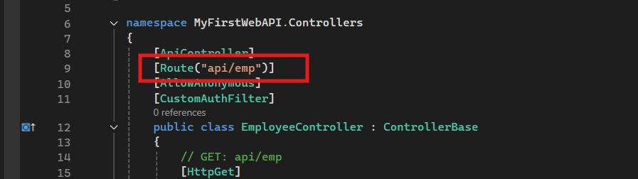

**Output:**

