**WebAPI_HandsOn-3**

1. **Web Api using custom model class:**

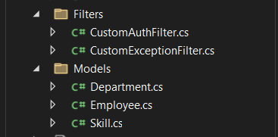

**//Models/Department.cs**

namespace MyFirstWebAPI.Models;

public class Department

{

public int Id { get; set; }

public string Name { get; set; }

}

**//Models/Employee.cs**

namespace MyFirstWebAPI.Models;

public class Employee

{

public int Id { get; set; }

public string Name { get; set; }

public int Salary { get; set; }

public bool Permanent { get; set; }

public Department Department { get; set; }

public List<Skill> Skills { get; set; }

public DateTime DateOfBirth { get; set; }

}

**//Models/Skill.cs**

namespace MyFirstWebAPI.Models;

public class Skill

{

public int Id { get; set; }

public string Name { get; set; }

}

1. **Create a Custom action filter for Authorization.**

**//Filters/CustomAuthFilter.cs**

using Microsoft.AspNetCore.Mvc;

using Microsoft.AspNetCore.Mvc.Filters;

namespace MyFirstWebAPI.Filters

{

public class CustomAuthFilter : ActionFilterAttribute

{

public override void OnActionExecuting(ActionExecutingContext context)

{

var headers = context.HttpContext.Request.Headers;

if (!headers.ContainsKey("Authorization"))

{

context.Result = new BadRequestObjectResult("Invalid request - No Auth token");

return;

}

var token = headers["Authorization"].ToString();

if (!token.Contains("Bearer"))

{

context.Result = new BadRequestObjectResult("Invalid request - Token present but Bearer unavailable");

return;

}

base.OnActionExecuting(context);

}

}

}

1. **Custom Exception filter**

**//Filter/CustomExceptionFilter.cs**

using Microsoft.AspNetCore.Mvc;

using Microsoft.AspNetCore.Mvc.Filters;

using System.IO;

namespace MyFirstWebAPI.Filters

{

public class CustomExceptionFilter : IExceptionFilter

{

public void OnException(ExceptionContext context)

{

string error = $"Exception: {context.Exception.Message}\nStack: {context.Exception.StackTrace}\n";

File.AppendAllText("exceptions.log", error);

context.Result = new ObjectResult("An internal server error occurred.")

{

StatusCode = 500

};

}

}

}

**Program.cs**

`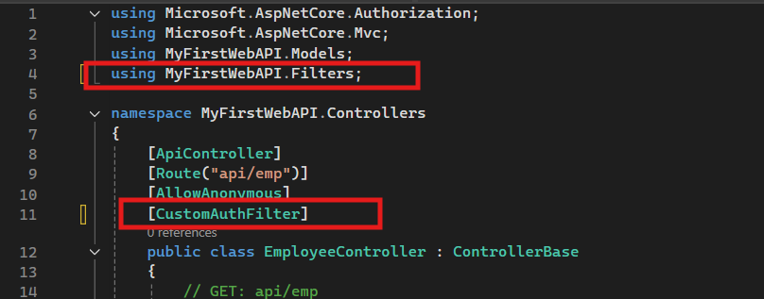

**Without Filter**

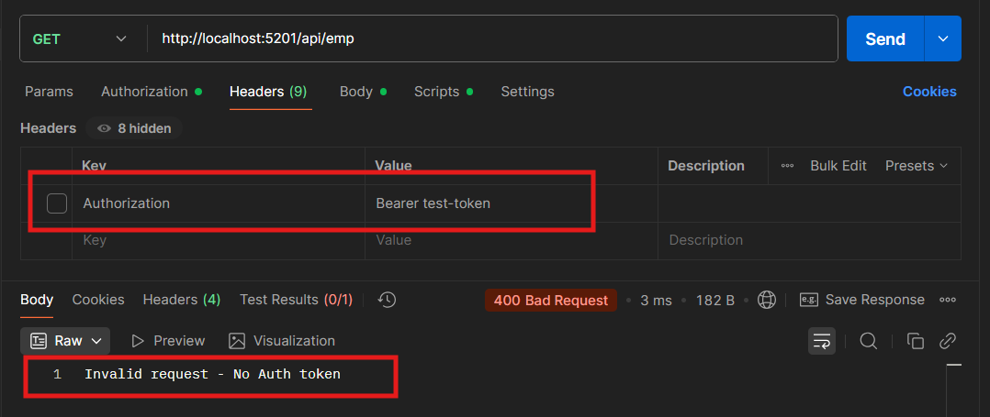

**With Filter**

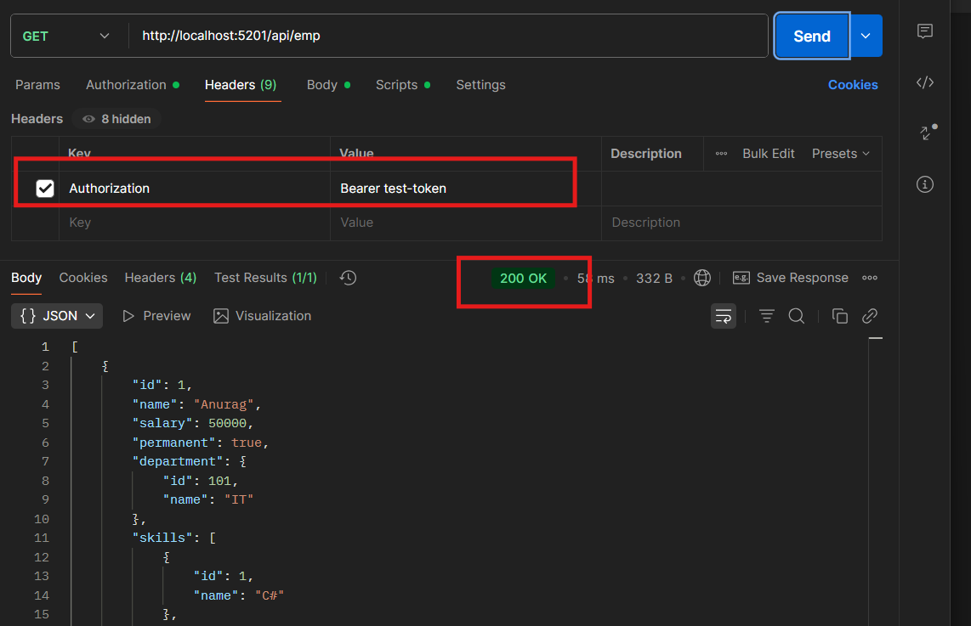

**Custom Exception**

