**WebAPI_HandsOn-5**

1. **JsonWebToken**

**File Structure:**

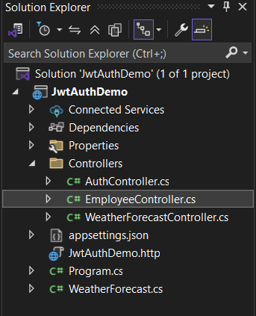

**//Program.cs**

using Microsoft.AspNetCore.Authentication.JwtBearer;

using Microsoft.IdentityModel.Tokens;

using System.Text;

var builder = WebApplication.CreateBuilder(args);

builder.Services.AddControllers();

builder.Services.AddCors(options =>

{

options.AddPolicy("AllowLocalhost",

policy => policy.WithOrigins("http://localhost:3000")

.AllowAnyHeader()

.AllowAnyMethod());

});

string securityKey = "mysuperdupersecurekey123456789012";

var symmetricSecurityKey = new SymmetricSecurityKey(Encoding.UTF8.GetBytes(securityKey));

builder.Services.AddAuthentication(options =>

{

options.DefaultAuthenticateScheme = JwtBearerDefaults.AuthenticationScheme;

options.DefaultChallengeScheme = JwtBearerDefaults.AuthenticationScheme;

})

.AddJwtBearer(options =>

{

options.TokenValidationParameters = new TokenValidationParameters

{

ValidateIssuer = true,

ValidateAudience = true,

ValidateLifetime = true,

ValidateIssuerSigningKey = true,

ValidIssuer = "mySystem",

ValidAudience = "myUsers",

IssuerSigningKey = symmetricSecurityKey

};

});

var app = builder.Build();

app.UseCors("AllowLocalhost");

app.UseAuthentication();

app.UseAuthorization();

app.MapControllers();

app.Run();

**//AuthController.cs**

using Microsoft.AspNetCore.Authorization;

using Microsoft.AspNetCore.Mvc;

using Microsoft.IdentityModel.Tokens;

using System.IdentityModel.Tokens.Jwt;

using System.Security.Claims;

using System.Text;

namespace JwtAuthDemo.Controllers

{

[ApiController]

[Route("api/[controller]")]

[AllowAnonymous]

public class AuthController : ControllerBase

{

[HttpGet("token")]

public IActionResult GetToken()

{

var token = GenerateJSONWebToken(1, "Admin");

return Ok(new { token });

}

private string GenerateJSONWebToken(int userId, string userRole)

{

var securityKey = new SymmetricSecurityKey(Encoding.UTF8.GetBytes("mysuperdupersecurekey123456789012"));

var credentials = new SigningCredentials(securityKey, SecurityAlgorithms.HmacSha256);

var claims = new List<Claim>

{

new Claim(ClaimTypes.Role, userRole),

new Claim("UserId", userId.ToString())

};

var token = new JwtSecurityToken(

issuer: "mySystem",

audience: "myUsers",

claims: claims,

expires: DateTime.Now.AddMinutes(2),

signingCredentials: credentials);

return new JwtSecurityTokenHandler().WriteToken(token);

}

}

}

**//EmployeeController.cs**

using Microsoft.AspNetCore.Authorization;

using Microsoft.AspNetCore.Mvc;

namespace JwtAuthDemo.Controllers

{

[ApiController]

[Route("api/[controller]")]

//[Authorize(Roles = "Admin,POC")]

[Authorize(Roles = "POC")]

public class EmployeeController : ControllerBase

{

[HttpGet]

public IActionResult GetData()

{

return Ok("You are Authorized!");

}

}

}

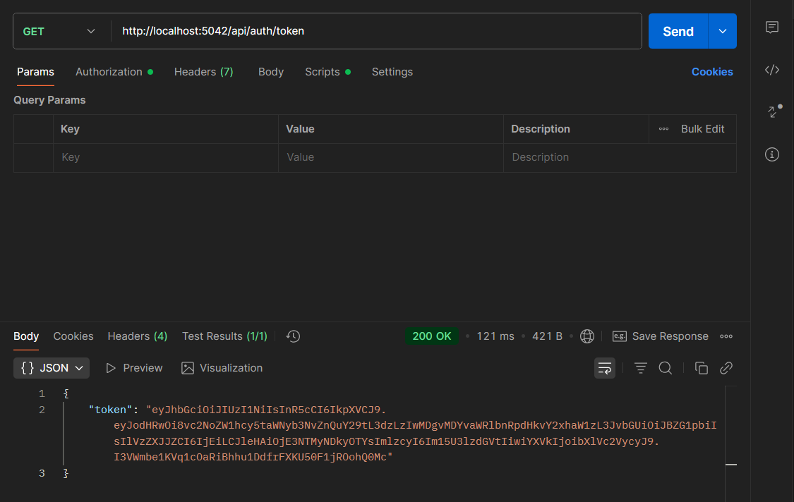

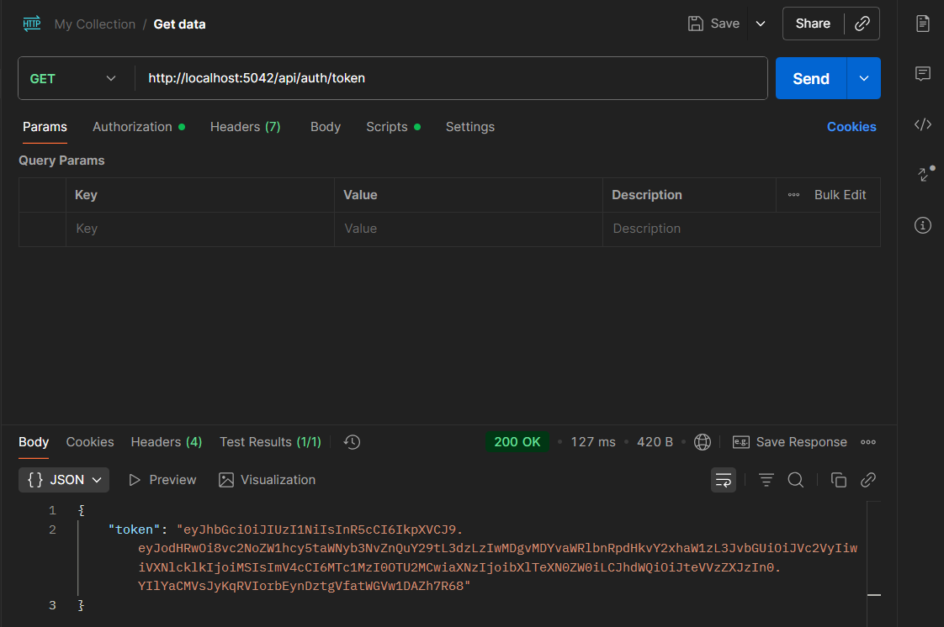

1. **Use the JWT generated thru the AuthController to be used in POSTMAN request.**

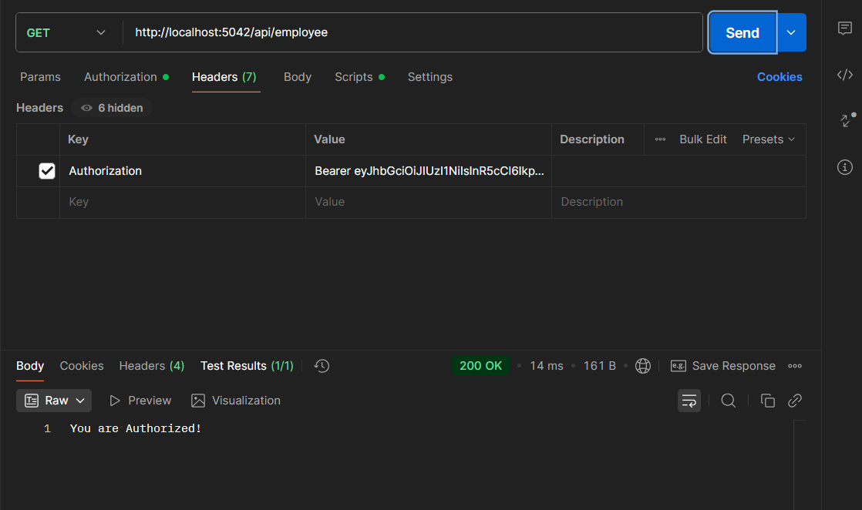

1. **Check for JWT expiration**

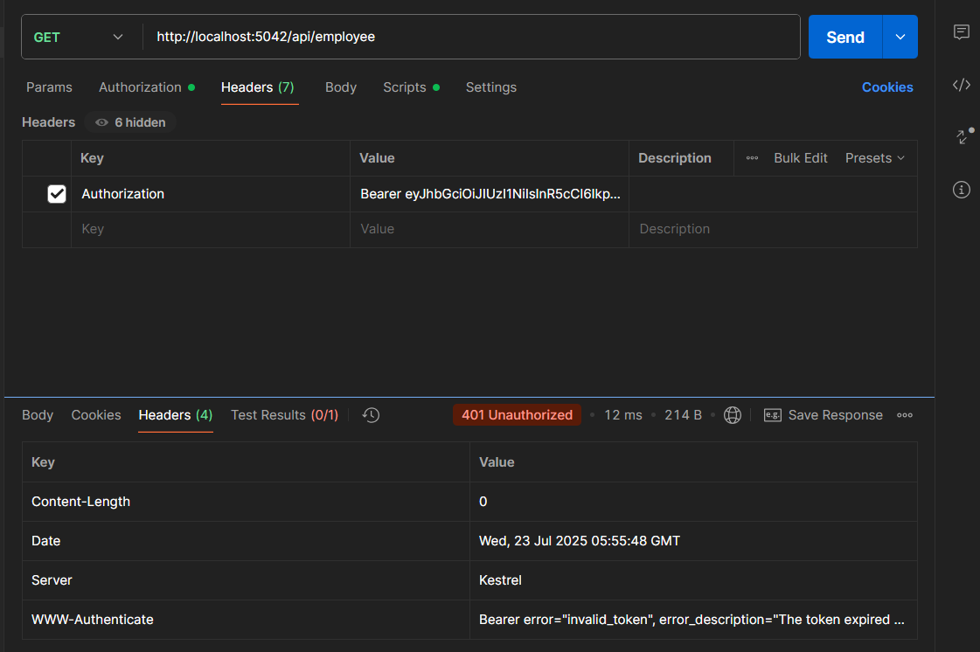

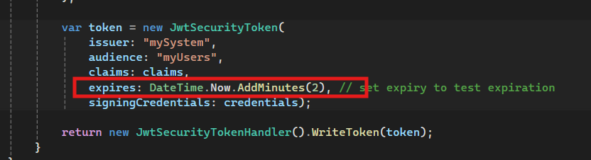

1. **Add the roles to be authorized in the Authorize attribute.**

