**REACT HandsOnLAB - 2**

1. **Explain React components**

**Sol:** React components are reusable, self-contained building blocks of a React app that define how a part of the UI should look and behave. They take props as input and return React elements to render on the screen. Components can also manage state and handle user interactions to create dynamic interfaces.

1. **Identify the differences between components and JavaScript functions**

**Sol:**

|  |  |  |
| --- | --- | --- |
| **Feature** | **React Components** | **JavaScript Functions** |
| Returns | JSX/UI | Values (e.g., number, string) |
| Used in | React for UI rendering | General logic |
| Syntax | function or class based | Pure function syntax |
| Lifecycle | Has lifecycle methods (in class) | No lifecycle |

1. **Identify the types of components**

**Sol: 1. Class Components**

**2. Functional Components**.

1. **Explain class component**

**Sol:** Class components are ES6 classes that extend React.Component. They have access to lifecycle methods and can maintain state using this.state.

1. **Explain function component**

**Sol:**  Functional components are JavaScript functions that return JSX. With the introduction of hooks, they can now handle state and lifecycle events that were previously only available in class components.

1. **Define component constructor**

**Sol:**  A method in class components to initialize state or bind methods.

constructor(props) {

  super(props);

  this.state = { name: "StudentApp" };

}

1. **Define render() function**

**Sol:** The render() method is the most important method in a React class component. It's the only required method and determines what gets displayed on the screen.

**Purpose**

The render() method returns the JSX elements that represent the component's UI. It describes what the component should look like based on the current props and state.

**In this hands-on lab, you will learn how to:**

* **Create a class component**
* **Create multiple components**
* **Render a component**

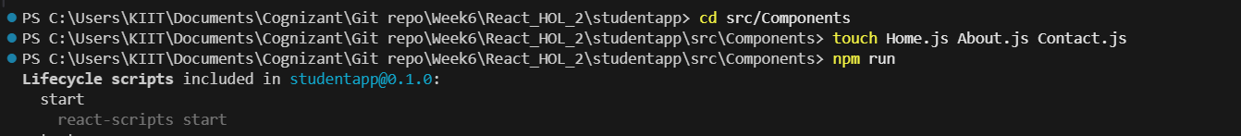

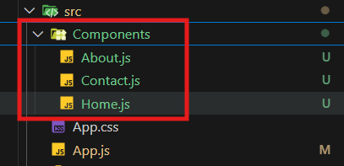

**//Home.js**

import React from 'react'

const Home = () => {

  return (

    <h1>Welcome to the Home page of Student Management Portal</h1>

  )

}

export default Home

**//About.js**

import React from 'react'

const About = () => {

  return (

    <h1>Welcome to the About page of Student Management Portal</h1>

  )

}

export default About

**//Contact.js**

import React from 'react'

const Contact = () => {

  return (

    <h1>Welcome to the Contact page of Student Management Portal</h1>

  )

}

export default Contact

**//App.js**

import React from 'react'

import Home from './Components/Home'

import About from './Components/About'

import Contact from './Components/Contact'

const App = () => {

  return (

    <>

    <Home/>

    <About/>

    <Contact/>

    </>

  )

}

export default App

