**REACT HandsOnLAB - 5**

**In this hands-on lab, you will learn how to:**

* **Style a react component**
* **Define styles using the CSS Module**
* **Apply styles to components using className and style properties**

**File Structure:**

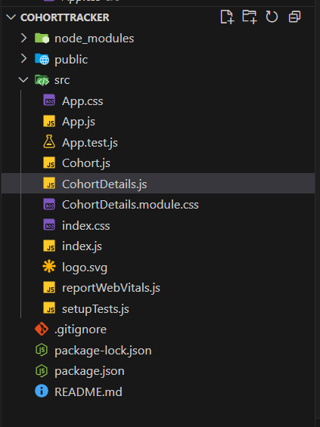

**CohortDetails.module.css**

.box {

  width: 300px;

  display: inline-block;

  margin: 10px;

  padding: 10px 20px;

  border: 1px solid black;

  border-radius: 10px;

}

.dt {

  font-weight: 500;

}

**CohortDetails.js**

import style from "./CohortDetails.module.css";

function CohortDetails(props) {

  const isOngoing = props.cohort.currentStatus === "Ongoing";

  const headingStyle = {

    color: isOngoing ? "green" : "blue",

  };

  return (

    <div className={style.box}>

      <h3 style = {headingStyle}>

        {props.cohort.cohortCode} -<span>{props.cohort.technology}</span>

      </h3>

      <dl>

        <dt className={style.dt}>Started On</dt>

        <dd>{props.cohort.startDate}</dd>

        <dt className={style.dt}>Current Status</dt>

        <dd>{props.cohort.currentStatus}</dd>

        <dt className={style.dt}>Coach</dt>

        <dd>{props.cohort.coachName}</dd>

        <dt className={style.dt}>Trainer</dt>

        <dd>{props.cohort.trainerName}</dd>

      </dl>

    </div>

  );

}

export default CohortDetails;

**App.js**

import './App.css';

import { CohortsData} from './Cohort'

import CohortDetails from './CohortDetails';

function App() {

  return (

  <div>

    <h1>Cohorts Details</h1>

    {CohortsData.map(cohort => <CohortDetails cohort={cohort}/>)}

  </div>

  );

}

export default App;

