**REACT HandsOnLAB - 9**

In this hands-on lab, you will learn how to:

* Use map() method of ES6
* Apply arrow functions of ES6
* Implement Destructuring features of ES6

**Create a React Application named “cricketapp” with the following components:**

**PlayersData.js**

export const players = [

  { name: 'Jack', score: 50 },

  { name: 'Michael', score: 70 },

  { name: 'John', score: 40 },

  { name: 'Ann', score: 61 },

  { name: 'Elisabeth', score: 61 },

  { name: 'Sachin', score: 95 },

  { name: 'Dhoni', score: 100 },

  { name: 'Virat', score: 84 },

  { name: 'Jadeja', score: 64 },

  { name: 'Raina', score: 75 },

  { name: 'Rohit', score: 80 }

];

// Arrays for merging

const T20Players = ['First Player', 'Second Player', 'Third Player'];

const RanjiTrophyPlayers = ['Fourth Player', 'Fifth Player', 'Sixth Player'];

// Merge the two arrays using the spread operator

export const IndianPlayers = [...T20Players, ...RanjiTrophyPlayers];

// Another array for destructuring example

export const IndianTeam = ['Sachin1', 'Dhoni2', 'Virat3', 'Rohit4', 'Yuvraj5', 'Raina6'];

**App.js**

import React from 'react';

import './App.css';

import { players, IndianPlayers, IndianTeam } from './playersData';

import ListofPlayers from './components/ListofPlayers';

import Scorebelow70 from './components/Scorebelow70';

import { OddPlayers, EvenPlayers } from './components/TeamPlayers';

import ListofIndianPlayers from './components/ListofIndianPlayers';

function App() {

  // Set flag to true or false to see different outputs

  const flag = true;

  if (flag) {

    return (

      <div className="App">

        <h1>List of Players</h1>

        <ListofPlayers players={players} />

        <hr />

        <h1>List of Players having Scores Less than 70</h1>

        <Scorebelow70 players={players} />

      </div>

    );

  } else {

    return (

      <div className="App">

        <h1>Odd Players</h1>

        {OddPlayers(IndianTeam)}

        <hr />

        <h1>Even Players</h1>

        {EvenPlayers(IndianTeam)}

        <hr />

        <h1>List of Indian Players Merged:</h1>

        <ListofIndianPlayers IndianPlayers={IndianPlayers} />

      </div>

    );

  }

}

export default App;

**Components/ListofIndianPlayers.js**

import React from 'react';

function ListofIndianPlayers({ IndianPlayers }) {

  return (

    <div>

      {IndianPlayers.map((player, index) => (

        <li key={index}>Mr. {player}</li>

      ))}

    </div>

  );

}

export default ListofIndianPlayers;

**Components/ListofPlayers.js**

import React from 'react';

function ListofPlayers({ players }) {

  return (

    <div>

      {players.map((player, index) => (

        <li key={index}>

          Mr. {player.name} {player.score}

        </li>

      ))}

    </div>

  );

}

export default ListofPlayers;

**Compoenents/Scorebelow70.js**

import React from 'react';

function Scorebelow70({ players }) {

  // Filter players with score <= 70 and then map to display them

  const playersBelow70 = players

    .filter(player => player.score <= 70)

    .map((player, index) => (

      <li key={index}>

        Mr. {player.name} {player.score}

      </li>

    ));

  return <div>{playersBelow70}</div>;

}

export default Scorebelow70;

**Compoents/TeamPlayers.js**

import React from 'react';

export function OddPlayers([first, , third, , fifth]) {

  return (

    <div>

      <li>First: {first}</li>

      <li>Third: {third}</li>

      <li>Fifth: {fifth}</li>

    </div>

  );

}

export function EvenPlayers([, second, , fourth, , sixth]) {

  return (

    <div>

      <li>Second: {second}</li>

      <li>Fourth: {fourth}</li>

      <li>Sixth: {sixth}</li>

    </div>

  );

}

**With Flag == True**

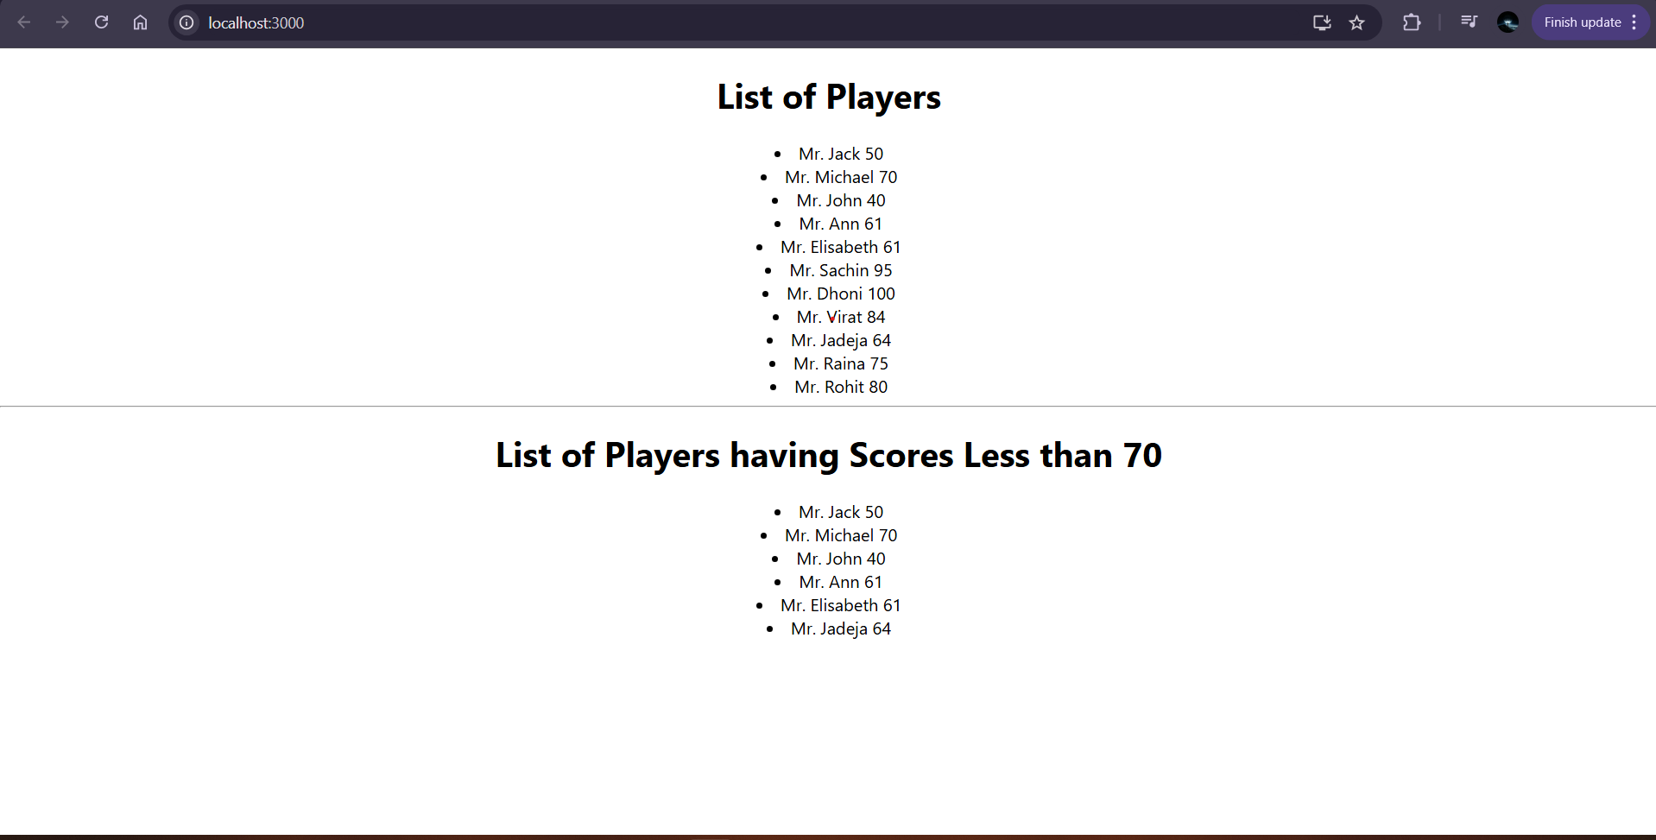

**With Flag == Flase**

