**GIT HandsOnLAB - 1**

In this hands-on lab, you will learn how to:

* Setup your machine with Git Configuration
* Integrate notepad++.exe to Git and make it a default editor
* Add a file to source code repository

**Step 1: Setup your machine with Git Configuration**

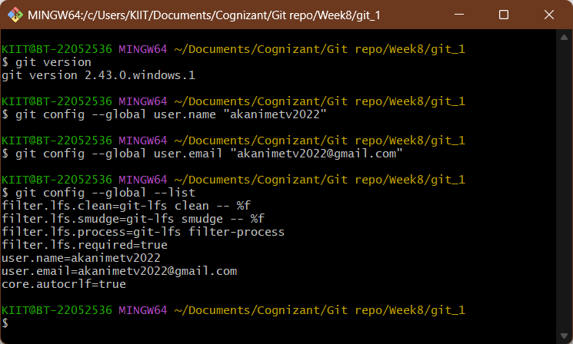

**Step 2: Integrate notepad++.exe to Git and make it a default editor**

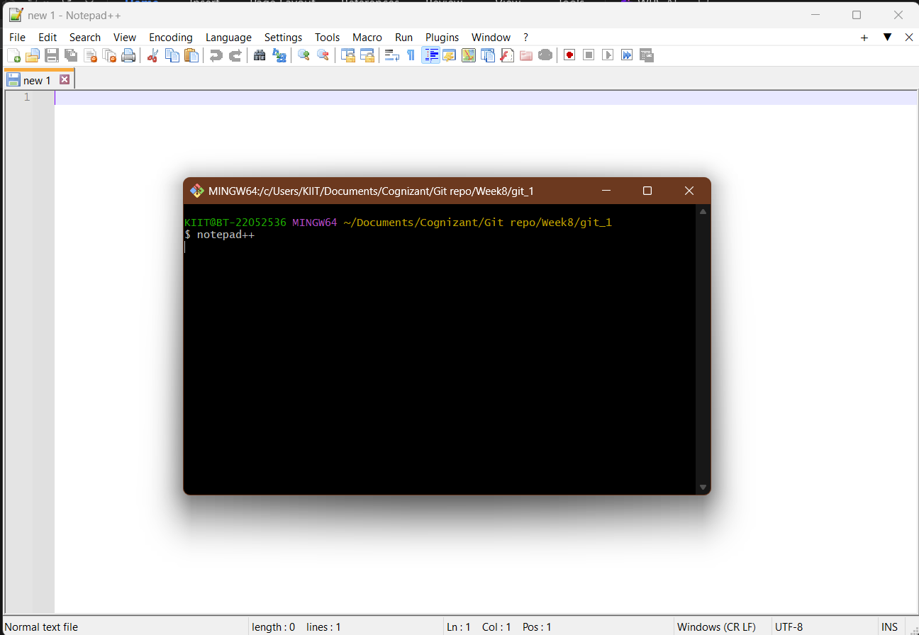

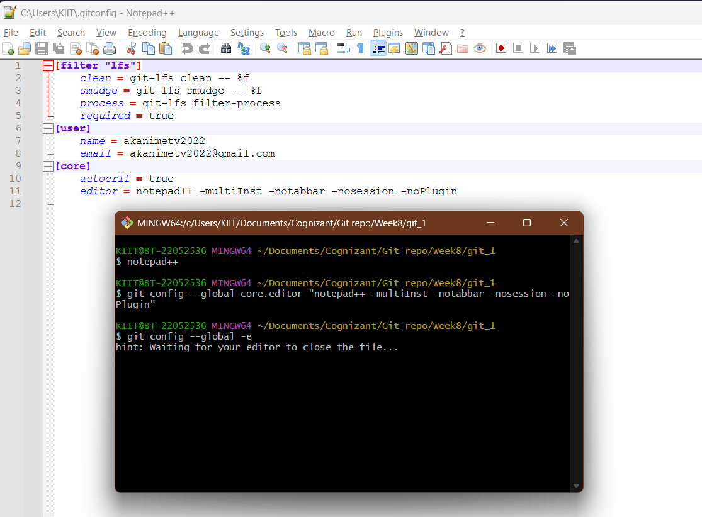

**Step 3: Add a file to source code repository**

