**GIT HandsOnLAB - 3**

In this hands-on lab, you will learn how to:

* Construct a branch, do some changes in the branch, and merge it with master (or trunk)

**Branching**

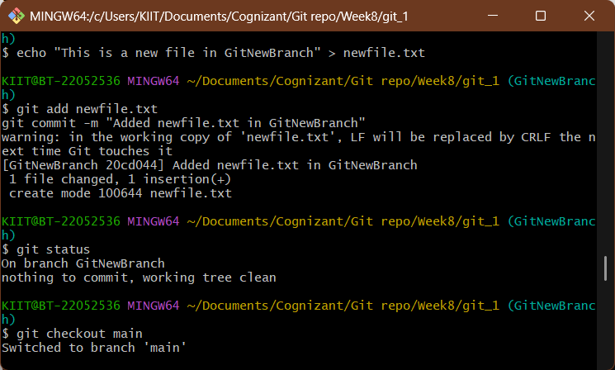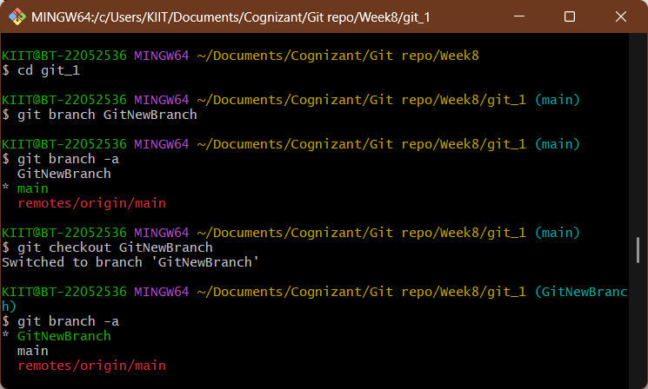

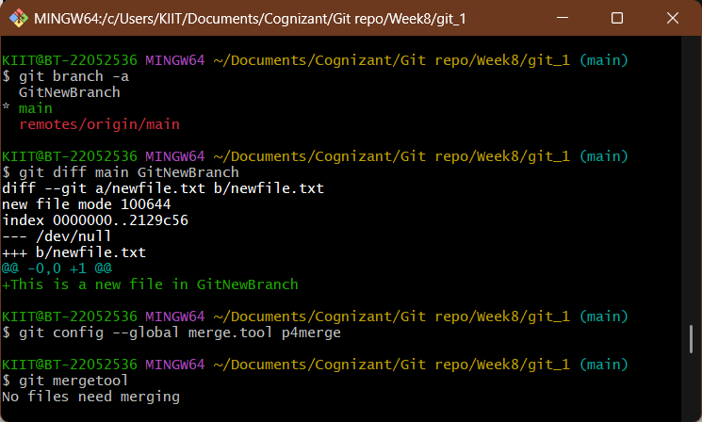

**Merging**

