**Selenium Locators Assignment:**

**Problem 1**- Open <https://www.phptravels.net/hotels> website and locate the following and Write xpath.

* PHPTRAVLES Logo

//*[@id="fadein"]/header/div[2]/div/div/div/div/div[1]/a/img

* Home

//*[@id="fadein"]/header/div[2]/div/div/div/div/div[2]/nav/ul/li[1]/a

* Flights

//*[@id="fadein"]/header/div[2]/div/div/div/div/div[2]/nav/ul/li[3]/a

* Tours

//*[@id="fadein"]/header/div[2]/div/div/div/div/div[2]/nav/ul/li[4]/a

* Company

//*[@id="fadein"]/header/div[2]/div/div/div/div/div[2]/nav/ul/li[8]/a

* Signup Btn

//*[@id="fadein"]/header/div[1]/div/div/div[2]/div/div/a[1]

* Login Btn

//*[@id="fadein"]/header/div[1]/div/div/div[2]/div/div/a[2]

* Agents DropDown

//*[@id="agents"]

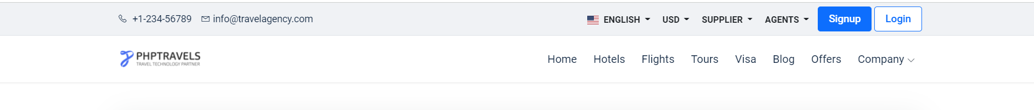

*Note - You have to use Id, Name, Class, CSS Selector, TagName and write Relative and absolute xpath*

**Problem 2**- Write **Xpath** for Below Web elements using Xpath Axes (such as preceding, following, ancestor, following-sibling etc..)

* Check in - Calendar Icon

//*[@id="hotels-search"]/div/div/div[2]/div/div[1]/span

* Check Out – Calendar Icon

//*[@id="hotels-search"]/div/div/div[2]/div/div[1]/span

* “- ” for Adults

//*[@id="hotels-search"]/div/div/div[3]/div/div/div/div/div[2]/div/label

* “+” for Adults

//*[@id="hotels-search"]/div/div/div[3]/div/div/div/div/div[2]/div/div/div[2]/i

* “-“ for Childs

//*[@id="hotels-search"]/div/div/div[3]/div/div/div/div/div[3]/div/div/div[1]/i

* “+” for Childs

//*[@id="hotels-search"]/div/div/div[3]/div/div/div/div/div[3]/div/div/div[1]/i

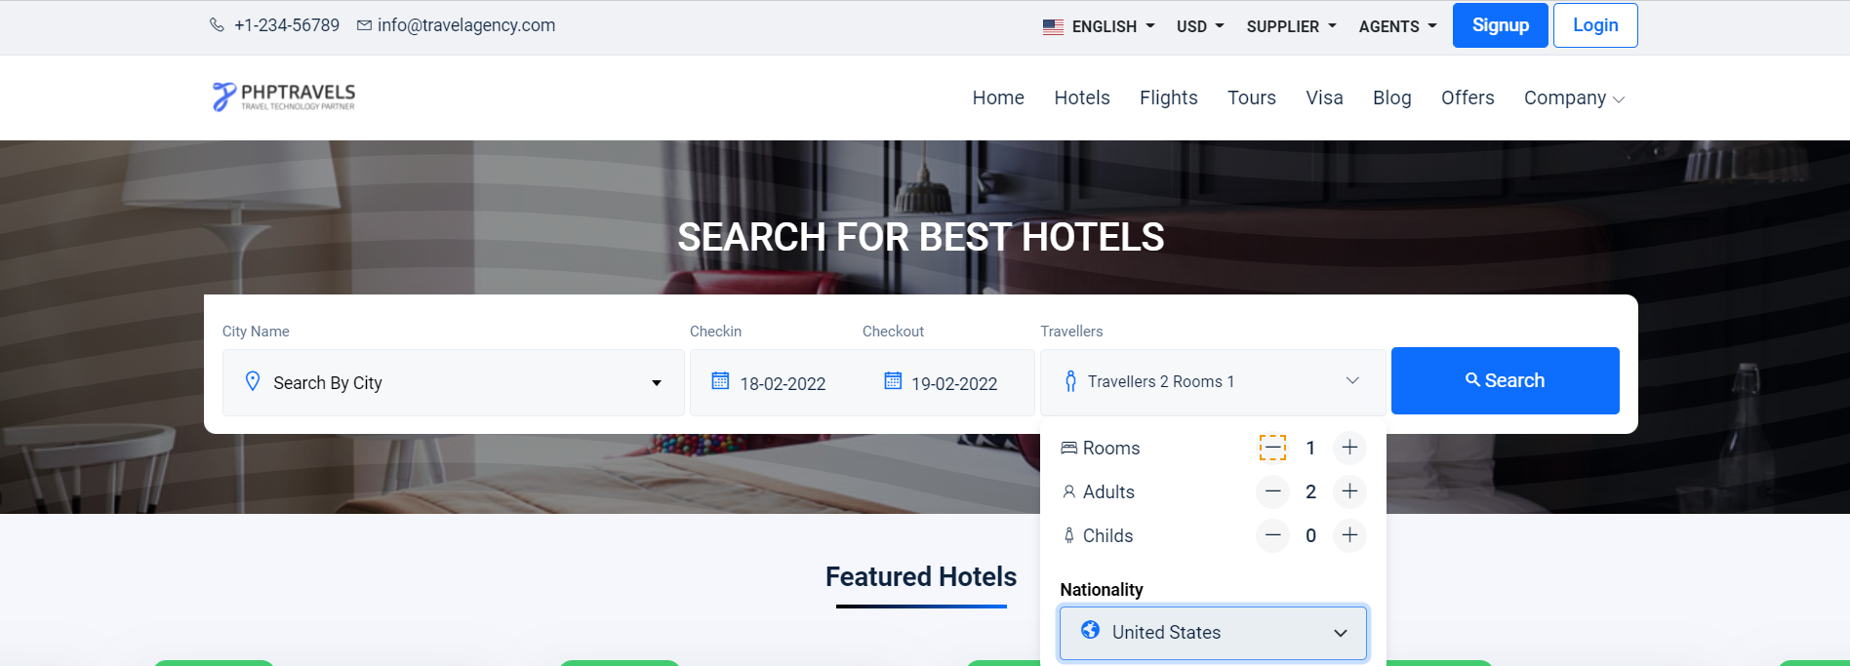

**Note : Don’t Use Indexes**