**PROJECT PROPOSAL**

**Project Name:** Bearcat Market Place

**Team Name:** Intruders

**Team Members:** Anurag Kumar

Lokeswari Pittu

Vyshnavi Yalamareddy

Sreelekha Vijaya

**Aim:**

This marketplace is majorly for Bearcat Students and employees, where anyone can sell their old items which is of no use to them to others who need it like tables, cycles, beds and many more items for less price than the market price. Other than that they can find the rooms nearby the locations reducing the burden of finding rooms for students. Since this app is majorly for the bearcat student and employees it can be spread to a wide range making it a useful application.

**Working:**

Initially after opening the app, user will be directed to the registration page, where user has to enter the details and that will be saved in the database. Once the user is done with the registration then user will be directed to login page. After login, next user will be directed to the marketplace. Initially all the top pickup will be shown to the user, then user can apply the filter option that he is looking for exact item. Then after applying filters all filtered items will be shown. Then after click over the item which user prefer to buy that items description page will be open. From there user can go to chat room where the user and seller can bargain the price and then fix a meetup location. Then after the deal is done, the sell can mark it as sold.

**Technical Aspects:**

In frontend we are planning to create 10-12 activities and in backend we will have database named SQLite where all the user data , items details will be stored.

Following are the rough sketches of the activities that we are planning to include in our application.

This is the home page that displays after opening the application.

Activity 1:

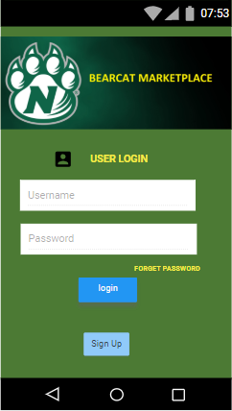

1. Enter the user credentials
2. Clicking on the login button opens Activity 3
3. Clicking on the Sign Up button opens Activity 2

Activity 2:

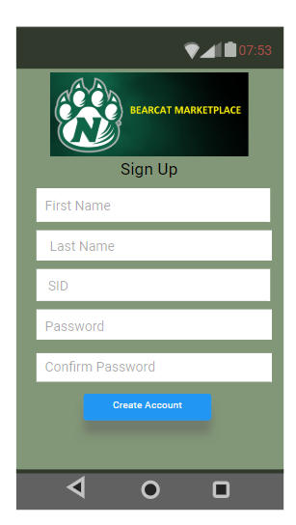

1. Enter the user credentials
2. Clicking on the create account button opens Activity 1
3. Again Clicking on the login button opens Activity 3

Activity 3:

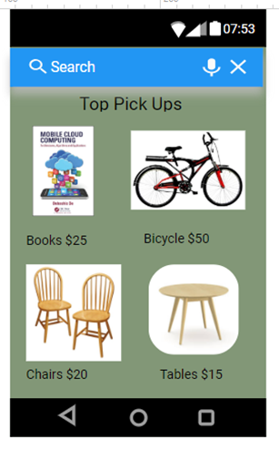

After this one, Activity 4 will be displayed

On Selecting the category in Activity 4 opens Activity 5.

Activity 4:

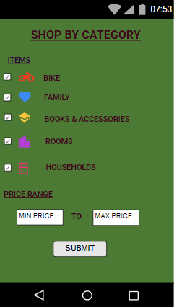

Activity 5:

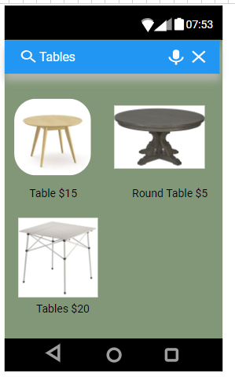

Selecting one item in this Activity displays Activity 6.

Clicking on open chat button opens Activity 7.

Activity 6:

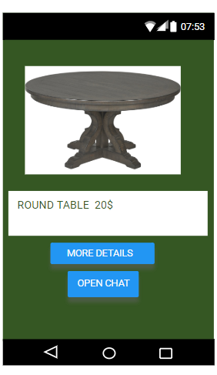

Activity 7:

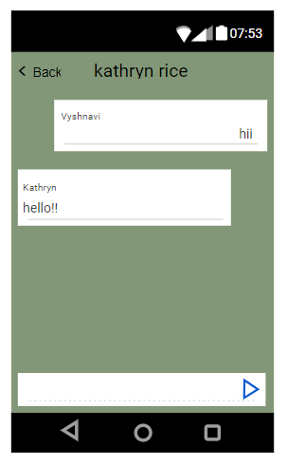

If the user likes the deal, he can buy the item. If the item was sold, it displays that the item was sold as shown in Activity 8.

Activity 8:

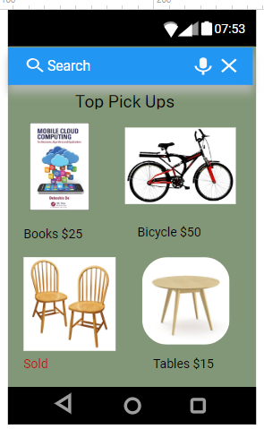

**Team Member Roles:**

Vyshnavi Yalamareddy – Programmer

Lokeswari Pittu – Programmer

Anurag Kumar – Database

Sreelekha Vijaya – Database