AI Resume Matcher - Project Report
Made by: Anurag Makwana

Tools & Technologies
- Python (Backend logic and AI integration)
- JavaScript (Frontend interactive UI)
- HTML/CSS & TailwindCSS (Styling and layout)
- PostgreSQL (Relational Database for users and history)
- Google Gemini & HuggingFace (LLMs for intelligent matching and embeddings)
- Playwright (Automated web interactions for testing/snapshots)

Frameworks
- FastAPI (High performance backend API)
- React & Vite (Frontend build tool and UI library)
- SQLAlchemy (Python ORM for database operations)
- Pydantic (Data validation and parsing)

Architecture Overview
The AI Resume Matcher follows a modern Client-Server architecture pattern. The client-side is a Single Page Application (SPA) built with React and Vite, utilizing TailwindCSS for responsive styling. The server-side is a RESTful API built with FastAPI, which handles authentication (via JWT), business logic, and communication with the PostgreSQL database using SQLAlchemy. When a user uploads a resume and job description, the FastAPI backend processes the documents, extracts text using pdfplumber, and leverages large language models (LLMs) to perform semantic analysis and generate a match score. The results are stored in PostgreSQL and returned to the React frontend for display.

Application Visuals

Home Page (Intelligent Match Analysis)
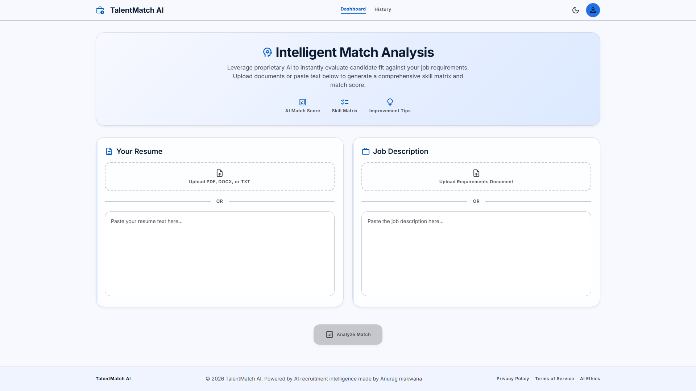

Login Page


Admin Dashboard (User Management)
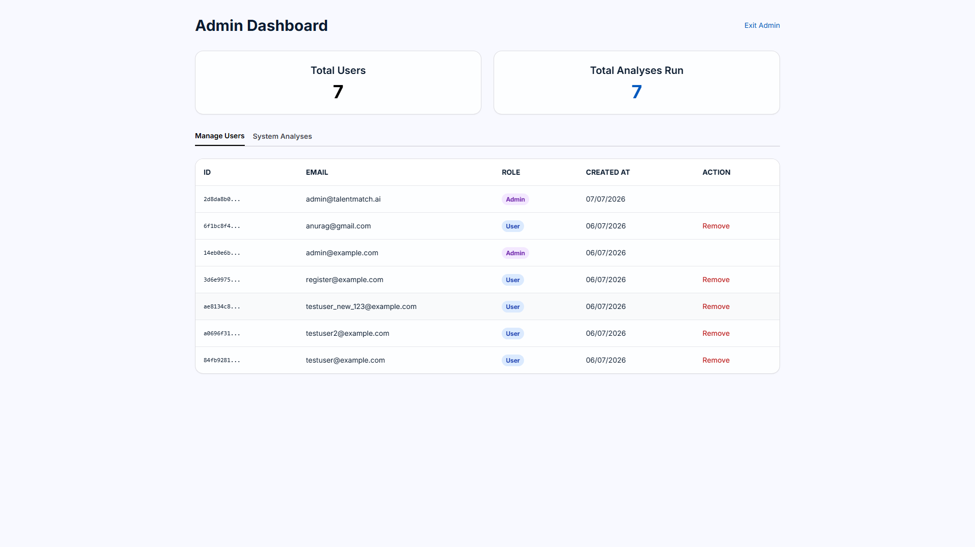

Analysis Result Page
