# DIFFERENTIAL TESTING OF REAL TIME SCHEDULERS

# Abstract

A real time scheduler needs to not only schedule all tasks in an efficient way, but it also must do so in a timely manner. Each task must also meet its deadline. Every real time application has a unique set of requirements which it needs to cater and for each such application, a suitable scheduler algorithm needs to be selected. In addition to this, there is a one to many mappings between the scheduling algorithms and the schedulers available in the market. This makes it even more difficult in choosing the right scheduler for the application.

A Real Time scheduler ‘A’ is said to be as good to be real time scheduler ‘B’ if, both ‘A’ and ‘B’ can schedule a set of tasks without missing a deadline. Differential testing is a technique in which a set of inputs is given to two applications/algorithms or different implementations of the same algorithm and observe the anomalies in the output. If the output differs, algorithm/program under test is said to be not optimal. This concept of differential testing can be used to randomly generate a set of tasks and feed them in two different implementations of the schedulers and effectively test them.

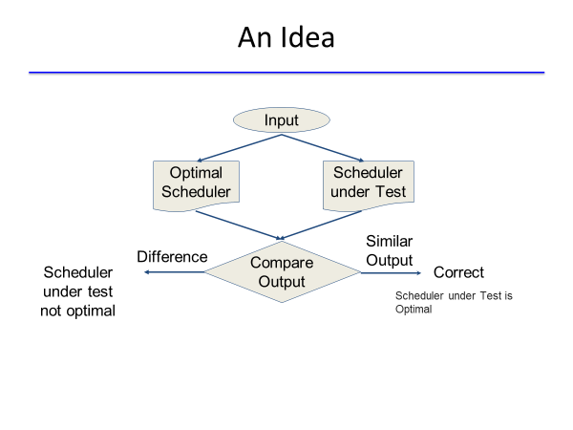

# Proposed Idea

1. Identify the type of scheduling algorithm to be tested (Static or Dynamic, pre-emptive or non pre-emptive).
2. Identify the criterions for testing. (response time, deadlines met, lower cpu utilization, etc.)
3. Generate random set of periodic tasks with random execution time so as them meet the utilization bounds of the scheduler.
4. Feed the set of tasks to the program under test and the optimal schedular and observe the output for differences.
5. Continue steps 3 and 4 for various sets of random tasks or till the execution time expires.
6. Analyse the outputs.