**AIRFACE LENS : IMAGE PROCESSING**

**AND TEXT DETECTION**

Name :- Anurag Pattnaik

Date:-20-10-2021

**Purpose :-** To build a trained model in python that can be able to read an image captured in a camera , identify and classify the objects/items in the image and read the texts from the image.

**Environment** :- Python 3.8.10

**IDE** :- Google Colab, PyCharm

**Tools and Packages Required :-**

* OpenCV
* Pandas
* Numpy
* Pytesseract
* Matpotlib
* Tensorflow
* imutils

**Functional Requirements :-**

1. The model must be able to capture an image from camera and read the captured image..
2. The model needs to be able to identify the objects in the image and classify them into different categories.
3. The trained model must be able to detect the characteristics and properties of the identified objects and categorize them.
4. The model must be able to detect and read texts in the image upto maximmum accuracy and efficiency.

**Sample Use Cases:-**



-----> Nokia

Connecting People

*Input Image*  *Output*

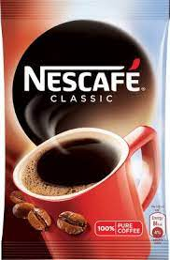

**Object** – Cup

**Color** - Red

**---------> Text -** Nescape

CLASSIC

*Input Image Output*

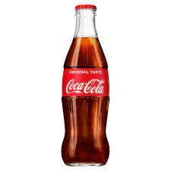

*------>* Object – Bottle

Text – Original Taste

Coca Cola

*Input Image Output*

**EAST : An Efficinient and Accurate Scene Text Detector Algorithm based on Deep Learning**

**--------------------------------------------------------**

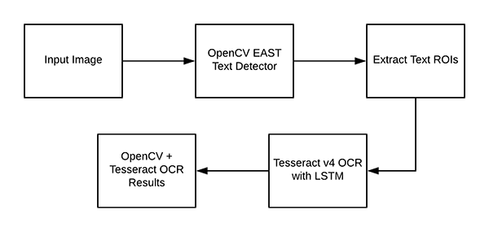

**Process Flow Diagram :-**

------------------------------

