1. Create Navigation menu as shown below. Show the chosen option as shown below.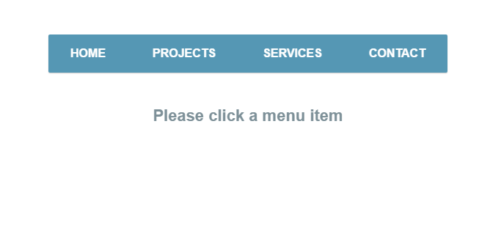

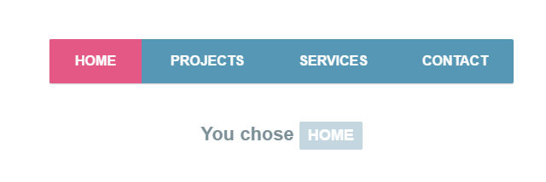

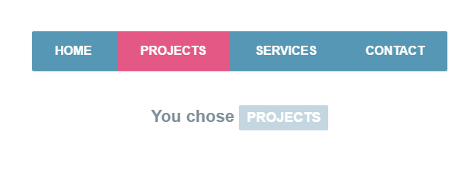

CODE:

src/index.js

import React from 'react';

import ReactDOM from 'react-dom';

import App from './components/App';

ReactDOM.render(<App />,document.querySelector('#root'));

src/components/App.js

import React from 'react';

import MenuButtonList from './MenuButtonList';

import './App.css';

**class** App **extends** React.Component{

buttonNames=['HOME','PROJECTS','SERVICES','CONTACT'];

render(){

return(

<div className='center'>

<MenuButtonList buttonNames={this.buttonNames}/>

</div>

);

};

}

export default App;

src/components/App.css

.center {

margin-left: auto;

margin-right: auto;

width: 30%;

padding: 10px;

}

src/components/MenuButtonList.js

import React from 'react';

import './MenuButton.css';

**class** MenuButtonList **extends** React.Component{

state={selectedButton:null,

index:null};

onButtonClick=(term,index)**=>**{

this.setState({selectedButton:term,index:index});

};

render(){

**const** style={backgroundColor:'gray' ,color:'white'};

**const** MenuButtons=this.props.buttonNames.map((buttonName,index)**=>**{

**let** btnClass=this.state.index===index?"redButton":"blueButton";

return <button className={btnClass}

onClick={()**=>**this.onButtonClick(buttonName,index)}

key={buttonName}

>

{buttonName}

</button>;

});

if(this.state.selectedButton!=null){

return (<div>

<div>{MenuButtons}</div>

<br></br>

<div className='container'>You chose <span style={style}>{this.state.selectedButton}</span></div>

</div>

);

}

else{

return (<div>

<div>{MenuButtons}</div>

<br></br>

<div className='container'>Please click a menu item</div>

</div>

);

}

};

}

export default MenuButtonList;

src/components/MenuButtonList.css

.blueButton{

background-color:cornflowerblue;

color: white;

border:none

}

.redButton{

background-color:indianred;

color: white;

border:none

}

.container {

position: absolute;

top: 10%;

left: 45%;

transform: translateX(-50%) translateY(-50%);

}

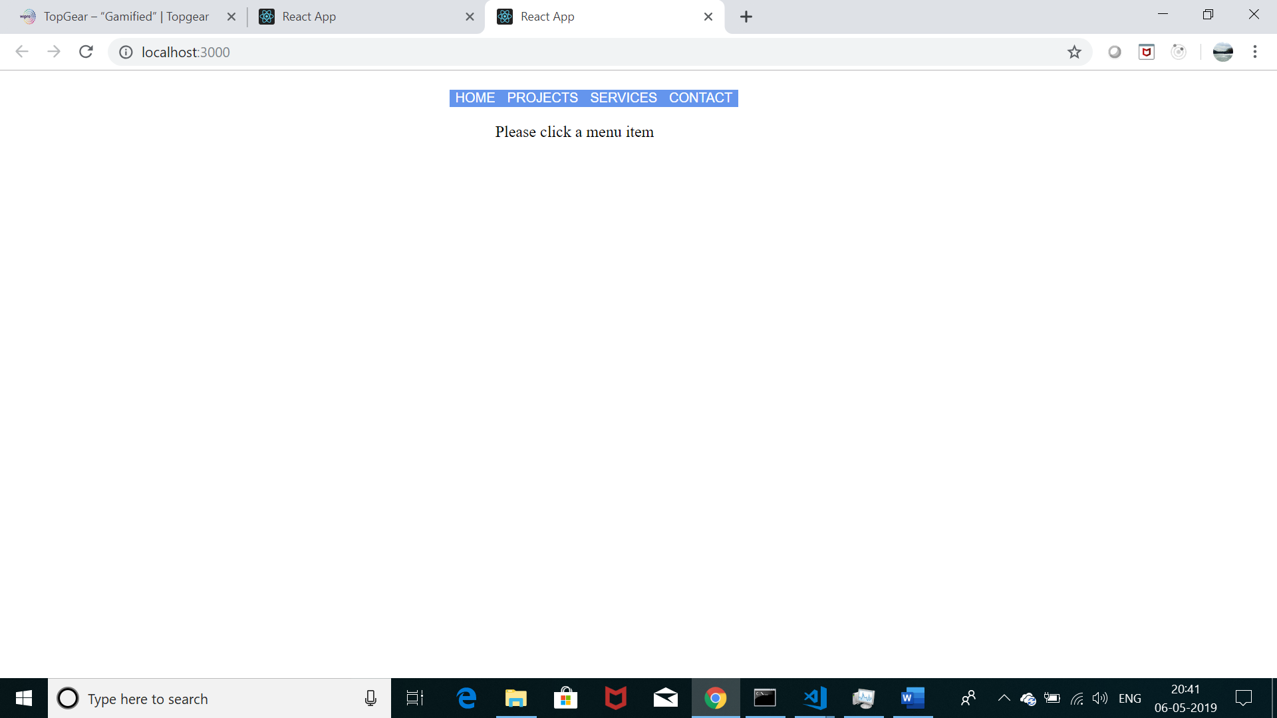

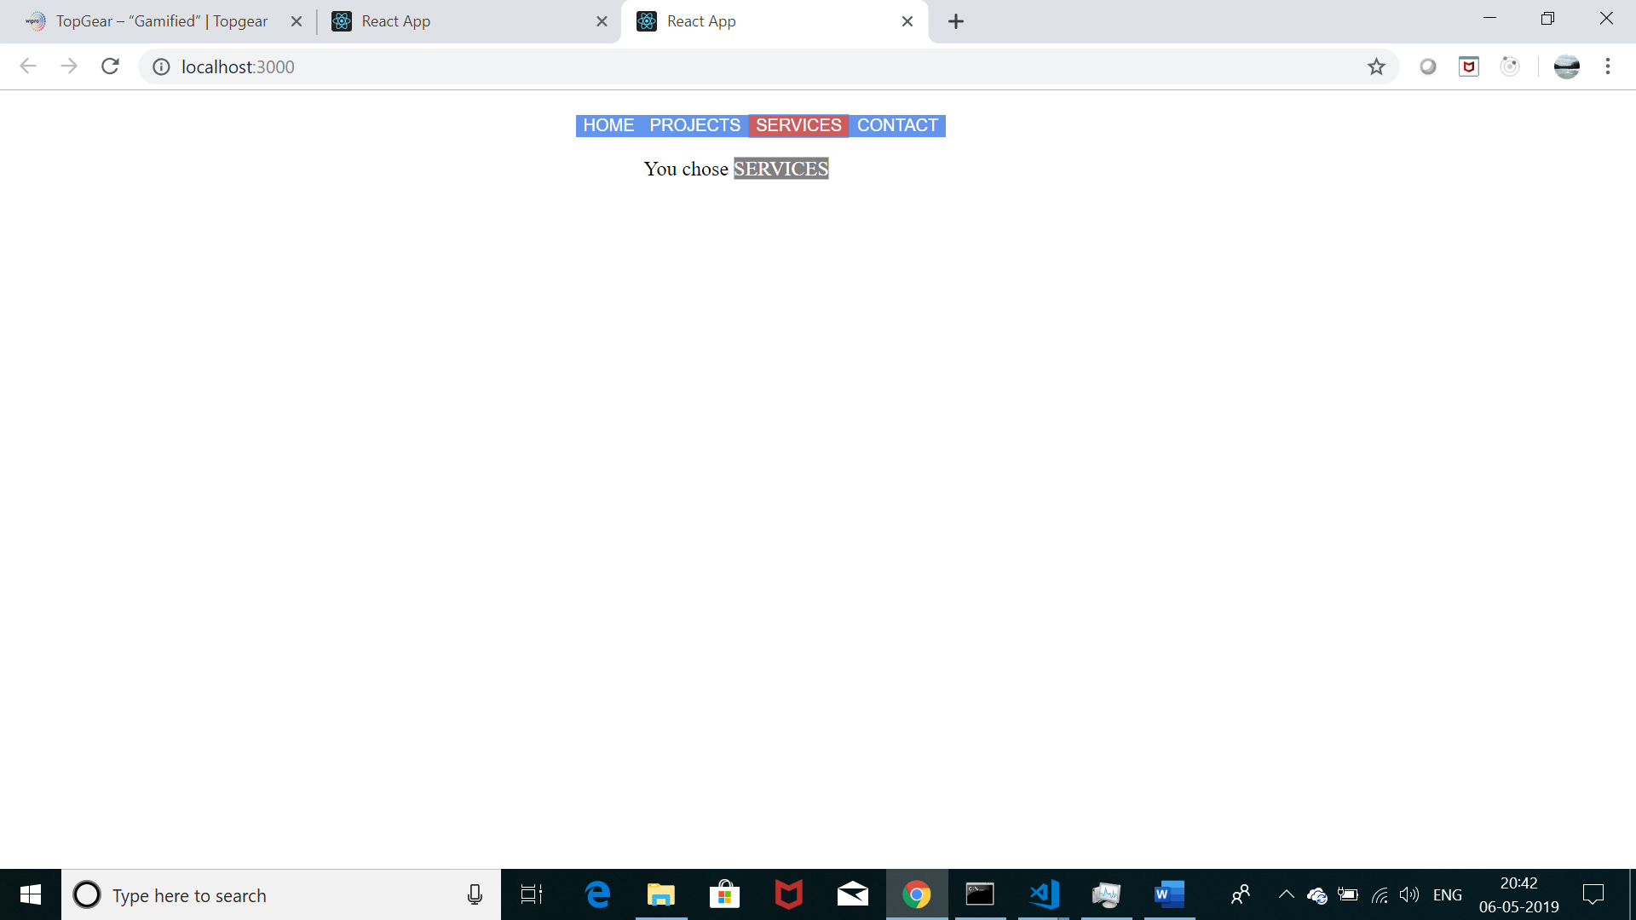

1. Create a SPA using React routing. Home page having 3 links home, contact and about. Create routing configuration to display content of different page depending on the user’s choice. Do not load all modules at the beginning.

src/index.js

import React from 'react';

import ReactDOM from 'react-dom';

import "./index.css";

import App from './componets/App';

ReactDOM.render(<App />,document.querySelector('#root'));

src/index.css

body {

background-color: rgb(69, 129, 168);

padding: 20px;

margin: 0;

}

h1, h2, p, ul, li {

font-family: sans-serif;

}

ul.header li {

display: inline;

list-style-type: none;

margin: 0;

}

ul.header {

background-color: #111;

padding: 0;

}

ul.header li a {

color: #FFF;

font-weight: bold;

text-decoration: none;

padding: 20px;

display: inline-block;

}

.content {

background-color: #FFF;

padding: 50px;

}

.content h2 {

padding: 0;

margin: 0;

}

.content li {

margin-bottom: 10px;

}

.active {

background-color: white;

}

src/components.App.js

import React from 'react';

import {BrowserRouter,Route} from 'react-router-dom';

import About from './About';

import Contact from './Contact';

import Header from './Header';

import Home from './Home';

**class** App **extends** React.Component{

render(){

return(<div>

<h1>SAP</h1>

<BrowserRouter >

<div>

<Header />

<div className="content">

<Route path='/' exact component={Home}/>

<Route path='/About' component={About}/>

<Route path='/Contact' component={Contact}/>

</div>

</div>

</BrowserRouter>

</div>);

};

}

export default App;

src/components.Home.js

import React from 'react';

**const** Home=()**=>**{

return (

<div>

<h2>HELLO</h2>

<p>Welcome to the SAP where we have create a SPA using React routing.

where Home page having 3 links home, contact and about.

thus creating routing configuration to display content of different

page depending on the user’s choice.</p>

<p>Each page has a single module.</p>

</div>

);

};

export default Home;

src/components.About.js

import React from 'react';

**const** About=()**=>**{

return (

<div>

<h2>ABOUT</h2>

<p>This app was made using react-router-dom </p>

</div>

);

};

export default About;

src/components.Contact.js

import React from 'react';

**const** Contact=()**=>**{

return (

<div>

<h2>GOT QUESTIONS?</h2>

<p>The easiest thing to do is post on

our <a href="http://wipro.com">forums</a>.

</p>

</div>

);

};

export default Contact;

src/components/Header.js

import React from 'react';

import {Link} from 'react-router-dom';

**class** Header **extends** React.Component{

render(){

return(

<ul className="header">

<li><Link exact to="/">Home</Link></li>

<li><Link to="/about">About</Link></li>

<li><Link to="/contact">Contact</Link></li>

</ul>);

};

}

export default Header;

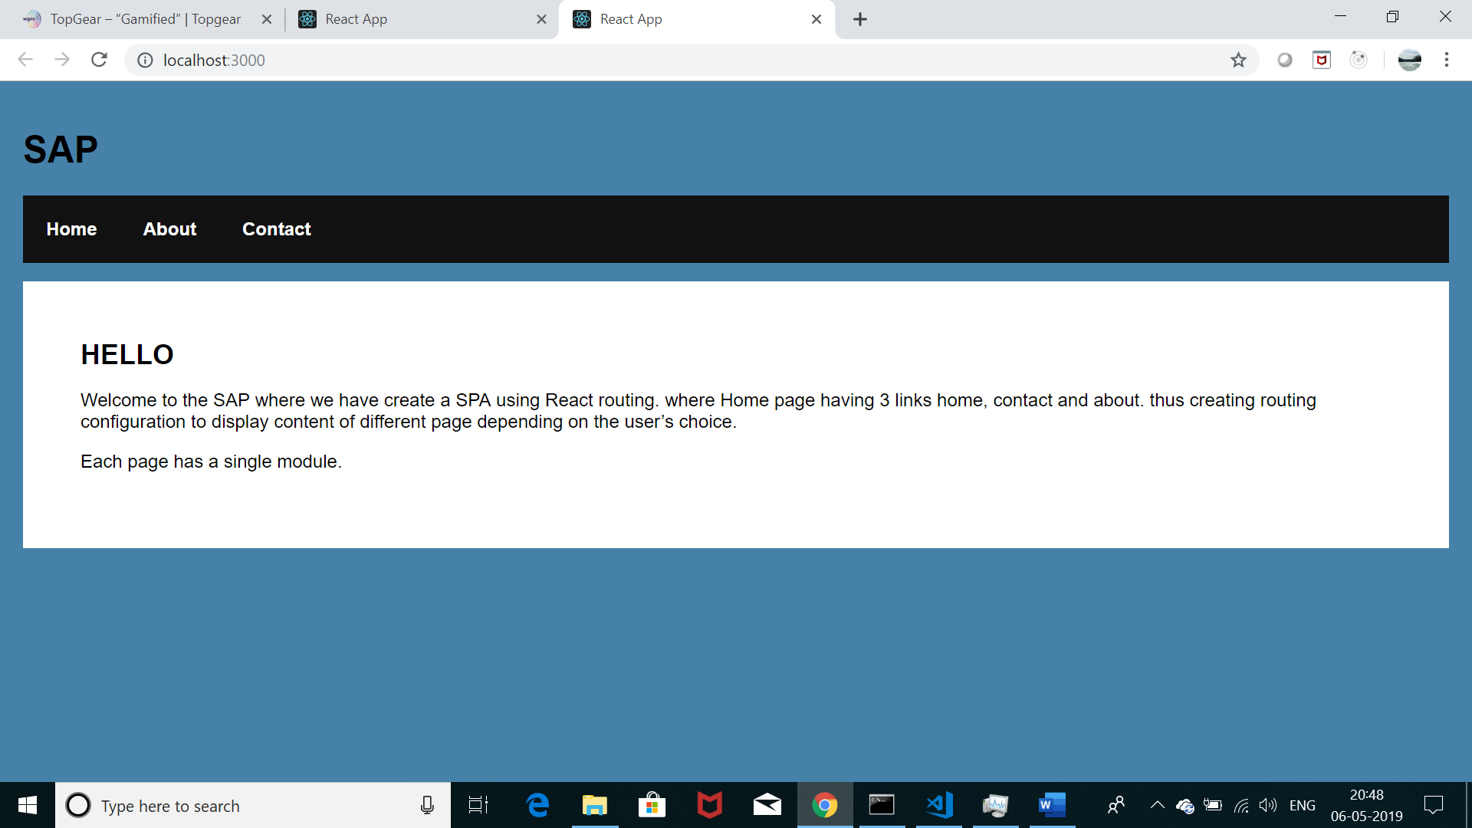

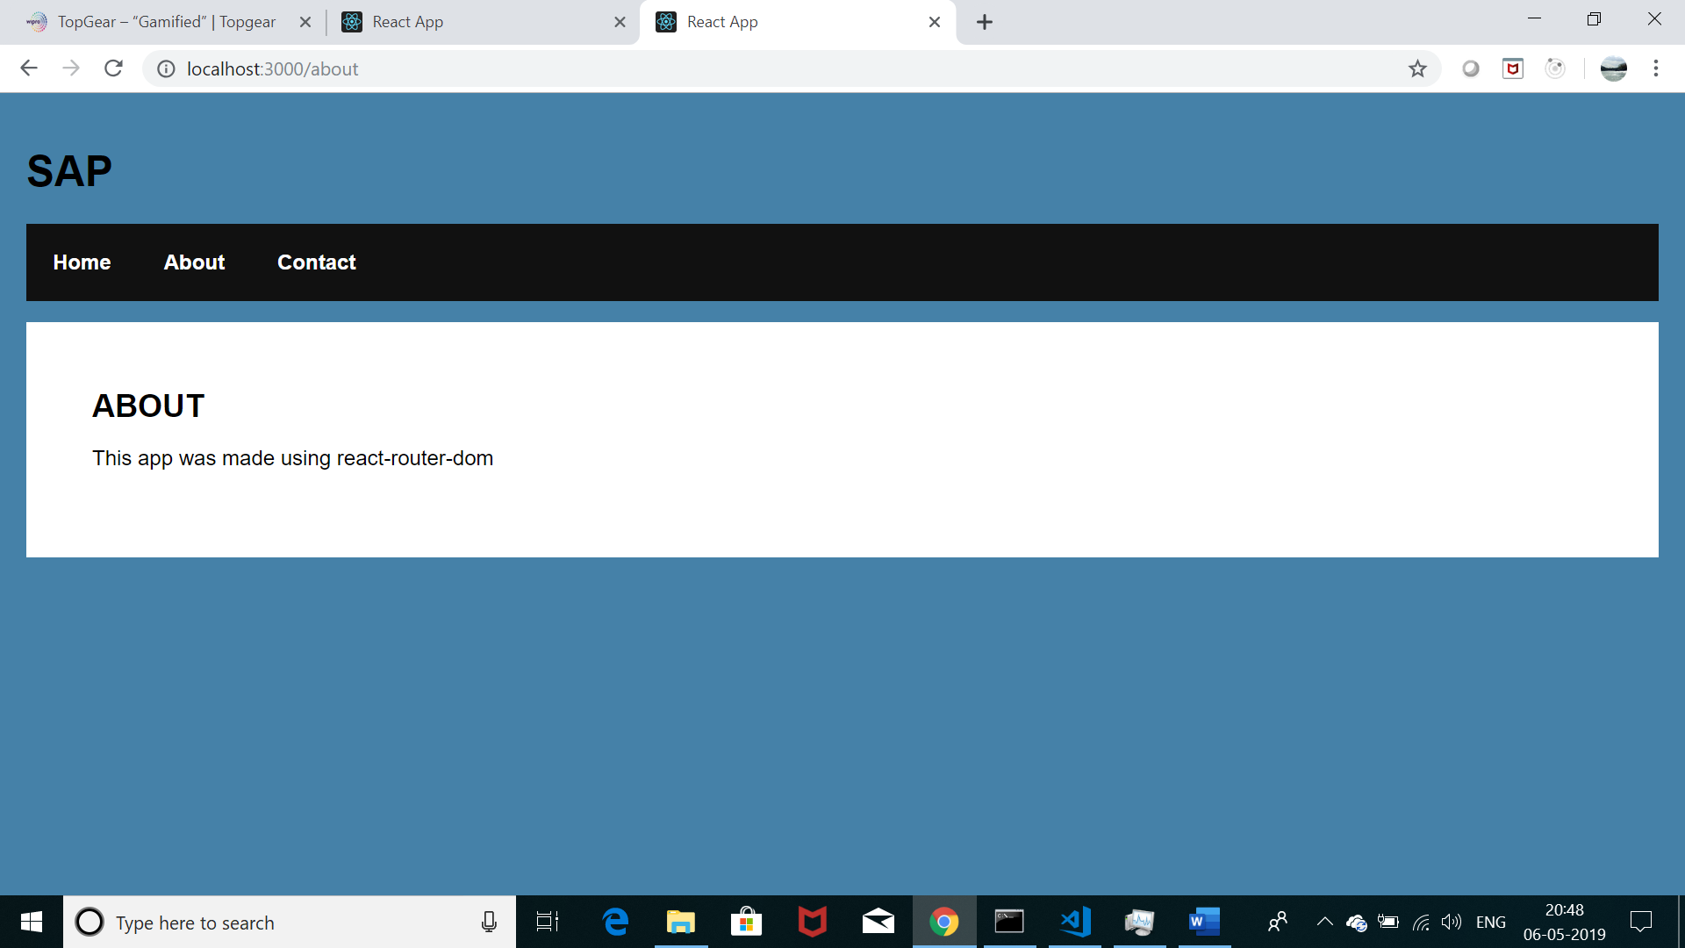

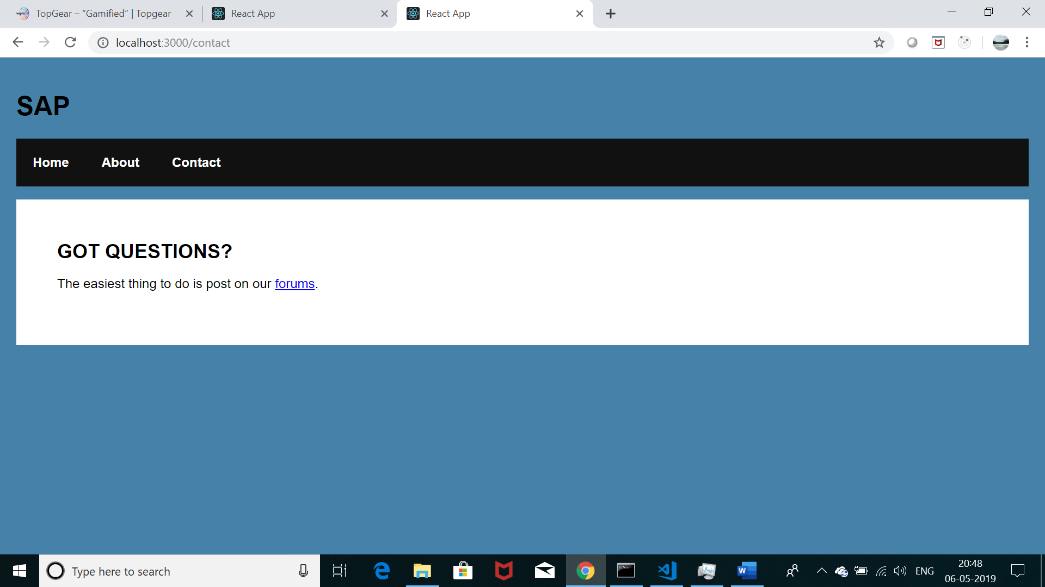

## Two-way data binding

* + In Component class, define a string property and define a text box in HTML template and use two-way data binding to display an initial value in the text box and on changing the value in the text box, update back the property in Component class.

src/index.js

import React from 'react';

import ReactDOM from 'react-dom';

import App from './components/App';

ReactDOM.render(<App/>,document.querySelector('#root'));

src/components/App.js

import React from 'react';

**class** App **extends** React.Component{

state={textValu:'initial text'};

onInputChange=(event)**=>**{

console.log(event.target.value);

this.setState({textValu:event.target.value});

}

render(){

return(<div>

<label>Enter Text</label>

<input onChange={this.onInputChange}

value={this.state.textValu}

/>

</div>);

};

}

export default App;

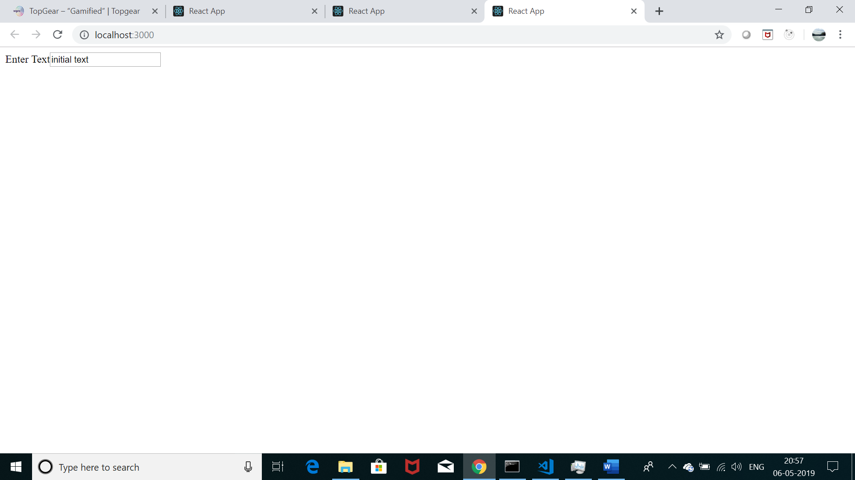

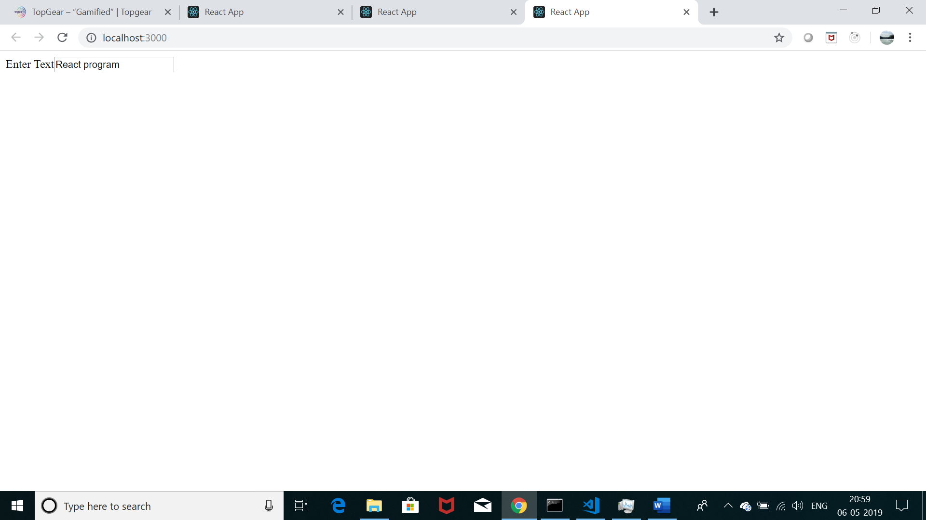

## Interpolation

* + Interpolation concepts [ i.e. Using of **{ …}** ]
  + Display in template view, a property defined in Component class
  + Display in template view, a combination of hard coded string and a property defined in Component class
  + Display in template view, a value returned by a method defined in Component class
  + Display in template view, a combination of hard coded string and a value returned by a method defined in Component class

## Passing data from outer component to inner component

* + Defined two components, “App” component and “Users” component.
  + Enhance the “App” component to pass the name of the country to the “Users” component so that title of the “Users” component can display the country the users belong to.

src/index.js

import React from 'react';

import ReactDOM from 'react-dom';

import App from './components/App';

ReactDOM.render(<App />,document.querySelector('#root'));

src/components/App.js

import React from 'react';

import Users from './Users';

**class** App **extends** React.Component{

state={countryName:''};

onInputChange=(event)**=>**{

this.setState({countryName:event.target.value});

};

render(){

return(<div>

<label>Enter your country name:</label>

<input onChange={this.onInputChange}

value={this.state.countryName}/>

<Users countryName={this.state.countryName}/>

</div>);

};

}

export default App;

src/components/Users.js

import React from 'react';

import DocumentTitle from 'react-document-title';

**class** Users **extends** React.Component{

componentDidMount(){

document.title=this.props.countryName;

};

render(){

return(<div>

<DocumentTitle title={this.props.countryName} />

</div>);

};

}

export default Users;

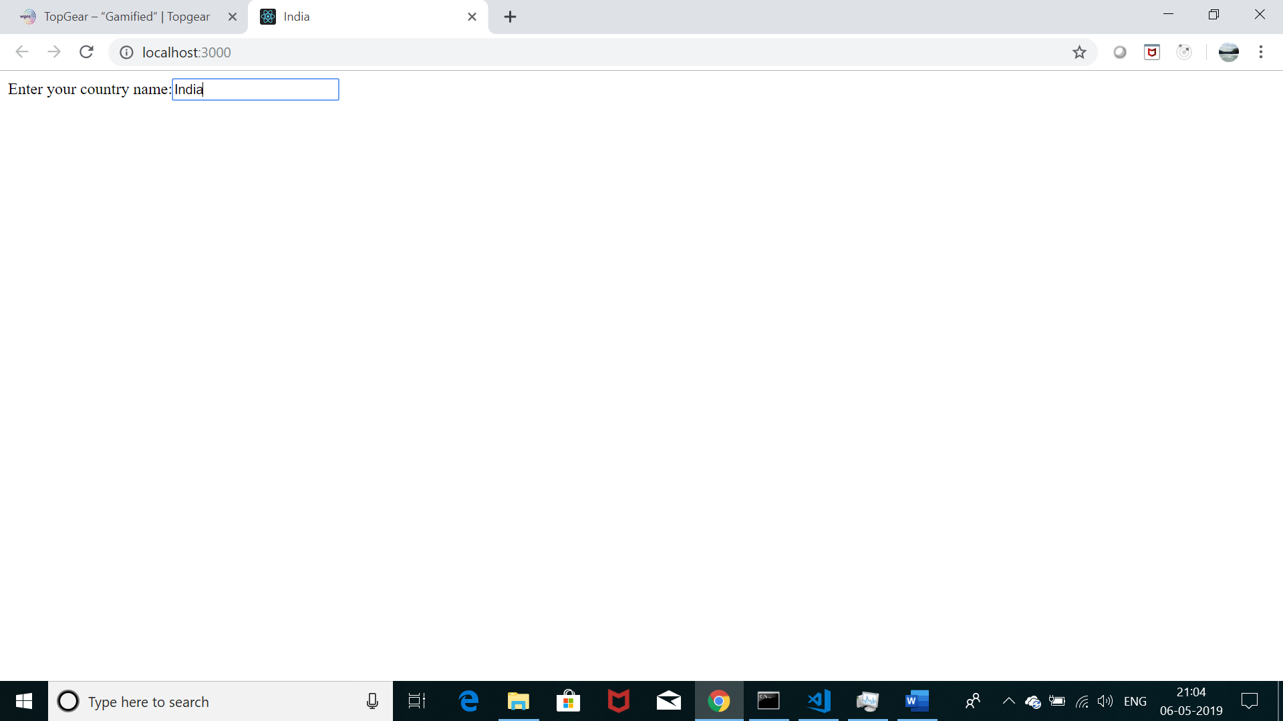

## Communicating from inner component to outer component

* + The “Multiple Components” code (Assignment 5) had defined two components, “App” component and “Users” component.
  + Enhance the “App” and “Users” component so that when a username among the list of users displayed is clicked, the “Users” component should communicate to the “App” component the user which was actually clicked.
  + The “App” component should then display the selected user in the “App” component view.

src/index.js

import React from 'react';

import ReactDOM from 'react-dom';

import App from './components/App';

ReactDOM.render(<App/>,document.querySelector('#root'));

src/components/App.js

import React from 'react';

import Users from './Users';

**class** App **extends** React.Component{

state={user:null};

onUserSelect=(user)**=>**{

this.setState({user:user});

};

render(){

if(this.state.user!=null){

return(<div>

Selected username is {this.state.user}

<Users

onUserSelect={this.onUserSelect}/>

</div>);

}

else{

return(<div>

Select a username

<Users onUserSelect={this.onUserSelect}/>

</div>);

}

};

}

export default App;

src/components/Users.js

import React from 'react';

**class** Users **extends** React.Component{

state={users:['user1','user2','user3',]};

render(){

**const** Users=this.state.users.map((user)**=>**{

return(

<div key={user}>

<button

onClick={()**=>**this.props.onUserSelect(user)}>

{user}

</button>

</div>);

});

return(<div>{Users}</div>);

};

}

export default Users;

