Data Structures Assignment 1



Name :

**PRN** : B24CE1047

**Branch and Batch** : Computer Engineering SY1 Batch (B)

1. **Title** : Rainfall tracking system

# Problem statement :

Write a program to track rainfall data for 3 cities over 4 months .Using a 2D array , we can store the data ,calculate the average rainfall for each city, and display the rainfall data in a tabular format.

**CODE :**

#include <iostream> using namespace std;

int main() {

float rainfall[3][4];

for (int i = 0; i < 3; i++) {

cout << "Enter rainfall data for City " << i + 1 << ":" << endl; for (int j = 0; j < 4; j++) {

cout << "Month " << j + 1 << ": "; cin >> rainfall[i][j];

**}**

**}**

cout << "\nRainfall Data (mm):\n"; for (int i = 0; i < 3; i++) {

cout << "City " << i + 1 << ": "; for (int j = 0; j < 4; j++) {



cout << rainfall[i][j] << "\t";

**}**

cout << endl;

**}**

for (int i = 0; i < 3; i++) { float sum = 0;

for (int j = 0; j < 4; j++) { sum += rainfall[i][j];

**}**

float avg = sum / 4;

cout << "Average rainfall for City " << i + 1 << " = " << avg << " mm" << endl;

**}**

return 0;

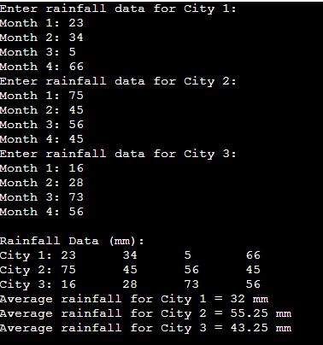

**OUTPUT :**

1. **Title :** Temperature tracker



# Problem statement :

Write a program for tracking daily temperatures of 3 cities for a week . The program calculates the average temperature for each day and for the week .

**CODE :**

#include <iostream> using namespace std;

int main() {

float temp[3][7]; // 3 cities, 7 days

// Input temperatures

for (int i = 0; i < 3; i++) {

cout << "Enter temperature for 7 days in City " << i + 1 <<

":\n";

for (int j = 0; j < 7; j++) {

cout << "Day " << j + 1 << ": "; cin >> temp[i][j];

**}**

**}**

// Display temperatures

cout << "\nTemperature tracking:\n"; for (int i = 0; i < 3; i++) {

cout << "City " << i + 1 << ": "; for (int j = 0; j < 7; j++) {

cout << temp[i][j] << "\t";

**}**



cout << endl;

**}**

// Calculate and display average temperature for each city for (int i = 0; i < 3; i++) {

float sum = 0;

for (int j = 0; j < 7; j++) { sum += temp[i][j];

**}**

float avg = sum / 7;

cout << "Average temperature for City " << i + 1 << " = " << avg << " °C" << endl;

**}**

return 0;

**}**

**OUTPUT :**

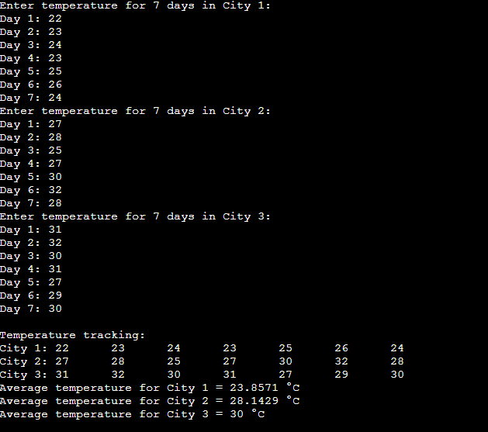

**THANK YOU !!!**