 **DATA STRUCTURE Experiment 10**



**Name** : [Anurag Patil](mailto:anuragpatil2024.comp@mmcoe.edu.in)

**PRN** : B24CE1047

**Branch and Batch** :Computer Engineering and SY1 Batch(B)



**TITLE:** Generate Expression Tree

**PROBLEM STATEMENT:**

**OUTCOME:** Student will be able to:

* Know how to construct expression trees.
* Know how to evaluate an expression using the tree



**IIT BOMBAY Vlab Review** : [LINK FOR THE VLAB](https://www.vlab.co.in/)

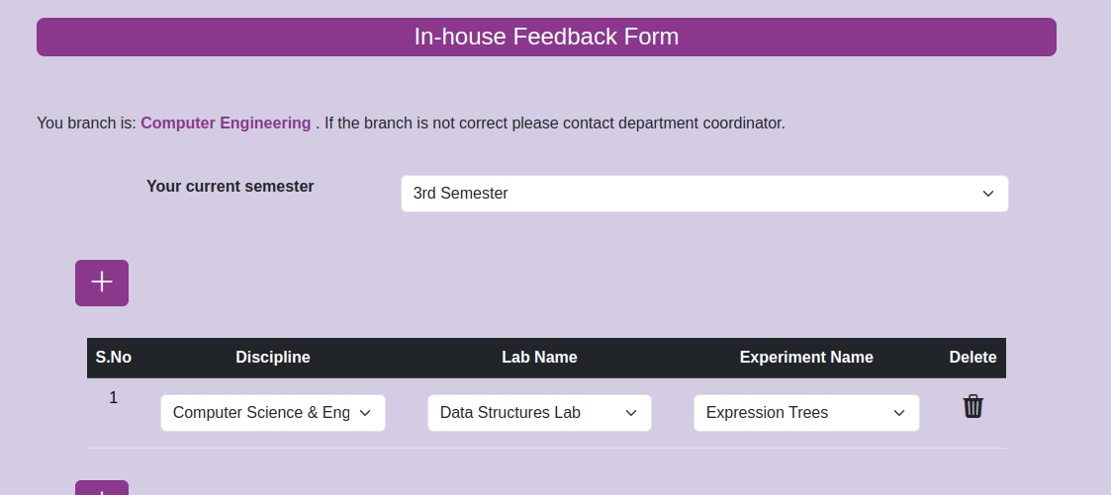

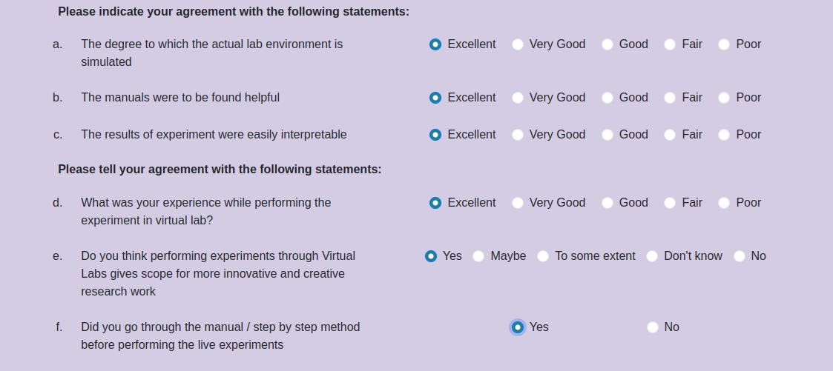

**AFTER Submitting The VLAB REVIEW :**

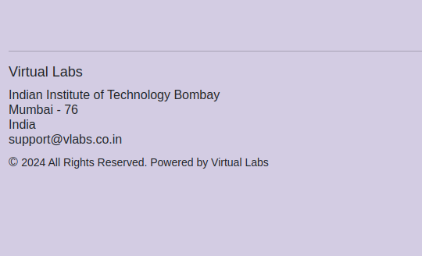

  
THANK YOU !!!