**Data Structures Assignment 2**



**Name** : [Anurag Patil](mailto:anuragpatil2024.comp@mmcoe.edu.in)

**PRN** : B24CE1047

**Branch and Batch** : Computer Engineering SY1 Batch (B)   
1.**Title** : Game Development

**Problem statement** :   
write a game development program that implements the Bubble Sort algorithm. The

program will simulate a simple game where the player can input a set of numbers,

and the numbers will be sorted using Bubble Sort to simulate a "level-up" scenario

where the player's scores are sorted in ascending order.

  
**CODE :**  
/* Using Bubble Sorting */

#include <iostream>

#include <string>

using namespace std;

void input(int*& array, int& size) {

cout << "Enter no of players : ";

cin >> size;

array = new int[size];

for (int i = 0; i < size; i++) {

cout << "Enter scores of the players :" << i + 1 << ": ";

cin >> array[i];

}

}

void display(int* array, int size) {

for (int i = 0; i < size - 1; i++) {

for (int j = 0; j < size - 1 - i; j++) {

if (array[j] > array[j + 1]) {

int temp = array[j];

array[j] = array[j + 1];

array[j + 1] = temp;

}

}

}

int winner = array[size - 1];

cout<<"The player with highest score is "<<winner<<endl;

cout << "The Scores of the player ";

for (int i = 0; i < size; i++) {

cout << array[i] << " ";

}

cout << endl;

}

int main() {

start:

int* array = nullptr;

int size = 0;

input(array, size);

display(array, size);

string play_again;

cout<<endl;

cout<<endl;

cout<<"Enter y to play again and n to quit: ";

cin>>play_again;

if(play_again != "y"){

cout<<"Thank you for playing..."<<endl;

}

else{

cout<<endl;

cout<<endl;

goto start;

}

delete[] array;

return 0;

}

**OUTPUT :**

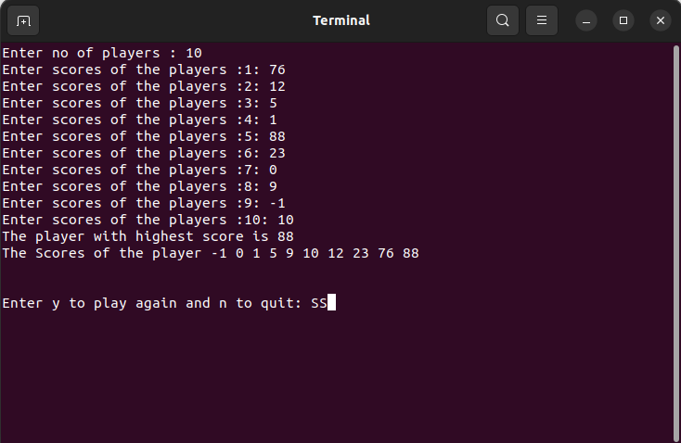



2.**Title** : Organizing Cards in a Hand

**Problem statement** :   
write a game development program that implements the Bubble Sort algorithm. The

program will simulate a simple game where the player can input a set of numbers,

and the numbers will be sorted using Bubble Sort to simulate a "level-up" scenario

where the player's scores are sorted in ascending order.



**CODE:**

/* Using Insertion Sorting */

#include <iostream>

#include <string>

using namespace std;

int input(int array[] , int size){

for(int i = 0; i < size ; i++){

int number = array[i] ;

int j = i - 1 ;

while(j >= 0 && array[j] > number){

array[j + 1] = array[j];

j--;

}

array[j + 1] = number;

}

return 0;

}

int display(int array[] , int size){

for(int i = 0 ; i<size ; i++){

cout<<array[i]<<" ";

}

cout<<""<<endl;

return 0;

}

int main(){

int size;

int array[100];

cout<<"Enter the size of the cards in Hand:";

cin>>size;

cout<<"Enter the cards number (enter 1 for ace , 11 for jack , 12 for queen , 13 for king): "<<endl;

for (int i = 0; i < size; i++) {

cin >> array[i];

}

display(array , size);

input(array , size);

cout<<"sorted Deck of Cards"<<" "<<endl;

display(array , size);

return 0 ;

}



**OUTPUT :**

