# Node Mcu And Oled Display connection

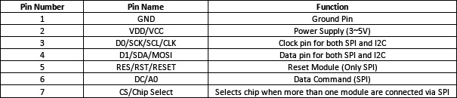

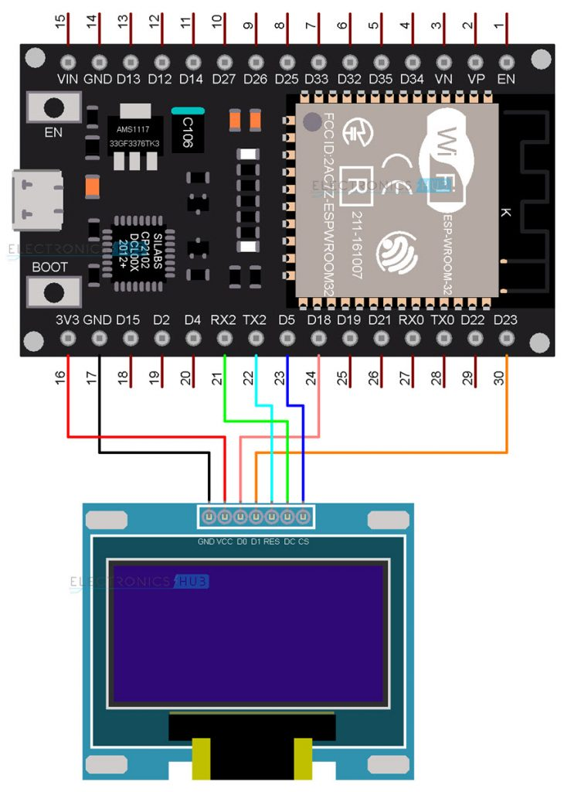

# Convert SPI(7pin) to I2C (4 pin)

1. Remove resistor from spi and attach to IIC on the back of the display.
2. Short R8

It will look like this:

