Problem Statement: There can be multiple customers, who can place multiple orders on the site. Now a sales person can handle these orders will distribute into multiple sales persons (One order will be assign to one salesperson only). So a sales person can have multiple orders of multiple customers
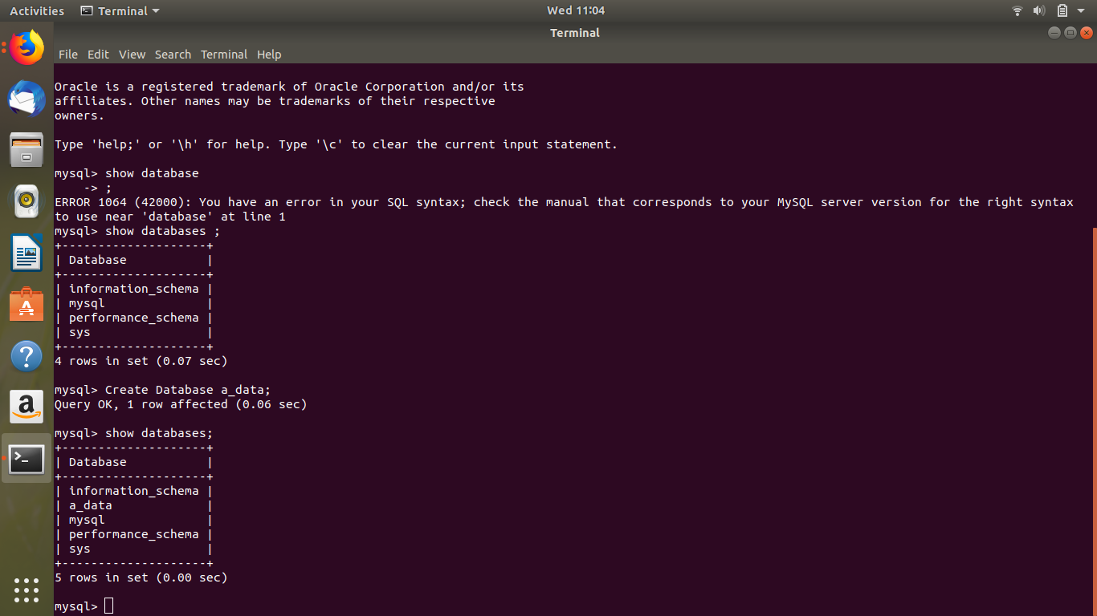
- Create Database

- Design Schema
Customer
c_id | Primary key
c_name | Customer name
c_add | Customer address

orders
o_id | Primary key(order id)
c_id | foreign key(key of Customer)
o_desc | Order description
s_id | Foreign key(key of sales

sales
s_id | Primary key(salesperson Id)
s_name | Sales person name

- Create tables 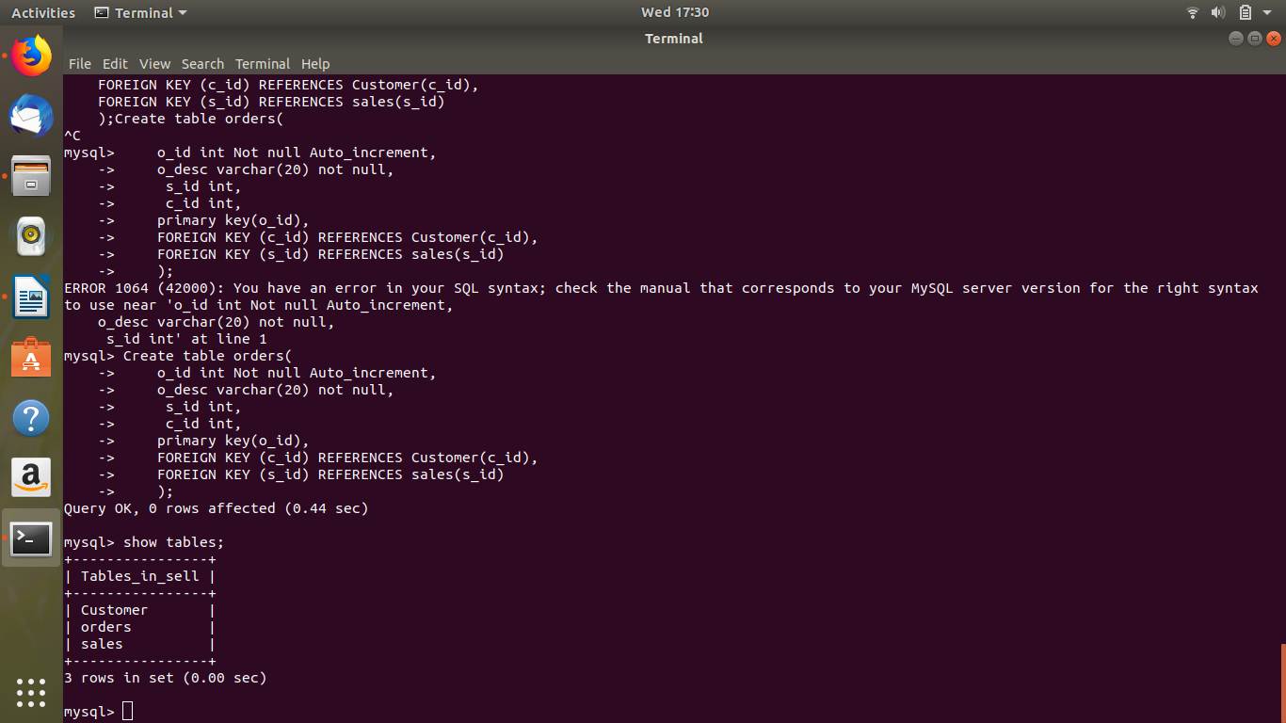

- Insert sample data 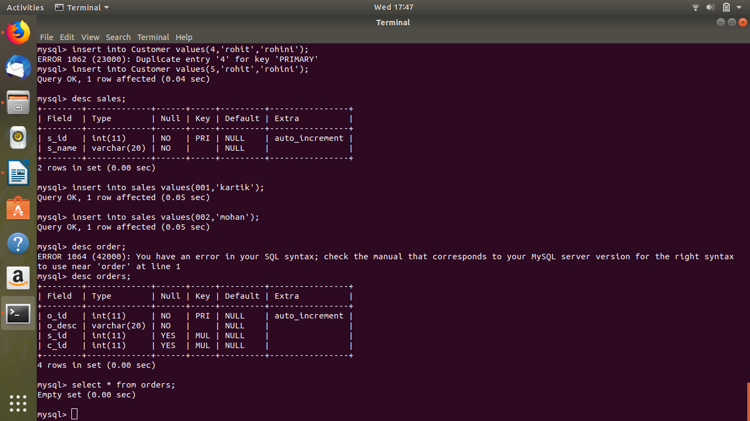

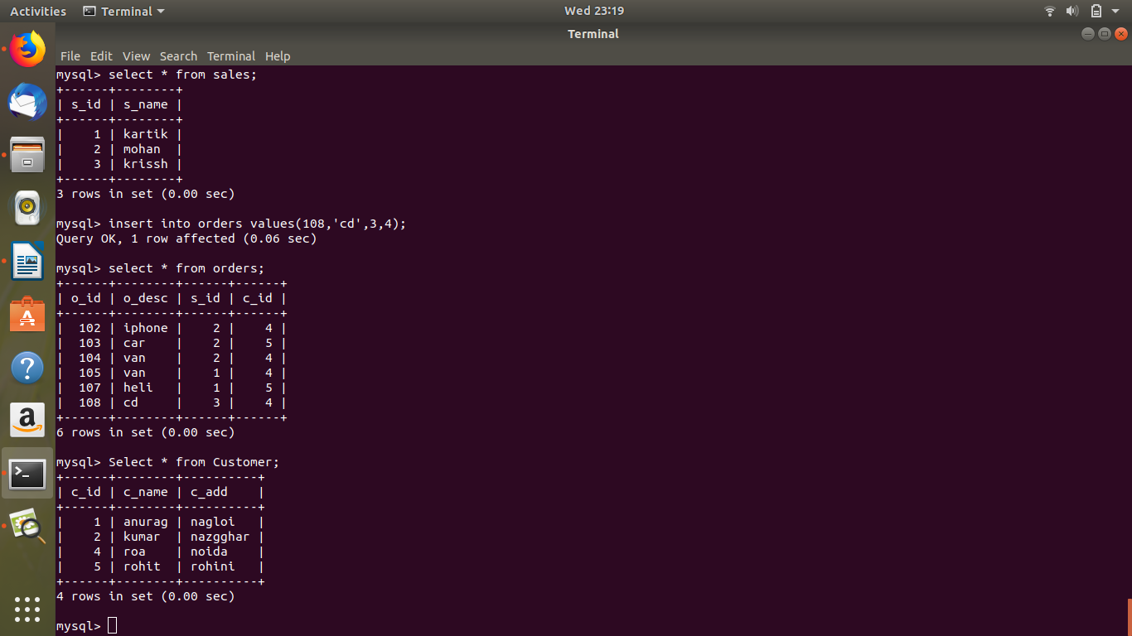
- Find the sales person have multiple orders.
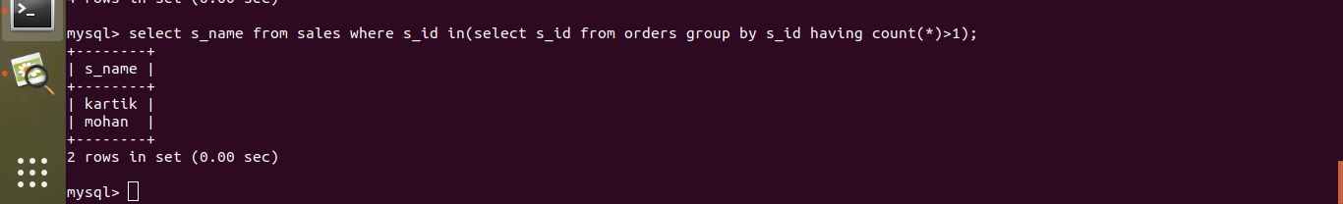
- Find the all sales person details along with order details
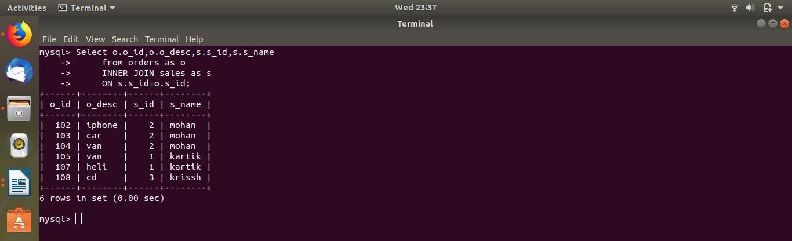

- Create index
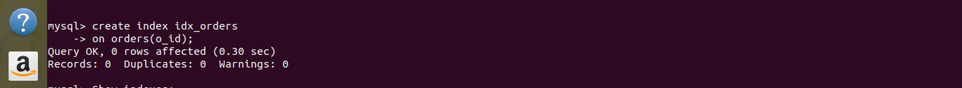

- How to show index on a table
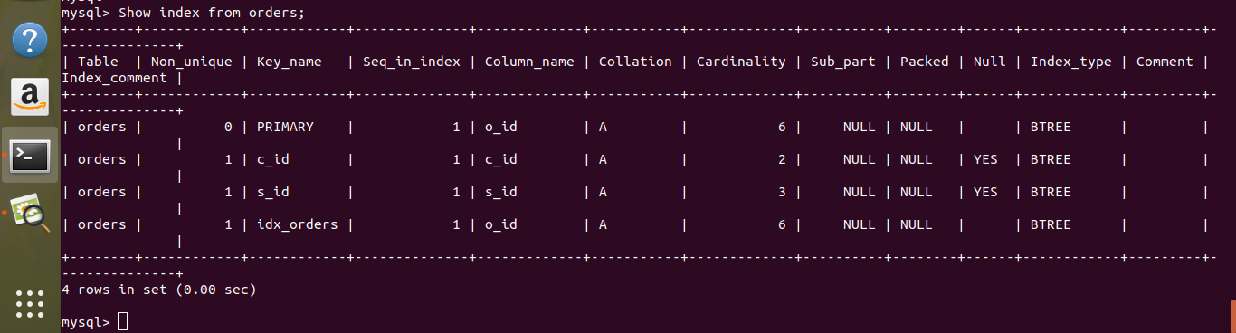

- Find the order number, sale person name, along with the customer to whom that order belongs to
