Q1. Write a program to replace a substring inside a string with other string ?
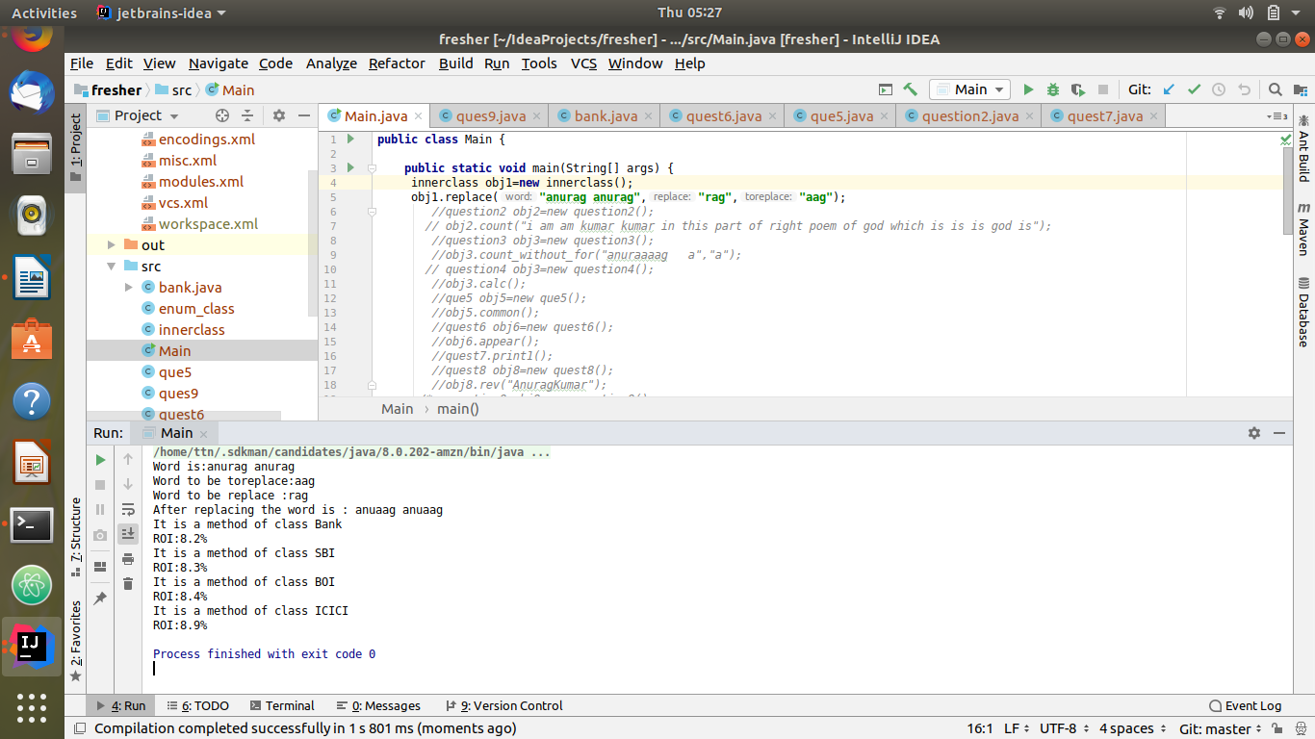
Code :main.java
public class Main {
public static void main(String[] args) {
innerclass obj1=new innerclass();
obj1.replace("anurag anurag","rag","aag");
//question2 obj2=new question2();
// obj2.count("i am am kumar kumar in this part of right poem of god which is is is god is");
//question3 obj3=new question3();
//obj3.count_without_for("anuraaaag a","a");
// question4 obj3=new question4();
//obj3.calc();
//que5 obj5=new que5();
//obj5.common();
//quest6 obj6=new quest6();
//obj6.appear();
//quest7.print1();
//quest8 obj8=new quest8();
//obj8.rev("AnuragKumar");
/* question9 obj9=new question9();
System.out.println(" integer sum overloading");
obj9.sum_overload(9,5);
System.out.println("double sum");
obj9.sum_overload(10.0,20.0);
System.out.println("Interger multiply");
obj9.mul(5,6);
System.out.println("Float multiply");
obj9.mul(5.05f,5.555f);
System.out.println("string concatination");
obj9.con_str("anurag ","kumar");
System.out.println("3 String conaction");
obj9.con_str("anurag ","kumar ","go");*/
/* bank b = new bank();
b.getDetails();
SBI b1 = new SBI();
b1.getDetails();
BOI b2 = new BOI();
b2.getDetails();
ICICI b3 = new ICICI();
b3.getDetails();*/

}
}

Innerclass.java
import java.sql.SQLOutput;
public class innerclass {
String word;
String replace;
String toreplace;
void replace(String word,String replace,String toreplace){
System.out.println("Word is:"+word);
System.out.println("Word to be toreplace:"+toreplace);
System.out.println("Word to be replace :"+replace);
System.out.println( "After replacing the word is : "+word.replace(replace,toreplace) );
}
}

Q2. Write a program to find the number of occurrences of the duplicate words in a string and print them ?
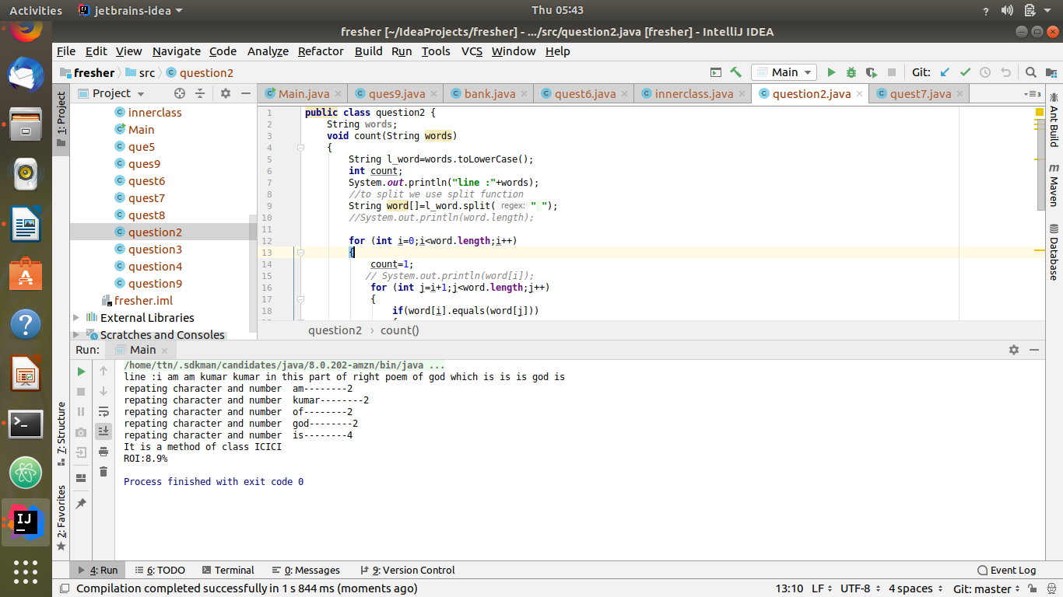
Code:
public class question2 {
String words;
void count(String words)
{
String l_word=words.toLowerCase();
int count;
System.out.println("line :"+words);
//to split we use split function
String word[]=l_word.split(" ");
//System.out.println(word.length);
for (int i=0;i<word.length;i++)
{
count=1;
// System.out.println(word[i]);
for (int j=i+1;j<word.length;j++)
{
if(word[i].equals(word[j]))
{
count++;
word[j]="0";
}
}
if(count>1 && word[i]!="0")
{
System.out.println("repating character and number " +word[i]+"--------"+count);
}
}
}
}

Q3. Write a program to find the number of occurrences of a character in a string without using loop?
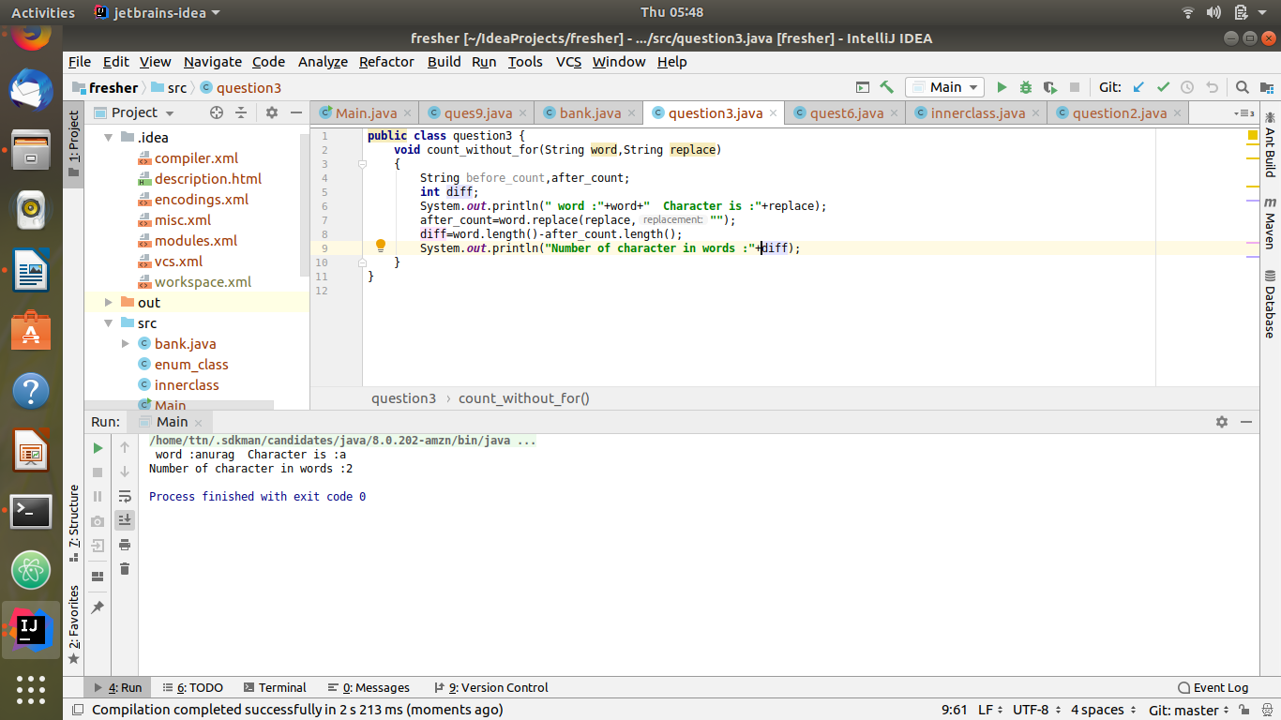
Code:
public class question3 {
void count_without_for(String word,String replace)
{
String before_count,after_count;
int diff;
System.out.println(" word :"+word+" Character is :"+replace);
after_count=word.replace(replace,"");
diff=word.length()-after_count.length();
System.out.println("Number of character in words :"+diff);
}
}
Q4. Calculate the number & Percentage Of Lowercase Letters,Uppercase Letters, Digits And Other Special Characters In A String
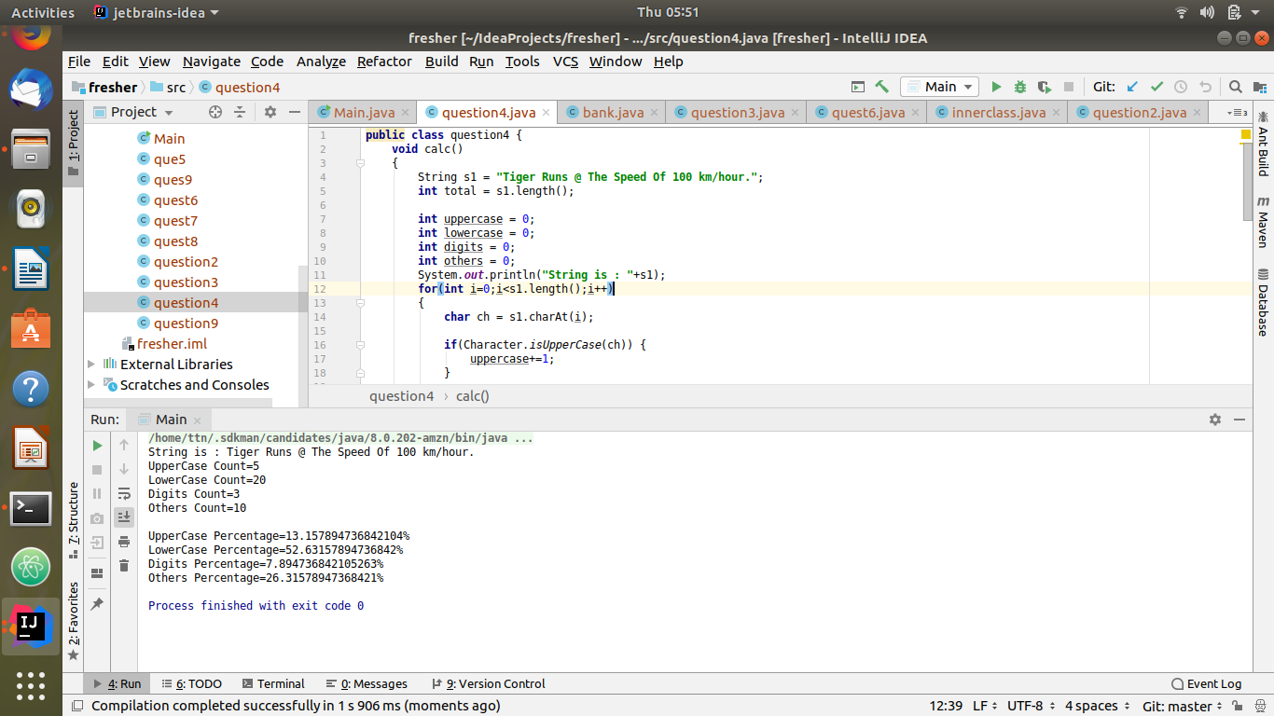
Code:
public class question4 {
void calc()
{
String s1 = "Tiger Runs @ The Speed Of 100 km/hour.";
int total = s1.length();
int uppercase = 0;
int lowercase = 0;
int digits = 0;
int others = 0;
System.out.println("String is : "+s1);
for(int i=0;i<s1.length();i++)
{
char ch = s1.charAt(i);
if(Character.isUpperCase(ch)) {
uppercase+=1;
}
else if(Character.isLowerCase(ch)) {
lowercase+=1;
}
else if(Character.isDigit(ch)) {
digits+=1;
}
else {
others+=1;
}
}
double uppercasePercentage = (uppercase*100.0)/total;
double lowercasePercentage = (lowercase*100.0)/total;
double digitsPercentage = (digits*100.0)/total;
double othersPercentage = (others*100.0)/total;
System.out.println("UpperCase Count="+uppercase);
System.out.println("LowerCase Count="+lowercase);
System.out.println("Digits Count="+digits);
System.out.println("Others Count="+others);
System.out.println("\nUpperCase Percentage="+uppercasePercentage+"%");
System.out.println("LowerCase Percentage="+lowercasePercentage+"%");
System.out.println("Digits Percentage="+digitsPercentage+"%");
System.out.println("Others Percentage="+othersPercentage+"%");
}
}
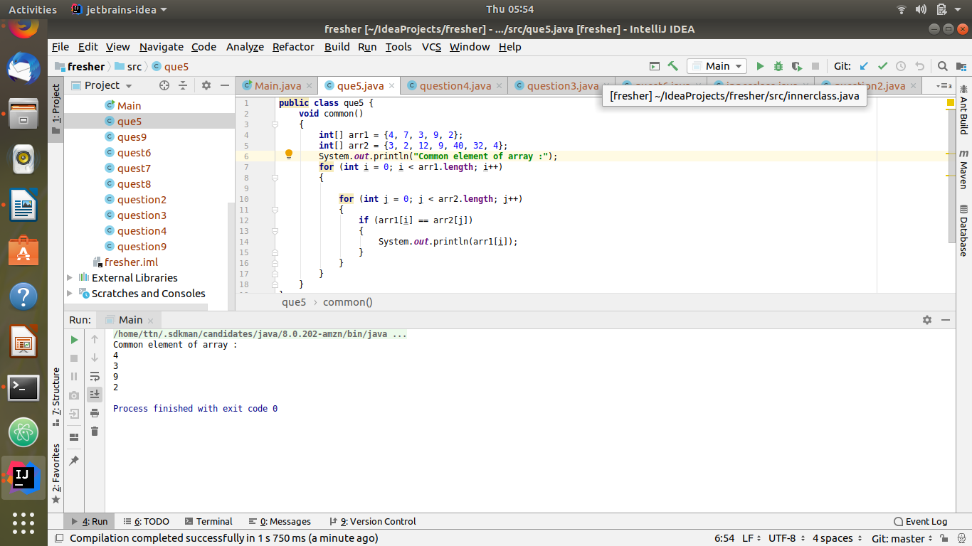
Q5. Find common elements between two arrays.

Code:
public class que5 {
void common()
{
int[] arr1 = {4, 7, 3, 9, 2};
int[] arr2 = {3, 2, 12, 9, 40, 32, 4};
System.out.println("Common element of array :");
for (int i = 0; i < arr1.length; i++)
{
for (int j = 0; j < arr2.length; j++)
{
if (arr1[i] == arr2[j])
{
System.out.println(arr1[i]);
}
}
}
}
}
Q6. There is an array with every element repeated twice except one. Find that element
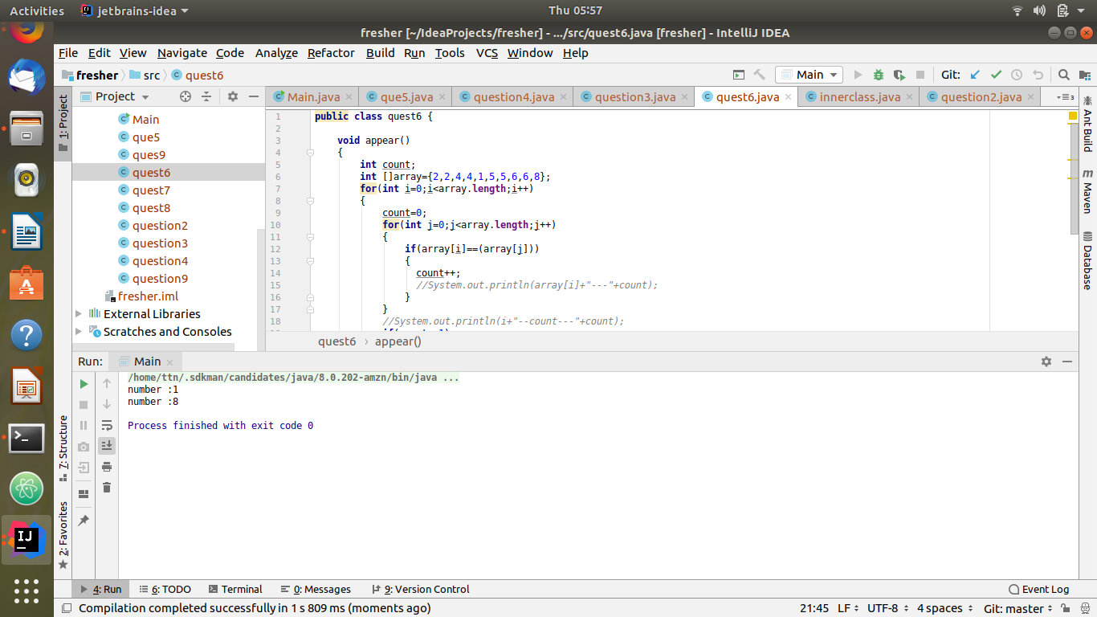
Code:
public class quest6 {
void appear()
{
int count;
int []array={2,2,4,4,1,5,5,6,6,8};
for(int i=0;i<array.length;i++)
{
count=0;
for(int j=0;j<array.length;j++)
{
if(array[i]==(array[j]))
{
count++;
//System.out.println(array[i]+"---"+count);
}
}
//System.out.println(i+"--count---"+count);
if(count==1)
{
System.out.println("number :"+array[i]);
}
}
}
}
Q7. Write a program to print your Firstname,LastName & age using static block,static method & static variable respectively
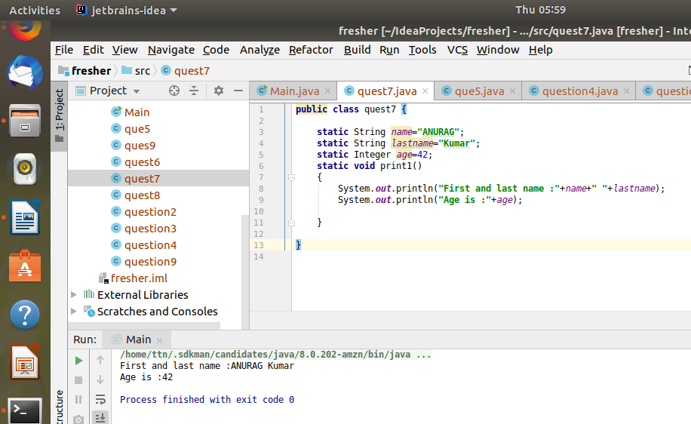
Code:
public class quest7 {
static String name="ANURAG";
static String lastname="Kumar";
static Integer age=42;
static void print1()
{
System.out.println("First and last name :"+name+" "+lastname);
System.out.println("Age is :"+age);
}
}

Q8. Write a program to reverse a string and remove character from index 4 to index 9 from the reversed string using String Buffer
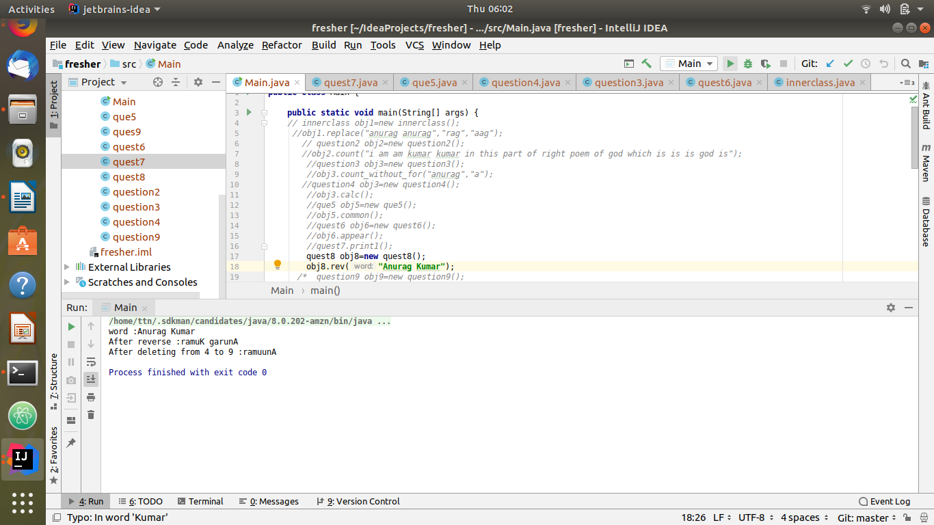
Code:
public class quest8 {
void rev(String word)
{
StringBuffer sb=new StringBuffer(word);
System.out.println("word :"+word);
sb=sb.reverse();
System.out.println("After reverse :"+sb);
System.out.println("After deleting from 4 to 9 :"+sb.delete(4,9));
}
}
Q9.Write a program to display values of enums using a constructor & getPrice() method (Example display house & their prices)
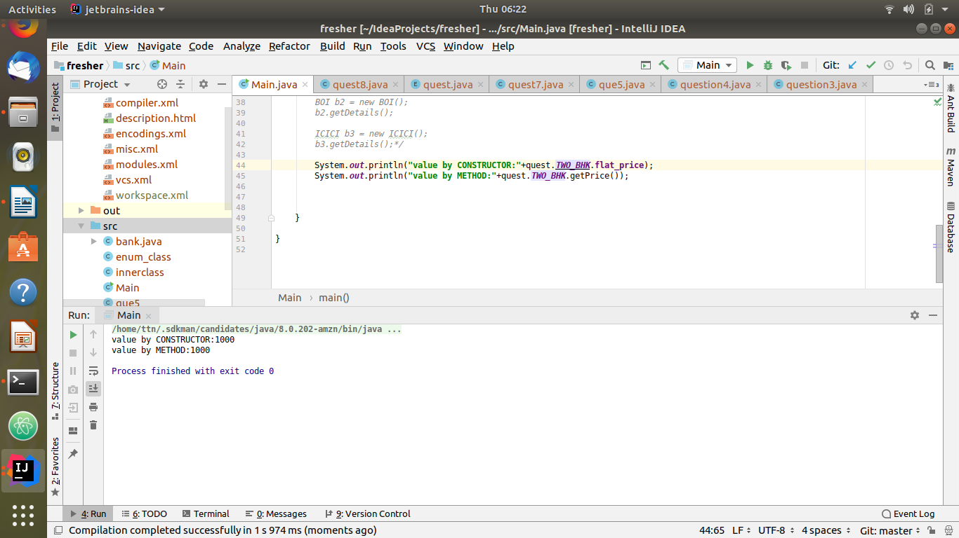
Code:
public enum quest {
ONE_BHK(500),
TWO_BHK(1000),
THREE_BHK(1500);
int flat_price;
quest(int i)
{
flat_price = i;
}
int getPrice()
{
return flat_price;
}
}

Q10.Write a single program for following operation using overloading
A) Adding 2 integer number
B) Adding 2 double
C) multiplying 2 float
D) multiplying 2 int
E) concate 2 string
F) Concate 3 String

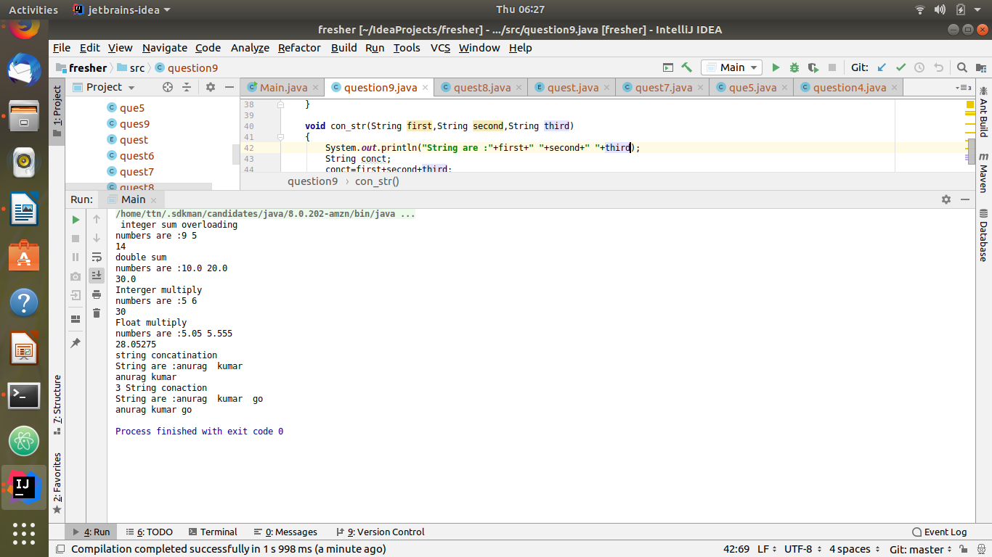

code:
import javax.print.DocFlavor;
public class question9 {
void sum_overload(Integer a,Integer b)
{
System.out.println("numbers are :"+a+" "+b);
Integer sum=a+b;
System.out.println(sum);
}
void sum_overload(Double c,Double k)
{
System.out.println("numbers are :"+c+" "+k);
Double f_sum=c+k;
System.out.println(f_sum);
}
void mul(Integer j,Integer r)
{
System.out.println("numbers are :"+j+" "+r);
Integer i_mul=r*j;
System.out.println(i_mul);
}
void mul(Float a,Float b)
{
System.out.println("numbers are :"+a+" "+b);
Float f_mul=a*b;
System.out.println(f_mul);
}
void con_str(String first,String second)
{
System.out.println("String are :"+first+" "+second);
System.out.println(first.concat(second));
}
void con_str(String first,String second,String third)
{
System.out.println("String are :"+first+" "+second+" "+third);
String conct;
conct=first+second+third;
System.out.println(conct);
}
}
Q11.Create 3 sub class of bank SBI,BOI,ICICI all 4 should have method called getDetails which provide there specific details like rateofinterest etc,print details of every banks
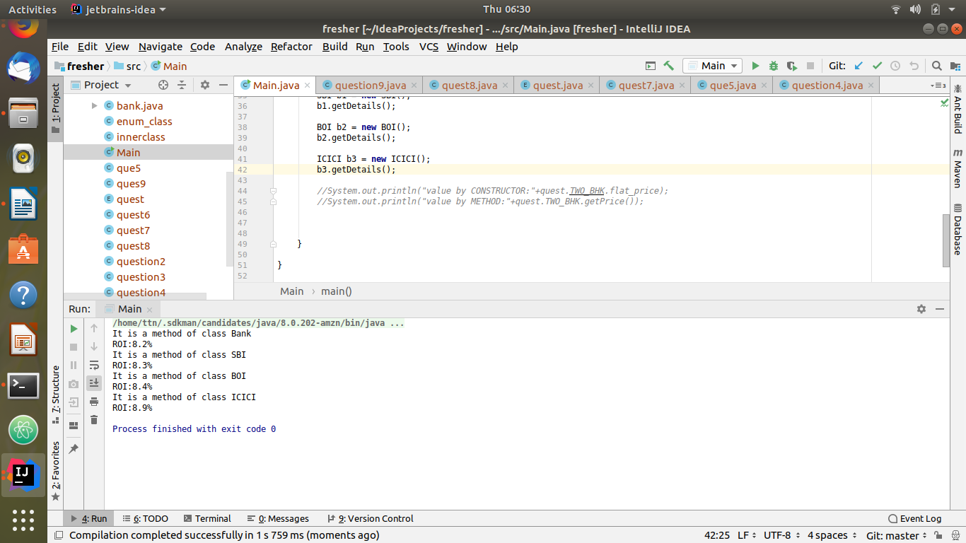

code:
public class bank {
void getDetails()
{
System.out.println("It is a method of class Bank");
System.out.println("ROI:"+8.2+"%");
}
}
class SBI extends bank
{
void getDetails()
{
System.out.println("It is a method of class SBI");
System.out.println("ROI:"+8.3+"%");
}
}
class BOI extends bank
{
void getDetails()
{
System.out.println("It is a method of class BOI");
System.out.println("ROI:"+8.4+"%");
}
}
class ICICI extends bank
{
void getDetails()
{
System.out.println("It is a method of class ICICI");
System.out.println("ROI:"+8.9+"%");
}
}

