- Write the following a functional interface and implement it using lambda:
  - (1) First number is greater than second number or not Parameter (int ,int ) Return boolean
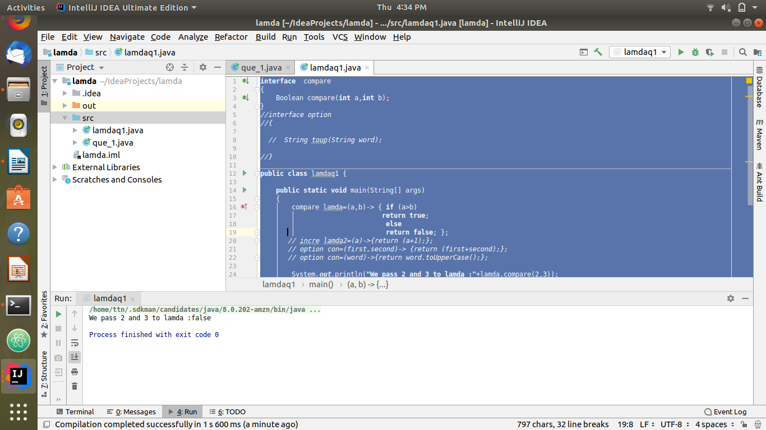
code:
interface compare
{
Boolean compare(int a,int b);
}

public class lamdaq1 {
public static void main(String[] args)
{
compare lamda=(a,b)-> { if (a>b)
return true;
else
return false; };

System.out.println("We pass 2 and 3 to lamda :"+lamda.compare(2,3));

}
}

  - (2) Increment the number by 1 and return incremented value Parameter (int) Return int
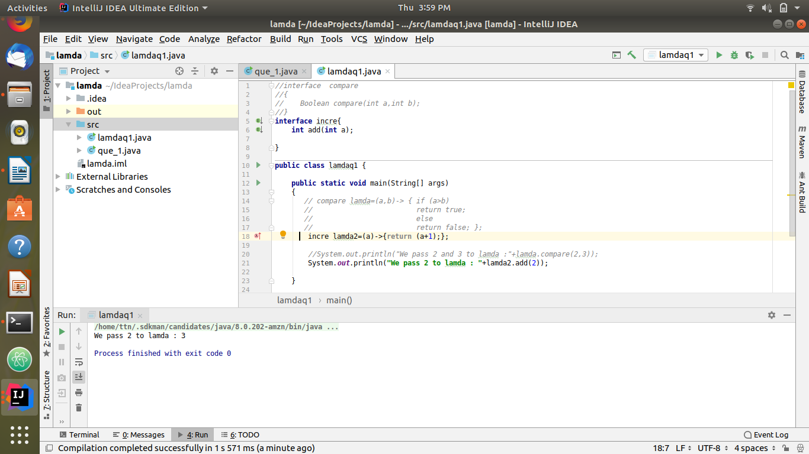
code:
interface incre{
int add(int a);
}
public class lamdaq1
{
public static void main(String[] args)
{

incre lamda2=(a)->{return (a+1);}
System.out.println("We pass 2 to lamda : "+lamda2.add(2));
}
}

  - (3) Concatination of 2 string Parameter (String , String ) Return (String)
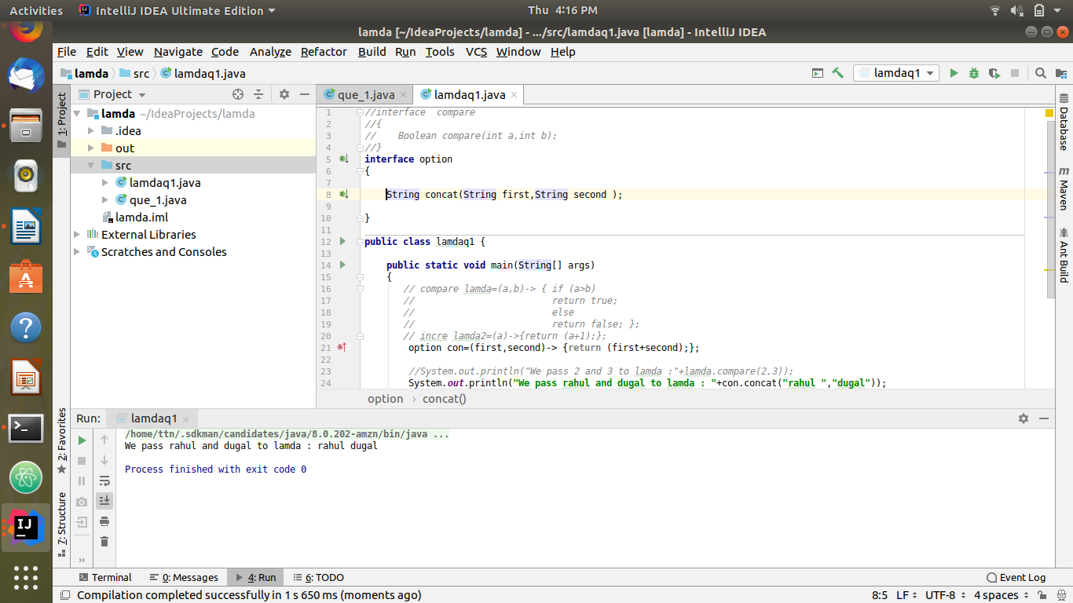
code:

interface option
{
String concat(String first,String second );
}
public class lamdaq1 {
public static void main(String[] args)
{

option con=(first,second)-> {return (first+second);};

System.out.println("We pass rahul and dugal to lamda : "+con.concat("rahul ","dugal"));
}
}

  - (4) Convert a string to uppercase and return . Parameter (String) Return (String)
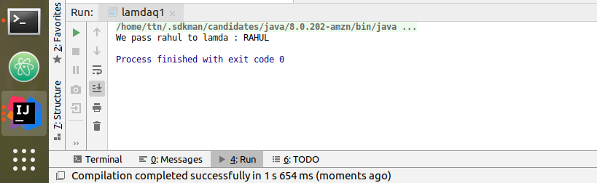

code:

interface option
{
String toup(String word);
}
public class lamdaq1 {
public static void main(String[] args)
{

option con=(word)->{return word.toUpperCase();};

System.out.println("We pass rahul to lamda : "+con.toup("rahul"));
}
}

- Create a functional interface whose method takes 2 integers and return one integer.
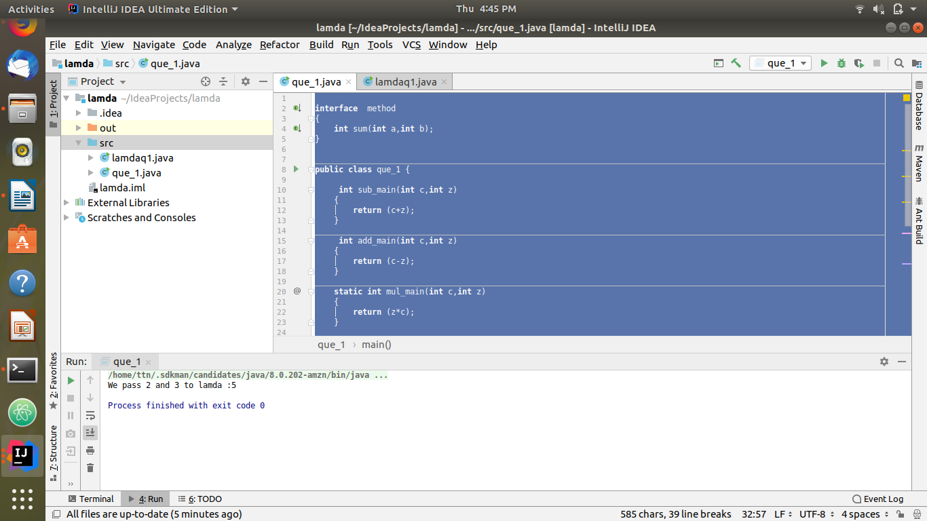
Code:
interface method
{
int sum(int a,int b);
}

public static void main(String[] args)
{
method mylam = (a, b) -> a+b;

System.out.println("We pass 2 and 3 to lamda :"+mylam.sum(2, 3));
}
}

- Using (instance) Method reference create and apply add and subtract method and using (Static) Method reference create and apply multiplication method for the functional interface created.
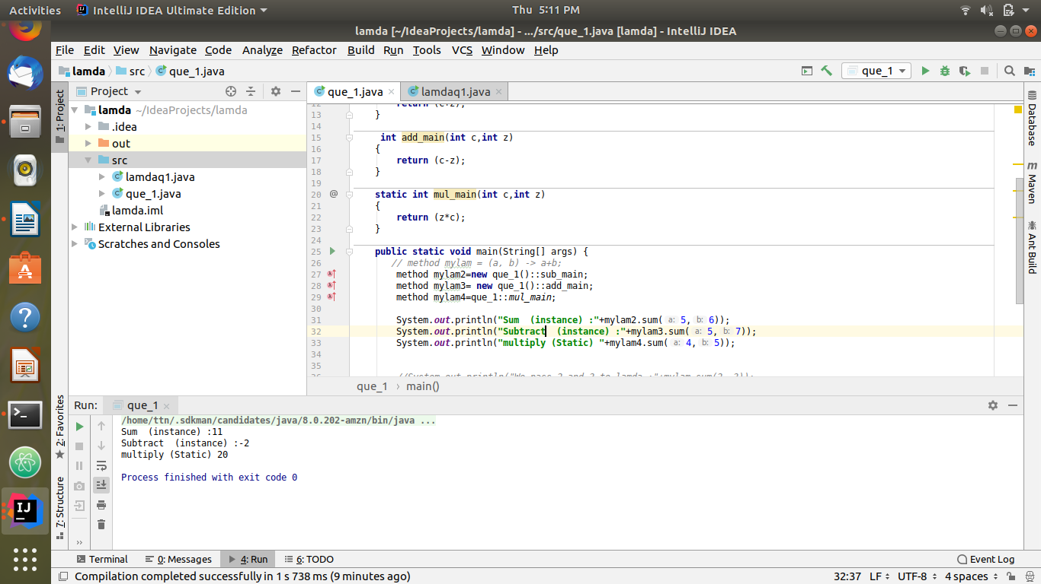
CODE:
interface method
{
int sum(int a,int b);
}
public class que_1 {
int sub_main(int c,int z)
{
return (c+z);
}
int add_main(int c,int z)
{
return (c-z);
}
static int mul_main(int c,int z)
{
return (z*c);
}
public static void main(String[] args) {
// method mylam = (a, b) -> a+b;
method mylam2=new que_1()::sub_main;
method mylam3= new que_1()::add_main;
method mylam4=que_1::mul_main;
System.out.println("Sum (instance) :"+mylam2.sum(5,6));
System.out.println("Subtract (instance) :"+mylam3.sum(5,7));
System.out.println("multiply (Static) "+mylam4.sum(4,5));
//System.out.println("We pass 2 and 3 to lamda :"+mylam.sum(2, 3));
}
}
- Create an Employee Class with instance variables (String) name, (Integer)age, (String)city and get the instance of the Class using constructor reference
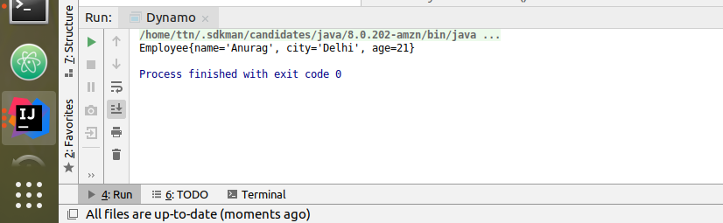
Code:
interface zombie
{
threading employee(String name,Integer age, String city);
}
class threading
{
String name, city;
int age;
public threading(String name, int age, String city)
{
this.name = name;
this.age = age;
this.city = city;
}
@Override
public String toString() {
return "Employee{" +
"name='" + name + '\'' +
", city='" + city + '\'' +
", age=" + age +
'}';
}
}
class Dynamo
{
public static void main(String[] args) {
zombie obj1 = threading::new;
System.out.println(obj1.employee("Anurag",21,"Delhi"));
}
}

- Implement following functional interfaces from java.util.function using lambdas:
  - (1) Consumer
  - (2) Supplier
  - (3) Predicate
  - (4) Function
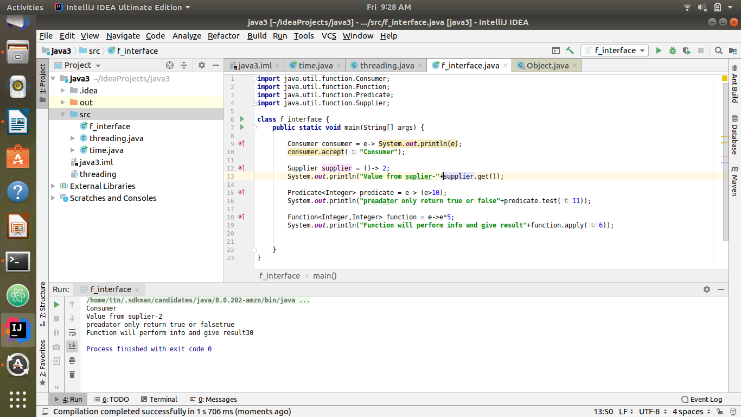

Code:
import java.util.function.Consumer;
import java.util.function.Function;
import java.util.function.Predicate;
import java.util.function.Supplier;
class f_interface {
public static void main(String[] args) {
Consumer consumer = e-> System.out.println(e);
consumer.accept("Consumer");
Supplier supplier = ()-> 2;
System.out.println("Value from suplier-"+supplier.get());
Predicate<Integer> predicate = e-> (e>10);
System.out.println("preadator only return true or false"+predicate.test(11));
Function<Integer,Integer> function = e->e*5;
System.out.println("Function will perform info and give result"+function.apply(6));
}
}

- Create and access default and static method of an interface.
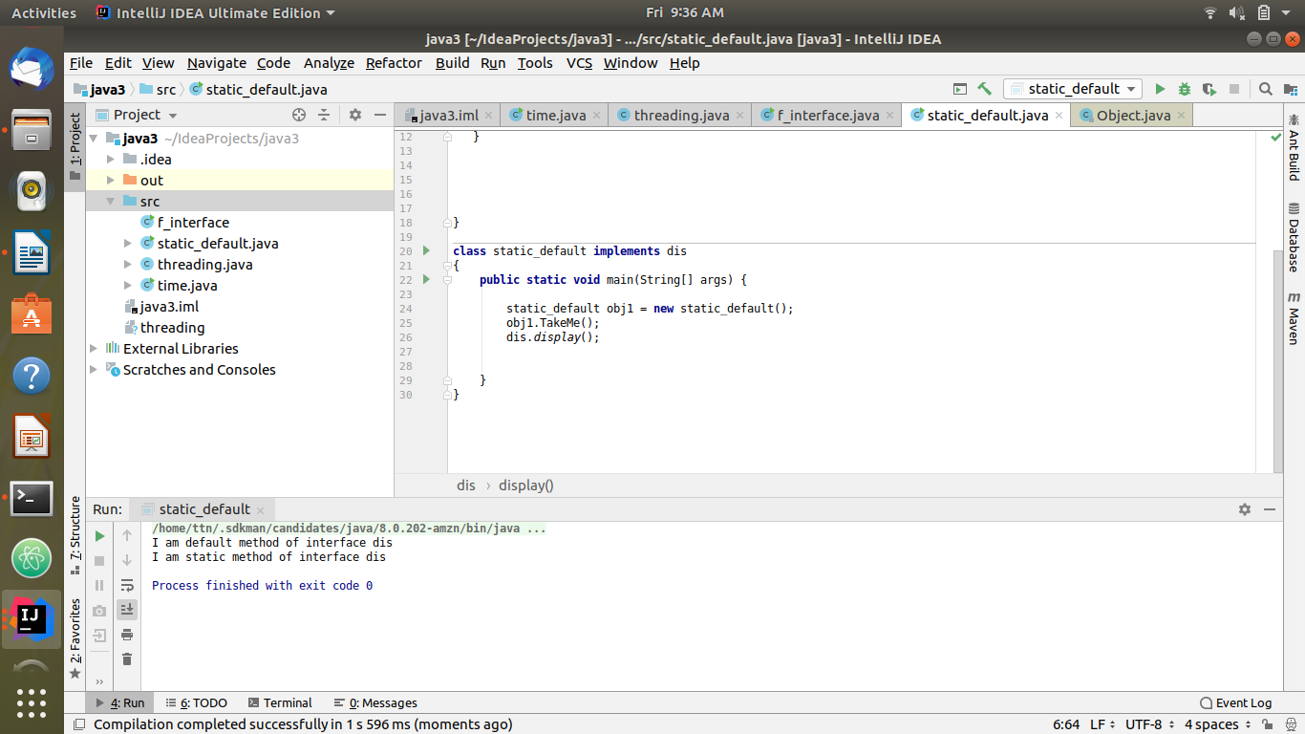
Code:
interface dis
{
static void display()
{
System.out.println("I am static method of interface dis");
}
default void TakeMe()
{
System.out.println("I am default method of interface dis");
}
}
class static_default implements dis
{
public static void main(String[] args) {
static_default obj1 = new static_default();
obj1.TakeMe();
dis.display();
}
}

- Override the default method of the interface.
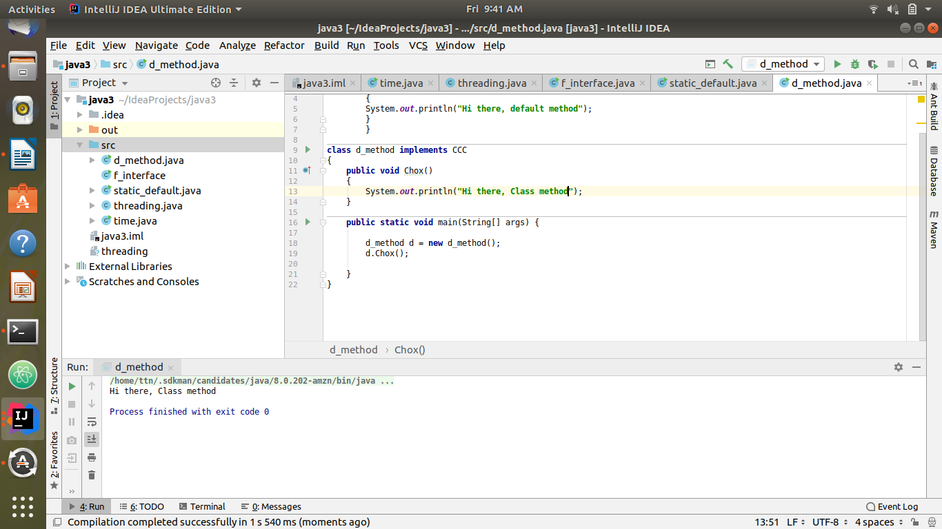
Code:
interface CCC
{
default void Chox()
{
System.out.println("Hi there, default method");
}
}
class d_method implements CCC
{
public void Chox()
{
System.out.println("Hi there, Class method");
}
public static void main(String[] args) {
d_method d = new d_method();
d.Chox();
}
}

- Implement multiple inheritance with default method inside interface.
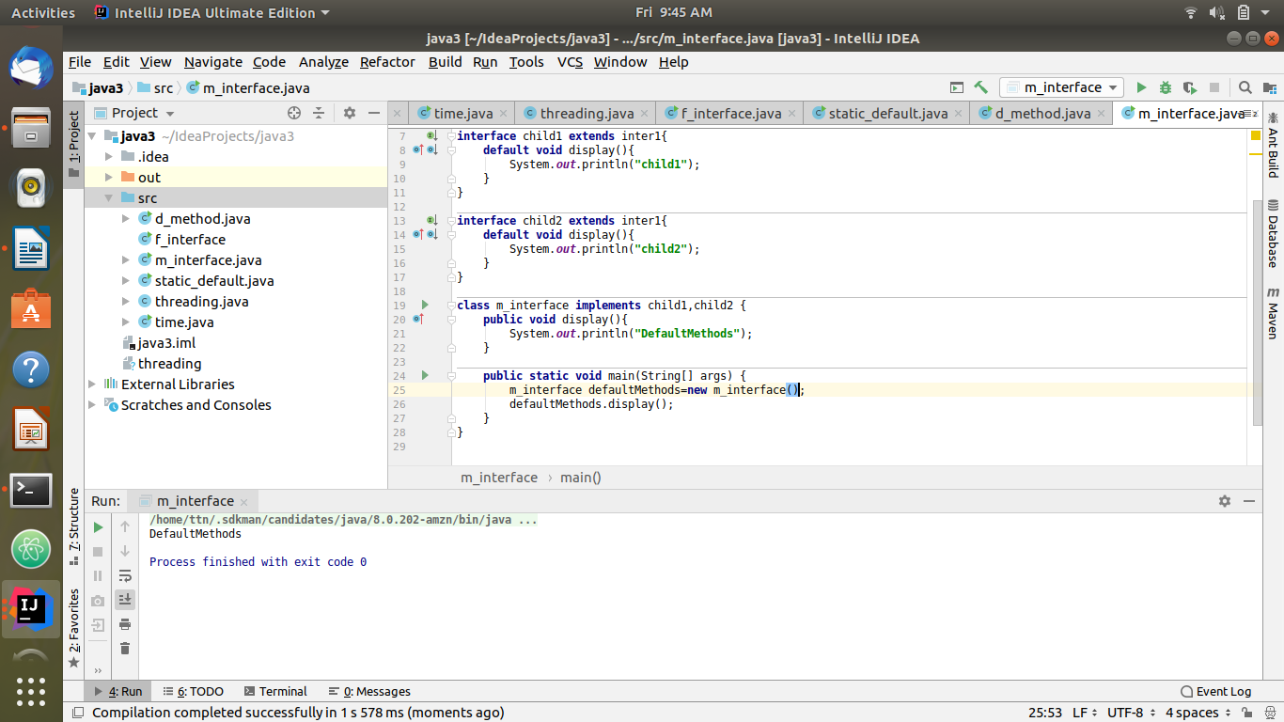
Code:
interface inter1 {
default void display(){
System.out.println("inter1");
}
}
interface child1 extends inter1{
default void display(){
System.out.println("child1");
}
}
interface child2 extends inter1{
default void display(){
System.out.println("child2");
}
}
class m_interface implements child1,child2 {
public void display(){
System.out.println("DefaultMethods");
}
public static void main(String[] args) {
m_interface defaultMethods=new m_interface();
defaultMethods.display();
}
}

- Collect all the even numbers from an integer list.
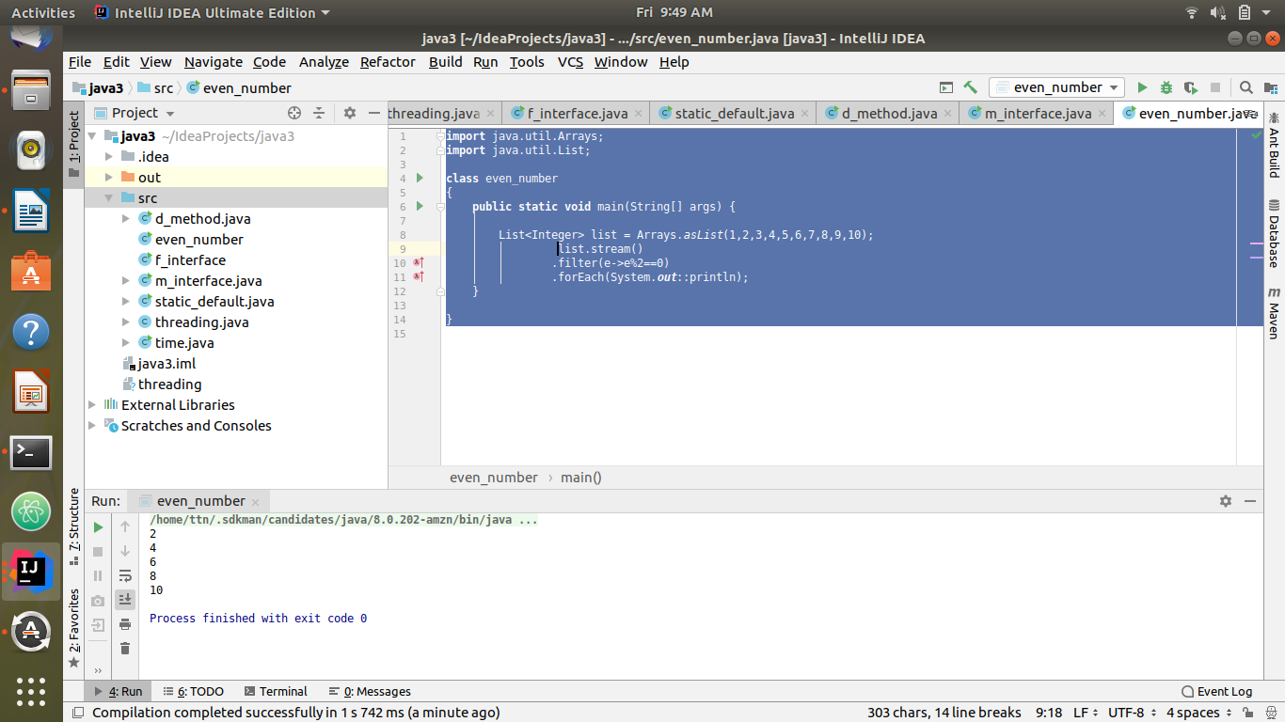
Code:
import java.util.Arrays;
import java.util.List;
class even_number
{
public static void main(String[] args) {
List<Integer> list = Arrays.asList(1,2,3,4,5,6,7,8,9,10);
list.stream()
.filter(e->e%2==0)
.forEach(System.out::println);
}
}

- Sum all the numbers greater than 5 in the integer list.
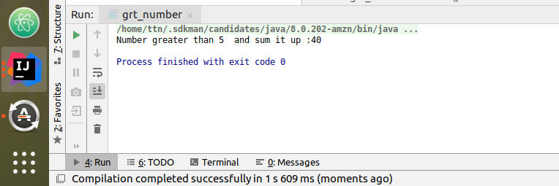
Code:
import java.util.Arrays;
import java.util.List;
import java.util.stream.Collectors;
class grt_number {
public static void main(String[] args) {
List<Integer> list = Arrays.asList(1,2,3,4,5,6,7,8,9,10);
int N = list
.stream()
.filter(e->e>5)
.collect(Collectors.summingInt(e->e));
System.out.println("Number greater than 5 and sum it up :"+N);
}
}

- Find average of the number inside integer list after doubling it.

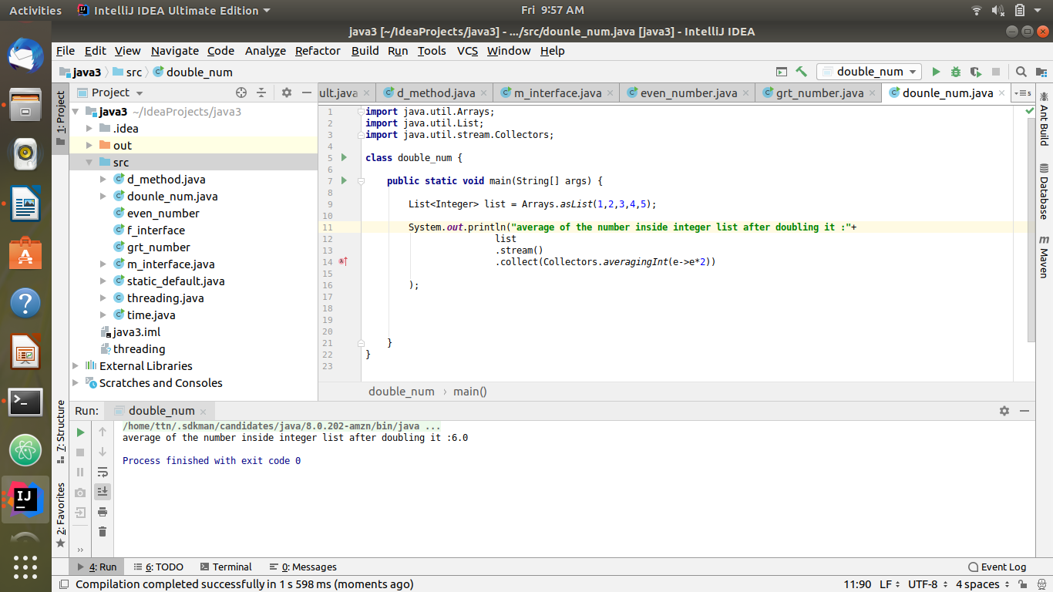
Code:
import java.util.Arrays;
import java.util.List;
import java.util.stream.Collectors;
class double_num {
public static void main(String[] args) {
List<Integer> list = Arrays.asList(1,2,3,4,5);
System.out.println("average of the number inside integer list after doubling it :"+
list
.stream()
.collect(Collectors.averagingInt(e->e*2))
);
}
}

- Find the first even number in the integer list which is greater than 3.
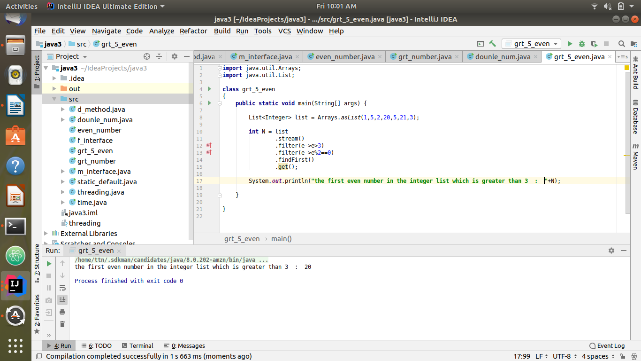
Code:
import java.util.Arrays;
import java.util.List;
class grt_5_even
{
public static void main(String[] args) {
List<Integer> list = Arrays.asList(1,5,2,20,5,21,3);
int N = list
.stream()
.filter(e->e>3)
.filter(e->e%2==0)
.findFirst()
.get();
System.out.println("the first even number in the integer list which is greater than 3 : "+N);
}
}

