- Implement Singleton Design Pattern on a dummy class.
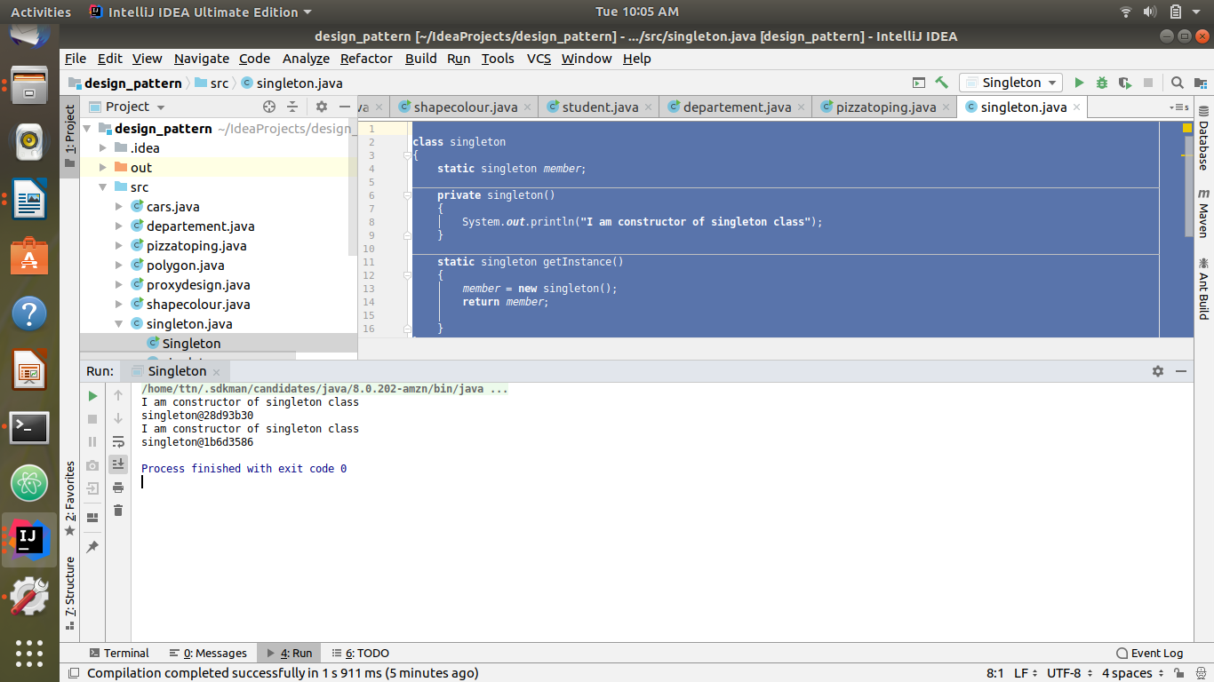
Code:
class singleton
{
static singleton member;
private singleton()
{
System.out.println("I am constructor of singleton class");
}
static singleton getInstance()
{
member = new singleton();
return member;
}
}
class Singleton
{
public static void main(String[] args)
{
System.out.println(singleton.getInstance());
System.out.println(singleton.getInstance());
}
}

- Implement Factory Pattern to get the Polygon of differnt type.
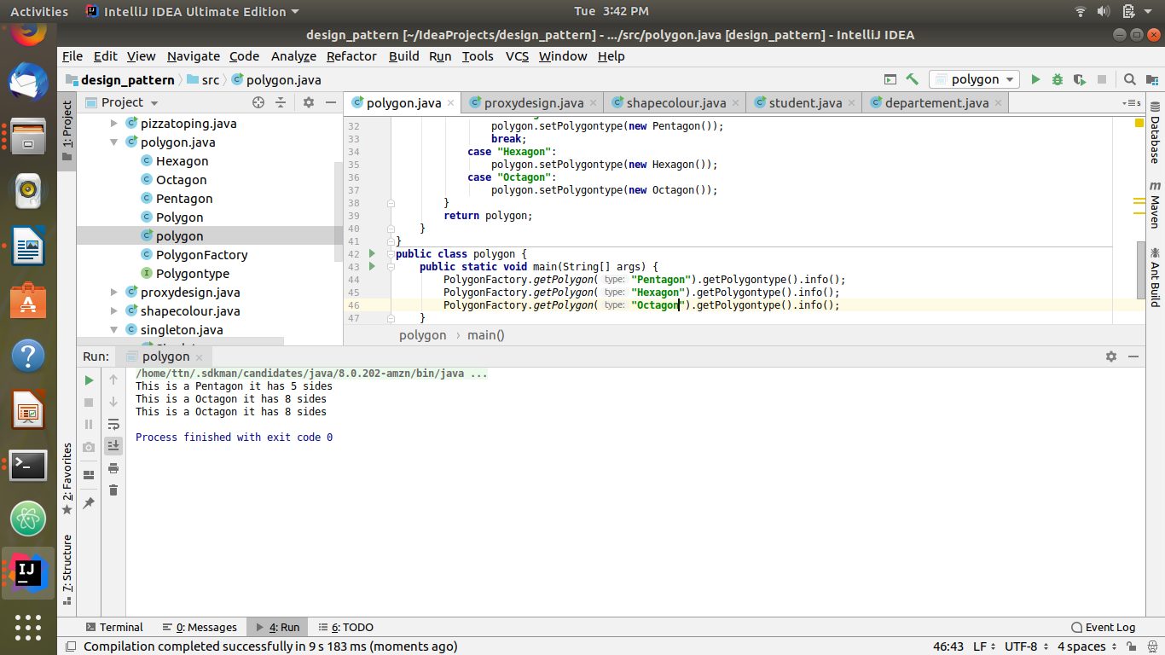
Code:
//Implement Factory Pattern to get the Polygon of different type.
interface Polygontype{
void info();}
class Pentagon implements Polygontype{
@Override
public void info() {
System.out.println("This is a Pentagon it has 5 sides ");
}}
class Hexagon implements Polygontype{
@Override
public void info() {
System.out.println("This is a Hexagon it has 6 sides ");
}}
class Octagon implements Polygontype{
@Override
public void info() {
System.out.println("This is a Octagon it has 8 sides ");
}}
class Polygon{
Polygontype polygontype;
public Polygontype getPolygontype() {
return polygontype;
}
public void setPolygontype(Polygontype polygontype) {
this.polygontype = polygontype;
}}
class PolygonFactory{
static Polygon getPolygon(String type){
Polygon polygon=new Polygon();
switch (type){
case "Pentagon":
polygon.setPolygontype(new Pentagon());
break;
case "Hexagon":
polygon.setPolygontype(new Hexagon());
case "Octagon":
polygon.setPolygontype(new Octagon());
}
return polygon;
}
}
public class polygon {
public static void main(String[] args) {
PolygonFactory.getPolygon("Pentagon").getPolygontype().info();
PolygonFactory.getPolygon("Hexagon").getPolygontype().info();
PolygonFactory.getPolygon("Octagon").getPolygontype().info();
}
}

- Implement Abstract Factory Pattern to create cars of different categories from different countries.
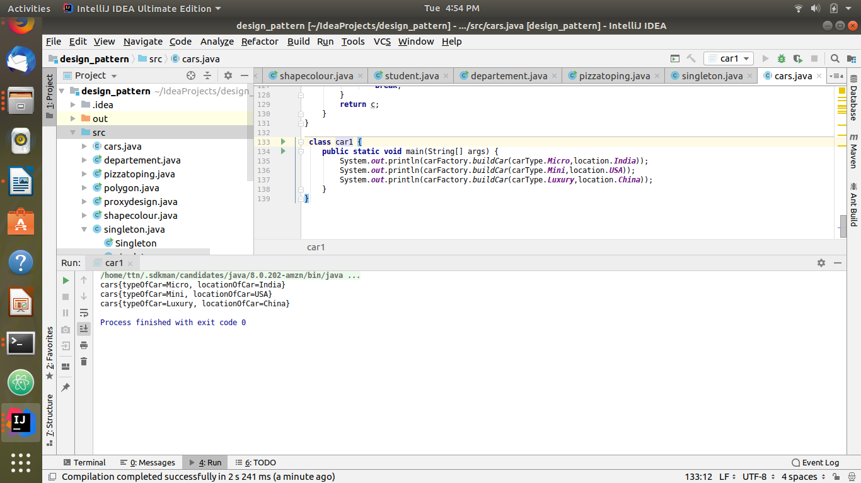
Code:
enum carType{
Micro,Mini,Luxury;
}
enum location{
India,USA,China;
}
abstract class cars{
carType typeOfCar;
location locationOfCar;
public cars(carType typeOfCar,location locationOfCar){
this.locationOfCar = locationOfCar;
this.typeOfCar = typeOfCar;
};
abstract void construct();
@Override
public String toString() {
return "cars{" +
"typeOfCar=" + typeOfCar +
", locationOfCar=" + locationOfCar +
'}';
}
}
class microCar extends cars{
public microCar(location loc){
super(carType.Micro,loc);
}
@Override
void construct() {
System.out.println(" connect to micro cars ");
}
}
class miniCar extends cars{
public miniCar(location loc){
super(carType.Mini,loc);
}
@Override
void construct() {
System.out.println(" connect to mini cars ");
}
}
class luxuryCar extends cars{
public luxuryCar(location loc){
super(carType.Luxury,loc);
}
@Override
void construct() {
System.out.println(" connect to micro cars ");
}
}
class IndianCarFactory{
static cars buildCar(carType typeOfCar){
cars c = null;
switch(typeOfCar){
case Mini:
c = new miniCar(location.India);
break;
case Micro:
c = new microCar(location.India);
break;
case Luxury:
c = new luxuryCar(location.India);
break;
}
return c;
}
}
class ChinaCarFactory{
static cars buildCar(carType typeOfCar) {
cars c = null;
switch (typeOfCar){
case Mini:
c = new miniCar(location.China);
break;
case Micro:
c = new microCar(location.China);
break;
case Luxury:
c = new luxuryCar(location.China);
break;
}
return c;
}
}
class USACarFactory{
static cars buildCar(carType typeOfCar) {
cars c = null;
switch (typeOfCar) {
case Mini:
c = new miniCar(location.USA);
break;
case Micro:
c = new microCar(location.USA);
break;
case Luxury:
c = new luxuryCar(location.USA);
break;
}
return c;
}
}
class carFactory{
static cars buildCar(carType typeOfCar,location locationOfCar) {
cars c = null;
switch (locationOfCar) {
case India:
c = IndianCarFactory.buildCar(typeOfCar);
break;
case USA:
c = USACarFactory.buildCar(typeOfCar);
break;
case China:
c = ChinaCarFactory.buildCar(typeOfCar);
break;
}
return c;
}
}
class car1 {
public static void main(String[] args) {
System.out.println(carFactory.buildCar(carType.Micro,location.India));
System.out.println(carFactory.buildCar(carType.Mini,location.USA));
System.out.println(carFactory.buildCar(carType.Luxury,location.China));
}
}

- Implement Builder pattern to create a student object with more than 6 fields.
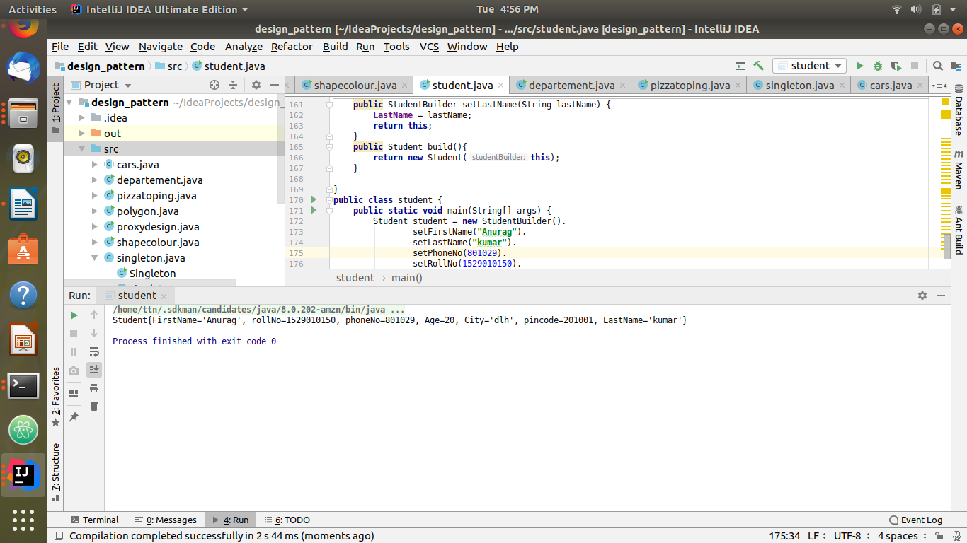
Code:
//Implement Builder pattern to create a student object with more than 6 fields.
class Student{
String FirstName;
int rollNo;
int phoneNo;
int Age;
String City;
int pincode;
String LastName;
public Student(StudentBuilder studentBuilder) {
FirstName=studentBuilder.getFirstName();
rollNo=studentBuilder.getRollNo();
phoneNo=studentBuilder.getPhoneNo();
Age=studentBuilder.getAge();
City=studentBuilder.getCity();
pincode=studentBuilder.getPincode();
LastName=studentBuilder.getLastName();
}
@Override
public String toString() {
return "Student{" +
"FirstName='" + FirstName + '\'' +
", rollNo=" + rollNo +
", phoneNo=" + phoneNo +
", Age=" + Age +
", City='" + City + '\'' +
", pincode=" + pincode +
", LastName='" + LastName + '\'' +
'}';
}
public String getFirstName() {
return FirstName;
}
public void setFirstName(String firstName) {
FirstName = firstName;
}
public int getRollNo() {
return rollNo;
}
public void setRollNo(int rollNo) {
this.rollNo = rollNo;
}
public int getPhoneNo() {
return phoneNo;
}
public void setPhoneNo(int phoneNo) {
this.phoneNo = phoneNo;
}
public int getAge() {
return Age;
}
public void setAge(int age) {
Age = age;
}
public String getCity() {
return City;
}
public void setCity(String city) {
City = city;
}
public int getPincode() {
return pincode;
}
public void setPincode(int pincode) {
this.pincode = pincode;
}
public String getLastName() {
return LastName;
}
public void setLastName(String lastName) {
LastName = lastName;
}
}
class StudentBuilder{
String FirstName;
int rollNo;
int phoneNo;
int Age;
String City;
int pincode;
String LastName;
public String getFirstName() {
return FirstName;
}
public StudentBuilder setFirstName(String firstName) {
this.FirstName = firstName;
return this;
}
public int getRollNo() {
return rollNo;
}
public StudentBuilder setRollNo(int rollNo) {
this.rollNo = rollNo;
return this;
}
public int getPhoneNo() {
return phoneNo;
}
public StudentBuilder setPhoneNo(int phoneNo) {
this.phoneNo = phoneNo;
return this;
}
public int getAge() {
return Age;
}
public StudentBuilder setAge(int age) {
Age = age;
return this;
}
public String getCity() {
return City;
}
public StudentBuilder setCity(String city) {
City = city;
return this;
}
public int getPincode() {
return pincode;
}
public StudentBuilder setPincode(int pincode) {
this.pincode = pincode;
return this;
}
public String getLastName() {
return LastName;
}
public StudentBuilder setLastName(String lastName) {
LastName = lastName;
return this;
}
public Student build(){
return new Student(this);
}
}
public class student {
public static void main(String[] args) {
Student student = new StudentBuilder().
setFirstName("Anurag").
setLastName("kumar").
setPhoneNo(801029).
setRollNo(1529010150).
setPincode(201001).
setCity("dlh").
setAge(20).build();
System.out.println(student.toString());
}
}

- Implement Bridge Design Pattern for Color and Shape such that Shape and Color can be combined together e.g BlueSquare, RedSquare, PinkTriangle etc.
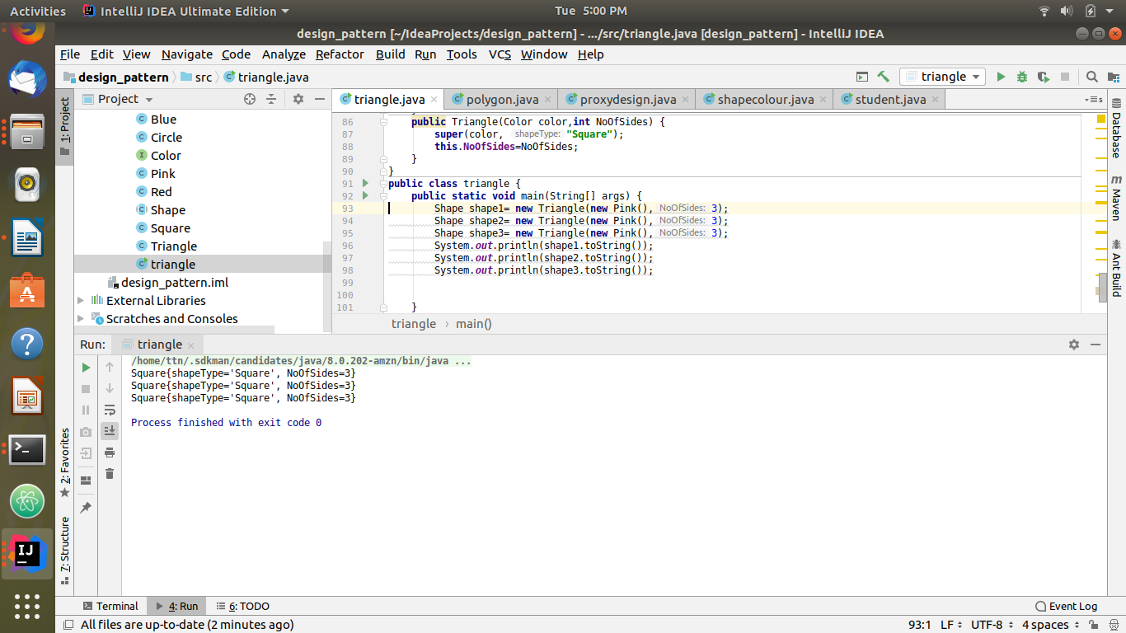
Code:
import javax.print.attribute.standard.Sides;
//Implement Bridge Design Pattern for Color and
// Shape such that Shape and Color can be combined together e.g BlueSquare, RedSquare, PinkTriangle etc.
//Interface
interface Color{
void colorInfo();
}
//concrete implementation
class Pink implements Color{
@Override
public void colorInfo() {
System.out.println("using color pink ");
}
}
class Blue implements Color{
@Override
public void colorInfo() {
System.out.println("using color Blue ");
}
}
class Red implements Color{
@Override
public void colorInfo() {
System.out.println("using color Red ");
}
}
//Abstraction
abstract class Shape{
Color color;
String shapeType;
public Shape(Color color, String shapeType) {
this.color = color;
this.shapeType = shapeType;
}
}
//refined Abstraction
class Square extends Shape{
int NoOfSides;
@Override
public String toString() {
return "Square{" +
"shapeType='" + shapeType + '\'' +
", NoOfSides=" + NoOfSides +
'}';
}
public Square(Color color, int NoOfSides) {
super(color, "Square");
this.NoOfSides=NoOfSides;
}
}
class Circle extends Shape{
int NoOfSides;
@Override
public String toString() {
return "Square{" +
"shapeType='" + shapeType + '\'' +
", NoOfSides=" + NoOfSides +
'}';
}
public Circle(Color color,int NoOfSides) {
super(color, "Square");
this.NoOfSides=NoOfSides;
}
}
class Triangle extends Shape{
int NoOfSides;
@Override
public String toString() {
return "Square{" +
"shapeType='" + shapeType + '\'' +
", NoOfSides=" + NoOfSides +
'}';
}
public Triangle(Color color,int NoOfSides) {
super(color, "Square");
this.NoOfSides=NoOfSides;
}
}
public class triangle {
public static void main(String[] args) {
Shape shape1= new Triangle(new Pink(),3);
Shape shape2= new Triangle(new Pink(),3);
Shape shape3= new Triangle(new Pink(),3);
System.out.println(shape1.toString());
System.out.println(shape2.toString());
System.out.println(shape3.toString());
}
}

- Implement Decorator pattern to decorate the Pizza with topings.
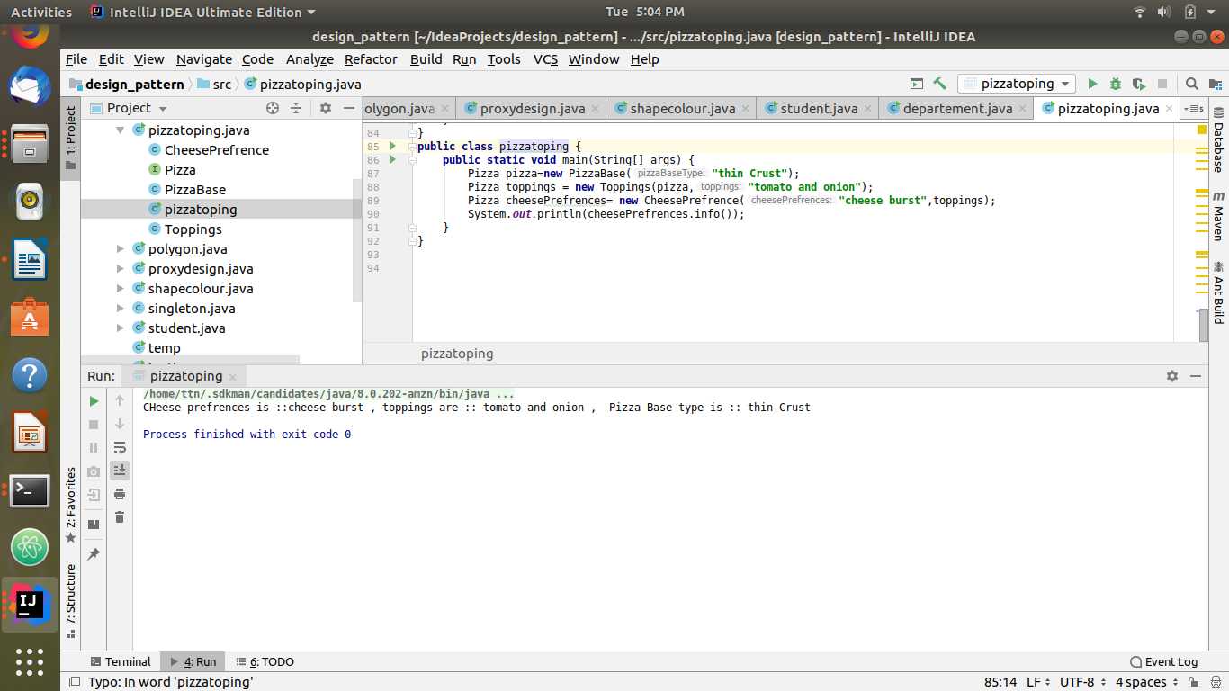
Code:
//Implement Decorator pattern to decorate the Pizza with toppings.
interface Pizza{
String info();
}
class PizzaBase implements Pizza{
String PizzaBaseType;
public PizzaBase(String pizzaBaseType) {
this.PizzaBaseType = pizzaBaseType;
}
public String getPizzaBaseType() {
return PizzaBaseType;
}
public void setPizzaBaseType(String pizzaBaseType) {
PizzaBaseType = pizzaBaseType;
}
@Override
public String info() {
return " Pizza Base type is :: "+PizzaBaseType;
}
}
class Toppings implements Pizza{
Pizza pizza;
String toppings;
public Toppings(Pizza pizza, String toppings) {
this.pizza = pizza;
this.toppings = toppings;
}
public Pizza getPizzaBase() {
return pizza;
}
public void setPizza(Pizza pizza) {
this.pizza = pizza;
}
public String getToppings() {
return toppings;
}
public void setToppings(String toppings) {
this.toppings = toppings;
}
@Override
public String info() {
return "toppings are :: "+toppings +" , "+pizza.info();
}
}
class CheesePrefrence implements Pizza {
String cheesePrefrences;
Pizza pizza;
public CheesePrefrence(String cheesePrefrences, Pizza pizza) {
this.cheesePrefrences = cheesePrefrences;
this.pizza = pizza;
}
public String getCheesePrefrences() {
return cheesePrefrences;
}
public void setCheesePrefrences(String cheesePrefrences) {
this.cheesePrefrences = cheesePrefrences;
}
public Pizza getPizza() {
return pizza;
}
public void setPizza(Pizza pizza) {
this.pizza = pizza;
}
@Override
public String info() {
return "CHeese prefrences is ::"+cheesePrefrences +" , "+pizza.info();
}
}
public class pizzatoping {
public static void main(String[] args) {
Pizza pizza=new PizzaBase("thin Crust");
Pizza toppings = new Toppings(pizza,"tomato and onion");
Pizza cheesePrefrences= new CheesePrefrence("cheese burst",toppings);
System.out.println(cheesePrefrences.info());
}
}

- Implement Composite Design Pattern to maintaing the directories of employees on the basis of departments.
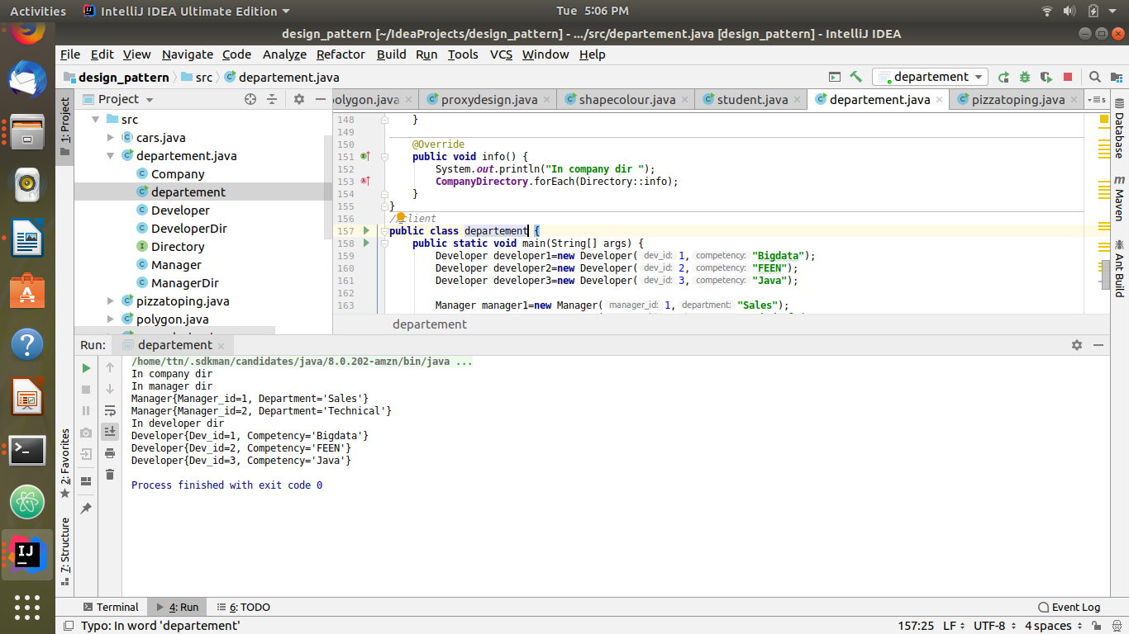
Code:
import java.util.ArrayList;
import java.util.Comparator;
import java.util.List;
//Implement Composite Design Pattern to maintaining the directories of employees on the basis of departments.
//component
interface Directory{
void info();
}
//leaf
class Developer implements Directory{
private int Dev_id;
private String Competency;
public Developer(int dev_id, String competency) {
Dev_id = dev_id;
Competency = competency;
}
public int getDev_id() {
return Dev_id;
}
public void setDev_id(int dev_id) {
Dev_id = dev_id;
}
public String getCompetency() {
return Competency;
}
public void setCompetency(String competency) {
Competency = competency;
}
@Override
public String toString() {
return "Developer{" +
"Dev_id=" + Dev_id +
", Competency='" + Competency + '\'' +
'}';
}
@Override
public void info() {
System.out.println("Developer{" +
"Dev_id=" + Dev_id +
", Competency='" + Competency + '\'' +
'}');
}
}
class Manager implements Directory{
private int Manager_id;
private String Department ;
public Manager(int manager_id, String department) {
Manager_id = manager_id;
Department = department;
}
public int getManager_id() {
return Manager_id;
}
public void setManager_id(int manager_id) {
Manager_id = manager_id;
}
public String getDepartment() {
return Department;
}
public void setDepartment(String department) {
Department = department;
}
@Override
public String toString() {
return "Manager{" +
"Manager_id=" + Manager_id +
", Department='" + Department + '\'' +
'}';
}
@Override
public void info() {
System.out.println("Manager{" +
"Manager_id=" + Manager_id +
", Department='" + Department + '\'' +
'}');
}
}
//composites
class DeveloperDir implements Directory{
private List<Directory> developerList=new ArrayList<>();
public DeveloperDir() {
}
public List<Directory> getDeveloperList() {
return developerList;
}
public void setDeveloperList(List<Directory> developerList) {
this.developerList = developerList;
}
@Override
public void info() {
System.out.println("In developer dir ");
developerList.forEach(Directory::info);
}
}
class ManagerDir implements Directory{
private List<Directory> managerList=new ArrayList<>();
public ManagerDir() {
}
public List<Directory> getManagerList() {
return managerList;
}
public void setManagerList(List<Directory> managerList) {
this.managerList = managerList;
}
@Override
public void info() {
System.out.println("In manager dir ");
managerList.forEach(Directory::info);
}
}
class Company implements Directory{
private List<Directory> CompanyDirectory = new ArrayList<>();
public Company() {
}
public List<Directory> getCompanyDirectory() {
return CompanyDirectory;
}
public void setCompanyDirectory(List<Directory> companyDirectory) {
CompanyDirectory = companyDirectory;
}
@Override
public void info() {
System.out.println("In company dir ");
CompanyDirectory.forEach(Directory::info);
}
}
//client
public class departement {
public static void main(String[] args) {
Developer developer1=new Developer(1,"Bigdata");
Developer developer2=new Developer(2,"FEEN");
Developer developer3=new Developer(3,"Java");
Manager manager1=new Manager(1,"Sales");
Manager manager2=new Manager(2,"Technical");
DeveloperDir developerDir=new DeveloperDir();
developerDir.getDeveloperList().add(developer1);
developerDir.getDeveloperList().add(developer2);
developerDir.getDeveloperList().add(developer3);
ManagerDir managerDir=new ManagerDir();
managerDir.getManagerList().add(manager1);
managerDir.getManagerList().add(manager2);
Company company=new Company();
company.getCompanyDirectory().add(managerDir);
company.getCompanyDirectory().add(developerDir);
company.info();
}
}

- Implement proxy design for accessing Record of a student and allow the access only to Admin.

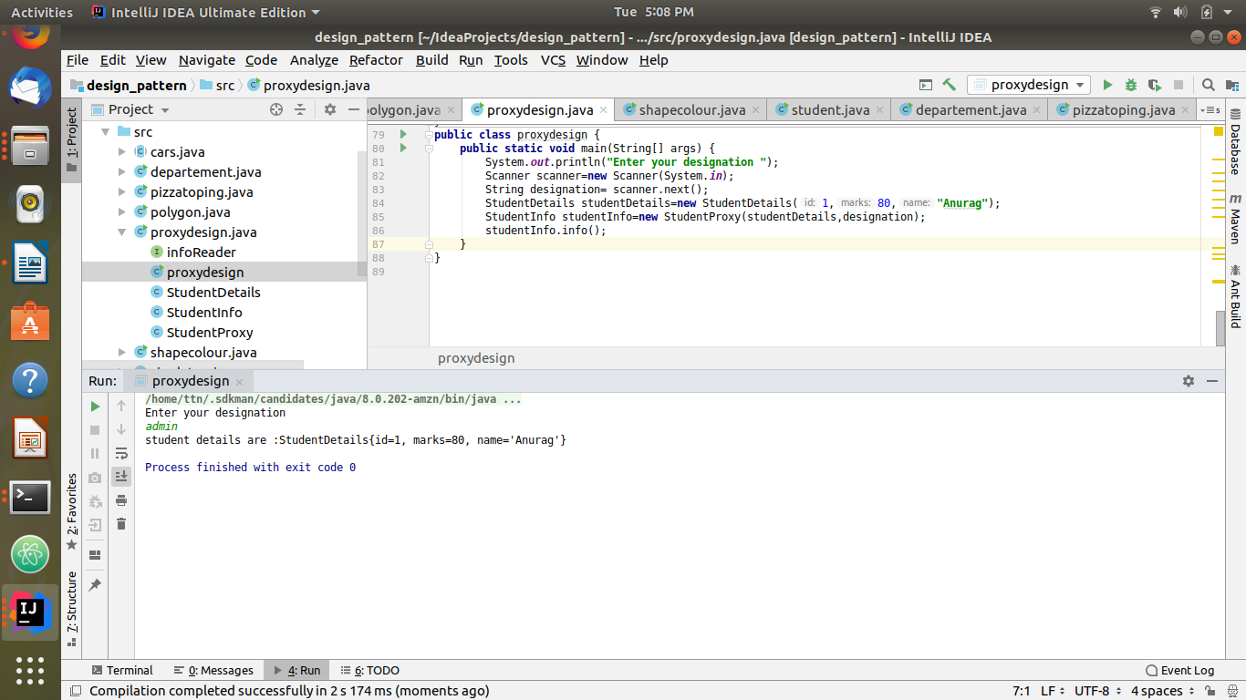
Code:
import java.util.Scanner;
//Implement proxy design for accessing Record of a student and allow the access only to Admin.
class StudentDetails {
private int id;
private int marks;
private String name;
public StudentDetails(int id, int marks, String name) {
this.id = id;
this.marks = marks;
this.name = name;
}
public int getId() {
return id;
}
public void setId(int id) {
this.id = id;
}
public int getMarks() {
return marks;
}
public void setMarks(int marks) {
this.marks = marks;
}
public String getName() {
return name;
}
public void setName(String name) {
this.name = name;
}
@Override
public String toString() {
return "StudentDetails{" +
"id=" + id +
", marks=" + marks +
", name='" + name + '\'' +
'}';
}
}
interface infoReader{
void info();
}
class StudentInfo implements infoReader{
protected StudentDetails student;
public StudentInfo(StudentDetails student) {
this.student = student;
}
@Override
public void info() {
System.out.println("student details are :"+student.toString());
}
}
class StudentProxy extends StudentInfo{
String designation;
public StudentProxy(StudentDetails student,String designation) {
super(student);
this.designation=designation;
}
@Override
public void info() {
if(designation.equals("admin"))
System.out.println("student details are :"+student.toString());
else
System.out.println("Permission denied");
}
}
public class proxydesign {
public static void main(String[] args) {
System.out.println("Enter your designation ");
Scanner scanner=new Scanner(System.in);
String designation= scanner.next();
StudentDetails studentDetails=new StudentDetails(1,80,"Anurag");
StudentInfo studentInfo=new StudentProxy(studentDetails,designation);
studentInfo.info();
}
}

