- Prompt for amount, interest rate and no. of years and calculate simple interest.
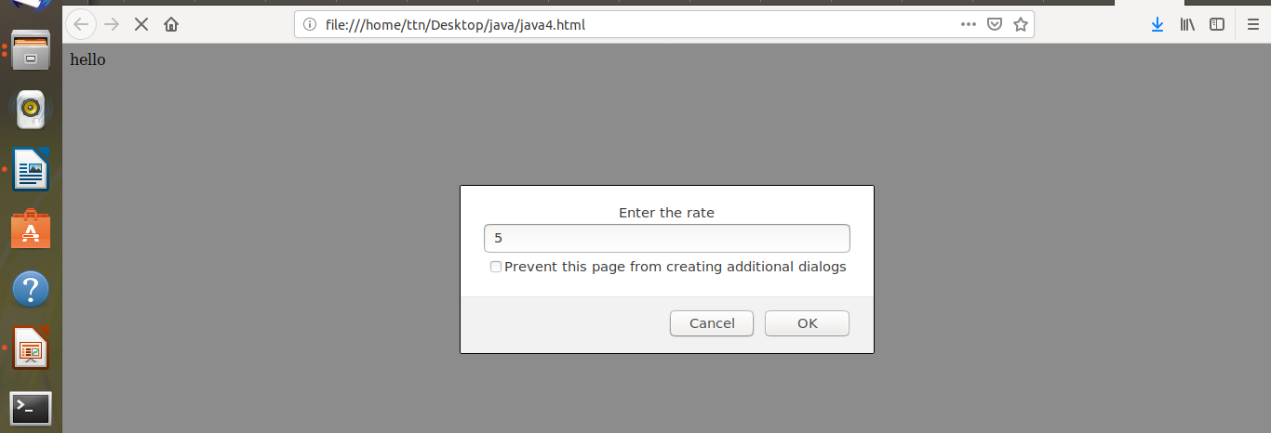

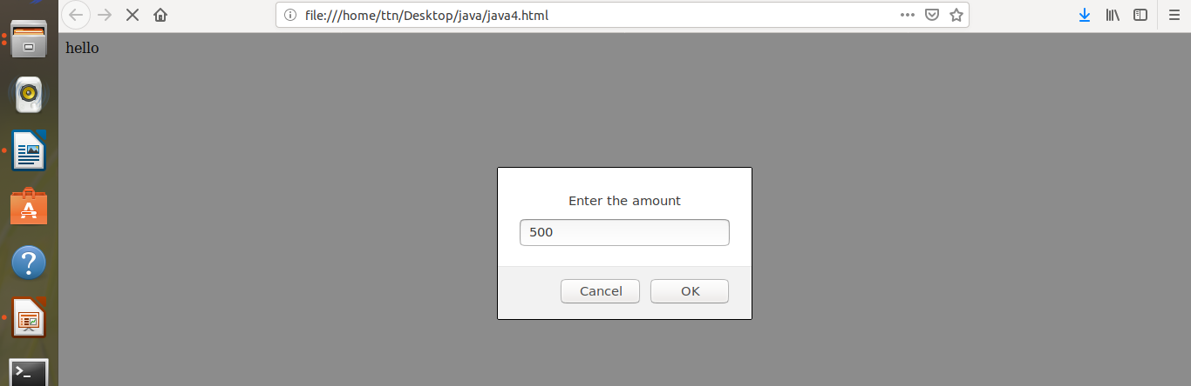

Code:
<html>
<head>
hello
</head>
<body>
<script>
var p=prompt("Enter the amount");
console.log(p);
var r=prompt("Enter the rate");
console.log(r);
var y=prompt("Enter the year");
console.log(y);
var result=(p*r*y)/100;
alert("simple intrest="+(result))
</script>
</body>

</html>
- is palindrome string
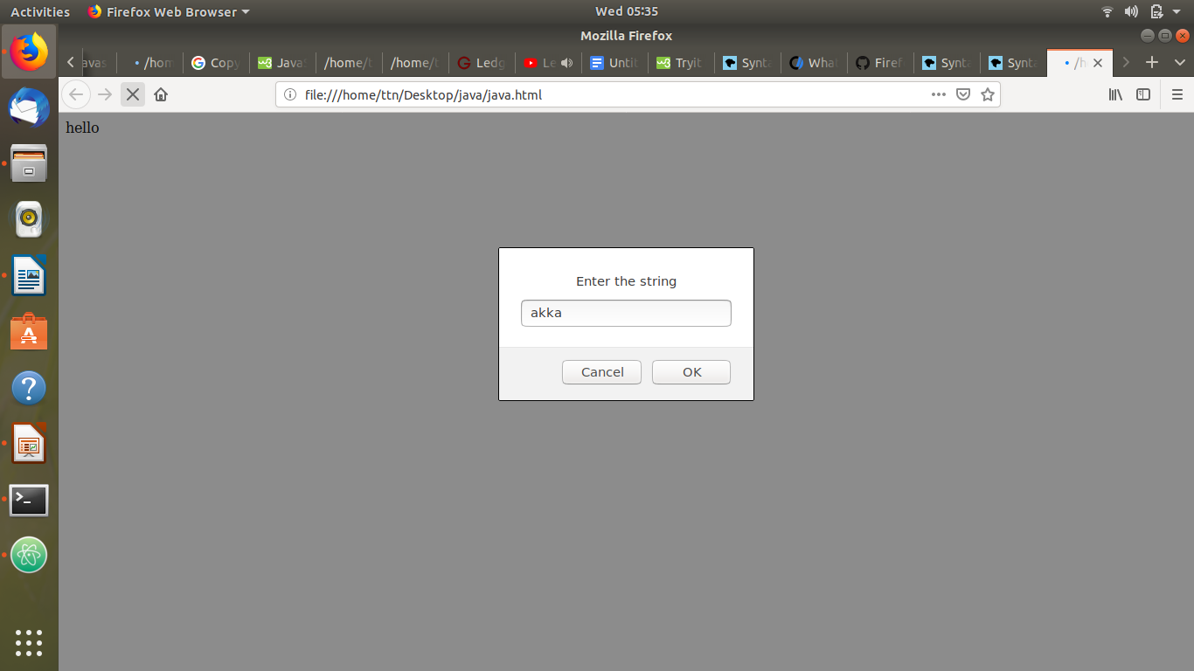


Code:
<html>
<head>
hello
</head>
<body>
<script>
var input=prompt("Enter the string");
console.log(input);
var output=input.split('').reverse().join('');

if(output==input)
{
alert("palindrome");
}
else
{
alert("Not a palindrome");
}
</script>

</body>

</html>

- Area of circle


Code:
<html>
<head>
hello
</head>
<body>
<script>
var input=prompt("Enter the string");
console.log(input);
var output=input.split('').reverse().join('');

if(output==input)
{
alert("palindrome");
}
else
{
alert("Not a palindrome");
}
</script>

</body>

</html>

- Copy information of one object to another and log it to console.
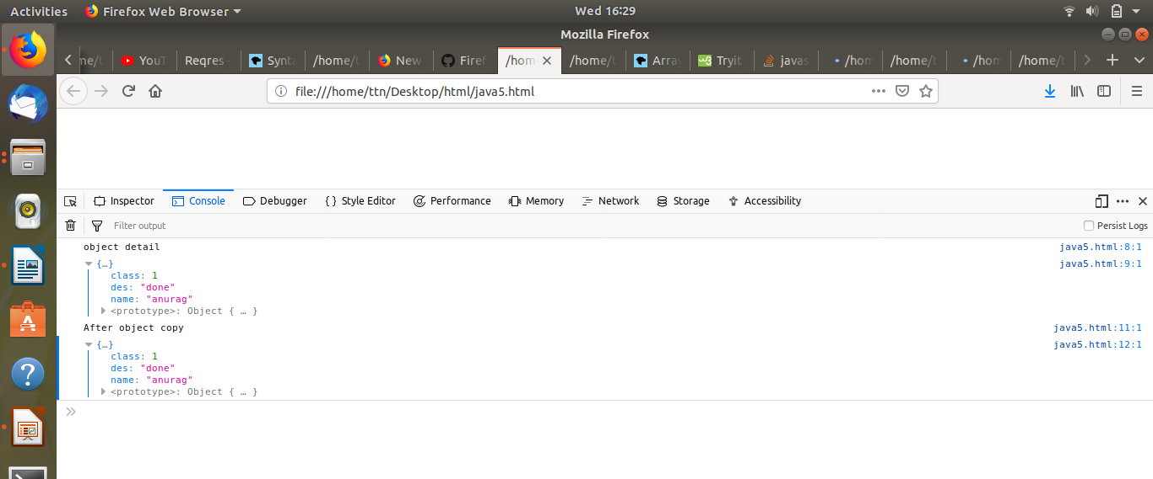

Code:
<html>
<head>
<meta charset="utf-8">
</head>
<body>
<script>
a={name:"anurag",class:1,des:"done"};
console.log("object detail")
console.log(a);
b=a;
console.log("After object copy")
console.log(b);

</script>
</body>

</html>

- create a list of objects of Employee with info as follow :
  - Name, age, salary ,DOB
  - filter all employees with salary greater than 5000
  - group employee on the basis of their age
  - fetch employees with salary less than 1000 and age greater than 20. Then give them an increment 5 times their salary.

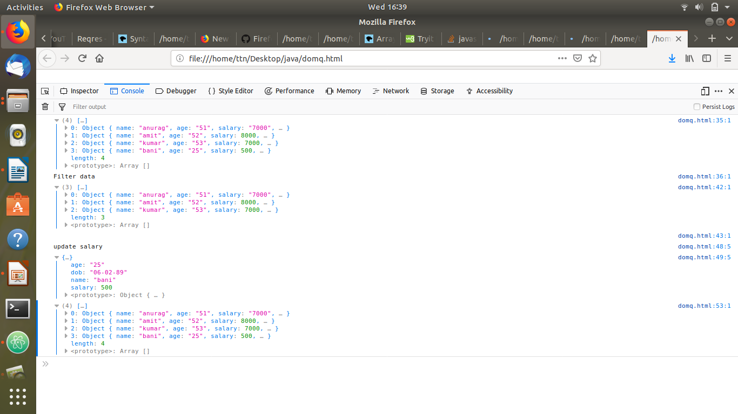

Code:
<html>
<head>
<meta charset="utf-8">
</head>
<body>
<script>
var employee=[
{
name:"anurag",
age:'51',
salary:'7000',
dob:'6-04-94'

},
{
name:"amit",
age:'52',
salary:8000,
dob:"6-08-94"

},
{
name:"kumar",
age:'53',
salary:7000,
dob:"6-04-99"
},
{
name:"bani",
age:'25',
salary:100,
dob:"06-02-89"
}
];
console.log(employee);
console.log("Filter data");
var new_array=employee.filter(function(numb)
{
return numb.salary>5000;

});
console.log(new_array)
console.log("")
for(i=0;i<employee.length;i++)
{
if(employee[i].salary<1000 && employee[i].age>20 )
{
console.log("update salary")
console.log(employee[i]);
employee[i].salary=employee[i].salary*5;
}
}
console.log(employee)

</script>
</body>

</html>

