|  |  |  |
| --- | --- | --- |
| evolve_relative_wealth_discrete_contnatural(nsim = 4000, delta = 0 ,alpha1 = 3, alpha2 = .1,risksz = 10,T = 1,dt = .01,A1_init = 10, A2_init = 100,decay = .005,start_p = .8, gamma=.7, lambda = 10, A_costs = 0) |  | Poor guy is high alpha who think high probability is done deal.  **Rich guy is regular low-alpha guy who overvalues low probability but undervalues high probability (risk-seeking for low probability).** |
| evolve_relative_wealth_discrete_contnatural(nsim = 4000, delta = 0 ,alpha1 = .1, alpha2 = 3,risksz = 10,T = 1,dt = .01,A1_init = 10, A2_init = 100,decay = .005,start_p = .8, gamma=.7, lambda = 10, A_costs = 0) |  | We start with a high probability. Rich guy is high alpha (risk-averse in some sense). Poor (low-alpha) is risk-seeking in the true sense. |
| evolve_relative_wealth_discrete_contnatural(nsim = 4000, delta = 0 ,alpha1 = .1, alpha2 = 3,risksz = 10,T = 1,dt = .01,A1_init = 10, A2_init = 100,decay = .01,start_p = .4, gamma=.7, lambda = 10, A_costs = 0) |  | The only difference from poor-risk-taking guy is that starting probabilty was lower this time. |
| evolve_relative_wealth_discrete_contnatural(nsim = 4000, delta = 0 ,alpha1 = .1, alpha2 = 3,risksz = 10,T = 1,dt = .01,A1_init = 10, A2_init = 100,decay = .5,start_p = .4, gamma=.7, lambda = 10, A_costs = 0) |  |  |
| evolve_relative_wealth_discrete_contnatural(nsim = 4000, delta = 0 ,alpha1 = 3, alpha2 = .1,risksz = 10,T = 1,dt = .01,A1_init = 10, A2_init = 100,decay = .5,start_p = .4, gamma=.7, lambda = 10, A_costs = 0) |  |  |
| x <- evolve_relative_wealth_discrete_contnatural(nsim = 1000, delta = 0 ,alpha1 = 3, alpha2 = .1,risksz = 10,T = 1,dt = .01,A1_init = 100, A2_init =10 ,decay = .1,start_p = .5, gamma=.7, lambda = 10, A_costs = 0) |  | Slow decay. Medium starting p. |
| x <- evolve_relative_wealth_discrete_contnatural(nsim = 1000, delta = 0 ,alpha1 = 3, alpha2 = .1,risksz = 10,T = 1,dt = .01,A1_init = 100, A2_init =10 ,decay = .9,start_p = .9, gamma=.7, lambda = 10, A_costs = 0) |  | High starting p – doesn’t change much. Rich guy risk-averse nothing changes. This is not good for economy. |
| x <- evolve_relative_wealth_discrete_contnatural(nsim = 100, delta = 0 ,alpha1 = 3, alpha2 = .1,risksz = 10,T = 1,dt = .01,A1_init = 100, A2_init =10 ,decay = .9,start_p = .5, gamma=.7, lambda = 10, A_costs = 0) |  | Again medium starting p – doesn’t change much. Rich guy is risk-averse. |
| x <- evolve_relative_wealth_discrete_contnatural(nsim = 1000, delta = 0 ,alpha1 = .1, alpha2 = 3,risksz = 10,T = 1,dt = .01,A1_init = 100, A2_init =10 ,decay = .9,start_p = .9, gamma=.7, lambda = 10, A_costs = 0) |  | High starting p. Rich guy is the risk-seeker – who gains a lot in the end but habits lead to decline. |
| x <- evolve_relative_wealth_discrete_contnatural(nsim = 1000, delta = 0 ,alpha1 = .1, alpha2 = 3,risksz = 10,T = 1,dt = .01,A1_init = 100, A2_init =10 ,decay = .9,start_p = .4, gamma=.7, lambda = 10, A_costs = 0) |  | Low starting p but rich guy is risk-seeking now. |
| x <- evolve_relative_wealth_discrete_contnatural(nsim = 1000, delta = 0 ,alpha1 = .1, alpha2 = 3,risksz = 10,T = 1,dt = .01,A1_init = 100, A2_init =10 ,decay = .9,start_p = .5, gamma=.7, lambda = 10, A_costs = 0.1) |  | Rich guy risk-taking, medium start-p, high A_costs but the the shape doesn’t change. |
| x <- evolve_relative_wealth_discrete_contnatural(nsim = 1000, delta = 0 ,alpha1 = .1, alpha2 = 3,risksz = 10,T = 1,dt = .01,A1_init = 10, A2_init =100 ,decay = .1,start_p = .5, gamma=.7, lambda = 10, A_costs = 0.1) |  |  |
| x <- evolve_relative_wealth_discrete_contnatural(nsim = 2000, delta = 0.1 ,alpha1 = .1, alpha2 = 3,risksz = 10,T = 1,dt = .01,A1_init = 100, A2_init =10 ,decay = .9,start_p = .5, gamma=.7, lambda = 10, A_costs = 0) |  | A costs and tax too. Rich guy risk-seeking. |
| x <- evolve_relative_wealth_discrete_contnatural(nsim = 3000, delta = 0.1 ,alpha1 = 3, alpha2 = .1,risksz = 10,T = 1,dt = .01,A1_init = 100, A2_init =10 ,decay = .9,start_p = .5, gamma=.7, lambda = 10, A_costs = 0) |  | With tax. Rich guy risk-averse. Wealth decline slowly. If risk declines the difference is what would pay the poorer consumer (assuming the end-goal of taxation is inequality reduction). |
| x <- evolve_relative_wealth_discrete_contnatural(nsim = 5000, delta = 0.05 ,alpha1 = 3, alpha2 = .1,risksz = 10,T = 1,dt = .01,A1_init = 500, A2_init =10 ,decay = .3,start_p = .5, gamma=.7, lambda = 10, A_costs = 0) |  |  |

# Observations

Differences in wealth seem to influence settlement level and the reversion is not to the mean. This is important because we believe that richer consumer is allowed to be more risk-taking. Is this what happens?

The interesting bit here is that the resources are limited – if there are more asset differences one may have more risk initiative than the other. If we compare (10,490), (50,450), (100,400), (150,350, (200,300) for rich risk-seeker (so the total wealth is the same), we see that more inequality leads to sharper drops – the convergence is not to mean.

x <- evolve_relative_wealth_discrete_contnatural(nsim = 1000, delta = 0 ,alpha1 =2, alpha2 = .1,risksz = 10,T = 1,dt = .01,**A1_init**, **A2_init**, decay = .1,start_p = .5, gamma=.7, lambda = 10, A_costs = 0, plot_range = F)

|  |  |  |
| --- | --- | --- |
| 10,490 | 28 |  |
| 50,450 | 68 |  |
| 150,350 | 169 |  |
| 200,300 | 218 |  |

The key point is that combined effort that is spent in gold mining goes to waste. When the consumers are not too far from reference levels (less inequality) the flight from loss could be less.

Are we better off if we leave the rich being more risk-averse? Yes, because if the risk-lose they would end up where poor is – as the nature dries up.

When we take the **poor risk-seeker**, we have the following result for A1_init=150, A2_init=450

x <- evolve_relative_wealth_discrete_contnatural(nsim = 2000, delta = 0 ,alpha1 =.1, alpha2 = 2,risksz = 10,T = 1,dt = .01,**A1_init**, **A2_init**,decay = .1,start_p = .5, gamma=.7, lambda = 10, A_costs = 0, plot_range = F)

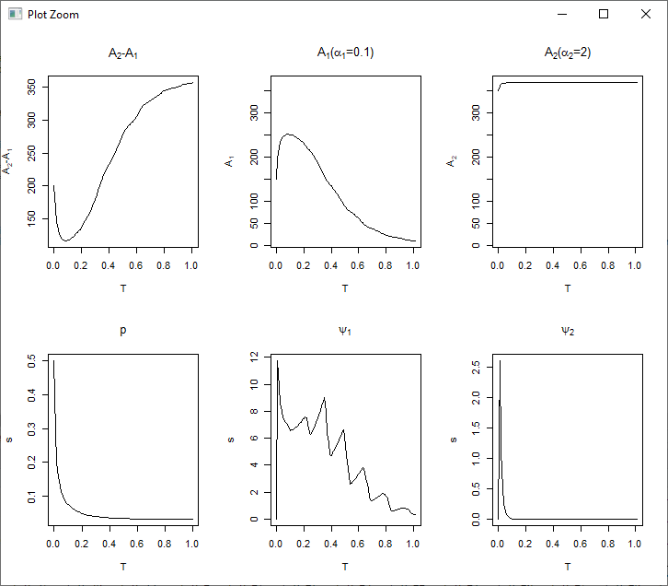

The poor being the risk-seeking individual keeps taking the risk – but wealth gradually declines as the mines dry out. When the asset differences are higher here, this is worsened. Again closer asset differences help.

This really gives us the cost of innovation.

|  |  |  |
| --- | --- | --- |
| 10,490 | (0,521) |  |
| 50,450 | (0,471) |  |
| 150,350 | (15,367) |  |
| 200,300 | (171,316) |  |

|  |  |
| --- | --- |
| x <- evolve_relative_wealth_discrete_contnatural(nsim = 1000, delta = 0 ,alpha1 =2, alpha2 = .1,risksz = 10,T = 1,dt = .01,A1_init = 10, A2_init =**300** ,decay = .1,start_p = .5, gamma=.7, lambda = 10, A_costs = 0, plot_range = F) |  |
| x <- evolve_relative_wealth_discrete_contnatural(nsim = 1000, delta = 0 ,alpha1 =2, alpha2 = .1,risksz = 10,T = 1,dt = .01,A1_init = 10, A2_init =**1000** ,decay = .1,start_p = .5, gamma=.7, lambda = 10, A_costs = 0, plot_range = F) |  |
| x <- evolve_relative_wealth_discrete_contnatural(nsim = 1000, delta = 0 ,alpha1 =2, alpha2 = .1,risksz = 10,T = 1,dt = .01,A1_init = 10, A2_init =**50** ,decay = .1,start_p = .5, gamma=.7, lambda = 10, A_costs = 0, plot_range = F) |  |
| x <- evolve_relative_wealth_discrete_contnatural(nsim = 1000, delta = 0 ,alpha1 =2, alpha2 = .1,risksz = 10,T = 1,dt = .01,A1_init = 10, A2_init =30 ,decay = .1,start_p = .5, gamma=.7, lambda = 10, A_costs = 0, plot_range = F)  #settles at 20 |  |
| x <- evolve_relative_wealth_discrete_contnatural(nsim = 1000, delta = 0 ,alpha1 =2, alpha2 = .1,risksz = 10,T = 1,dt = .01,A1_init = 10, A2_init =**200** ,decay = .1,start_p = .5, gamma=.7, lambda = 10, A_costs = 0, plot_range = F)  settles at 28 |  |

We’re unlikely to see this in the real world because the mine hardly ever dries – and the decay is extremely slow – if it did decline however above is what we’re likely to see. Innovation is necessary for maintaining the levels in general. We should be able to verify this by considering the scenario when the decay is super slow.

**Poor risk-seeker** – still happy. It even seems that differences in wealth are better because the combined effort is more this way. p drops to higher than .2.

x <- evolve_relative_wealth_discrete_contnatural(nsim = 1000, delta = 0 ,alpha1 =.1, alpha2 = 2,risksz = 10,T = 1,dt = .01,A1_init, A2_init,decay = .001,start_p = .5, gamma=.7, lambda = 10, A_costs = 0, plot_range = F); print(colMeans(x$A1)); print(colMeans(x$A2))

|  |  |  |
| --- | --- | --- |
| 10,490 | 608,4630 |  |
| 50,450 | 1148, 3546 |  |
| 100,400 |  |  |
| 150,350 | 1531, 2784 |  |
| 200,300 | 1615, 2462 |  |

**Rich risk-seeker** in a risk situation – plays a lot in the beginning but being a risk-seeker pays a lot and comes down. p drops to .2. If p drops a lot means that means a lot of effort is being made. Remember that low alpha isn’t really a risk-seeker but just someone who undervalues low-probability so she would actually lose out. We need to be sure that this corresponds to real-world occupations. Do professors…

evolve_relative_wealth_discrete_contnatural(nsim = 1000, delta = 0 ,alpha1 =2, alpha2 = .1,risksz = 10,T = 1,dt = .01,**A1_init**, **A2_init**,decay = .001,start_p = .5, gamma=.7, lambda = 10, A_costs = 0, plot_range = F); print(colMeans(x$A1)); print(colMeans(x$A2))

|  |  |  |
| --- | --- | --- |
| 10,490 | 468, 363 |  |
| 50,450 | 1000, 853 |  |
| 150,350 | 1300,1000 |  |
| 200,300 | 1500,1200 |  |

Once again we see that the right balance is better – but probability being higher – both participants can have high final payoffs – if the game had to stop at .2 or a new regime had to be kick in with a new discovery – this would be the permanent effect.

==

The effect of taxes arises not when growth is higher but when it is low.

Consider rich risk-seeker with near-zero decline in p.

**Rich Risk-seeker**

x <- evolve_relative_wealth_discrete_contnatural(nsim = 1000, delta = .05 ,alpha1 =2, alpha2 = .1,risksz = 10,T = 1,dt = .01,**A1_init**, **A2_init**, decay = .1,start_p = .5, gamma=.7, lambda = 10, A_costs = 0, plot_range = F)

|  |  |  |
| --- | --- | --- |
| 10,490 | 276 |  |
| 50,450 | 278 |  |
| 150,350 | 276 |  |
| 200,300 | 276 |  |

The effect of wealth differences is reduced due to taxes. **TAXES** do seem to offer a genuine protection to when the rich take risks. On the other hand, when we have the poor risk seeker, .

**Poor Risk-Seeker**

x <- evolve_relative_wealth_discrete_contnatural(nsim = 2000, delta = 0.05 ,alpha1 =.1, alpha2 = 2,risksz = 10,T = 1,dt = .01,**A1_init**, **A2_init**,decay = .1,start_p = .5, gamma=.7, lambda = 10, A_costs = 0, plot_range = F)

|  |  |  |
| --- | --- | --- |
| 10,490 | 288,288 |  |
| 50,450 | 297,297 |  |
| 100,400 | 305 |  |
| 150,350 | 300,300 |  |
| 200,300 | 291 |  |

Having a poor risk-seeker is actually better for everybody now. **Why?**

Here, is what happens with 50, 450 graph - x <- evolve_relative_wealth_discrete_contnatural(nsim = 2000, delta = 0.05 ,alpha1 =.1, alpha2 = 2,risksz = 10,T = 1,dt = .01,A1_init=50, A2_init=450,decay = .1,start_p = .5, gamma=.7, lambda = 10, A_costs = 0, plot_range = F) :

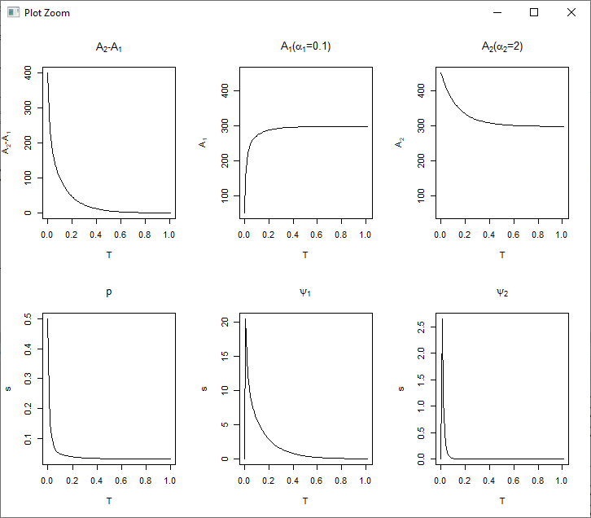

p only drops to .25 from .5

Poor Risk Seeker

evolve_relative_wealth_discrete_contnatural(nsim = 2000, delta = 0.0 ,alpha1 =.1, alpha2 = 2,risksz = 10,T = 1,dt = .01,A1_init=frow$x, A2_init=frow$y,decay = .0001,start_p = .5, gamma=.7, lambda = 10, A_costs = 0, plot_range = F)

|  |  |  |
| --- | --- | --- |
| 10,490 | 3904 | 41828 |
| 50,450 | 5818 | 32884 |
| 100,400 | 7583 | 27189 |
| 150,350 | 7957 | 25032 |
| 200,300 | 8471 | 22927 |

Poor Risk Seeker – under flatted p

evolve_relative_wealth_discrete_contnatural(nsim = 2000, delta = 0.0 ,alpha1 =.1, alpha2 = 2,risksz = 10,T = 1,dt = .01,A1_init=frow$x, A2_init=frow$y,decay = .00001,start_p = .5, gamma=.7, lambda = 10, A_costs = 0, plot_range = F)

|  |  |  |
| --- | --- | --- |
| 10,490 | 17464 | 417027 |
| 50,450 | 43451 | 330710 |
| 100,400 | 46420 | 294611 |
| 150,350 | 53262 | 259907 |
| 200,300 | 61746 | 255547 |

One again, wealth differences are lower when the risk-seeker is rich – rich loses out. Relatively remember that towards the end – low-alpha consumer is somebody who overvalues low probability and high-alpha is one who ignores low-probability events (not going to happen). Taxes seem to provide protection to against risk-taking.

Rich Risk Seeker

evolve_relative_wealth_discrete_contnatural(nsim = 2000, delta = 0.0 ,alpha1 =2, alpha2 = .1,risksz = 10,T = 1,dt = .01,A1_init=frow$x, A2_init=frow$y,decay = .0001,start_p = .5, gamma=.7, lambda = 10, A_costs = 0, plot_range = F);

|  |  |  |
| --- | --- | --- |
| 10,490 | 5583 | 3068 |
| 50,450 | 10827 | 5249 |
| 100,400 | 13487 | 6620 |
| 150,350 | 15325 | 7984 |
| 200,300 | 16289 | 7899 |

**Rich Risk-Seeker – under flatter p**

x <- evolve_relative_wealth_discrete_contnatural(nsim = 2000, delta = 0.0 ,alpha1 =2, alpha2 = .1,risksz = 10,T = 1,dt = .01,A1_init=frow$x, A2_init=frow$y,decay = .0001,start_p = .5, gamma=.7, lambda = 10, A_costs = 0, plot_range = F)

|  |  |  |
| --- | --- | --- |
| 10,490 | 5009 | 3081 |
| 50,450 | 11376 | 5453 |
| 100,400 | 12807 | 6562 |
| 150,350 | 15374 | 7097 |
| 200,300 | 15655 | 7966 |

Checking how this happens at low rates of decay and rise in probability.

evolve_relative_wealth_discrete_contnatural(nsim = 3000, delta = 0.0 ,alpha1 =.1, alpha2 = 2,risksz = 5,

T = 1,dt = .01,A1_init=frow$x, A2_init=frow$y,decay = .01,

start_p = .1, gamma=.7, lambda = 10, A_costs = 0, plot_range = F, sigma_func=rise_func)

[1] "( 10 , 490 ) A1: 5.23247196014827 A2: 718300392250.207"

[1] "( 50 , 450 ) A1: 45.556347182402 A2: 78109932951.714"

[1] "( 100 , 400 ) A1: 72.7782293481165 A2: 90074708.5864488"

[1] "( 150 , 350 ) A1: 99.7396011416792 A2: 358.724118129039"

[1] "( 200 , 300 ) A1: 138.507297980686 A2: 1500.69306500222"

evolve_relative_wealth_discrete_contnatural(nsim = 3000, delta = 0.0 ,alpha1 =.1, alpha2 = 2,risksz = 2,

T = 1,dt = .01,A1_init=frow$x, A2_init=frow$y,decay = .01,

start_p = .1, gamma=.7, lambda = 10, A_costs = 0, plot_range = F, sigma_func=rise_func)

"( 10 , 490 ) A1: 166004641.081581 A2: 1.08939937917971e+21"

[1] "( 50 , 450 ) A1: 29.192692463597 A2: 4.29969560484186e+20"

[1] "( 100 , 400 ) A1: 1076348741.44489 A2: 34804739052831621120"

[1] "( 150 , 350 ) A1: 17721881333.4647 A2: 753011994708638720"

[1] "( 200 , 300 ) A1: 6349067822139.12 A2: 5291845454287015936"

# No Taxes – Different risk-sizes

## Poor risk seeker - low(ish) p

delta= 0 alpha1= 0.1 alpha2= 2 gamma= 0.7 lambda= 10 risksz= 5 T= 1 dt= 0.01 A1_init= 10 A2_init= 490 decay= 0.01 start_p= 0.1 A_costs= 0

( 10 , 490 ) A1: 3.57343170482318 A2: 489.997050035563

( 50 , 450 ) A1: 27.3406230481907 A2: 449.997692842616

( 100 , 400 ) A1: 54.4457408403399 A2: 399.998504249001

( 150 , 350 ) A1: 87.2629351117529 A2: 349.997909369471

( 200 , 300 ) A1: 105.411189283591 A2: 299.998475761972

"delta= 0 alpha1= 0.1 alpha2= 2 gamma= 0.7 lambda= 10 risksz= 10 T= 1 dt= 0.01 A1_init= 10 A2_init= 490 decay= 0.01 start_p= 0.1 A_costs= 0"

[1] "( 10 , 490 ) A1: 18.2935101286178 A2: 490.000250446545"

[1] "( 50 , 450 ) A1: 74.9887908681958 A2: 450.000822025453"

[1] "( 100 , 400 ) A1: 131.164074275631 A2: 400.00114729568"

[1] "( 150 , 350 ) A1: 192.941100142531 A2: 350.002388191672"

[1] "( 200 , 300 ) A1: 228.184303889061 A2: 300.00173983526"

## Rich risk seeker - low(ish) p

x <- evolve_relative_wealth_discrete_contnatural(nsim = 3000, delta = 0.0 ,alpha1 =2, alpha2 = .1,risksz = 5,

T = 1,dt = .01,A1_init=frow$x, A2_init=frow$y,decay = .01,

start_p = .1, gamma=.7, lambda = 10, A_costs = 0, plot_range = F, sigma_func=rise_func)

"delta= 0 alpha1= 2 alpha2= 0.1 gamma= 0.7 lambda= 10 risksz= 5 T= 1 dt= 0.01 A1_init= 10 A2_init= 490 decay= 0.01 start_p= 0.1 A_costs= 0"

[1] "( 10 , 490 ) A1: 9.99928205698351 A2: 704.278373869881"

[1] "( 50 , 450 ) A1: 49.9989828776224 A2: 664.034884594205"

[1] "( 100 , 400 ) A1: 99.9990208726705 A2: 524.680983160073"

[1] "( 150 , 350 ) A1: 149.997918593755 A2: 432.493828140718"

[1] "( 200 , 300 ) A1: 199.99768099587 A2: 335.720152950876"

Higher Risk-Size

x <- evolve_relative_wealth_discrete_contnatural(nsim = 3000, delta = 0.0 ,alpha1 =2, alpha2 = .1,risksz = 10,

T = 1,dt = .01,A1_init=frow$x, A2_init=frow$y,decay = .01,

start_p = .1, gamma=.7, lambda = 10, A_costs = 0, plot_range = F, sigma_func=rise_func)

[1] "delta= 0 alpha1= 2 alpha2= 0.1 gamma= 0.7 lambda= 10 risksz= 10 T= 1 dt= 0.01 A1_init= 10 A2_init= 490 decay= 0.01 start_p= 0.1 A_costs= 0"

[1] "( 10 , 490 ) A1: 10.0040210189338 A2: 4032.45730732924"

[1] "( 50 , 450 ) A1: 50.004856506027 A2: 3936.15251383626"

[1] "( 100 , 400 ) A1: 100.00288768038 A2: 3369.20805046168"

[1] "( 150 , 350 ) A1: 150.004022801126 A2: 2622.44991901166"

[1] "( 200 , 300 ) A1: 200.002527720575 A2: 1874.69086717803"

# Role of Taxes in High Rising

## Taxes High Rising - Rich risk seeker

|  |
| --- |
| evolve_relative_wealth_discrete_contnatural(nsim = 3000, delta = 0.05 ,alpha1 =2, alpha2 = .1,risksz = 10,  T = 1,dt = .01,A1_init=frow$x, A2_init=frow$y,decay = .01,  start_p = .4, gamma=.7, lambda = 10, A_costs = 0,  plot_range = F, sigma_func=rise_func)  [1] "delta= 0.05 alpha1= 2 alpha2= 0.1 gamma= 0.7 lambda= 10 risksz= 10 T= 1 dt= 0.01 A1_init= 10 A2_init= 490  decay= 0.01 start_p= 0.4 A_costs= 0"  [1] "( 10 , 490 ) A1: 5976.2417168356 A2: 6042.44337445302"  [1] "( 50 , 450 ) A1: 5929.91842062209 A2: 5985.74552651802"  [1] "( 100 , 400 ) A1: 6078.52701415528 A2: 6173.07948398653"  [1] "( 150 , 350 ) A1: 5916.24548800959 A2: 6011.53450493398"  [1] "( 200 , 300 ) A1: 5164.22344920273 A2: 5277.15196939668" |
|  |
| |  | | --- | |  | |

## Taxes High Rising - Poor risk seeker

evolve_relative_wealth_discrete_contnatural(nsim = 3000, delta = 0.05 ,alpha1 =.1, alpha2 = 2,risksz = 10, T = 1,dt = .01,A1_init=frow$x, A2_init=frow$y,decay = .01, start_p = .4, gamma=.7, lambda = 10, A_costs = 0, plot_range = F, sigma_func=rise_func)

[1] "delta= 0.05 alpha1= 0.1 alpha2= 2 gamma= 0.7 lambda= 10 risksz= 10 T= 1 dt= 0.01 A1_init= 10 A2_init= 490 decay= 0.01 start_p= 0.4 A_costs= 0"

[1] "( 10 , 490 ) A1: 5220.47110218153 A2: 4202.97824786903"

[1] "( 50 , 450 ) A1: 4250.44532976448 A2: 3342.61838665515"

[1] "( 100 , 400 ) A1: 3107.48851451296 A2: 2515.39565795714"

[1] "( 150 , 350 ) A1: 2487.53694258124 A2: 2037.60495587771"

[1] "( 200 , 300 ) A1: 2104.80202564233 A2: 1826.9775440671"

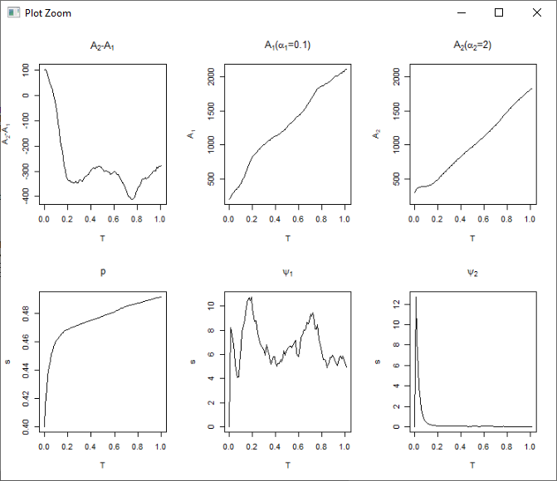

# Role of Taxes in Low Rising

## Taxes Low Rising - Rich risk seeker

evolve_relative_wealth_discrete_contnatural(nsim = 3000, delta = 0.05 ,alpha1 =2, alpha2 = .1,risksz = 10,

T = 1,dt = .01,A1_init=frow$x, A2_init=frow$y,decay = .01,

start_p = .1, gamma=.7, lambda = 10, A_costs = 0, plot_range = F, sigma_func=rise_func)

"delta= 0.05 alpha1= 2 alpha2= 0.1 gamma= 0.7 lambda= 10 risksz= 10 T= 1 dt= 0.01 A1_init= 10 A2_init= 490 decay= 0.01 start_p= 0.1 A_costs= 0"

[1] "( 10 , 490 ) A1: 1473.80321844026 A2: 1483.82717973873"

[1] "delta= 0.05 alpha1= 2 alpha2= 0.1 gamma= 0.7 lambda= 10 risksz= 10 T= 1 dt= 0.01 A1_init= 50 A2_init= 450 decay= 0.01 start_p= 0.1 A_costs= 0"

[1] "( 50 , 450 ) A1: 1252.53812378198 A2: 1263.13852356476"

[1] "delta= 0.05 alpha1= 2 alpha2= 0.1 gamma= 0.7 lambda= 10 risksz= 10 T= 1 dt= 0.01 A1_init= 100 A2_init= 400 decay= 0.01 start_p= 0.1 A_costs= 0"

[1] "( 100 , 400 ) A1: 1138.83302855396 A2: 1153.91416017184"

[1] "delta= 0.05 alpha1= 2 alpha2= 0.1 gamma= 0.7 lambda= 10 risksz= 10 T= 1 dt= 0.01 A1_init= 150 A2_init= 350 decay= 0.01 start_p= 0.1 A_costs= 0"

[1] "( 150 , 350 ) A1: 917.502059579659 A2: 928.314775479169"

[1] "delta= 0.05 alpha1= 2 alpha2= 0.1 gamma= 0.7 lambda= 10 risksz= 10 T= 1 dt= 0.01 A1_init= 200 A2_init= 300 decay= 0.01 start_p= 0.1 A_costs= 0"

[1] "( 200 , 300 ) A1: 678.50612972076 A2: 682.147219302921"

## 

Still low, rising slightly more to .15 from .1 (shape same).

x <- evolve_relative_wealth_discrete_contnatural(nsim = 3000, delta = 0.05 ,alpha1 =2, alpha2 = .1,risksz = 10,

T = 1,dt = .01,A1_init=frow$x, A2_init=frow$y,decay = .01,

start_p = .1, gamma=.7, lambda = 10, A_costs = 0, plot_range = F, sigma_func=rise_func)

"delta= 0.05 alpha1= 2 alpha2= 0.1 gamma= 0.7 lambda= 10 risksz= 10 T= 1 dt= 0.01 A1_init= 10 A2_init= 490 decay= 0.01 start_p= 0.1 A_costs= 0"

[1] "( 10 , 490 ) A1: 2079.07532463424 A2: 2096.15318083561"

[1] "( 50 , 450 ) A1: 2001.25874308098 A2: 2018.87960491417"

[1] "( 100 , 400 ) A1: 1706.14601825694 A2: 1718.52303789691"

[1] "( 150 , 350 ) A1: 1514.77361520531 A2: 1528.73460625395"

[1] "( 200 , 300 ) A1: 1014.82685511559 A2: 1024.30831644254"

And to .2 from .1

[1] "delta= 0.05 alpha1= 2 alpha2= 0.1 gamma= 0.7 lambda= 10 risksz= 10 T= 1 dt= 0.01 A1_init= 10 A2_init= 490 decay= 0.01 start_p= 0.1 A_costs= 0"

[1] "( 10 , 490 ) A1: 2762.31093420677 A2: 2788.52942017295"

[1] "( 50 , 450 ) A1: 2746.84218596283 A2: 2762.701941873"

[1] "( 100 , 400 ) A1: 2484.11602352841 A2: 2503.02925224756"

[1] "( 150 , 350 ) A1: 2275.52847885861 A2: 2295.2285655008"

[1] "( 200 , 300 ) A1: 1628.41901018927 A2: 1643.60687635761"

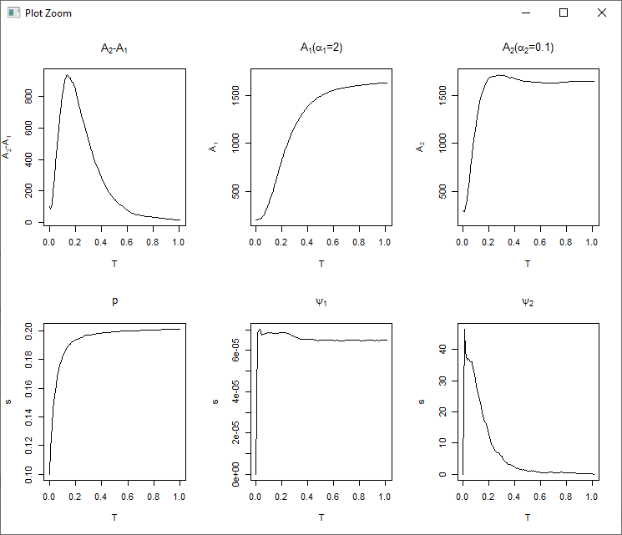

## Taxes Low Rising - Poor risk seeker

# Role of Taxes in High Decline

## Taxes High Decline - Rich risk seeker

## Taxes High Decline - Poor risk seeker

# Role of Taxes in Low Decline

## Taxes Low Decline - Rich risk seeker

## Taxes Low Decline - Poor risk seeker

# Role of AssetCosts in High Rising

## AssetCosts High Rising - Rich risk seeker

## AssetCosts High Rising - Poor risk seeker

# Role of AssetCosts in Low Rising

## AssetCosts Low Rising - Rich risk seeker

## AssetCosts Low Rising - Poor risk seeker

# Role of AssetCosts in High Decline

## AssetCosts High Decline - Rich risk seeker

## AssetCosts High Decline - Poor risk seeker

# Role of AssetCosts in Low Decline

## AssetCosts Low Decline - Rich risk seeker

## AssetCosts Low Decline - Poor risk seeker

Also check that happens with the rates start at high p (almost certain events – this hardly ever happens in the real world).

In terms of status consumption, the influence is that risk would not be taken.

**[DIGGING==STATUS CONSUMPTION?]** We classify consumption as those that are a consequence of one’s acquisitions and others that amount to risk one takes towards future wealth –e.g. education, personal investments etc. that all have a necessary uncertainty associated with them. The latter are not a direct constraint imposed by the assets one acquires but are expected to provide an unlikely (risky) payoff through social or positional improvement.

If non-durable consumption can be viewed as either a wealth-adjusted need or an investment for one’s perceived future, status consumption would fall into the latter kind of investment. Status competitions are expected to thrive when consumers take over the manners of those richer than themselves (i.e. those with seemingly achievable differences in wealth levels) and acquire assets that are as good as theirs. To each participating consumer, status consumption provides a promise of better social positioning as well as an improvement in one’s self-image - realised through the relative quality in consumption when not through real wealth. Outside this perceived subjective future of one’s wealth, status consumption in fact has no significance. Thus while not all risk-taking by the consumer may amount to status consumption (some risk-taking is inherent in the assets one acquires), all status consumption is certainly a risky prospect i.e. the consumption of the latter kind. This is because relative quality in non-durable consumption only provides a probabilistic monetary gain – with a subjective (personal) probability attached to the consumer’s decision.

The risk-taking that is driven by the wealth one acquires can be associated with the wealth that the consumer accounts so that all risk in excess of consumer’s real wealth can be viewed as the consumer’s risk towards the future wealth. In other words, there is no visible consumption needs that is not encompassed by this view of positional consumption as a risky investment.

A stochastic wealth game (DESCRIBE) therefore summarises the notion of status consumption. The consumption associated with assets accumulated over the lifetime is separated from consumption that is not associated with asset account (one can incorporate empirical realities such as a sharp rise in maintenance or upkeep for expensive assets in certain economies but defining a cost-function associated with the wealth). All consumption that isn’t realised into material asset gains over a long period of time – is of a subjective value to the consumer. The uncertainty in wealth is modelled with a “natural” stochastic process that rewards the consumers consumption with a certain probability. While this natural process does not distinguish between the consumers, the consumer decisions are shaped by their attitudes to risk. The model therefore attempts to understand how wealth differences could develop when consumers differ in risk-attitudes while observing a common stochastic process of wealth changes. The consumer’s subjectivity to this “natural” process of income / wealth is implied by the weights she assigns to be various probabilities of wealth transition.

To incorporate various conditions of the economy e.g. a market where risk-takers are rewarded vs one where risk-takers get penalised – we consider a natural processes of wealth with declining and rising chances of wealth rise in the model. In the declining risk environment – the opportunities to increase wealth by taking risks dry up over time (and effort) whereas in the rising risk environment, opportunities open up and expand. The former could represent a declining economy and latter a rapidly growing or expanding economy. We’re interested in how existing attitude to risk – which are as stable as wealth differences due to occupational and social structures - play a role in final wealth value as consumers act having a certain time-horizon in mind.

**[MYOPIA]** Time-horizonsfor consumer decision are a key feature of the model. The consumers are assumed to be myopic in making decisions towards a risky allocation as they have no way of predicting the decline or rise in p and act upon the current value of p. More particularly, the consumer decision at time t assumes that p stays the same in the near future (whereas the consumer’s wealth might grow unexpectedly with the probability p). The dynamics of the model are so that p declines much slower than the consumers would scale their allocation to upside or downside risks. With respect to the returns they their efforts (allocation), the consumer do know the cost of owning assets i.e. how much their costs of living as well as taxation which rise if they own accumulate more assets (wealth).

**[REWARD FOR RISK]** The program assumes A_{t+1} = A_{t} + R*W*psi – i.e. the payoff scales up with “effort” or the allocation. The natural process therefore doesn’t favour the rich over the poor but just rewards participants based on the total amount of money spent. This is a basic set up - the behaviour of the consumer in response to a stochastic process interests us more than how well this process represents the real economy. We wish to quantitatively explain the effect of taxation and asset-cost structures on status consumption among consumers with different by risk-seeking levels.

**[RISK-ATTITUDES and STATUS CONSUMPTION]** We consider two types of consumers – based on the weighted function. The low-alpha consumer is one who overvalues low – probability and takes high probability as certain. The other user ignores low-probability events (as if they didn’t exist) and overvalues high-probability events – treating them almost certain. Evidently, the low-alpha individual is far more likely to engage in status consumption than the high-alpha individual as the latter may remain circumspect about taking chances in small probability social mobility bets – and consider tax-income certain.

**[Equations]**

**[MECHANICS]** The goal of the model is to highlight the concerns of relative growth in income/wealth in an environment where risk-attitudes are fixed due to occupational and social structures as is the starting wealth difference. By choosing to keep her asset account the same, a consumer gives up the hope of closing the wealth gap. The extent to which the wealth differences matter to the consumer – are implied with a mid-point reference to her utility. This means that if the consumer is (relatively) poor – she may desperately want to get move away from being poor and become more likely to overvalue small risks (than in a situation where she is relatively rich). Similarly, the richer consumer would be less reluctant to taking risks (than when she is relatively poorer). The stochastic dynamics however implies that the richer consumer may encourage the poorer consumer by raising her mid-point reference point (and making the poorer consumer more risk-taking than she otherwise would be).

**[Stability: TAXES and ASSET-COSTS]** The above dynamics would imply that asset differences would be much higher than their starting points if a risk-taking consumer gets richer and the opportunities to gain mobility (return from the wealth process) dry up – leaving no chance for the poorer consumer to participate in the wealth game. To reduce final wealth differences and to leave the game in a state ripe enough until a natural process reinvigorates with more wealth, a taxation rate provides an additional control to the wealth differences in the wealth game. We assume as taxation simply as a transfer from the richer consumer to the poor consumer - proportional to the wealth differences. Note that the tax rates and its effect on the future income are known to the consumer (i.e. the tax rate serve as an input in the utility function). We use this model to understand how taxation would influence status consumption in a rising and declining economy.

Note that the stability of the model is merely the point where the consumers have run out of risk-taking opportunities – as their disposable income would approach near zero as the wealth opportunities dry out – or reaches a level where expected rise in income equals 0 (or the costs of assets in a non-zero asset costs model). In other word, the equilibrium state of the model is arrived at when costs balance the future expectation of income (wealth changes). Since our natural process is independent of time (driven only by the effort put together by the participating consumers), we don’t impose any timing constraints in the equilibrium.

In a growing economy model, where growth is exponential in the beginning would stabilise at a given rate. Similarly, in a declining economy the rates would stability to a lower value. We comment on the equilibria that would be implied by these environments. It is possible – for example – that asset differences keep growing and rich consumer (regardless of the starting wealth) continues to benefit from a risky environment. In real world, we don’t see this because both taxation and asset-costs provide this stability. We thus consider the **role of the two** in the model as well.

**Stability conditions (contd.)**: When the probability is high the low-alpha – who used to be risk-seeking in low probabilities - becomes risk-averse as she is circumspect about high probability whereas the high alpha – who used to be risk-averse in low probabilities - becomes risk-seeking since she always takes high probability to be granted.

Consider is going to rise to about 30% - what would happen – when the risk-seeker (low-alpha) takes a lot of risk – she might lose.

**Classes not implemented**: The real world is full of lacunae where consumers linger by limiting their needs – the only way this is represented by our model is how consumers take extreme risks. We could probably consider two reference points – to places of equilibrium to represent stratification – i.e. multiple reference points – but since we don’t use the model to explain a class-like stratification, we use a single reference point that drives risk-attitude and asset differences to explain all observed social differences.

Assumption 1

*All social differences are represented by asset differences and risk-attitudes (alpha value).*

Assumption 2

*The characteristics of the consumer are stationary.*

This means that the consumer characteristics don’t change because of evolution.

Assumption 3

*The consumers don’t observe long-term changes in p.*

Assumption 4

*High-alpha consumer is less likely to engage in status consumption.*

Property 1

*Consumption of status goods should declines if the consumer moves towards poverty*

[**LOSS AVERSION**] That the consumption of status goods should declines if the consumer moves towards poverty is evident from the model. This is because the tendencies of loss aversion becomes more relevant towards poverty (with respect to a certain point of reference).