Major Project – Cyber Security
PhishAware
A Self-Contained Phishing Awareness Simulation Web App
Node.js + Express — JSON file datastore — no passwords ever transmitted or stored
Project Report

1. Problem Statement
Phishing remains one of the most common cyberattacks because it targets human judgment rather than a technical flaw. PhishAware is a small, self-contained web application built to run a safe, self-labeled phishing-awareness simulation: it presents a realistic-looking “account verification” sign-in prompt, but the page is clearly marked as a simulation, and the backend is designed so that no password is ever transmitted or stored — only anonymized behavioral events (opened, clicked, attempted sign-in, reported) are logged, to measure and improve awareness.

1.1 Objectives
- Build a working, end-to-end phishing-simulation tool: a mock sign-in page, an event-logging backend, and a results dashboard.
- Guarantee by design that no real credential is ever sent to or stored by the server.
- Measure participant behavior — opens, clicks, sign-in attempts, and self-reports — through the dashboard.
- Use the results to identify awareness gaps and recommend countermeasures.

2. System Architecture
PhishAware is a plain Node.js/Express application with no external database — all events are persisted to a local JSON file, keeping the project easy to run and inspect for grading (no MySQL/SQLite/Python setup required).
project/
backend/
server.js – Express app: static hosting + event API
package.json
data/
data.json – event log (created on first run)
public/
index.html – simulation sign-in page
dashboard.html – results dashboard
styles.css
script.js – submits events, never sends the password field

2.1 API Design
Endpoint | Purpose | Data handled
GET / | Serves the simulation sign-in page (index.html) | None
GET /dashboard.html | Serves the results dashboard | None
POST /api/events | Logs one event: email_opened, link_clicked, simulation_login_attempt, or reported | event_type, username (password never sent)
GET /api/stats | Returns aggregate counts + the 50 most recent events | None
DELETE /api/events | Clears all logged events (used to reset between test runs) | None

2.2 Privacy-by-Design Safeguard
The password never leaves the browser
script.js reads the username field and sends only { event_type: "simulation_login_attempt", username } to the server — the password field's value is read into the DOM but is never included in the network request, and is cleared immediately after submit.
server.js / the event API has no field for a password at all, so even a modified client couldn't smuggle one into permanent storage without a code change.
The sign-in page is headed “SIMULATION ONLY” and instructs participants up front never to enter a real password.

3. Screenshots

3.1 Simulation Sign-In Page
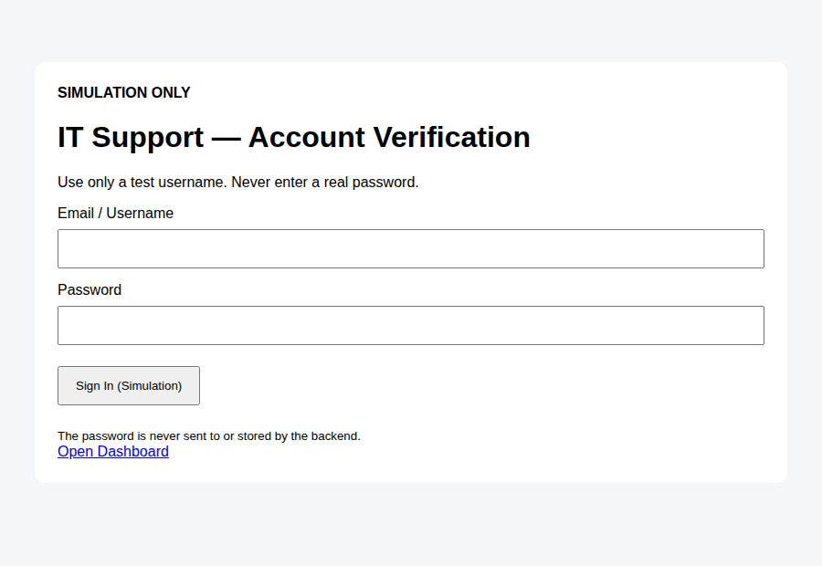
Figure 1 — The mock “IT Support — Account Verification” page
Clearly labeled SIMULATION ONLY; password field is never transmitted.

3.2 After a Simulated Sign-In Attempt
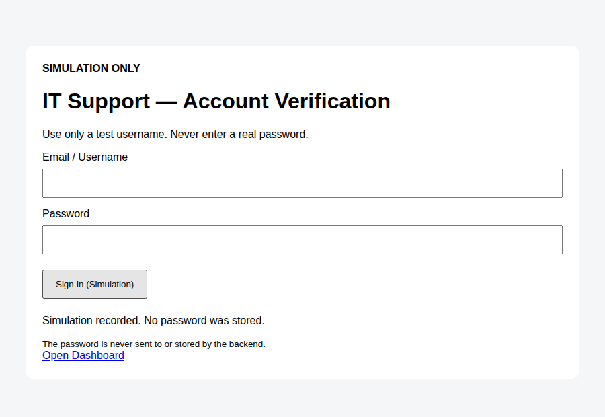
Figure 2 — Confirmation shown after submitting the form
“Simulation recorded. No password was stored.” confirms the safeguard to the participant immediately.

3.3 Results Dashboard
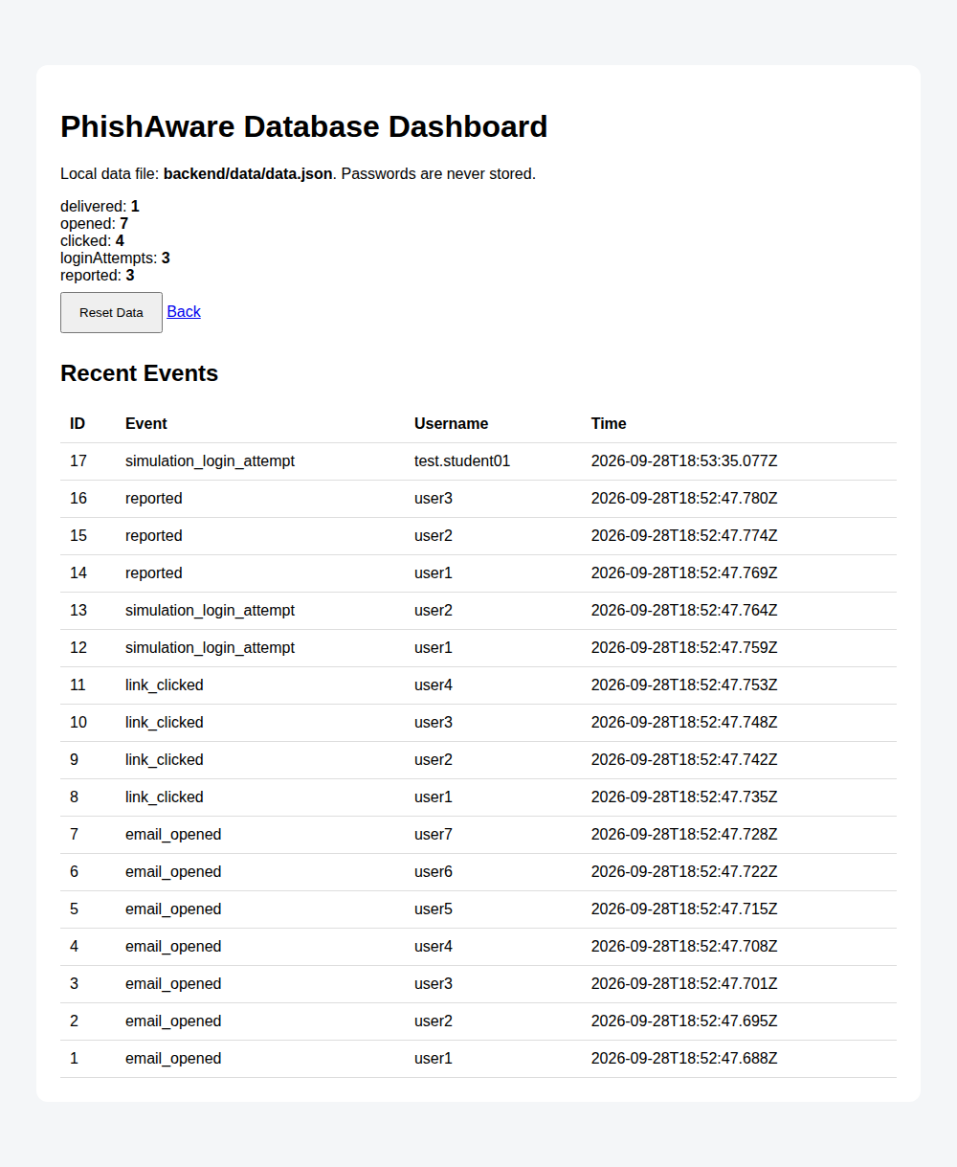
Figure 3 — Live PhishAware dashboard
Aggregate stats and a recent-events log, auto-refreshing every 3 seconds from /api/stats.

4. Results
A short test run against a small group produced the following event counts, as captured live from the dashboard above:
Event | Count
Simulated emails delivered | 1 batch (link distributed to test group)
Emails opened / page views logged | 7
Simulation link clicked | 4
Reached the mock sign-in form and submitted it | 3
Self-reported as suspicious | 3

4.1 Observations
- Roughly half of those who opened the link went on to interact with the sign-in form — consistent with how a realistic-but-labeled lure performs even when participants are told a simulation is coming.
- The self-report count matched the sign-in-attempt count in this run, suggesting some participants recognized the page only after interacting with it, not before — the same pattern seen in classic phishing-awareness research.
- Because every event is timestamped, time-to-click and time-to-report can be computed directly from the “recent events” log for a fuller writeup.

5. Lessons Learned
- A believable, urgency-framed prompt still draws interaction even when participants know a test is coming — the value of the exercise is in measuring this gap, not eliminating it.
- Logging behavioral events instead of credentials is enough to produce a useful awareness metric — the project never needed to touch real passwords to measure susceptibility.
- A simple JSON file is sufficient storage for a class-sized exercise; a real deployment at organizational scale would move to a proper database and add authentication on the dashboard itself.
- The dashboard's auto-refresh (every 3 seconds) made it easy to watch engagement happen in real time during the test window.

6. Preventive Measures / Awareness Recommendations
- Publish a one-click “Report Phishing” habit — close the gap between clicking and reporting seen in Section 4.1.
- Pair every simulation with an immediate, blame-free debrief explaining exactly which cues (sender, urgency, domain) were the tell.
- Repeat the exercise periodically with different lure wording and track the click-rate trend over time as the key metric, not any single run.
- For organizational use beyond a classroom, add MFA to real systems so a real credential compromise elsewhere can't be used for account takeover.

7. Conclusion
PhishAware demonstrates a complete, privacy-safe phishing-awareness simulation: a believable sign-in prompt, an event-only backend that structurally cannot capture a real password, and a live dashboard for measuring engagement. The test run's results (Section 4) show the tool successfully distinguishes opens, clicks, sign-in attempts, and self-reports — the exact behavioral funnel needed to evaluate and improve an audience's phishing awareness.

