CbyCo graph (neglecting –Kd\*x term)



Power vs temperature(we vary the temperature term in Ethermo

Power =((Eoutput)^2)/100

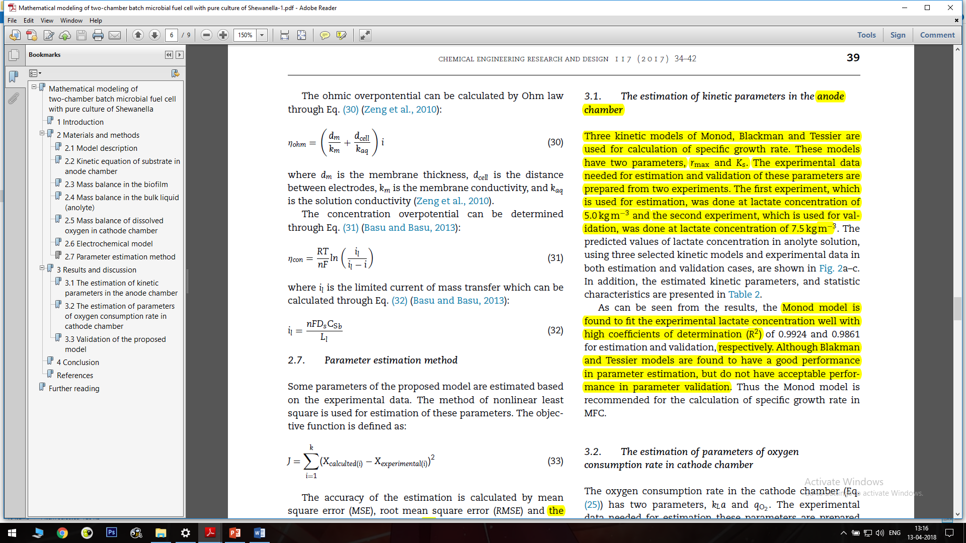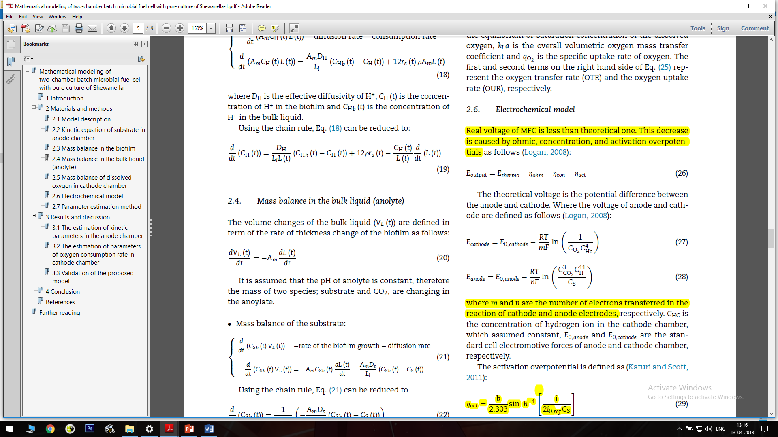

Overpotential vs log(current density)

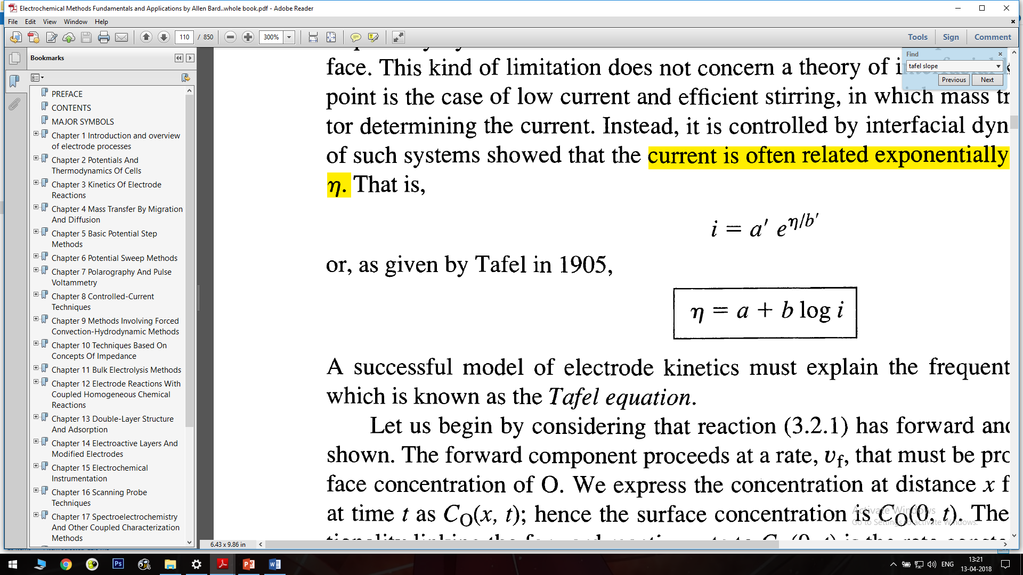 Tafel’s equation

This helped us compute a new value of exchange cureent which was used to calculate overpotential vs concentration of lactate using existing equation

Overpotential vs concentration of lactate

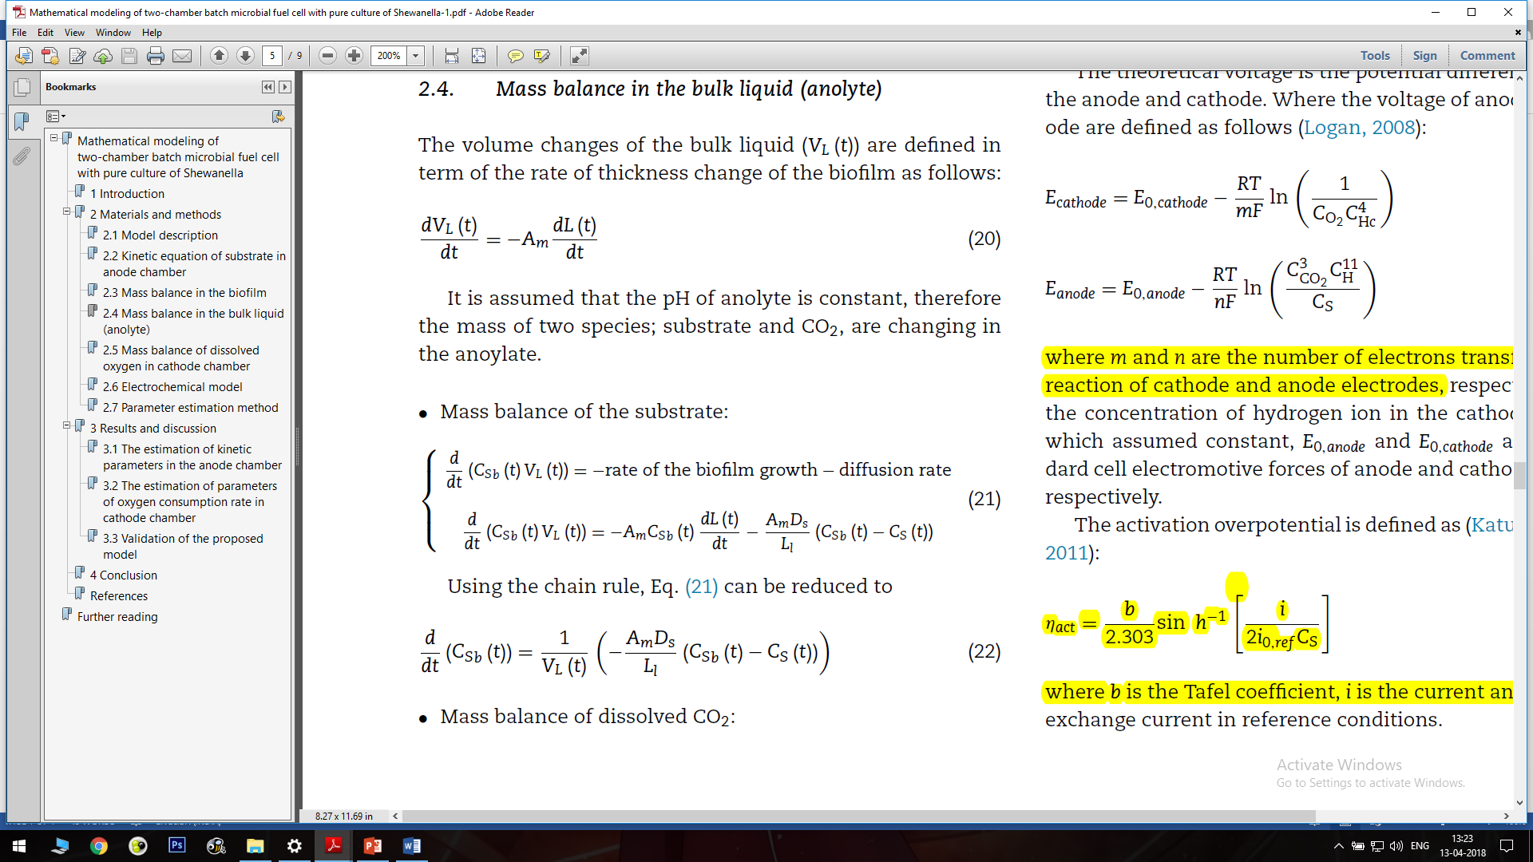

Eoutput vs Concentration of lactate

