SYNOPSIS ON

**Smart Attendance Management System**

**Index**

|  |  |  |
| --- | --- | --- |
| SR.NO | CONTENT | PAGE NO. |
| 1 | INTRODUCTION | 3 |
| 2 | PROBLEM STATEMENT | 4 |
| 3 | LITERATURE REVIEW | 5-7 |
| 4 | OBJECTIVES | 8 |
| 5 | METHODOLOGY | 9 |
| 6 | RESULT | 9 – 12 |
| 7 | FLOW CHART | 12 |
| 8 | SYSTEM REQUIREMENT | 13 |
| 9 | TIMELINE AND PERT CHART | 14-15 |
| 10 | SWOT ANALYSIS | 16 |
| 11 | REFERENCES | 17 |

# 1:Introduction

Traditional attendance marking systems, either through manual roll calls or RFID cards, are time-consuming and susceptible to proxy attendance, where students can falsely register attendance on behalf of others. To address these challenges, a smart attendance system using modern technologies like geolocation and real-time pattern verification is proposed.

This system provides a secure and efficient method for teachers to mark attendance in real-time, ensuring that students are physically present in the classroom. The teacher displays a unique pattern or code on the projector, and students are required to draw the same pattern on their devices to mark their attendance. This, combined with geolocation verification, ensures both security and ease of use.

3

# 2: Problem Statement

1. Attendance management systems are usually time-consuming and prone to human errors.
2. A significant problem is where students can mark attendance for their absent peers.
3. Teachers and administrators face challenges in maintaining and managing attendance records efficiently.
4. Many institutions do not leverage existing technology to streamline the attendance process, which could lead to inefficiencies.

The Smart Attendance Management System addresses these challenges by integrating geolocation technology and pattern-based verification, ensuring that students are physically present in the classroom while making the attendance process seamless.

4

# 3: Literature Review

Attendance management has been a significant concern in academic and professional environments, primarily due to issues like proxy attendance and inefficient manual tracking. The rapid advancements in technology, such as geolocation APIs, RFID, and biometric systems, offer various solutions to these challenges. A review of the literature from relevant sources provides a comprehensive understanding of these technologies and their application in attendance management systems.

1. Geolocation API and Its Integration in Web Applications

According to the W3C Geolocation API Specification, geolocation services offer significant potential in tracking and managing student or employee attendance in real-time. By leveraging geolocation APIs, web applications can obtain the geographical coordinates of a user’s device, allowing attendance systems to verify physical presence within designated zones, such as classrooms or workplaces. This solution, however, requires the proper handling of user privacy and security concerns, as location data is sensitive [1].

Doe (2022) expanded on this by discussing how custom pattern matching algorithms can be implemented to improve the performance and accuracy of web applications that rely on location-based services. The paper highlighted the need for optimization when processing geolocation data, which often includes noise and inaccuracies. The challenge of managing large datasets in real-time is addressed by custom algorithms that filter and refine location-based information, offering enhanced accuracy for attendance verification systems [2].

5

1. Technological Solutions for Proxy Attendance

Smith and Patel (2021) explored the growing concern of proxy attendance in educational institutions. Their research highlights how traditional attendance methods, such as manual roll calls or card swipes, can be easily manipulated. To counteract this, they propose the use of geolocation-based solutions in combination with RFID and biometric systems. Geolocation APIs enable systems to verify the presence of a student or employee within a specified area (e.g., within the school campus), significantly reducing the potential for proxy attendance. The authors also discussed challenges in implementation, such as GPS inaccuracies in indoor environments and the reliance on mobile devices [3].

1. Biometrics and Geofencing for Attendance Tracking

Clarke (2019) reviewed biometric systems use (fingerprints, facial recognition, etc.) with geofencing technologies. Biometrics provide a higher level of security and accuracy, ensuring that attendance is recorded only when the authorized individual is present. Geofencing, meanwhile, creates virtual boundaries around specific locations, such as classrooms or office buildings. When a person enters or exits the geofence, their attendance is automatically registered. Clarke concluded that combining these two technologies presents an effective solution to both the accuracy and security issues in attendance management, although privacy concerns remain a significant challenge [4].

1. Security Concerns in Geolocation and API-based Solutions

Thompson (2020) focused on securing RESTful APIs, which are often used in geolocation and attendance systems to transfer location data between the client and the server. Ensuring the security of these APIs is crucial, as they handle sensitive data that could be misused if exposed. Thompson emphasized the importance of implementing encryption, authentication, and authorization mechanisms to safeguard the data flow within attendance management systems. These practices prevent unauthorized access and ensure that location data is only accessible by the intended recipients, mitigating risks of data breaches [5].

1. IoT and Geofencing for Attendance Management

Sharma (2023) reviewed the use of IoT devices and geofencing in attendance management systems. IoT-based solutions, such as smart devices equipped with RFID or NFC technology, allow for seamless integration into attendance systems. When combined with geofencing, IoT devices can automate the process of attendance logging as individuals move in and out of designated zones. Sharma noted that IoT-based systems offer significant scalability and flexibility for large organizations or institutions, where traditional methods would be cumbersome and prone to error [6].

7

# 4: Objectives

* Implement robust authorization and authentication mechanisms to ensure that only authorized personnel (teachers) can initiate the attendance marking process and that only enrolled students can mark their attendance.
* Integrate accurate geolocation verification to confirm that students are physically present within the designated classroom area during the attendance marking period.
* Develop and deploy an efficient pattern recognition system that requires students to draw or replicate a unique pattern displayed by the teacher

8

# Chapter 5: Methodology

The system is developed in two main components:

* **Frontend (Student and Teacher Interface)**:
  + The student interface will allow students to draw the pattern. o The teacher interface will include the ability to display the pattern or code.
* **Backend (Geolocation and Verification)**:
  + When a student attempts to mark attendance, the system captures their location using the Geolocation API to ensure they are within a defined radius of the classroom.
  + The system will verify the drawn pattern against the one displayed by the teacher. If both the geolocation and pattern are correct, the student’s attendance will be marked.

The process involves:

**1.Geolocation Check**: The system will validate the student’s location.

**2.Pattern Matching**: The student draws a pattern that must match the one displayed by the teacher.

**3.Database Management**: Once verified, the system marks the attendance and stores it in a database for later retrieval and reporting.

9

# RESULT

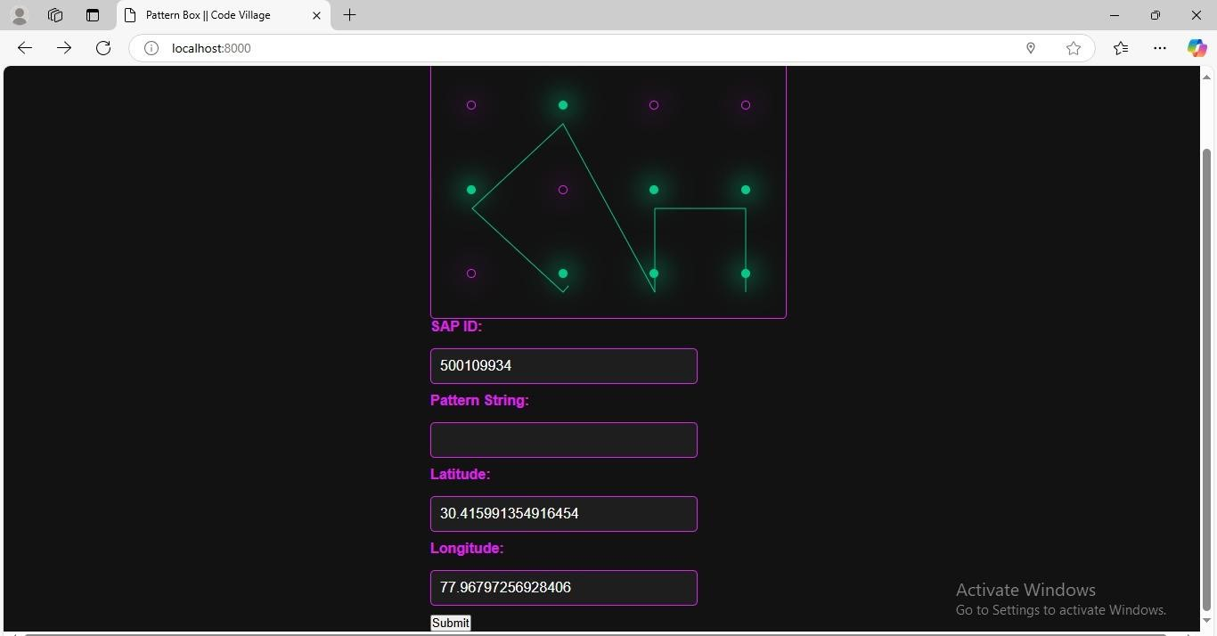

Fig 1:Student screen for attendance

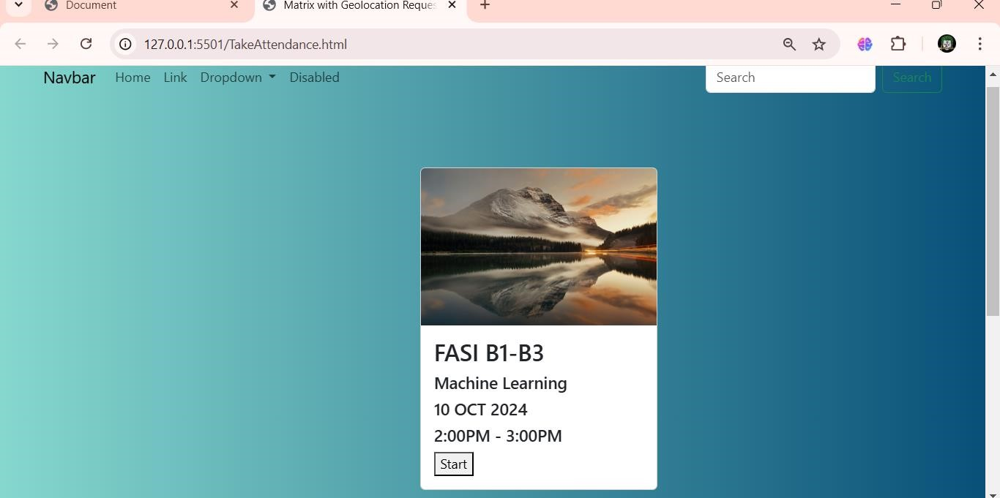

Fig 2: Teacher interface for starting attendance

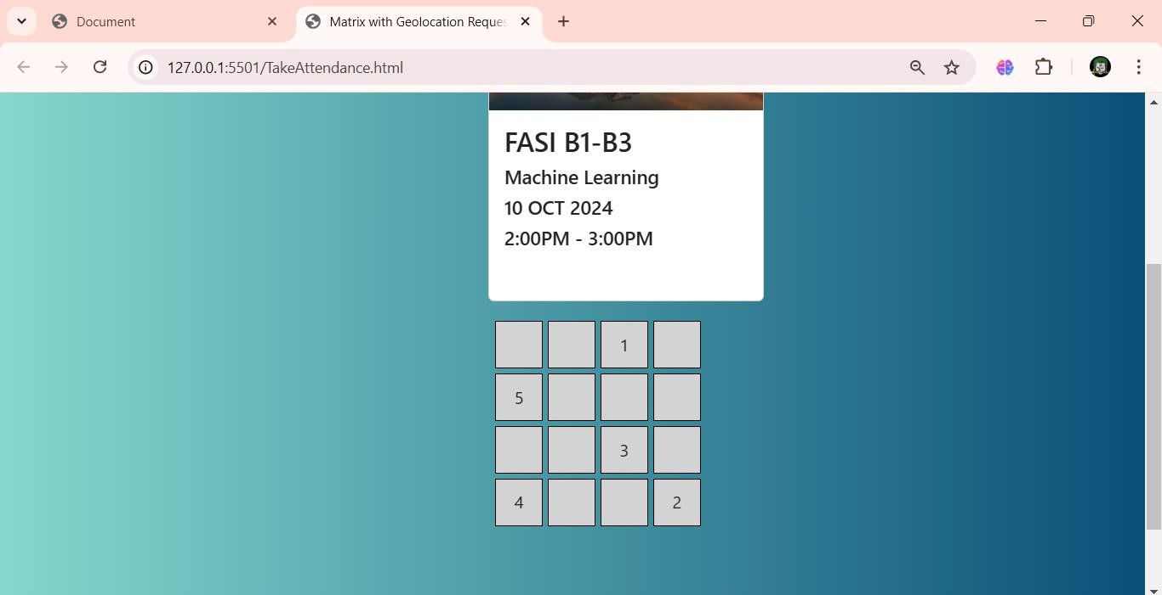

Fig 3: Teacher interface for Pattern Displaying

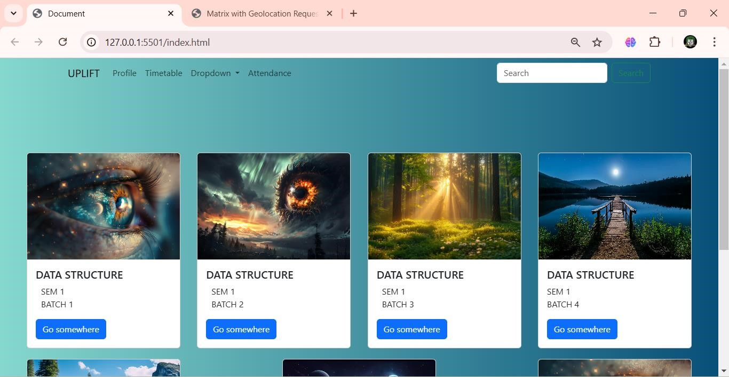Fig 4. Teacher Portal



Fig 5: Authorization and Authentication

**7. FLOW CHART**

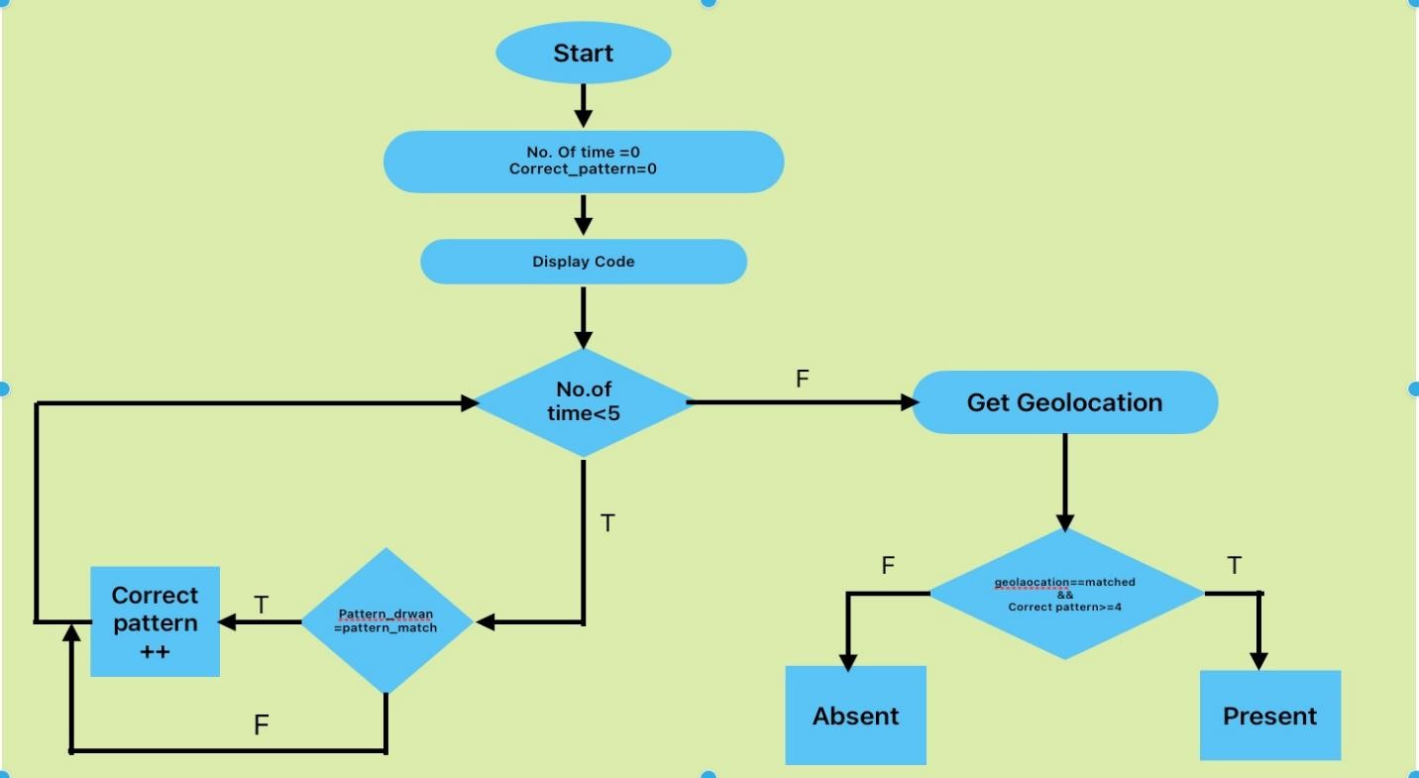

Fig 4:Workflow of the program

12

## Chapter 8: System Requirements

***Hardware Requirements:***

* **Server**:
  + Minimum: 4-core CPU, 8 GB RAM, 100 GB SSD.
  + Recommended: 8-core CPU, 16 GB RAM, 250 GB SSD.
* **Teacher and Student Devices**:
  + Any device capable of running modern browsers (Laptops, Desktops, Tablets, Smartphones). o Internet connectivity

***Software Requirements:***

* **Frontend Technologies**:
  + HTML5, CSS3, JavaScript (for user interfaces).
  + Bootstrap (for responsive design).
* **Backend Technologies**:
  + Node.js for server-side processing. o MySQL or MongoDB for attendance data storage.
  + RESTful APIs for communication between the frontend and backend.
* **APIs**:
  + Geolocation API for verifying the physical presence of students.
  + Pattern matching library or custom JavaScript logic to verify drawn patterns.

13

## Chapter 9: Timeline and Pert Chart

|  |  |  |
| --- | --- | --- |
| **TASK NO** | **TASK DESCRIPTION** | **DURATION** |
| 1 | REQUIREMENT GATHERING | 5 DAYS |
| 2 | SYSTEM DESIGN | 7 DAYS |
| 3 | FRONTEND DEVELOPMENT(UI/UX) | 14 DAYS |
| 4 | BACKEND DEVELOPMENT(API AND DATABASE) | 15 DAYS |
| 5 | INTEGRATE GEOLOCATION FUNCTIONALITY | 5 DAYS |
| 6 | IMPLEMENT PATTERN DRAWING AND MATCHING | 7 DAYS |
| 7 | SECUIRTY AND TESTING | 10 DAYS |
| 8 | FINAL INTEGRATION AND DEBUGGING | 5 DAYS |
| 9 | DEPLOYMENT | 3 DAYS |

14

Fig

5:

per chart

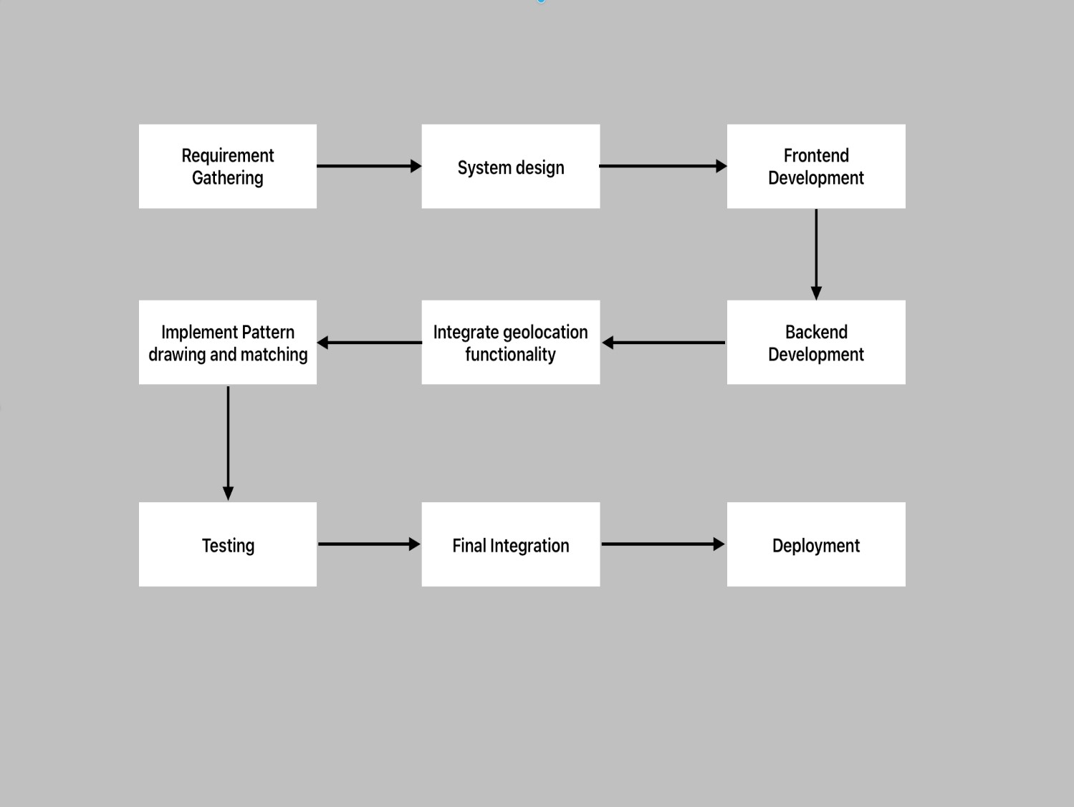

15

## 10:SWOT ANALYSIS

Strengths:

* The use of unique patterns and geolocation technology significantly reduces the chances of proxy attendance and improves the accuracy of attendance records.
* The system’s design for both teachers and students is intuitive, ensuring ease of use and quick adoption.
* Reduce the overall time process.

Weakness

* Dependence on technology could lead to potential issues such as system malfunctions, connectivity problems, or software bugs, which could disrupt attendance tracking.
* Both teachers and students may face an initial learning curve in adapting to the new system, which could impact the efficiency of its adoption.

Opportunities:

* + Remote Learning Integration: With the growing popularity of remote learning, this system can be adapted to validate student participation from home or other locations.
  + Corporate Use: This system can be adapted for corporate environments, replacing traditional clock-in systems with secure attendance methods.

Threats:

16

* + Privacy Concerns: Tracking student location could raise privacy issues, especially if the data is not handled securely. Transparency and data encryption must be maintained to mitigate concerns.
  + Data Breaches: If location data is mishandled or systems are hacked, sensitive student information could be compromised.

## 11: References

* [1] [W3C Geolocation API Specification](https://www.w3.org/TR/geolocation-API/)
* [2] Doe, J. (2022). *Implementing Custom Pattern Matching Algorithms in Web Applications*. Journal of Web Development, 10(4), 221-234.
* [3] Smith, A., & Patel, R. (2021). *Challenges of Proxy Attendance and Technological Solutions in Academia*. International Journal of Educational Technology, 7(2), 145-157.
* [4] Clarke, M. (2019). *Biometrics and Geofencing for Attendance Tracking: A Review*. Computing Research, 14(3), 89-101.
* [5] Thompson, B. (2020). *Securing RESTful APIs: A Comprehensive Guide*. API Security Press.
* [6] Sharma, P. (2023). *Geofencing and IoT-Based Attendance Management Systems: A Review*. International Journal of Computer Applications, 81(5), 210-220.

17