E-Commerce Website

By

Anurag Tiwari

Espire Infolabs Pvt. Ltd.

A REPORT Submitted in partial fullfillment of the requirements for the degree

Bachelor of Technology

Department of Information Technology

2021

Approved By:

Mantha Sir

Abstraction

The business-to-consumer aspect of product commerce (e-commerce) is the most visible business use of the World Wide Web. The primary goal of an e-commerce site is to sell goods online.  
This project deals with developing an e-commerce website for Online Product Sale. It provides the user with a catalog of different product available for purchase in the store. In order to facilitate online purchase a shopping cart is provided to the user.

The user can then view the complete specification of each product. They can also view the product reviews and also write their own reviews. The application also provides a drag and drop feature so that a user can add a product to the shopping cart by dragging the item in to the shopping cart. The main emphasis lies in providing a userfriendly search engine for effectively showing the desired results and its drag and drop behaviour.

Table of Contents

Abstraction 2

Acknowledgements 5

1. Introduction 6

1.1 Overview 6

1.2 Background Study 7

1.3 Project Planning 7

1.4 Purpose of Project 8

1.5 Scope 8

2. System Design 9

2.1 Design 9

2.2 User Characteristics 9

2.3 Use Case Diagram 10

2.4 Deployement Diagram 11

2.5 Package Diagram 12

2.6 Object Diagram 13

2.7 Class Diagram 14

System Information 15

1. Hardware

2. Software

3. System Analysis

3.1 System Feasibility

3.1.1 Economic Feasibility

3.1.2 Technical Feasibility

3.1.3 Behavioural Feasibility

4. Design Goal

4.1 Architectural Design

4.1.1 Architectural Context

4.2 Description of architectural diagram

4.3 Procedural/Modular Approach

4.3.1 Shop Products Module

4.3.2 Product Description Module

4.3**.**3 ShoppingCart Module

5. Software Testing

5.1 Testing Strategy

5.1.1 White box testing

5.1.2 Black box testing

5.1.3 Unit testing

5.1.4 Validation testing

6. Result and Challenges

7. Conclusion and Future Enhancement

7.1 Limitations

7.2 Future Aspects

8. References

Acknowledgement

I would like to thank my major trainer Mantha Sir for his constant guidance and help throughout the project. I would also like to thank Mantha Sir for graciously accepting to be on my committee.

Finally, I would like to thank my family and my friends for all the support and encouragement.

**1.Introdcution**

* 1. **Overview**

The ‘Online E-commerce Web application’ Services department strives to provide solutions to develop and transfer easy and efficient way in the digital age and to help reduces the human pressure and time. To help support shop collections, the digital initiatives, and external partner institution digital projects, It provide services that include the digitization of analog objects, metadata management, digital preservation, and discovery and access of digital collections. “Shop Management System” is a web application written for all operating systems, designed to help users maintain and organize shop virtually. This software is easy to use for both beginners and advanced users. It features a familiar and well thoughtout, an attractive user interface, combined with strong searching Insertion and reporting capabilities. The report generation facility of shop system helps to get a good idea of which are the various items brought by the members, makes users possible to get the product easily. The ‘Online E-commerce Web application’ Services department strives to provide solutions to develop and transfer easy and efficient way in the digital age and to help reduces the human pressure and time. To help support shop collections, the digital initiatives, and external partner institution digital projects, It provides services that include the digitization of analog objects, metadata management, digital preservation, and discovery and access of digital collections. “Shop Management System” is a web application written for all operating systems, designed to help users maintain and organize shop virtually. This software is easy to use for both beginners and advanced users. It features a familiar and well thoughtout, an attractive user interface, combined with strong searching Insertion and reporting capabilities. The report generation facility of shop system helps to get a good idea of which are the various items brought by the members, makes users possible to get the product easily.

* 1. **Background Study**

E-commerce is fast gaining ground as an accepted and used business paradigm. More and more business houses are implementing web sites providing functionality for performing commercial transactions over the web. It is reasonable to say that the process of shopping on the web is becoming commonplace. The objective of this project is to develop a general-purpose e-commerce store where any product (such as books, CDs, computers, mobile phones, electronic items, and home appliances) can be bought from the comfort of home through the Internet. However, for implementation purposes, this paper will deal with an online ecommerce store. An online store is a virtual store on the Internet where customers can browse the catalog and select products of interest. The selected items may be collected in a shopping cart. At checkout time, the items in the shopping cart will be presented as an order. At that time, more information will be needed to complete the transaction.  
  
Usually, the customer will be asked to fill or select a billing address, a shipping address, a shipping option, and payment information such as a credit card number. An email notification is sent to the customer as soon as the order is placed.

* 1. **Project Planning**

Project planning is part of project management, which relates to the use of schedules such as Gantt charts to plan and subsequently report progress within the project environment. Initially, the project scope is defined and the appropriate methods for completing the project are determined. Following this step, the durations for the various tasks necessary to complete the work are listed and grouped into a work breakdown structure. The logical dependencies between tasks are defined using an activity network diagram that enables identification of the critical path. Float or slack time in the schedule can be calculated using project management software. Then the necessary resources can be estimated and costs for each activity can be allocated to each resource, giving the total project cost. At this stage, the project plan may be optimized to achieve the appropriate balance between resource usage and project duration to comply with the project objectives. Once established and agreed, the plan becomes what is known as the baseline. Progress will be measured against the baseline throughout the life of the project.

* 1. **Purpose Of Project**

The project is about to handle all the information of the shop regarding members. Also it manages resources which were managed and handled by manpower previously. The main purpose of the project is to integrate distinct sections of the shop into consistent manner so that complex functions can be handled smoothly.  
  
Automation of product manipulation. Buying products. To manage information of different types of items. Consistently update information of all the item. Managing security by providing authorized email & password. Manages database efficiently.

* 1. **Scope**

• The current system can be extended to allow the users to create accounts and save products in to wish list.

• The users could subscribe for price alerts which would enable them to receive messages when price for products fall below a particular level.

• The current system is confined only to the shopping cart process. It can be extended to have a easy to use check out process.

• Users can have multiple shipping and billing information saved. During checkout they can use the drag and drop feature to select shipping and billing information.

**System Design**

* 1. **Design**

Design The system is divided into some parts these are Register system, Login System, Search System, Buying System, Order Received System, Viewing System side with database represent the server using PHP , MYSQL and APACHE with XAMPP server.

* 1. **User Characteristics**

**Admin** The administrator has all the rights to access the system. He is the one who has all rights to view the members and product details, modify those details. He can add various product based on the category. He can also set the available quantity of a product and its reasonable price. Also he can also set discount in various occasion. Admin can also view the details of a member. The admin have the power to generate the scratch card so that users can also use the recharge card to buy various product.

**Users** The user can log in to the system by using his specific email and password. User can view the products and order the products according to their own needs. He can view his profile and update his details. He can update his personal information by logging into the system. User can find various product by using search option easily. update his details. He can update his personal information by logging into the system. User can find various product by using search option easily.

* 1. **Use case Diagram**

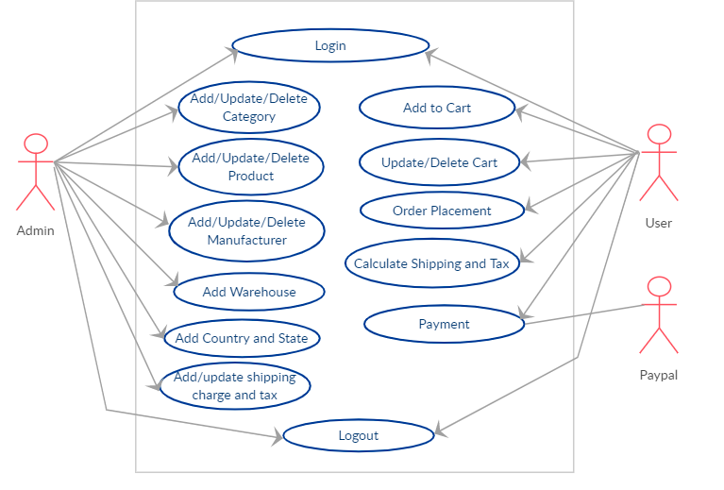

**Use case Diagram**

* 1. **Deployement Diagram**

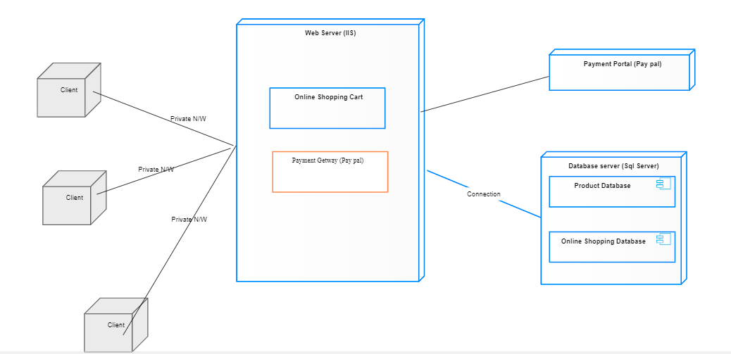

**Deployement Diagram**

* 1. **Package Diagram**

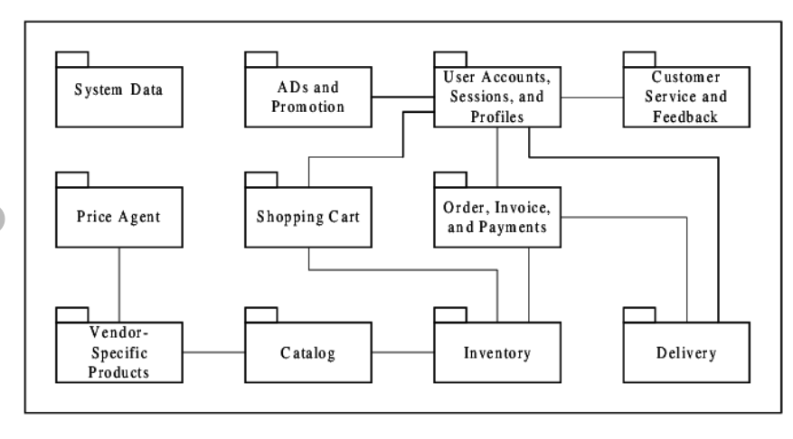

**Package Diagram**

* 1. **Object Diagram**

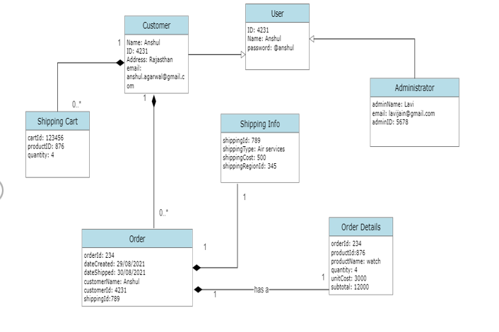

**Object Diagram**

* 1. **Class Diagram**

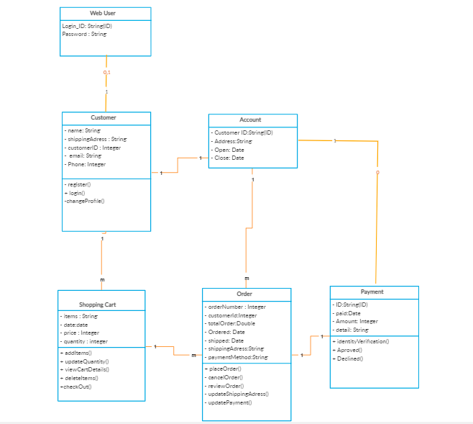

Class Diagram

**System Information**

**Hardware Specification**

Processor P IV

RAM 250 MB

Minimum Space Required 100 MB

Display 16 bit color

**Software Specification**

Operating Environment

Win 2000/XP Platform

.Net Framework & IIS Visual Studio 2008

Database SQL Server 2005

**System Analysis**

System Analysis refers into the process of examining a situation with the intent of improving it through better procedures and methods. System Analysis is the process of planning a new system to either replace or complement an existing system. But before any planning is done the old system must be thoroughly understood and the requirements determined. System analysis is therefore, the process of gathering and interpreting facts, diagnosing problems and using the information to recomment improvements in the system.

Evaluate the system concept for feasibility. Perform economic and technical analysis. Allocate functions to hardware, software people, database and other system elements. Establish cost and schedule constraints. Create a system definition that forms the foundation for all the subsequent engineering work.

To increase the ease of use the user should be able to add a product to the shopping cart by dragging a product and dropping it in the shopping cart. A user should able to edit the contents of a shopping cart. They should be able to update the quantities of the products added to the cart and remove the products from the cart. The user should be able to remove the product from the shopping cart by dragging the product and dropping it outside the cart. The application can be made interactive by pop up messages when a product has been dropped in to the shopping cart or out of the shopping cart. The user can be notified 4 if the cursor enters a drop area and the object that could be dropped. Also users are impatient making it important to load pages soon. Other than this, I did a lot of research on various other methods of building this application which and was able to incorporate a few stronger features into the application. The tools and controls used in the application are recommended ASP.NET controls and AJAX Toolkit controls which improves the navigation and usability and interactivity.

* 1. **System Feasibility**

Whatever we think need not be feasible .It is wise to think about the feasibility of any problem we undertake. Feasibility is the study of impact, which happens in the organization by the development of a system. The impact can be either positive or negative. When the positives nominate the negatives, then the system is considered feasible.

* + 1. **Economic Feasibility**

The project is economically feasible as the only cost involved is having a computer with the minimum requirements mentioned earlier. For the users to access the application, the only cost involved will be in getting access to the Internet.

* + 1. **Technical Feasibility**

To deploy the application, the only technical aspects needed are mentioned below:

Operating Environment Win 2000/XP Platform

.Net Framework & IIS

Database SQL Server 2005

**For Users:**

Internet Browser Internet Connection

* + 1. **Behavioural Feasibility**

The application requires no special technical guidance and all the views available in the application are self explanatory. The users are well guided with warning and failure messages for all the actions taken.

**Design Goal**

1. The design of the web application involves the design of the forms for listing the products, search for products, display the complete specification for the product, and design a shopping cart that is easy to use.

2. Design of an interactive application that enables the user to filter the products based on different parameters.

3. Design of an application that has features like drag and drop etc.

4. Design of application that decreases data transfers between the client and the server.

**4.1 Architectural Design**

**4.1.1 Architectural Context**

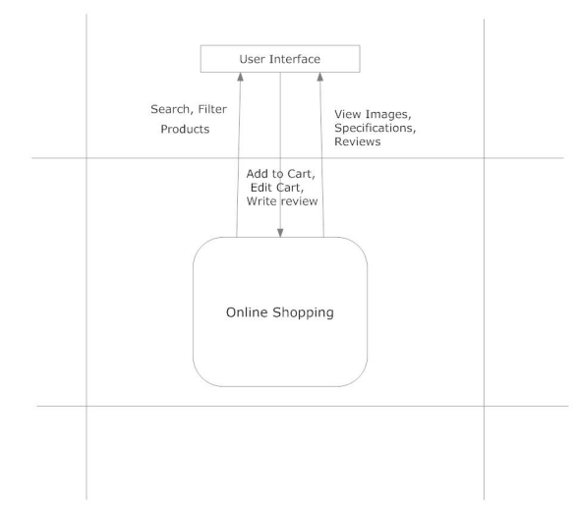

**4.2 Description of architectural diagram**

In this context diagram, the information provided to and received from the ‘Online Shopping’ is identified. The arrows represent the information received or generated by the application. The closed boxes represent the set of sources and sinks of information. 13 In the system, we can observe that the user interacts with the application through a graphical user interface. The inputs to the system are the Search and Filter criteria provided by the user and a new review written by the user. Also, the output is in the form of Repeater and grid views which present the users with list of Products available. The users can view complete specification, view Images and reviews by other users.

**4.3 Procedural/Modular Approach**

Following are all the modules designed for the Online Shopping System.

**4.3.1 Shop Products Module**

This module starts when the user visits the home page or when a user searches for a product by entering a search term. This part of the application includes displaying all the products that are available or the products that match the search term entered by the user. The user can then filter these products based on various parameters like manufacturer, product type, operating system supported or a price range. The user browse through the products and each product would be displayed with an image and its features like operating system supported, number of user licenses and if it is a full version or an upgrade version. A user can add a product to the cart either by dragging the product and dropping it in the cart or by clicking a button. The user would be able to see the shopping cart summary.

**4.3.2 Product Description Module**

This module starts when a user visits the product description page. A user can view various images of the product of different sizes. The use can see an enlarged image in a popup window. The user can view the complete specification of the product like its features, operating system supported, system requirements etc. A user can also view the manufacturer information and also information about rebates, exchange policies etc. A user can also view the reviews of the product. A user can also write a review for the product.

**4.3.3 Shopping Cart Module**

This module starts when the user views the shopping cart. All the products that have been added to the shopping cart by the user are listed along with their price and the quantity. The total price of all the products added to cart is displayed. A user can edit the quantity of each product or remove the product from the shopping cart. A user can remove the product from the cart by clicking a button or by dragging the product and dropping it outside the cart. The total price changes accordingly when a user edits the quantity of a product or when a product is removed from the cart.

**Software Testing**

**Why Software Testing is Needed Tool-bars work properly?**

Are all menu function and pull down sub function properly listed? Is it possible to invoke each menu function using a logical assumptions that if all parts of the system are correct, the goal will be successfully achieved? In adequate testing or non-testing will leads to errors that may appear few months later. Testing represents an interesting anomaly for the software engineer. During earlier software engineering activities, the engineer attempts to build software from an abstract concept to a tangible product. Now comes testing. The engineer creates a series of test cases that are intended to “demolish” the software that has been built. In fact, testing is the one step in the software process that could be viewed (psychologically, at least) as destructive rather than constructive. Testing requires that the developer discard preconceived notions of the “correctness” of software just developed and overcome a conflict of interest that occurs when errors are uncovered. If testing is conducted successfully (according to the objectives stated previously) it will uncover errors in the software. As a secondary benefit, testing demonstrates that software functions appear to be working according to specification, that behavioural and performance requirements appear to have been met. In addition, data collected as testing is conducted provide a good indication of software reliability and some indication of software quality as a whole. But testing cannot show the absence of errors and defects, it can show only that software errors and defects are present. It is important to keep this (rather gloomy) statement in mind as testing is being conducted.

**5.1 Testing Strategy**

There are types of testing that we implement. They are as follows: While deciding on the focus of testing activities, study project priorities. For example, for an online system, pay more attention to response time. Spend more time on the features used frequently. Decide on the effort required for testing based on the usage of the system. If the system is to be used by a large number of users, evaluate the impact on users due to a system failure before deciding on the effort. This create two problem ⎫ Time delay between the cause and appearance of the problem. ⎫ The effect of the system errors on files and records within the system. The purpose of the system testing is to consider all the likely variations to which it will be suggested and push the systems to limits. The testing process focuses on the logical intervals of the software ensuring that all statements have been tested and on functional interval is conducting tests to  
  
uncover errors and ensure that defined input will produce actual results that agree with the required results. Program level testing, modules level testing integrated and carried out. There are two major type of testing they are:

1. White Box Testing.
2. Black Box Testing.

**5.1.2 White Box Testing**

White box sometimes called “Glass box testing” is a test case design uses the control structure of the procedural design to drive test case. Using white box testing methods, the following tests where made on the system a) All independent paths within a module have been exercised once. In our system, ensuring that case was selected and executed checked all case structures. The bugs that were prevailing in some part of the code where fixed b) All logical decisions were checked for the truth and falsity of the values.

**5.1.2 Black Box Testing**

Black box testing focuses on the functional requirements of the software. This is black box testing enables the software engineering to derive a set of input conditions that will fully exercise all functional requirements for a program. Black box testing is not an alternative to white box testing rather it is complementary approach that is likely to uncover a different class of errors that white box methods like.   
  
Interface errors. Performance in data structure. Performance errors. Initializing and termination errors.

**5.1.3 Unit Testing**

Unit testing emphasizes the verification effort on the smallest unit of software design i.e.; a software component or module. Unit testing is a dynamic method for verification, where program is actually compiled and executed. Unit testing is performed in parallel with the coding phase. Unit testing tests units or modules not the whole software. I have tested each view/module of the application individually. As the modules were built up testing was carried out simultaneously, tracking out each and every kind of input and checking the corresponding output until module is working correctly. 20 The functionality of the modules was also tested as separate units. Each of the three modules was tested as separate units. In each module all the functionalities were tested in isolation. In the Shop Products Module when a product has been added to cart it has been made sure that if the item already exists in the shopping cart then the quantity is increased by one else a new item is created in the shopping cart. Also the state of the system after a product has been dragged in to the shopping cart is same as the state of the system if it was added by clicking the add to cart button. Also it has been ensured that all the images of the products displayed in the shop products page are drag gable and have the product property so that they can be dropped in the cart area. In the Product Description Module it has been tested that all the images are displayed properly. Users can add review and the as soon as a user adds a review it is updated in the view customer review tab. It has been checked to see if the whole page refreshes or a partial page update happens when a user writes a review. In the Cart Details it has been tested that when a user edits a quantity or removes a product from the cart, the total price is updated accordingly. It has been checked to see if the whole page refreshes or a partial page update happens when a user edits the cart. Visual Studio 2008 has in built support for testing the application. The unit testing can be done using visual studio 2008 without the need of any external application. Various methods have been created for the purpose of unit testing. Test cases are automatically generated for these methods. The tests run under the ASP.NET context which means settings from Web.config file are automatically picked up once the test case starts running. Methods were written to retrieve all the manufacturers from the database, strings that match a certain search term, products that match certain filter criteria, all images that belong to a particular product etc. Unit test cases were automatically generated for these methods and it can be seen in figure that the tests have passed.

**5.1.4 Validation Testing**

It provides final assurances that software meets all functional, behavioral & performance requirement. Black box testing techniques are used. There are three main components - Validation test criteria (no. in place of no. & char in place of char) - Configuration review (to ensure the completeness of s/w configuration.) - Alpha & Beta testing-Alpha testing is done at developer’s site i.e. at home & Beta testing once it is deployed. Since I have not deployed my application, I could not do the Beta testing. Test Cases- I have used a number of test cases for testing the product. There were different cases for which different inputs were used to check whether desired output is produced or not.

1. Addition of a new product to the cart should create a new row in the shopping cart.

2. Addition of an existing product to the cart has to update the quantity of the product.

3. Any changes to items in the cart have to update the summary correctly.

4. Because same page is inserting data into more than one table in the database atomicity of the transaction is tested.

5. The state of the system after a product has been dragged in to the cart should be same as the state of the system if the same product is added to the cart by clicking a button.

**Results and Challenges**

The application can be used for any Ecommerce application. It is easy to use, since it uses the GUI provided in the user dialog. User friendly screens are provided. The application is easy to use and interactive making online shopping a recreational activity for users. It has been thoroughly tested and implemented.

**Challenges**

• Compatibility with browsers like Mozilla Firefox, Internet explorer etc.

• Using a layered approach in developing the application which would make the application maintainable.

• Learning new technologies like using JavaScript for drag and drop behaviour and Ajax toolkit controls with little guidance.

The overall idea of doing this project is to get a real time experience

**Conclusion and Future Enhancement**

This project is only a humble venture to satisfy the needs in a shop. Several user friendly coding have also adopted. This package shall prove to be a powerful package in satisfying all the requirements of the organization. The objective of software planning is to provide a frame work that enables the manger to make reasonable estimates made within a limited time frame at the beginning of the software project and should be updated regularly as the project progresses. This website provides a computerized version of shop manipulate system which will benefit the users as well as the visitor of the shop. It makes entire process online where users can search product, and buy various product. It also has a facility for common user by login into the system where user can login and can see status of ordered item as well request for items or give some suggestions. It provide the facility of admin’s login where admins can add various item, review users activity and also give occasional discount and also add info about different events for the customer.

**Limitations :**

This application does not have a built in check out process. An external checkout package has to be integrated in to this application. Also users cannot save the shopping carts so that they can access later i.e. they cannot create wish lists which they can access later. This application does not have features by which user can set price ranges for products and receive alerts once the price reaches the particular range.

**Future Aspects**

The project has a very vast scope in future. The project can be implemented on intranet in future. Project can be updated in near future as and when requirement for the same arises, as it is very flexible in terms of expansion. With the proposed software of database Space Manager ready and fully functional the client is now able to manage and hence run the entire work in a much better, accurate and error free manner.

Should be added payment gateway can be added inventory management system can be added multiple branches can be added multilingual to this site and many features can be added this project to make it more robust.

**References**

1. <https://www.w3schools.com/>
2. <https://www.tutorialspoint.com/index.htm>
3. <https://github.com/>
4. <https://www.javatpoint.com/>
5. <https://www.geeksforgeeks.org/>