Prompt comparison — statistical report
Source workbook: prompt-worksheet_duplicate_AB.xlsx
Descriptives, figures (boxplot, RM line plot, mean±95% CI), repeated-measures ANOVA, Holm-adjusted pairwise tests, and cluster-robust regression.

Summary
Workbook: prompt-worksheet_duplicate_AB.xlsx
Design: repeated measures — 10 scenarios × three prompts (A, B, C).
Outcome per row: numeric Overall (column K) when present; otherwise mean of D1–D6 (E–J). Re-save the workbook in Excel once if column K holds formulas and cached values look missing.

1. Descriptive statistics
Mean and standard deviation of Overall by prompt (complete cases only).
Prompt | Mean overall | SD
Prompt A | 4.1110 | 0.1009
Prompt B | 4.5050 | 0.1465
Prompt C | 4.7833 | 0.0805

2. Figures for repeated-measures design
Three standard figures for a within-subject (repeated-measures) prompt comparison: distributions, individual scenario trajectories, and marginal means with uncertainty. Together they complement the ANOVA and post-hoc tests below.

1. Boxplot (primary distribution comparison)
This is the primary distribution view for the experiment. It shows score distributions, medians, spread and variance, and overlap between Prompt A, B, and C. Use it alongside the repeated-measures ANOVA.
Axes: horizontal axis = prompt condition (A, B, C); vertical axis = Overall score.
What to look for: if the experimental pattern is A lowest, B intermediate, and C highest, you should see separation and ordering consistent with that pattern (medians and boxes shifted upward from A to C).
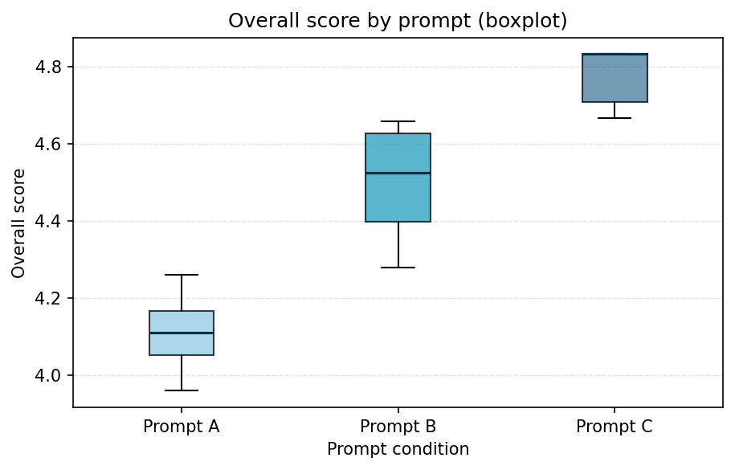

2. Repeated-measures line plot
Ideal for this design because the same scenarios are evaluated under each prompt. Each line is one scenario across Prompt A, B, and C.
Axes: horizontal axis = prompt condition; vertical axis = Overall score.
What to look for: many lines trending upward from A → B → C indicates within-scenario improvement as the prompt changes, which is strong evidence for a prompt effect at the paired level.
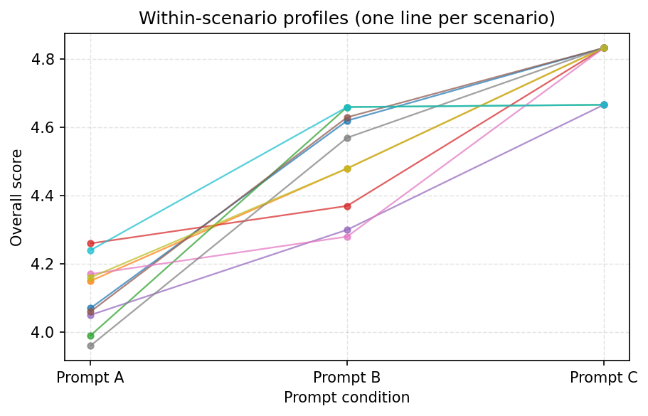

3. Mean with 95% confidence intervals
Shows marginal means with uncertainty (95% confidence intervals of the mean per prompt). This is a clean companion to the omnibus ANOVA and effect size.
Axes: horizontal axis = prompt condition; vertical axis = mean Overall score. Error bars are 95% CIs of the mean (n = 10 scenarios per prompt).
Alternative: you could plot mean ± SD instead of CI for raw dispersion; CIs emphasize precision of the mean.
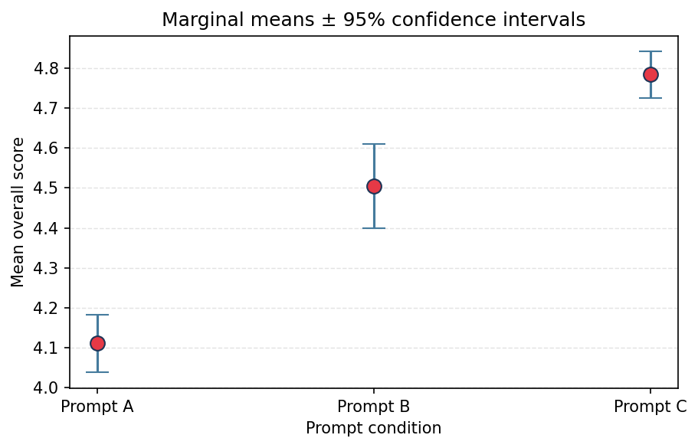

Plot | Purpose
Boxplot | Main distribution comparison across prompts (medians, spread, overlap); supports the RM ANOVA.
Repeated-measures line plot | Each line is one scenario across A → B → C; upward trends show within-scenario improvement.
Mean ± 95% CI | Marginal means with error bars (95% CI of the mean); concise summary of average differences.

3. Repeated-measures ANOVA
One-way repeated-measures ANOVA (within factor = Prompt A/B/C, subject = Scenario).
Tests: Does prompt type significantly affect Overall scores?
F(2, 18) = 78.0693, p < 0.0001

4. Effect size (partial eta-squared)
Partial eta-squared (prompt main effect): η_p² = 0.8966
Magnitude: large (conventional η_p² ≥ 0.14).

5. Post-hoc pairwise comparisons
Paired t-tests on the same scenarios across prompts, with Holm adjustment across the three contrasts.
If the omnibus ANOVA is significant (p < 0.05), use p (Holm) < 0.05 to claim a pairwise difference.
Contrast | Mean Δ | t | p (uncorr.) | p (Holm)
B − A (same scenario) | 0.3940 | 6.1413 | 0.0001705 | 0.000341
C − A | 0.6723 | 17.5321 | 2.891e-08 | 8.674e-08
C − B | 0.2783 | 4.9324 | 0.0008106 | 0.0008106

6. Regression analysis
Linear regression of Overall score on prompt indicators (reference category: Prompt A). Standard errors are cluster-robust, clustering on scenario, so repeated observations from the same scenario are not treated as independent.
Model fit: R² = 0.869; N = 30 observations in 10 scenarios; covariance estimator: cluster-robust (HC0-type by cluster). With a balanced design, the intercept matches the mean for Prompt A; coefficients for B and C are the marginal mean differences versus A (consistent with the marginal means in the descriptives).
Term | Coef. | SE | z | p | 95% CI low | 95% CI high
Intercept (Prompt A mean) | 4.1110 | 0.0331 | 124.277 | <1e-6 | 4.0462 | 4.1758
Prompt B vs A | 0.3940 | 0.0665 | 5.926 | <1e-6 | 0.2637 | 0.5243
Prompt C vs A | 0.6723 | 0.0397 | 16.917 | <1e-6 | 0.5944 | 0.7502

