Objective Questions:
- What is the distribution of account balances across different regions?
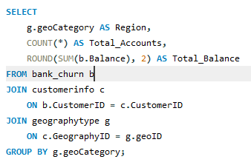
Output:
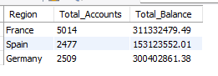
Method
• Joined customer and geography tables with bank balance data, then grouped by region to summarize number of accounts and total balance per region.
Insights
• France has the highest number of accounts and total balance, indicating a larger and more active customer base.
• Germany has fewer accounts than France but a high total balance, suggesting higher average balances per customer.
Recommendations
• Focus on retention and premium banking offerings in Germany, where customers hold higher balances.
• Target customer acquisition campaigns in Spain, where both account count and total balance are comparatively lower.

- Identify the top 5 customers with the highest Estimated Salary in the last quarter of the year. (SQL)

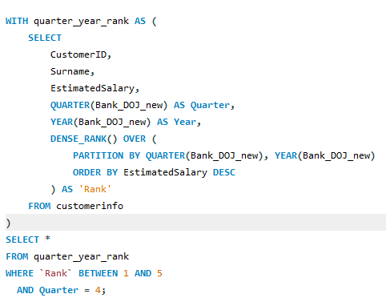
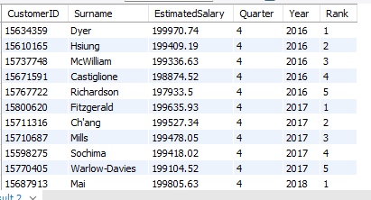

Method
• Ranked customers within each year's Q4 (Quarter 4) based on Estimated Salary using DENSE_RANK(), and then selected the top 5 from each year.
Insights
• Across all years, the top salaried customers consistently exceed ~198K, showing minimal variation among high-income customers.
• Q4 appears to attract or onboard more high-earning customers, possibly due to year-end financial planning or investments.
Recommendations
• Promote premium banking and wealth management services targeted at high earners especially in Q4.
• Analyze onboarding channels used during Q4 to replicate successful acquisition strategies in other quarters.
- Calculate the average number of products used by customers who have a credit card. (SQL)

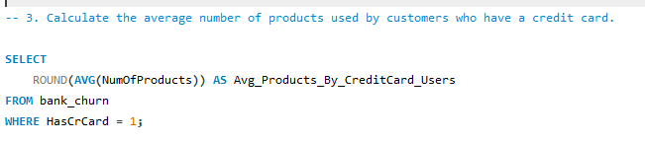
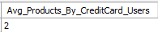
Method
• Filtered the dataset to include only customers who hold a credit card, then calculated the average number of products they use.
Insights
• Credit card holders on average use 2 products, indicating moderate engagement with bank services.
Recommendations
• Promote cross-sell and bundled product offers to credit card customers to increase product adoption beyond the average of 2.

- Determine the churn rate by gender for the most recent year in the dataset.
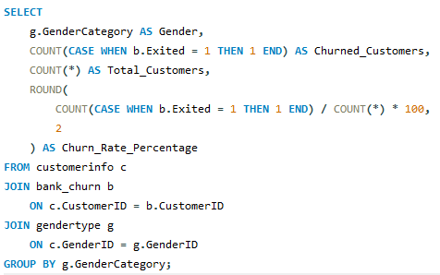
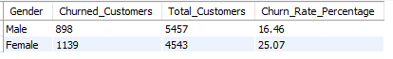
Method
• Grouped customers by gender and calculated the percentage of customers who exited (churn rate) within each gender group.
Insights
• Female customers show a higher churn rate (25.07%) compared to male customers (16.46%), indicating females are more likely to close accounts or leave the bank.
Recommendations
• Investigate customer experience factors specifically affecting female customers and introduce targeted retention programs (e.g., personalized offers or support touchpoints).

- Compare the average credit score of customers who have exited and those who remain. (SQL)
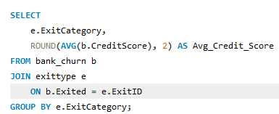

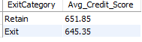

Method
• Grouped customers by exit status and calculated the average credit score for each group to compare retained vs. exited customers.
Insights
• Customers who remain have a slightly higher average credit score (651.85) compared to those who exited (645.35), indicating lower credit score customers are slightly more likely to churn.
Recommendations
• Monitor and support customers with lower credit scores through credit counseling, limit protection, or flexible repayment options to reduce churn risk.

- Which gender has a higher average estimated salary, and how does it relate to the number of active accounts? (SQL)
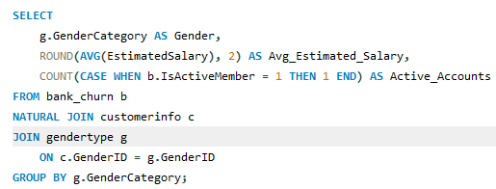
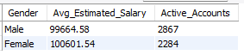
Method
• Calculated the average estimated salary and counted active members for each gender by grouping on the gender category.
Insights
• Female customers have a slightly higher average salary, but Male customers have more active accounts, suggesting salary does not directly determine engagement level.
Recommendations
• Encourage higher engagement programs targeted towards female customers, such as personalized offers or awareness of digital banking features to boost active participation.

- Segment the customers based on their credit score and identify the segment with the highest exit rate. (SQL)
WITH cust_with_cate AS (
SELECT
CustomerId,
CreditScore,
CASE
WHEN CreditScore BETWEEN 800 AND 850 THEN 'Excellent'
WHEN CreditScore BETWEEN 740 AND 799 THEN 'Very Good'
WHEN CreditScore BETWEEN 670 AND 739 THEN 'Good'
WHEN CreditScore BETWEEN 580 AND 669 THEN 'Fair'
WHEN CreditScore BETWEEN 300 AND 579 THEN 'Poor'
ELSE 'Unknown'
END AS CreditCategory
FROM bank_churn
)

SELECT
c.CreditCategory,
ROUND(100 * COUNT(CASE WHEN b.Exited = 1 THEN 1 END) / COUNT(*), 2) AS Exit_Rate,
ROUND(100 * COUNT(CASE WHEN b.Exited = 0 THEN 1 END) / COUNT(*), 2) AS Retain_Rate,
DENSE_RANK() OVER (
ORDER BY COUNT(CASE WHEN b.Exited = 1 THEN 1 END) / COUNT(*) DESC
) AS 'Rank'
FROM bank_churn b
JOIN cust_with_cate c
ON b.CustomerId = c.CustomerId
GROUP BY c.CreditCategory;
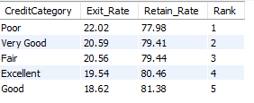
Method
• Categorized customers into credit score segments and calculated exit rate (%) within each segment to identify which group churns the most.
Insights
• Customers with Poor credit scores have the highest exit rate (22.02%), while Good credit score customers show the lowest churn (18.62%), indicating churn likelihood decreases as credit score increases.
Recommendations
• Provide supportive financial programs (credit score improvement plans, flexible credit terms) targeting Poor and Fair credit groups to reduce churn.

- Find out which geographic region has the highest number of active customers with a tenure greater than 5 years. (SQL)
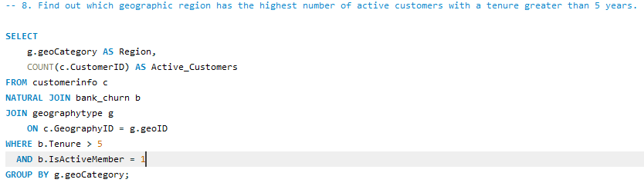
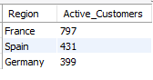
Method
• Filtered customers with tenure > 5 years and who are active members, then grouped by geographic region to count active long-term customers.
Insights
• France has the highest number of active long-tenured customers (797), indicating stronger long-term customer relationships in this region compared to Spain and Germany.
Recommendations
• Use France’s engagement strategy (loyalty programs, service quality, relationship management) as a best-practice model and apply similar retention approaches in Spain and Germany.

- What is the impact of having a credit card on customer churn, based on the available data?
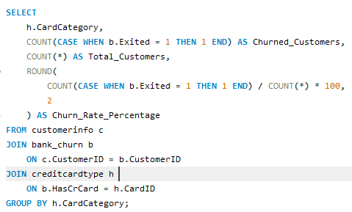

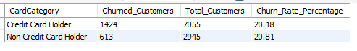
Method
• Compared churn rates between credit card holders and non-holders by grouping customers based on card status and calculating exit percentage for each group.
Insights
• Churn rates are almost the same for both groups (≈20%), with non–credit card holders being slightly more likely to churn (20.81%) than credit card holders (20.18%).
Recommendations
• Credit card ownership alone does not significantly reduce churn, so additional engagement or value-added benefits should be introduced to strengthen customer loyalty.

- For customers who have exited, what is the most common number of products they have used?

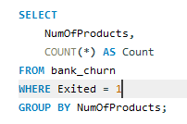
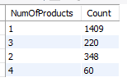
Method
• Filtered only exited customers and counted how many customers had each number of products, identifying which product usage level was most common among churned customers.
Insights
• Most exited customers used only 1 product (1409 customers), indicating low product engagement is strongly associated with higher churn.
Recommendations
• Implement cross-sell and bundled product strategies to encourage customers to adopt more than one product early in their relationship to improve retention.

- Examine the trend of customers joining over time and identify any seasonal patterns (yearly or monthly). Prepare the data through SQL and then visualize it.
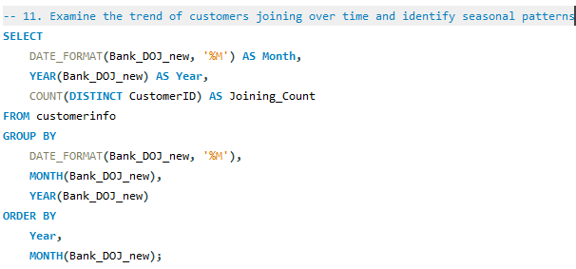
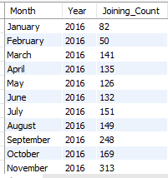
Method
• Grouped customers by their month and year of joining based on the Bank_DOJ_new column, and counted distinct customers per month to observe time-based trends in new customer acquisition.
Insights
• There is a clear seasonal pattern: customer joining counts peak consistently in September to December across all years, with December showing some of the highest join rates.
• The lowest joining months tend to be January and February, indicating a dip in customer acquisition at the start of the year.
Recommendations
• Increase marketing and onboarding efforts during the peak months (Sep–Dec) to maximize conversion when customer interest is naturally high.
• Boost promotional campaigns in low-acquisition months (Jan–Feb) to stabilize customer inflow and reduce seasonal drop-offs.
• Consider season-based product offers or discounts aligned with year-end financial planning behavior.
- Analyze the relationship between the number of products and the account balance for customers who have exited.
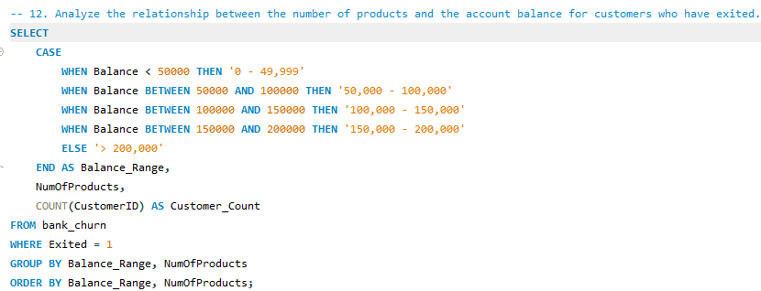
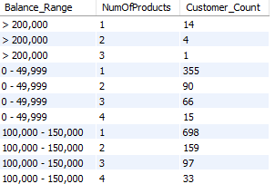
Method
• Filtered only customers who exited and grouped them by account balance ranges and number of products.
• Counted how many customers fall into each segment to understand churn patterns by product usage and balance.
Insights
• Across all balance ranges, the highest churn is seen among customers holding only 1 product, particularly in the 100,000–150,000 balance range (698 customers).
• This suggests that even customers with moderate to high account balances are likely to churn when they are not engaged with multiple products.
Recommendations
• Implement cross-selling strategies targeted at customers with balances above 100,000 but holding only 1 product to improve retention.
• Use relationship managers or personalized offers to encourage adoption of second product early in customer lifecycle.
- Identify any potential outliers in terms of balance among customers who have remained with the bank.

Method to Identify Balance Outliers
- Created a Scatter Plot using:
  - X-Axis: CustomerID
  - Y-Axis: Balance
- Applied a Visual-Level Filter:
  - Exited = 0
to ensure that only customers who have remained with the bank were included.

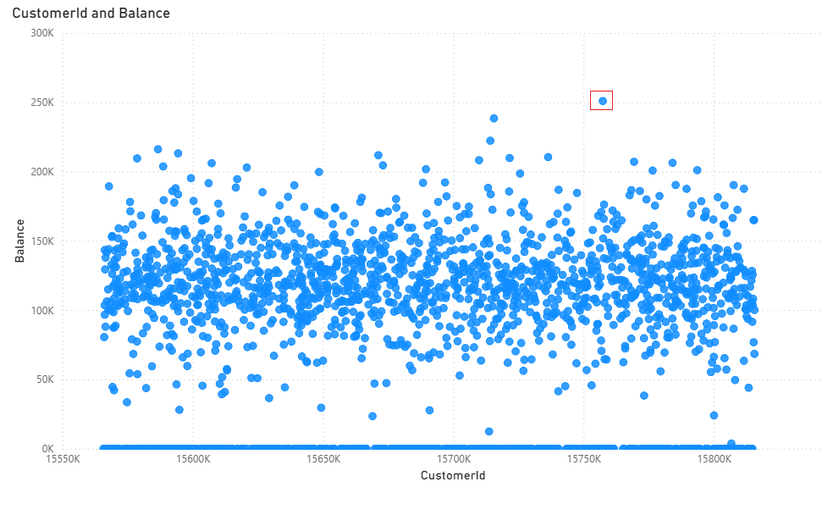
Insights
Some exited customers appear as high-balance outliers, meaning they left the bank despite holding significantly higher account balances.
Recommendations
For High-Balance Exited Outliers: Implement personalized relationship management, priority support, and targeted retention programs to prevent the loss of similar high-value customers in the future.

- How many different tables are given in the dataset, out of these tables which table only consists of categorical variables?
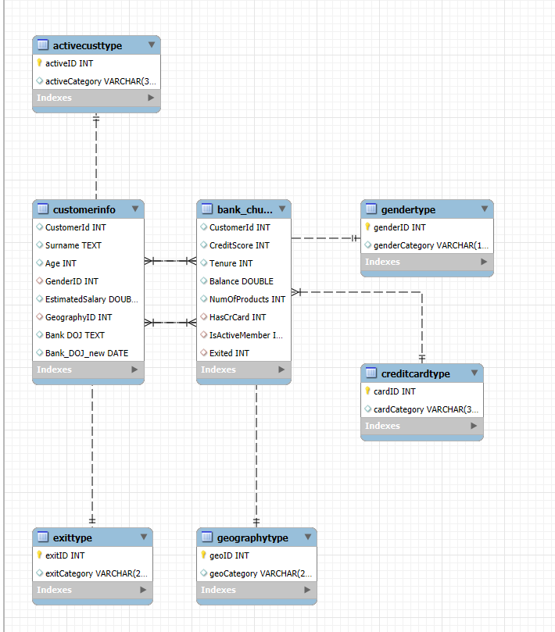
Method
- Used the Reverse Engineering feature in MySQL Workbench to generate the ER diagram automatically from the existing database schema.
Insights
- Diagram shows bank_churn as the central table linked to dimension tables like customerInfo, genderType, geographyType, and creditCardType.
- Represents a star schema suitable for churn analysis.
- Clearly defines relationships and dependencies among customer, account, and demographic data.
- Useful for ensuring data integrity and understanding data flow for analysis.

- Using SQL, write a query to find out the gender-wise average income of males and females in each geography id. Also, rank the gender according to the average value. (SQL)
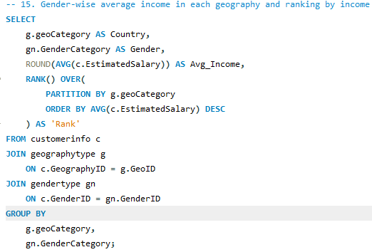
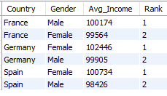
Method
• Calculated the average estimated salary by gender within each geographic region and used a window function to rank genders based on income levels per region.
Insights
• In Germany and Spain, Females have a higher average income than Males.
• In France, Males have a slightly higher average income than Females.
• This shows that income differences vary by region, indicating region-specific economic or demographic factors.
Recommendation
• Consider conducting region-specific compensation and role distribution analysis to understand factors driving these income variations (e.g., job roles, seniority, experience distribution).

- Using SQL, write a query to find out the average tenure of the people who have exited in each age bracket (18-30, 30-50, 50+).
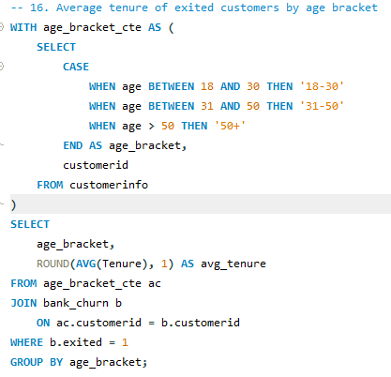
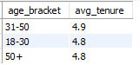
Method
• Categorized customers into age brackets and calculated the average tenure only for those who exited, to understand how long they typically stayed before leaving.
Insights
• The 31–50 age group has a slightly higher average tenure (4.9 years) before exiting, compared to younger (18–30) and older (50+) customers (both 4.8 years).
• This indicates that mid-age customers tend to stay slightly longer before deciding to leave the bank.
Recommendation
• For the 31–50 segment, consider proactive retention strategies around the 4–5 year tenure mark, when likelihood of churn may increase.

- Is there any direct correlation between salary and the balance of the customers? And is it different for people who have exited or not?
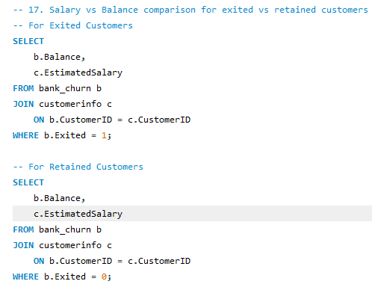
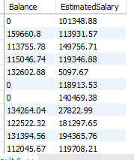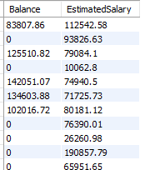

Method

- Filtered data by Exited status using SQL.
- Exported results to Excel.
- Used =CORREL() to calculate correlation between Estimated Salary and Credit Score (or Balance).
- Repeated for retained customers.

Insights
- Exited customers: Correlation = -0.0127
- Retained customers: Correlation = -0.0295
- Both values are near zero → no clear relationship between salary and credit score.

- Is there any correlation between the salary and the Credit score of customers?

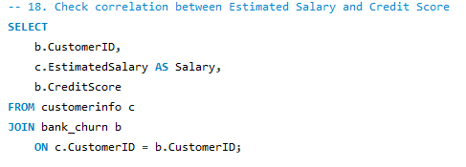
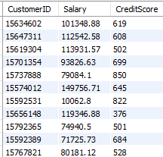

Method
- Retrieved Estimated Salary and Credit Score data from the database.
- Exported results to Excel.
- Used the =CORREL() function to calculate the correlation between both variables.
- Analyzed separately for overall customers.

Insights
- Correlation = 0.0645
- Indicates a very weak positive correlation between salary and credit score.
- Slight trend: customers with higher salaries may have slightly better credit scores, but the relationship is not strong.

Recommendations
- Encourage credit education programs for all income groups since salary alone doesn’t ensure strong credit health.
- Use additional factors (like payment history, product usage) to better assess creditworthiness and predict churn.

- Rank each bucket of credit score as per the number of customers who have churned the bank.
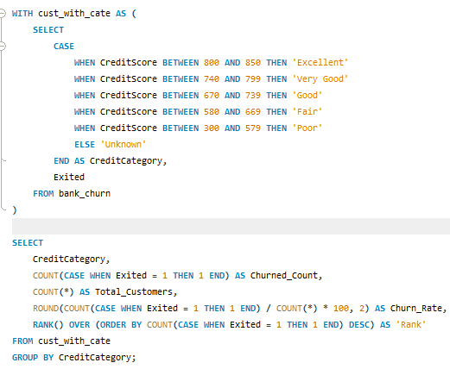
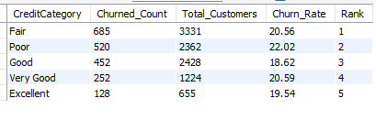
Method
• Categorized customers into credit score buckets and calculated the number and percentage of churned customers in each group.
• Ranked the buckets based on the highest churn count.
Insights
• The Fair credit score group has the highest number of churned customers (685), followed closely by the Poor category (520).
• Even customers in Very Good and Excellent categories are also churning, indicating churn is not solely driven by low credit score, but possibly by other engagement or service-related factors.
Recommendations
• Prioritize retention programs for customers in the Fair and Poor credit score groups, such as financial guidance, credit improvement programs, or personalized account support.
• Investigate churn triggers for Good and Very Good groups as they are financially stable but still leaving — suggesting relationship or experience issues rather than financial problems.

- According to the age buckets find the number of customers who have a credit card. Also retrieve those buckets that have lesser than average number of credit cards per bucket.
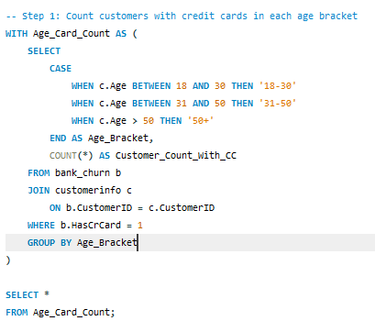

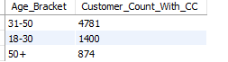

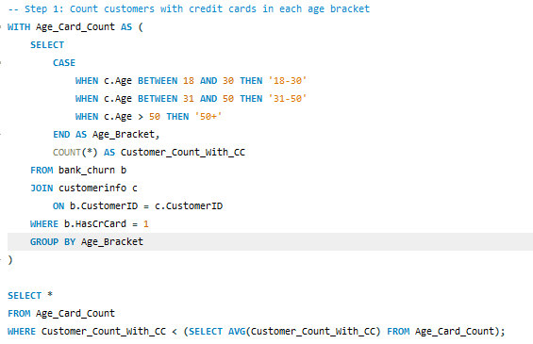
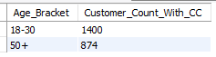

Method
- Counted the number of customers with a credit card in each age bracket.
- Calculated the average count across brackets.
- Selected brackets with counts below the average (≈2352).

Insights
- 18–30 (1400) and 50+ (874) age groups have lower credit card usage than average.
- 31–50 group shows the highest engagement with credit card products.

Recommendations
- 18–30: Promote entry-level cards with low fees and rewards aligned to youth spending.
- 50+: Offer simple, low-risk cards with benefits on healthcare, groceries, and utilities.
- Prioritize targeted marketing campaigns to increase card adoption in these two segments.

- Rank the Locations as per the number of people who have churned the bank and average balance of the customers.
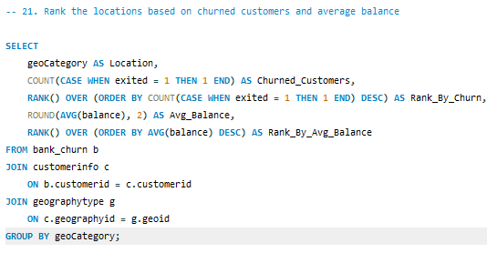
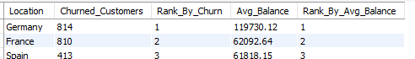

Method
• Grouped customers by geography and counted how many have exited.
• Calculated the average account balance for each geography.
• Ranked locations based on churn count and separately based on average balance.
Insights
• Germany has the highest churn (814 customers) and also the highest average balance (~119,730) — indicating high-value customers are more likely to leave.
• France has moderate churn and balance levels.
• Spain has the lowest churn (413) and also the lowest average balance, suggesting lower-value customers are more stable.
Recommendation
• Prioritize retention strategies in Germany, especially targeting high-balance customers, as losing them has a greater financial impact.
• Consider loyalty incentives, personalized advisory services, and risk monitoring for high-value accounts.
- As we can see that the “CustomerInfo” table has the CustomerID and Surname, now if we have to join it with a table where the primary key is also a combination of CustomerID and Surname, come up with a column where the format is “CustomerID_Surname”.
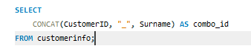
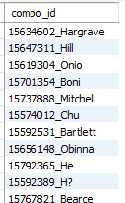

Method
- Used the CONCAT() function to combine CustomerID and Surname into a single field named combo_id.
- Retrieved data from the customerinfo table for easier identification and referencing of customers.
Insights
- Created a unique, descriptive identifier for each customer.
- Useful for data tracking, merging, or reporting, where readable combined IDs are preferred over numeric ones.

- Without using “Join”, can we get the “ExitCategory” from ExitCustomers table to Bank_Churn table? If yes do this using SQL.
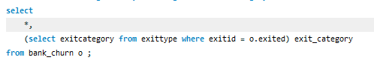
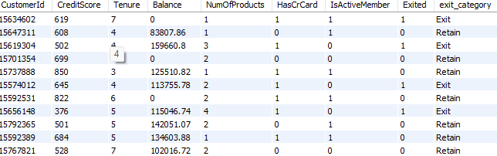

Method
• Used a correlated subquery in the SELECT clause to fetch ExitCategory from the ExitType table.
• This avoids using a JOIN and still maps the Exited value to its corresponding category.

Insight
• A correlated subquery allows lookup of related information row-by-row, which is useful when a join is not desired.
• However, for large datasets, this approach may be slower than using a join because the subquery executes repeatedly.

- Were there any missing values in the data, using which tool did you replace them and what are the ways to handle them?
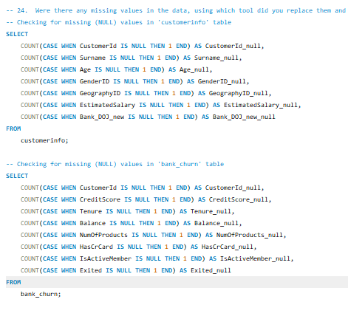
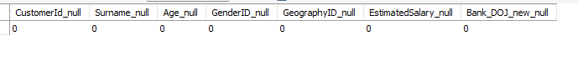
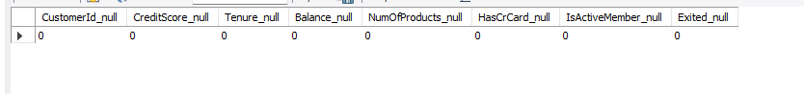
Method
• Checked each column for missing values using COUNT(CASE WHEN column IS NULL THEN 1 END) in both CustomerInfo and Bank_Churn tables.
• Verified whether any null data existed before proceeding with cleaning steps.
Insights
• The dataset did not contain any NULL values in key columns (Customer demographics, Salary, Credit Score, Balance, Tenure, Product usage, etc.).
• This indicates the dataset was already clean and preprocessed, likely sourced from a structured system or curated dataset.
- Write the query to get the customer IDs, their last name, and whether they are active or not for the customers whose surname ends with “on”.

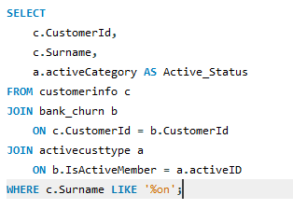
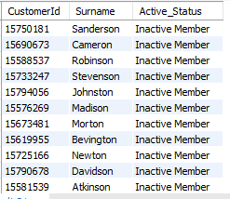

Method
• Filtered customers whose surname ends with "on" using LIKE '%on'.
• Joined CustomerInfo with Bank_Churn to retrieve active status of customers.
• Mapped the active status using the activecusttype reference table to get readable labels.
Insights
• This helps identify whether customers with similar surname patterns share behavior patterns (e.g., clustering in specific regions or activity status).
• Useful for segmentation, identity verification checks, or demographic profiling.

- Can you observe any data disrupency in the Customer’s data? As a hint it’s present in the IsActiveMember and Exited columns. One more point to consider is that the data in the Exited Column is absolutely correct and accurate.
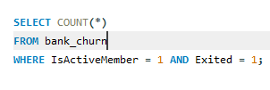
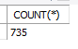
Method
- Checked unique combinations of IsActiveMember and Exited to detect contradictions.
- Counted records where customers are both active (IsActiveMember = 1) and exited (Exited = 1), which indicates inconsistent data.
- Trusted the Exited column as accurate, meaning IsActiveMember values are incorrect in these cases.

Insights
- Found 735 records where customers are marked as both active and exited.
- The IsActiveMember field likely has data entry or update lag issues.
- When a customer exits, the flag should change to 0 but remains 1 for some records, leading to misleading churn insights.

Subjective Question:

- Customer Behavior Analysis: What patterns can be observed in the spending habits of long-term customers compared to new customers, and what might these patterns suggest about customer loyalty?

WITH cust_type AS (
SELECT
b.CustomerId,
b.Balance,
b.NumOfProducts,
b.CreditScore,
b.IsActiveMember,
b.Exited,
c.Bank_DOJ_new,
c.age,
CASE
WHEN c.Bank_DOJ_new > DATE_SUB((SELECT MAX(Bank_DOJ_new) FROM customerinfo), INTERVAL 1 YEAR)
THEN 'New'
ELSE 'Old'
END AS customer_type
FROM bank_churn b
JOIN customerinfo c
ON b.CustomerId = c.CustomerId
)

SELECT
customer_type,
COUNT(*) AS total_customers,
ROUND(AVG(CASE WHEN Balance != 0 THEN Balance END), 2) AS avg_balance,
ROUND(AVG(NumOfProducts), 0) AS avg_num_of_products,
ROUND(AVG(CreditScore), 2) AS avg_credit_score,
ROUND(100 * COUNT(CASE WHEN IsActiveMember = 1 THEN 1 END) / COUNT(*), 2) AS active_percentage,
ROUND(100 * COUNT(CASE WHEN Exited = 1 THEN 1 END) / COUNT(*), 2) AS churn_rate,
COUNT(CASE WHEN Balance = 0 THEN 1 END) AS count_with_no_balance,
ROUND(100 * COUNT(CASE WHEN Balance = 0 THEN 1 END) / COUNT(*), 2) AS pct_with_no_balance,
ROUND(AVG(age), 2) AS avg_age
FROM cust_type
GROUP BY customer_type;

OUTPUT

Method
- Segmented customers as New (joined within last year) and Old (longer than a year) using DOJ.
- Calculated key behavioral metrics: average balance, product usage, credit score, activity level, and churn rate for each segment.
- Compared the financial engagement and churn patterns between both groups.

Insights
- Old customers generally maintain higher balances and use more products, indicating stronger financial engagement.
- New customers show higher % of zero balance accounts, suggesting slow onboarding or low trust initially.
- If churn rate is higher among new customers, it implies onboarding and early engagement gaps.
- If active rate is lower among new customers, it signals limited relationship development.

Recommendations
- Strengthen onboarding programs with personalized product recommendations to encourage early balance building.
- Introduce welcome offers or starter bundles to increase product adoption in the first 3–6 months.
- Proactively engage new customers using RM calls, app nudges, and benefit education campaigns to increase stickiness.
- Regularly monitor early churn indicators (low balance + single product use) and intervene early.

- Product Affinity Study: Which bank products or services are most commonly used together, and how might this influence cross-selling strategies?

WITH ProductUsage AS (
SELECT
CustomerID,
NumOfProducts,
CASE
WHEN NumOfProducts >= 4 THEN 'SavingsAccount, CreditCard, Loan, InvestmentAccount'
WHEN NumOfProducts = 3 THEN 'SavingsAccount, CreditCard, Loan'
WHEN NumOfProducts = 2 THEN 'SavingsAccount, CreditCard'
WHEN NumOfProducts = 1 THEN 'SavingsAccount'
END AS ProductCombination
FROM bank_churn
),
CombinationAnalysis AS (
SELECT
ProductCombination,
COUNT(CustomerID) AS CustomerCount
FROM ProductUsage
GROUP BY ProductCombination
)
SELECT
CustomerCount,
ProductCombination,
ROUND(CustomerCount * 100.0 / (SELECT COUNT(*) FROM bank_churn), 2) AS PercentageOfCustomers
FROM CombinationAnalysis;
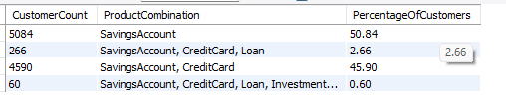

Method
- As the dataset did not include a dedicated “Service/Product” field, product combinations were derived manually using the NumOfProducts column.
- Created logical categories (Savings, Savings+Card, +Loan, +Investment) using a CASE statement.
- Aggregated customer counts and percentages by combination to identify usage patterns and cross-sell potential.

Insights
- >50% customers have only Savings Account — most common product.
- 45.9% use Savings + Credit Card — ideal for upselling additional services.
- 2.66% include a Loan, showing weak adoption.
- 0.60% use all four products, indicating very low full-service engagement.

Recommendations
- Cross-sell credit cards and loans to savings-only customers.
- Offer bundled product packages (Savings + Card + Loan) to boost engagement.
- Promote investment products through personalized offers.
- Use cross-product usage insights to tailor marketing and retention strategies.

- Geographic Market Trends: How do economic indicators in different geographic regions correlate with the number of active accounts and customer churn rates?
WITH cte AS (
SELECT
b.CustomerId,
b.CreditScore,
CASE
WHEN b.CreditScore BETWEEN 800 AND 850 THEN 'Excellent'
WHEN b.CreditScore BETWEEN 740 AND 799 THEN 'Very Good'
WHEN b.CreditScore BETWEEN 670 AND 739 THEN 'Good'
WHEN b.CreditScore BETWEEN 580 AND 669 THEN 'Fair'
WHEN b.CreditScore BETWEEN 300 AND 579 THEN 'Poor'
ELSE 'Unknown'
END AS CreditCategory,
g.geoCategory AS region,
b.Exited,
b.IsActiveMember
FROM bank_churn b
JOIN customerinfo c
ON b.CustomerId = c.CustomerId
JOIN geographytype g
ON c.GeographyID = g.geoID
)

SELECT
region,
CreditCategory,
ROUND(100 * COUNT(CASE WHEN IsActiveMember = 1 THEN 1 END) / COUNT(*), 2) AS active_percentage,
ROUND(100 * COUNT(CASE WHEN Exited = 1 THEN 1 END) / COUNT(*), 2) AS churn_rate
FROM cte
GROUP BY region, CreditCategory
ORDER BY region, CreditCategory;

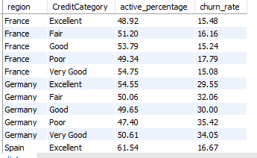

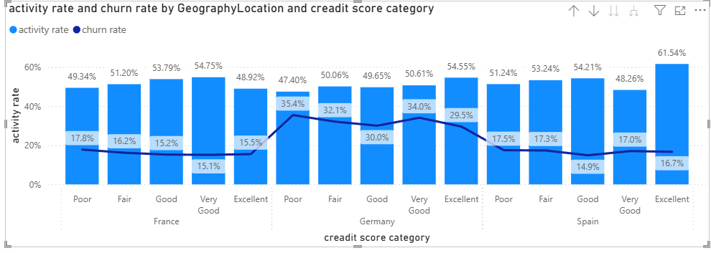

Method
- Customers were grouped by Credit Score Category to represent economic strength indicators.
- Regions were joined via GeographyID to analyze geographic impact on customer behavior.
- For each region and credit category:
  - Inactivity Rate (%) and Churn Rate (%) were calculated.
  - Visualization: A clustered column + line combo chart was created, showing Inactivity Rate (bars) and Churn Rate (line) by Credit Score Category and Geography.
- This visual enabled clear comparison of engagement and attrition patterns across both dimensions.

Insights
Region | Key Insight
France | Moderate and balanced churn across all credit bands; overall churn remains low and stable (15–18%). Indicates a financially steady customer base that is less churn-prone.
Spain | Active membership is relatively higher in Good and Fair categories (~53–54%), with churn consistently lower (<18%). Suggests strong engagement and healthy customer retention.
Germany | All credit score segments show significantly higher churn (29–35%), especially in Poor & Fair categories. Indicates retention challenges and possible dissatisfaction, independent of financial profile.
Overall Pattern:
- Germany is the high-risk churn region across all economic segments.
- France and Spain show healthier engagement and stable customer loyalty.
- The visualization highlights how churn line trends sharply upward in Germany compared to relatively flat, lower lines in France and Spain.

Recommendations
For Germany (High-Risk Region):
- Implement targeted retention strategies, including personalized offers and proactive relationship manager touchpoints.
- Conduct a service quality and fee structure audit to identify pain points driving churn.
- Focus loyalty programs on Poor and Fair credit segments, where churn is highest.
For Spain (Growth Potential):
- Strengthen cross-sell and upsell initiatives to capitalize on already high engagement and loyalty.
For France (Stable Base):
- Continue monitoring and maintaining retention baselines, as churn levels are well controlled and balanced across credit categories.

- Risk Management Assessment: Based on customer profiles, which demographic segments appear to pose the highest financial risk to the
-- STEP 1: Create a view to simplify customer category analysis
CREATE VIEW cust_category AS
SELECT
b.CustomerId,
b.Balance,
b.IsActiveMember,
b.Exited,
age,
genderID,
geographyID
FROM bank_churn b
JOIN customerinfo c
ON b.CustomerId = c.CustomerId;

Gender Wise :
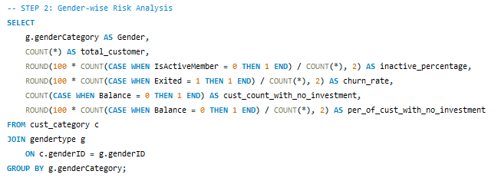
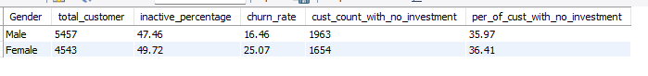
Method
- Categorized customers by gender using gendertype lookup.
- Calculated inactivity, churn rates, and no-investment percentages for each gender.
- Compared behavioral patterns across male and female groups.

Insights
- Female customers show significantly higher churn (25.07%) compared to males (16.46%).
- Both genders have similar levels of non-investment (~36%), indicating engagement issue is not investment-related alone.
- Female customers are also slightly more inactive (49.72%), suggesting lower ongoing relationship strength with the bank.

Recommendations
- Targeted Retention Campaign for Female Customers: Personalized offers, relationship manager follow-ups, and engagement calls.
- Financial Product Awareness Programs: Workshops or app-based nudges to increase product usage, especially for women customers.
- Introduce Female-Centered Financial Bundles: e.g., lower fee accounts, savings schemes for education/health goals.
- Monitor churn early indicators: Reduced balance movement or inactivity can trigger proactive outreach.

Age Wise
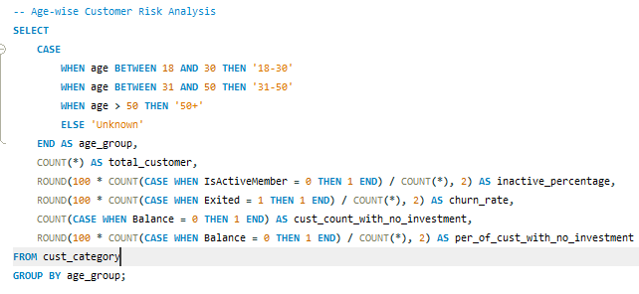
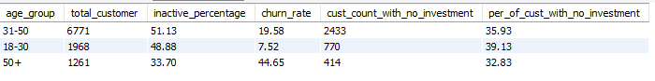
Method
- Grouped customers into age brackets: 18–30, 31–50, and 50+.
- Calculated inactivity rate, churn rate, and investment behavior for each group.
- Compared how age impacts churn and engagement.
- Visualized with a clustered column + line chart showing inactivity and churn by age group.

Insights (1-Liners)
- 50+ → Highest churn (44.65%), showing senior customers are most likely to leave.
- 31–50 → Largest group (6,771 customers) with moderate churn (19.58%).
- 18–30 → Lowest churn (7.52%) but highest no-investment rate (39.13%), indicating engagement without strong financial commitment.
Recommendations (1-Liners)
- 50+ → Assign Relationship Managers (RMs) for personal support, simplify digital use, and offer senior-focused savings & health plans.
- 31–50 → Cross-sell wealth products and retain through personalized financial offers.
- 18–30 → Launch starter investment plans and use app nudges to boost financial commitment.

- Customer Tenure Value Forecast: How would you use the available data to model and predict the lifetime (tenure) value in the bank of different customer segments?

SELECT
customerinfo.CustomerID,
Age,
EstimatedSalary,
CreditScore,
Tenure,
Balance,
NumOfProducts,
cardCategory AS CreditCardCategory,
ActiveCategory,
ExitCategory,
TIMESTAMPDIFF(YEAR, customerinfo.Bank_DOJ_new, CURDATE()) AS CurrentTenureYears
FROM customerinfo
JOIN geographytype g
ON customerinfo.GeographyID = g.GeoID
JOIN bank_churn
ON customerinfo.CustomerID = bank_churn.CustomerID
LEFT JOIN creditcardtype c
ON bank_churn.hascrcard = c.cardID
LEFT JOIN activecusttype A
ON bank_churn.isActivemember= A.ActiveID
LEFT JOIN exittype e
ON bank_churn.Exited = e.ExitID;

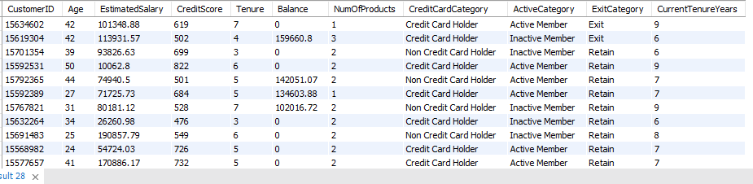

Method
- Combined customer, account, and activity data using direct joins.
- Calculated current tenure in years using TIMESTAMPDIFF(YEAR, BankDOJ, CURDATE()).
- Compared tenure across balance levels, activity status, product count, and exit categories to identify retention patterns.

Insights
- Higher balances → longer tenure, showing stronger loyalty.
- Inactive members have shorter tenure, indicating disengagement.
- Multi-product holders, especially with credit cards, stay longer — cross-selling improves retention.
- Exited customers show shorter tenures vs. retained ones, confirming tenure as a churn signal.

Recommendations
- Retain active members through personalized financial offers.
- Reactivate inactive customers using engagement or incentive programs.
- Cross-sell credit cards and related products to extend tenure and value.
- Apply predictive churn analytics to identify and retain at-risk customers early.

- Marketing Campaign Effectiveness: How could you assess the impact of marketing campaigns on customer retention and acquisition within the dataset? What extra information would you need to solve this?
To assess the impact of marketing campaigns on customer retention and acquisition within the dataset:

- Add data about which customers were part of a marketing campaign, including details such as campaign type, start date, and incentives offered. This could be in a new table campaigns that links to customerinfo.

- Compare retention and acquisition metrics before and after campaigns. You would analyze changes in Tenure, Balance, and NumOfProducts to see if customers engaged more after the campaign.

- Monitor the increase in new customers (CustomerID) after campaigns, comparing regions (GeographyLocation) or demographics to see which segments responded best.

- Measure how many customers stayed active (no ExitID) post-campaign versus those who exited. Campaign effectiveness could be tied to a higher percentage of active members after the campaign.

Additional Information Needed:

- Campaign participation details (campaign name, start/end date, customer segment).

- Data on customer engagement with specific marketing efforts (discounts, offers).

- Specific timestamps to track customer behaviors before and after campaigns.

- Customer Exit Reasons Exploration: Can you identify common characteristics or trends among customers who have exited that could explain their reasons for leaving?

Method
- Segmented exited vs non-exited customers across:
  - Tenure (how long they stayed in bank)
  - Number of Products Held
  - Credit Card Ownership
  - Credit Score Groups
- Calculated churn rates within each segment to identify exit-prone customer profiles.

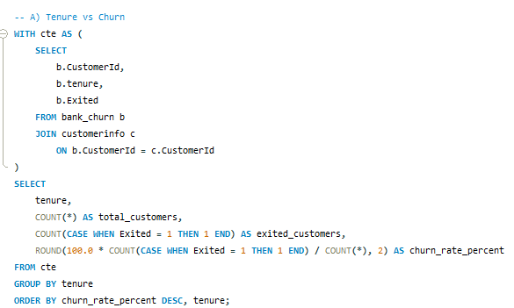
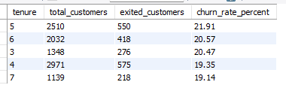

Insights
- Tenure 5 & 6 years show the highest churn rates (~21%), indicating customers are most likely to leave mid-journey.
- Customers in mid-tenure (3–6 years) churn more than new or long-term customers.
- Suggests customer engagement weakens after initial years and value perception declines over time.

Recommendations
- Introduce customer retention programs around year 3–5, such as:
  - Loyalty benefits and relationship manager support.
  - Personalized offers (credit limit upgrades, lower fees).
- Conduct mid-tenure satisfaction surveys to detect dissatisfaction earlier.
- Create proactive alerts for declining engagement behaviors (reduced product usage, decreasing balance).
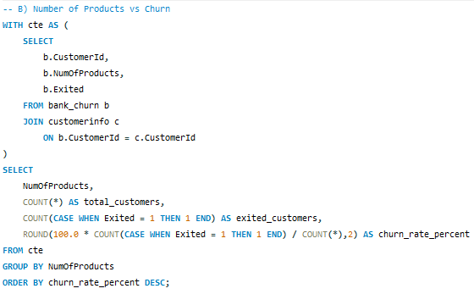
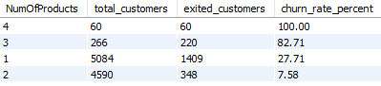
Insights
- 3+ products → Extremely high churn (83–100%) — over cross-selling may be driving dissatisfaction.
- 2 products → Most stable group with lowest churn (~7.6%).
- 1 product → Higher churn (~28%) — low engagement, at-risk segment.

Recommendations
- Identify services or product combinations where customers are facing dissatisfaction or loss.
- 1-product customers → Promote gradual upgrades and personalized offers.
- 3+ product customers → Ensure RM follow-up, simplify fees, and bundle benefits for better value perception.
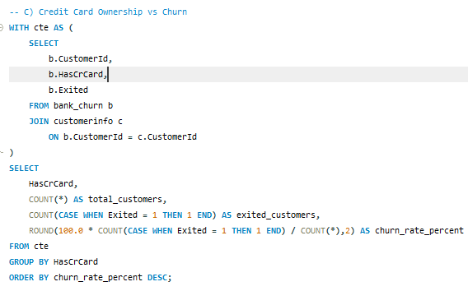
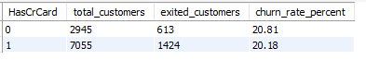

Insights
- Churn rate is similar for customers with and without credit cards (~20%).
- Credit card ownership isn’t a strong driver of retention or loyalty.

Recommendations
- Focus on engagement, not just card issuance, to build real loyalty.
- Launch reward-based activity programs (points for balance, transactions, or product use).

-- D) Credit Score Group vs Churn
WITH cte AS (
SELECT
b.CustomerId,
b.CreditScore,
b.Exited
FROM bank_churn b
JOIN customerinfo c
ON b.CustomerId = c.CustomerId
),
score_grouped AS (
SELECT
CASE
WHEN CreditScore < 580 THEN 'Poor (<580)'
WHEN CreditScore BETWEEN 580 AND 669 THEN 'Fair (580-669)'
WHEN CreditScore BETWEEN 670 AND 739 THEN 'Good (670-739)'
WHEN CreditScore BETWEEN 740 AND 799 THEN 'Very Good (740-799)'
WHEN CreditScore >= 800 THEN 'Excellent (800+)'
END AS credit_score_group,
Exited
FROM cte
)
SELECT
credit_score_group,
COUNT(*) AS total_customers,
COUNT(CASE WHEN Exited = 1 THEN 1 END) AS exited_customers,
ROUND(100.0 * COUNT(CASE WHEN Exited = 1 THEN 1 END) / COUNT(*),2) AS churn_rate_percent
FROM score_grouped
GROUP BY credit_score_group
ORDER BY churn_rate_percent DESC;
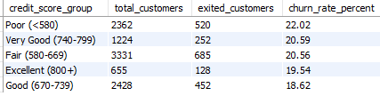

Insights
- Churn decreases as credit score improves — higher-score customers are more stable.
- Poor (<580) group shows the highest churn (22%), indicating a high-risk, low-loyalty segment.
- Good (670–739) and Excellent (800+) customers have the lowest churn, showing financial discipline and satisfaction.
- Fair (580–669) and Very Good (740–799) show similar churn → product fit and engagement also influence retention.

Recommendations
- Poor (<580) → Offer financial advisory, EMI flexibility, and small-limit products with proactive RM follow-ups.
- Fair (580–669) → Launch credit score improvement and loyalty-based limit increase programs.
- Good & Excellent (670+) → Promote premium bundles, relationship-driven offers, and high-value engagement plans.

- Are 'Tenure', 'NumOfProducts', 'IsActiveMember', and 'EstimatedSalary' important for predicting if a customer will leave the bank?
Yes, the variables 'Tenure', 'NumOfProducts', 'IsActiveMember', and 'EstimatedSalary' are important for predicting if a customer will leave the bank. Here's why each factor plays a key role in churn prediction:

Tenure:
- Customers with shorter tenure are more likely to leave because they haven't built a strong relationship with the bank yet. On the other hand, customers with longer tenure may be more loyal but may still churn due to dissatisfaction after a longer engagement.

NumOfProducts:
- Customers holding fewer products are less engaged with the bank and have less to lose if they leave, making them more prone to churn. On the other hand, customers with multiple products are likely more invested and harder to disengage.

IsActiveMember:
- Customers who are inactive or not actively using the bank's services are more likely to leave since they're less engaged. This makes the "IsActiveMember" status a strong predictor of potential churn.

EstimatedSalary:
- Customers with higher salaries are typically offered premium services, which could incentivize them to stay. However, customers with lower salaries may face financial difficulties or find better offers elsewhere, leading to higher churn rates.

These factors, along with others such as CreditScore and Balance, form a comprehensive profile that can be used to predict customer churn behavior using machine learning models like logistic regression, decision trees, or random forests.

- Utilize SQL queries to segment customers based on demographics and account details.

SELECT
b.CustomerId,
c.Age,
CASE
WHEN c.Age <=25 THEN 'Young'
WHEN c.Age BETWEEN 26 AND 35 THEN 'Adult'
WHEN c.Age BETWEEN 36 AND 50 THEN 'Middle Age'
WHEN c.Age > 50 THEN 'Senior'
END AS age_group,

b.tenure,
CASE
WHEN b.tenure < 3 THEN 'New'
WHEN b.tenure BETWEEN 3 AND 5 THEN 'Frequent'
WHEN b.tenure >= 6 THEN 'Loyal'
END AS tenure_group,

CASE
WHEN b.HasCrCard = 1 THEN 'Has Credit Card'
ELSE 'No Credit Card'
END AS credit_card_status,

CASE
WHEN b.CreditScore < 580 THEN 'Poor'
WHEN b.CreditScore BETWEEN 580 AND 669 THEN 'Fair'
WHEN b.CreditScore BETWEEN 670 AND 739 THEN 'Good'
WHEN b.CreditScore BETWEEN 740 AND 799 THEN 'Very Good'
WHEN b.CreditScore >= 800 THEN 'Excellent'
END AS credit_score_group

FROM bank_churn b
JOIN customerinfo c
ON b.CustomerId = c.CustomerId;

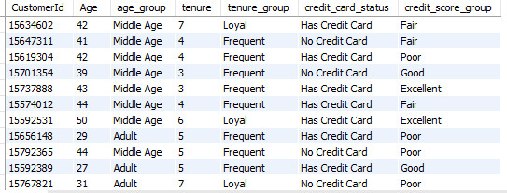

Method
- Joined customer demographic data (customerinfo) with account data (bank_churn) using CustomerId.
- Segmented customers into analytical groups for deeper behavior analysis:
  - Age Group → Young (≤25), Adult (26–35), Middle Age (36–50), Senior (>50)
  - Tenure Group → New (<3 yrs), Frequent (3–5 yrs), Loyal (≥6 yrs)
  - Credit Card Status → Has Credit Card / No Credit Card
  - Credit Score Group → Poor (<580), Fair (580–669), Good (670–739), Very Good (740–799), Excellent (≥800)
- This classification enables analysis of churn patterns, engagement levels, and retention trends across demographic and behavioral dimensions.

Insights:

- Many "Young Adults (25-35)" and "Middle Age (36-50)" customers have high credit scores (above 700) and high balances, indicating strong financial stability.

- Customers with "Good Credit" and "Loyal Customer" tenure segments generally hold credit cards and exhibit higher balances.

- Customers with "Poor Credit" tend to have low balances, particularly in the "Middle Age (36-50)" group, which could indicate financial challenges.

Recommendations:

- Focus on retaining "Loyal Customers" with good credit by offering premium services and rewards to maintain engagement.

- Develop financial products targeted at customers with "Poor Credit" to help improve their financial standing and reduce churn risk.

- Encourage cross-selling to "Moderate Customers" by offering additional products, particularly to those with "Average Credit" to increase product engagement and tenure.

- How can we create a conditional formatting setup to visually highlight customers at risk of churn and to evaluate the impact of credit card rewards on customer retention?

Methodology
Applied conditional formatting using
=AND($B:$B<500, $D:$D<30000)
to visually highlight high-risk customers (low credit score & low balance) and analyze the link between financial stability, churn risk, and credit card rewards.
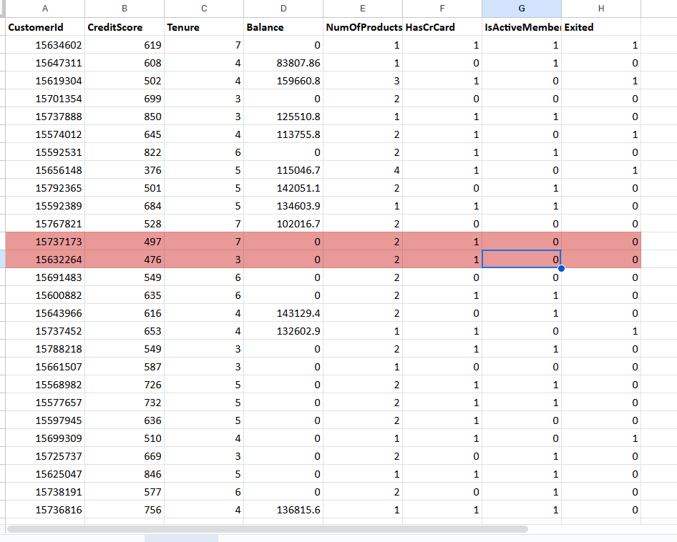

Insights
- Customers with credit score <500 and balance <30,000 are most prone to churn, reflecting financial instability.
- Conditional formatting helps quickly identify this at-risk segment for targeted retention actions.
- These customers often show low engagement and product usage, signaling early warning signs of attrition.
- Credit card rewards and benefit structures may influence retention within this group — customers with rewards tend to stay longer.

Recommendations
- Target this high-risk segment with credit-building offers and financial advisory support.
- Introduce simple, low-fee reward programs to boost engagement and trust.
- Offer EMI flexibility or small savings incentives to ease financial pressure.
- Track churn patterns of highlighted customers to measure the impact of reward-based retention efforts.

- What is the current churn rate per year and overall as well in the bank? Can you suggest some insights to the bank about which kind of customers are more likely to churn and what different strategies can be used to decrease the churn rate?
WITH exit_data AS (
SELECT
b.CustomerId,
YEAR(Bank_DOJ_new) + Tenure AS Exit_Year,
b.Exited
FROM bank_churn b
JOIN customerinfo c
ON b.CustomerId = c.CustomerId
)
-- Year-wise
SELECT
Exit_Year ,
COUNT(CASE WHEN Exited = 1 THEN 1 END) * 100.0 / COUNT(*) AS Churn_Rate_Percentage,
COUNT(CASE WHEN Exited = 1 THEN 1 END) AS Churned_Customers,
COUNT(*) AS Total_Customers
FROM exit_data
GROUP BY Exit_Year

UNION ALL

-- Overall
SELECT
'Overall' AS Year,
COUNT(CASE WHEN Exited = 1 THEN 1 END) * 100.0 / COUNT(*) AS Churn_Rate_Percentage,
COUNT(CASE WHEN Exited = 1 THEN 1 END) AS Churned_Customers,
COUNT(*) AS Total_Customers
FROM exit_data
ORDER BY
CASE WHEN Exit_Year = 'Overall' THEN 1 ELSE 0 END,
Exit_Year;

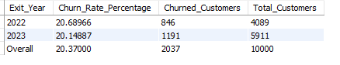

Methodology
Calculated year-wise and overall churn rate by deriving each customer’s exit year (YEAR(Bank_DOJ_new) + Tenure) and comparing churned vs total customers.

Insights
- 2022: 20.69% churn — slightly higher, showing moderate attrition.
- 2023: 20.15% churn — small improvement in retention.
- Overall: ~20.37% churn — stable but high; 1 in 5 customers leaving.

Recommendations
- Focus on early retention and engagement (first 1–3 years).
- Use predictive churn models to flag at-risk customers.
- Offer personalized loyalty and reward programs to reduce exits.
- Improve customer experience through targeted feedback actions.

- Create a dashboard incorporating all the KPIs and visualization-related metrics. Use a slicer in order to assist in selection in the dashboard.

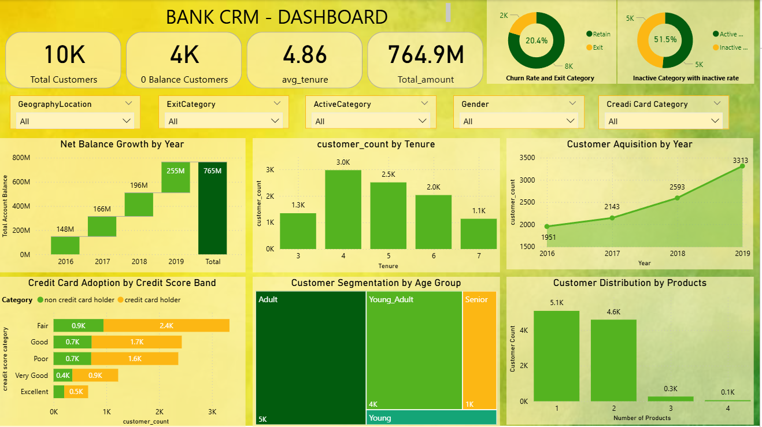
Methodology
- Built an interactive Churn Analysis Dashboard to evaluate customer retention and attrition patterns across regions, products, credit scores, and tenure levels.
- Integrated data from multiple SQL tables (bank_churn, customerinfo, creditcard, geography, activecustomer, exitcustomer) through direct joins to create a unified dataset.
- Calculated key churn metrics: Total Churned Customers, Churn %, Average Tenure, Average Balance, and Amount Lost.
- Derived Exit Year using TIMESTAMPDIFF(YEAR, Bank_DOJ, CURDATE()) to compute tenure and churn timelines.
- Dashboard name dynamically changes by region (France, Germany, Spain) using slicer selections.
- Applied conditional color formatting for KPIs — Green for healthy (low churn/inactivity) and Red for high-risk values — for immediate visual insights.
- Created visual comparisons for churn by year, tenure, product count, age group, and credit score to identify key churn drivers.

Insights
- Overall churn rate: ~20.4%, indicating that 1 in 5 customers are leaving.
- Churn trend: Improved slightly YoY (22% → 20%), showing early signs of retention progress.
- By services used:
  - 1-service customers → 28% churn (low engagement).
  - 2-service customers → 7% churn (most stable and loyal segment).
  - 3–4 services → 82–100% churn (over-complexity or dissatisfaction).
- By tenure: Churn peaks between 4–5 years, suggesting customer fatigue or unaddressed service issues mid-relationship.
- By age group: Younger customers (18–30) churn less (~7%), while Adults/Seniors show higher churn.
- By credit score:
  - Poor credit customers churn more due to financial instability.
  - Excellent credit customers also churn → driven by service experience, not financial stress.
- By region:
  - Germany: Highest churn (~32%), linked to dissatisfaction despite active usage.
  - France: Stable (~16%) with strong product adoption.
  - Spain: Low churn (~16.7%) but low engagement; many inactive accounts.

Recommendations
- Activate inactive and zero-balance accounts using reactivation campaigns, auto-sweep, and reward-linked saving offers.
- Cross-sell additional products (credit card, loan, investment) to single-service customers to build engagement and reduce churn.
- Simplify multi-product experiences — review fees, improve digital usability, and assign relationship managers for high-value customers.
- Introduce loyalty renewal offers (fee waivers, bonus rewards) at the 4–5 year mark to retain mid-tenure customers.
- Provide senior-friendly services with assisted support, simpler app design, and dedicated service desks.
- Retain excellent credit score customers with premium service tiers, faster service queues, and personalized offers.
- Improve Germany’s customer satisfaction through better complaint resolution, transparent pricing, and proactive outreach.
- Boost Spain’s customer activation using digital onboarding, referral programs, and engagement-based rewards.

- How would you approach this problem, if the objective and subjective questions weren't given?
If the objective and subjective questions weren't given, here’s how I would approach the problem of analyzing the "Bank_Churn" dataset with the goal of uncovering insights and solving relevant business challenges:

1. Understand the Schema
- Review the provided data schema and ER diagram to understand the relationships between different tables, columns, and data points (e.g., customerinfo, bank_churn, exitcustomer, activecustomer, etc.).
- Identify key tables such as customerinfo for demographic data, bank_churn for customer activity, and exitcustomer for churn data.

2. Data Cleaning and Preprocessing:
- Missing Values: Identify any missing or inconsistent values in the dataset, especially in critical fields like CreditScore, Balance, NumOfProducts, and EstimatedSalary.
- Data Discrepancies: Ensure that there are no conflicting data points in columns like IsActiveMember and Exited (for instance, an active member marked as exited).
- Data Transformation: Prepare the data for analysis by formatting columns (e.g., dates, currency), renaming ambiguous column names (HasCrCard to Has_creditcard), and generating new fields (e.g., combining CustomerID and Surname into a unique key).

3. Key Business Metrics Identification:
- Churn Rate: Compute the overall churn rate and segment it by demographics such as age, gender, geography, and tenure.
- Product Engagement: Analyze how many products each customer uses and the average number of products for different customer segments (e.g., those who have exited vs. those who remain).
- Credit Score Analysis: Compare average credit scores between customers who have exited and those who remain with the bank.
- Customer Lifetime Value (Tenure Forecast): Use customer tenure as a key metric to predict lifetime value based on demographic and behavioral patterns.

4. Customer Segmentation:
- Segment customers based on demographics (age, gender, geography) and account details (balance, credit score, number of products). This segmentation can help in creating marketing or retention strategies targeted to specific groups.
- Segment churned customers by their characteristics (e.g., tenure, product usage) to understand what factors are most likely to contribute to churn.

5. SQL Queries to Generate Insights:
- Churn Analysis: Write SQL queries to calculate the churn rate by year, geography, and gender. Analyze the characteristics of customers who churn (low engagement, low balance, etc.).
- Product Affinity: Investigate common product combinations (e.g., customers with both credit cards and loans) to identify cross-selling opportunities.
- Credit Score Impact: Query data to analyze the relationship between customer credit scores and churn or product engagement.
- Customer Retention: Analyze the retention rates of customers who use multiple products versus those who use fewer products.

6. Data Visualization and Reporting:
- Dashboards: Develop visualizations (e.g., in Power BI or Tableau) for key metrics like churn rate, customer segmentation, product usage, and credit score distribution.
- Conditional Formatting: Highlight high-risk customers in visual reports using conditional formatting to identify those most likely to churn.
- Time-Series Analysis: Visualize trends in customer sign-ups, exits, and product usage over time (e.g., seasonal or yearly trends).

7. Business Recommendations:
- Retention Strategies: Based on churn analysis, recommend personalized offers, loyalty programs, and engagement campaigns to retain customers who are likely to churn.
- Product Cross-Selling: Leverage product affinity insights to recommend cross-selling strategies that can increase customer engagement and retention.
- Credit Score Management: Suggest financial counseling or credit score improvement programs for customers with low credit scores to reduce churn and increase engagement.

This approach allows for a comprehensive understanding of the bank's customer behavior, churn patterns, and product engagement, leading to actionable insights and business strategies.

- In the “Bank_Churn” table how can you modify the name of the “HasCrCard” column to “Has_creditcard”?
Renamed the column HasCrCard to Has_creditcard in the bank_churn table using an ALTER TABLE command to maintain consistent and readable naming conventions across the dataset for better clarity and analysis.
