Practice 1

Section 1:

Navigate to System Properties table by typing sys_properties.LIST in the filter search box

Disable Next experience by looking up for the glide.ui.polaris.experience property and setting the value to false

Observe the change in the home page.

If you switch to UI15, switch back to UI16 before re-enabling next experience.

Section 2:

What are list and form views? What are filters?

1. List view – the format in which all the records in a table can be viewed is called a list view. We can create multiple views to view the records for different purposes.
2. Form view – the format in which individual record can be viewed for viewing, editing or new record creation purposes is called a form view. Depending on the necessity, each form view can contain different columns available to the particular form view.
3. Filter breadcrumb: [>](javascript:void(0))Active = true[>](javascript:void(0))State = In Progress .or. State = New .or. State = On Hold[>](javascript:void(0)) Category = Software

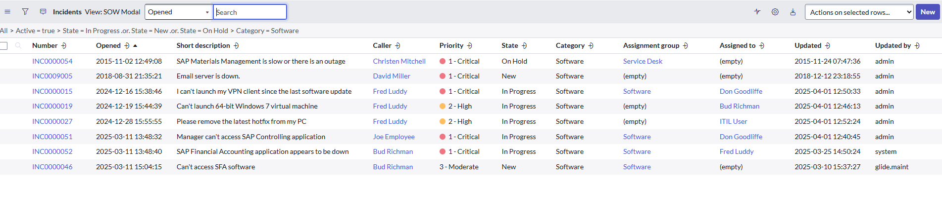

Section 3:

How will you configure it? Create your own filter and mark as favorite

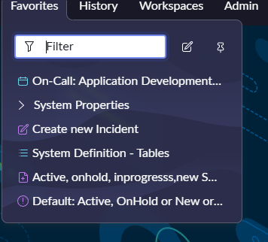

Question 4:

How to create views? Create one sample view in your instance of your choice

1. Navigate to incident table in a different page by typing incident.LIST in the filter search bar and hitting enter
2. Right click on any field and select Configure 🡪 List Layout
3. Under list view/view name, select “New”

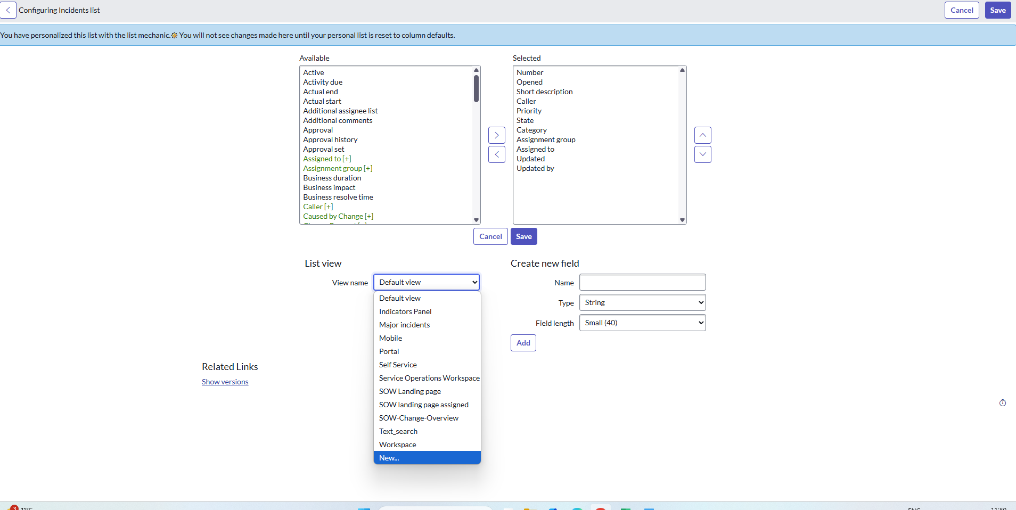

1. Type a name for the new view (for example: Incident high level view)
2. From the “Available” slush bucket, select “Incident State” and double click it
3. From “Selected” slush bucket move all fields except “Number”,” Short Description”,” Priority” and,” Incident State” and move them to the “Available” slush bucket
4. Select “Save”
5. Click on hamburger icon, select view and select “Incident high level view”

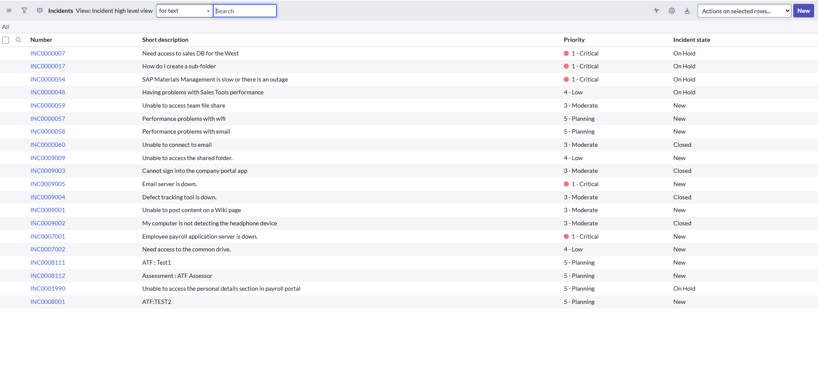

To delete the view, from home page, navigate to System UI 🡪 Views and find and delete the view

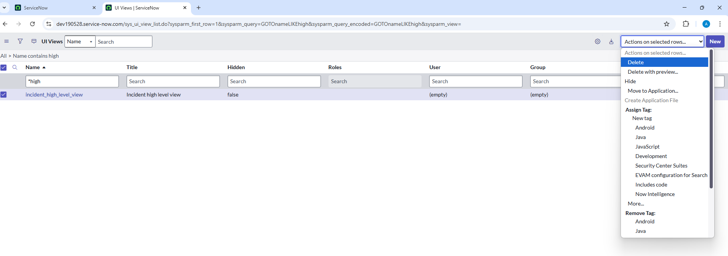

Section 5:

What type of searches are available in ServiceNow? What is the use of ServiceNow?

Practice 2

Section 1: Create a custom table

Create a custom table “School Database”

|  |  |
| --- | --- |
| Column Name | Column Type |
| Student Name | Reference (user) |
| Location | Reference (location) |
| Skills | Choice (PCM, PCMB, Commerce) |
| Admission Date | Date Time |
| Fee Paid | True/false |

Section 2: Create a Filter for PCM students

Filter: Only PCM Students

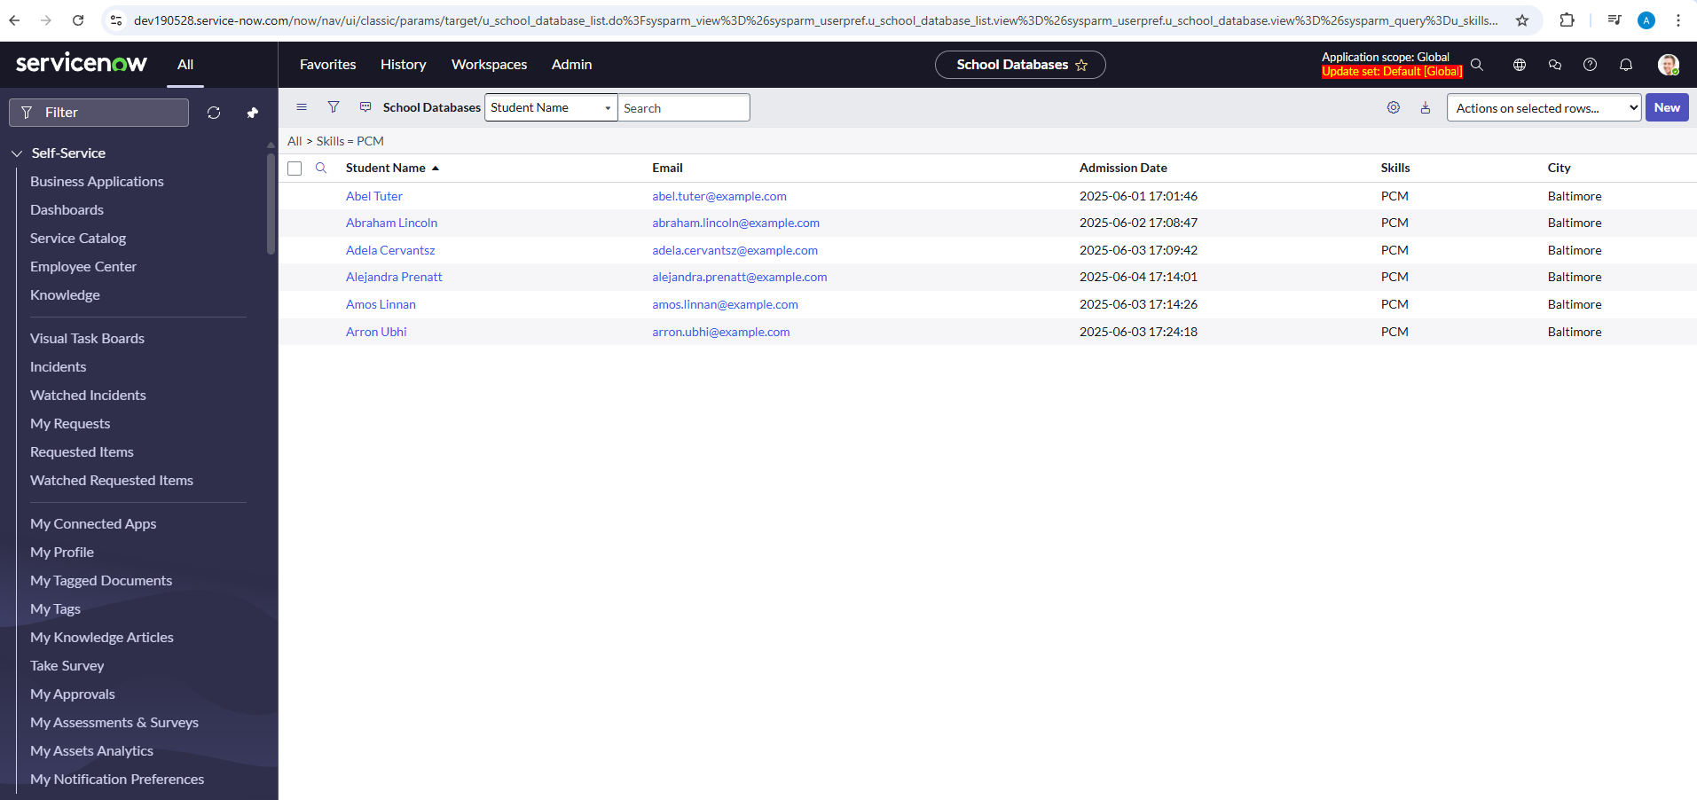

Section 2: Create a “Student View” without “Fee Paid” column

Student View – without “Fee Paid” column

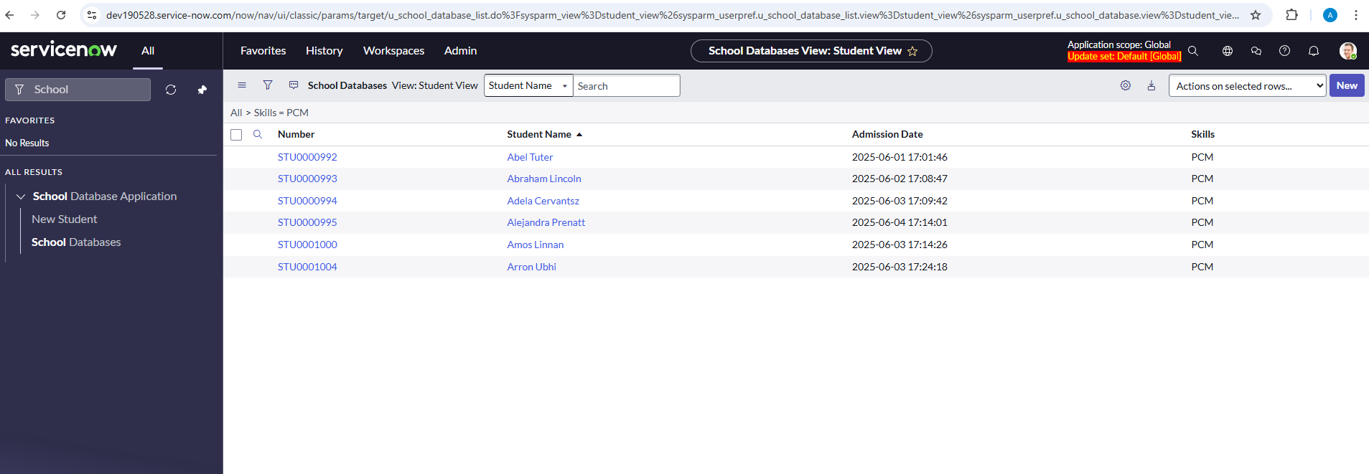

Section 3: Create a “Teacher View” with “Fee Paid” column

Teacher View – with “Fee Paid” column

Default view – without filter

Practice 3

Section 1: Create a read only column “College Name” of type “String” on “School Database” table

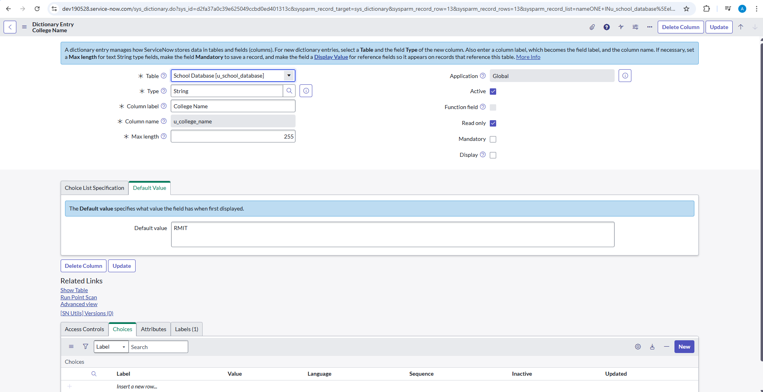

Section 2: Create form structure for the table with “College Name” on top

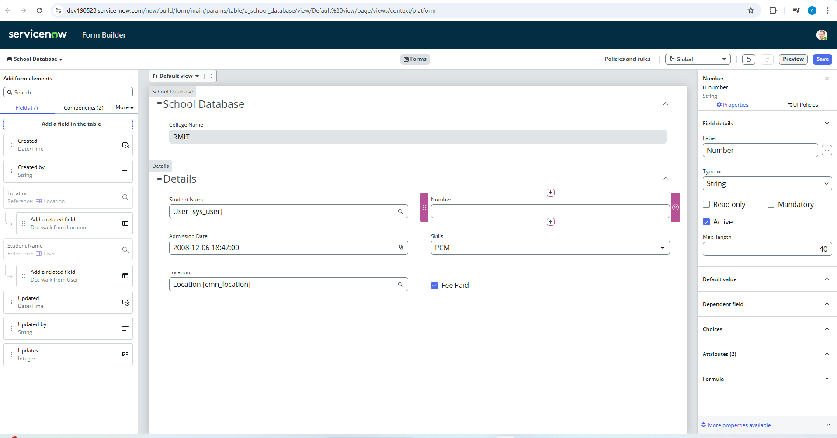

Form Builder Preview:

Section 3: Configure form structure for to be split into 2 columns for all fields except “College Name”

