Object Oriented Programming LAB REPORT

NAME: anuran chakraborty

Class: bcse-ii

Section: a1

Roll no.: 001610501020

Contents

**TOPICS**

1. C++
   1. ASSIGNMENT 1 (STUDENT)
   2. ASSIGNMENT 2 (BANK)
2. Java
   1. ASSIGNMENT 1 (HOSPITAL)
   2. ASSIGNMENT 2 (INDEXING A BOOK)

C++ Assignment 1:

**PROBLEM STATEMENT:**

Design a STUDENT class to store roll, name, course, admission date and marks in 5 subjects. Provide methods corresponding to admission date and receiving marks, preparing mark sheet. Support must be there to show the number of students who have taken admission.

**CLASS DIAGRAM:**

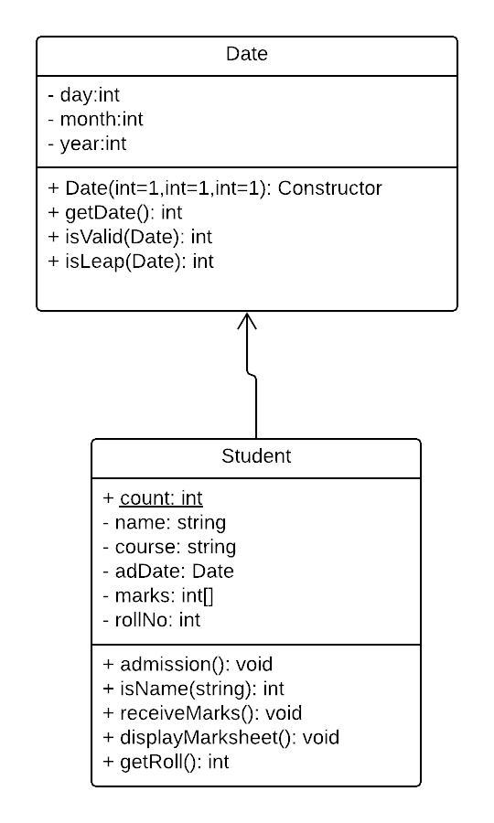

**OUTPUT:**

1. New Admission

2. Marks-entry

3. Marksheet display

4. Display total no of students

5. Exit

Enter choice

1

Enter name of student:

Ravi

Enter course name: Arts

Enter admission date: Enter date in dd-mm-yyyy format

14-05-2017

Admission successfull

Roll number of new student is: 100001

1. New Admission

2. Marks-entry

3. Marksheet display

4. Display total no of students

5. Exit

Enter choice

4

Total number of students: 1

1. New Admission

2. Marks-entry

3. Marksheet display

4. Display total no of students

5. Exit

Enter choice

1

Enter name of student:

Raj

Enter course name: Science

Enter admission date: Enter date in dd-mm-yyyy format

14-13-2017

Invalid date entered

Enter date in dd-mm-yyyy format

15-04-2018

Admission successfull

Roll number of new student is: 100002

1. New Admission

2. Marks-entry

3. Marksheet display

4. Display total no of students

5. Exit

Enter choice

2

Enter roll number of student 100001

Enter marks in 5 subjects

90

85

75

96

99

1. New Admission

2. Marks-entry

3. Marksheet display

4. Display total no of students

5. Exit

Enter choice

3

Enter roll number of student 100001

=================================================================

| Name :Ravi | Roll number: 100001 |

-----------------------------------------------------------------

| SUBJECT | MARKS |

-----------------------------------------------------------------

| Subject 0 | 90 |

| Subject 1 | 85 |

| Subject 2 | 75 |

| Subject 3 | 96 |

| Subject 4 | 99 |

-----------------------------------------------------------------

| Percentage: 89% |

=================================================================

1. New Admission

2. Marks-entry

3. Marksheet display

4. Display total no of students

5. Exit

Enter choice

4

Total number of students: 2

1. New Admission

2. Marks-entry

3. Marksheet display

4. Display total no of students

5. Exit

Enter choice

5

Quitting

C++ Assignment 2:

**PROBLEM STATEMENT:**

In a bank two types of accounts are there savings and current. For savings account a minimum deposit of Rs. 500 are to be kept. In current account overdraft up to Rs. 20,000 is allowed. Each transaction is noted. Design and implement the necessary classes.

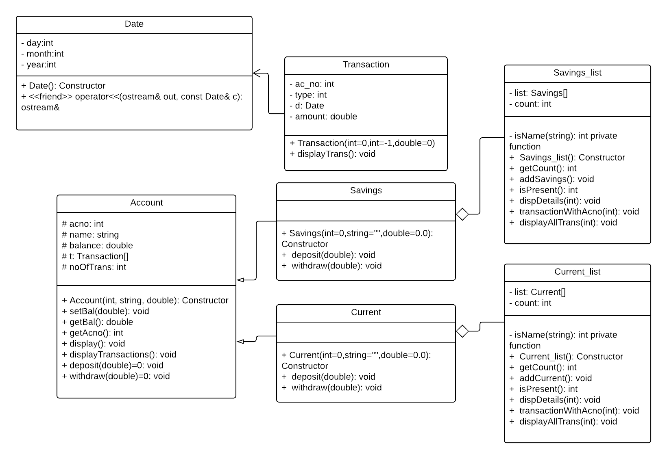**CLASS DIAGRAM:**

**OUTPUT:**

1. Add new savings account

2. Add new current account

3. Transact with existing savings account

4. Transact with existing current account

5. Display details of existing savings account

6. Display details of existing current account

7. Display transaction details of existing savings account

8. Display transaction details of existing current account

9. Exit

Enter choice

1

Enter name of account holder

Raj

Enter amount to deposit

5000

Your account details are

==================================================

YOUR ACCOUNT DETAILS ARE:

Account number: 10000

Name: Raj

Balance: Rs.5000 (if negative then consider overdraft)

===================================================

Account successfully added

1. Add new savings account

2. Add new current account

3. Transact with existing savings account

4. Transact with existing current account

5. Display details of existing savings account

6. Display details of existing current account

7. Display transaction details of existing savings account

8. Display transaction details of existing current account

9. Exit

Enter choice

3

Enter account number

10000

Enter type of transaction

0. Deposit

1. Withdrawal

0

Enter amount

4000

Deposit successful

1. Add new savings account

2. Add new current account

3. Transact with existing savings account

4. Transact with existing current account

5. Display details of existing savings account

6. Display details of existing current account

7. Display transaction details of existing savings account

8. Display transaction details of existing current account

9. Exit

Enter choice

5

Enter account number

10000

==================================================

YOUR ACCOUNT DETAILS ARE:

Account number: 10000

Name: Raj

Balance: Rs.9000 (if negative then consider overdraft)

===================================================

1. Add new savings account

2. Add new current account

3. Transact with existing savings account

4. Transact with existing current account

5. Display details of existing savings account

6. Display details of existing current account

7. Display transaction details of existing savings account

8. Display transaction details of existing current account

9. Exit

Enter choice

3

Enter account number

10000

Enter type of transaction

0. Deposit

1. Withdrawal

1

Enter amount

30000

Cannot withdraw...minimum balance must be maintained

1. Add new savings account

2. Add new current account

3. Transact with existing savings account

4. Transact with existing current account

5. Display details of existing savings account

6. Display details of existing current account

7. Display transaction details of existing savings account

8. Display transaction details of existing current account

9. Exit

Enter choice

3

Enter account number

10000

Enter type of transaction

0. Deposit

1. Withdrawal

1

Enter amount

3000

Withdraw successful

1. Add new savings account

2. Add new current account

3. Transact with existing savings account

4. Transact with existing current account

5. Display details of existing savings account

6. Display details of existing current account

7. Display transaction details of existing savings account

8. Display transaction details of existing current account

9. Exit

Enter choice

5

Enter account number

10000

==================================================

YOUR ACCOUNT DETAILS ARE:

Account number: 10000

Name: Raj

Balance: Rs.6000 (if negative then consider overdraft)

===================================================

1. Add new savings account

2. Add new current account

3. Transact with existing savings account

4. Transact with existing current account

5. Display details of existing savings account

6. Display details of existing current account

7. Display transaction details of existing savings account

8. Display transaction details of existing current account

9. Exit

Enter choice

2

Enter name of account holder

Raju

Enter amount to deposit

30000

Your account details are

==================================================

YOUR ACCOUNT DETAILS ARE:

Account number: 20000

Name: Raju

Balance: Rs.30000 (if negative then consider overdraft)

===================================================

Account successfully added

1. Add new savings account

2. Add new current account

3. Transact with existing savings account

4. Transact with existing current account

5. Display details of existing savings account

6. Display details of existing current account

7. Display transaction details of existing savings account

8. Display transaction details of existing current account

9. Exit

Enter choice

4

Enter account number

20000

Enter type of transaction

0. Deposit

1. Withdrawal

1

Enter amount

50000

Withdraw successful

1. Add new savings account

2. Add new current account

3. Transact with existing savings account

4. Transact with existing current account

5. Display details of existing savings account

6. Display details of existing current account

7. Display transaction details of existing savings account

8. Display transaction details of existing current account

9. Exit

Enter choice

6

Enter account number

20000

==================================================

YOUR ACCOUNT DETAILS ARE:

Account number: 20000

Name: Raju

Balance: Rs.-20000 (if negative then consider overdraft)

===================================================

1. Add new savings account

2. Add new current account

3. Transact with existing savings account

4. Transact with existing current account

5. Display details of existing savings account

6. Display details of existing current account

7. Display transaction details of existing savings account

8. Display transaction details of existing current account

9. Exit

Enter choice

4

Enter account number

20000

Enter type of transaction

0. Deposit

1. Withdrawal

1

Enter amount

4000

Cannot withdraw..overdraft limit reached

1. Add new savings account

2. Add new current account

3. Transact with existing savings account

4. Transact with existing current account

5. Display details of existing savings account

6. Display details of existing current account

7. Display transaction details of existing savings account

8. Display transaction details of existing current account

9. Exit

Enter choice

9

Quitting

JAVA Assignment 1:

**PROBLEM STATEMENT:**

Design and create a hospital information system with the following scenarios.

● Register a new patient.

● Each patient is assigned to one doctor, but a doctor can have any number of patients. Patients check in to the hospital and assigned a doctor if they don't already have one.

● While in the hospital, doctors record various observations about each patient at various times. Examples of observations are blood pressure and temperature. Record test results for a patient.

● The hospital keeps track of all the observations for a given patient until they check out of the hospital. Obtain all of a patient’s information given the social security number.

**CLASS DIAGRAM:**

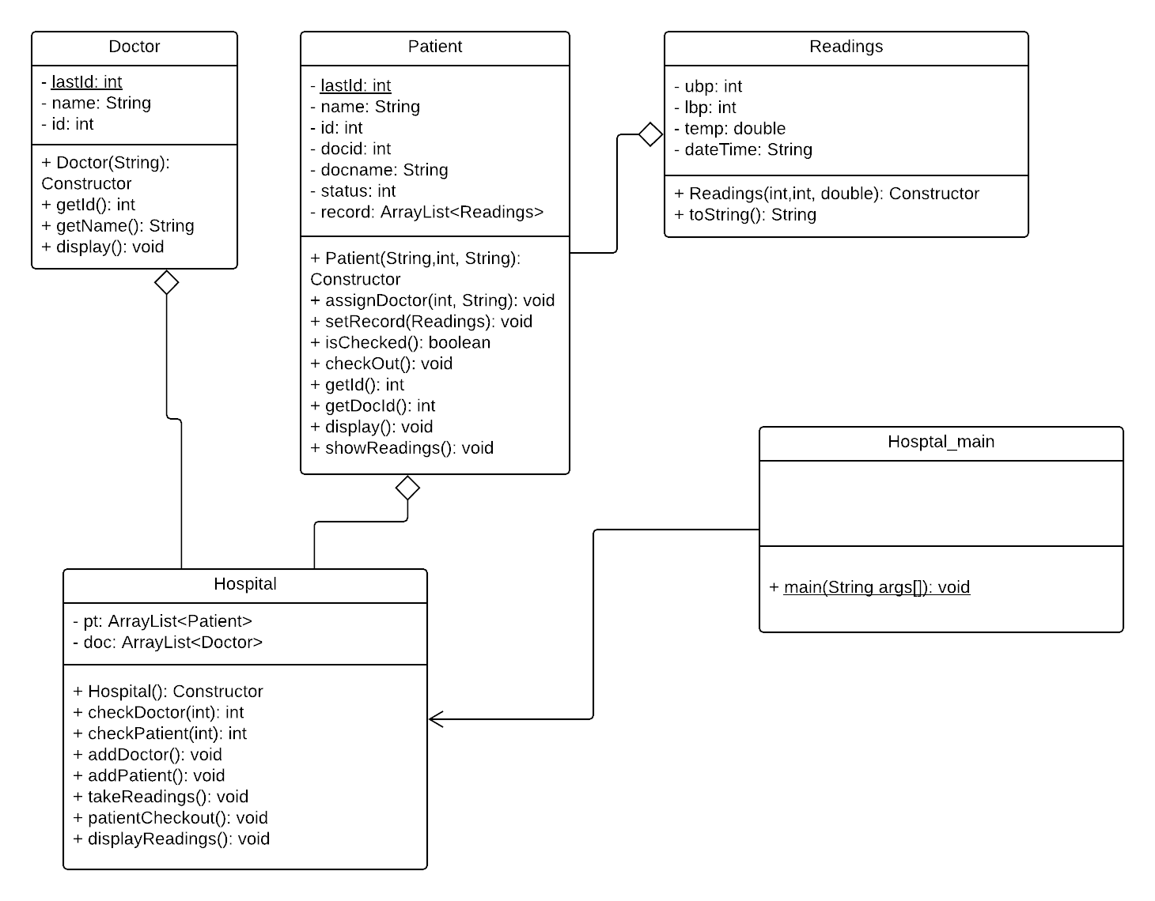

**OUTPUT:**

1. Add a new doctor

2. Add a new patient

3. Take readings

4. Checkout patient

5. Display all readings of a patient

6. Exit

Enter choice

1

Enter name of doctor

Dr. Ravi

Id: 20000

Name: Dr. Ravi

1. Add a new doctor

2. Add a new patient

3. Take readings

4. Checkout patient

5. Display all readings of a patient

6. Exit

Enter choice

1

Enter name of doctor

Dr. Ram

Id: 20001

Name: Dr. Ram

1. Add a new doctor

2. Add a new patient

3. Take readings

4. Checkout patient

5. Display all readings of a patient

6. Exit

Enter choice

2

Enter name of patient

Anu

Enter doctor id to assign to

23

Invalid doctor id

Enter doctor id to assign to

20001

1. Add a new doctor

2. Add a new patient

3. Take readings

4. Checkout patient

5. Display all readings of a patient

6. Exit

Enter choice

3

Enter patient id

1000

Invalid patient id

Enter patient id

10000

Enter upper and lower blood pressure

90

140

Invalid pressure

Enter upper and lower blood pressure

80

120

Invalid pressure

Enter upper and lower blood pressure

120

80

Enter body temperature in fahrenheit

98

1. Add a new doctor

2. Add a new patient

3. Take readings

4. Checkout patient

5. Display all readings of a patient

6. Exit

Enter choice

5

Enter patient id

10000

Taken by: Dr. Ram

-----------------------------------------------

15 Apr 2018 12:11:21

BP: 120/80

TEMPERATURE: 98.0

-------------------------------------------

1. Add a new doctor

2. Add a new patient

3. Take readings

4. Checkout patient

5. Display all readings of a patient

6. Exit

Enter choice

4

Enter patient id..enter -1 to exit

10000

Patient successfully checked out

1. Add a new doctor

2. Add a new patient

3. Take readings

4. Checkout patient

5. Display all readings of a patient

6. Exit

Enter choice

4

Enter patient id..enter -1 to exit

10000

Patient already checked out

1. Add a new doctor

2. Add a new patient

3. Take readings

4. Checkout patient

5. Display all readings of a patient

6. Exit

Enter choice

6

Now quitting

JAVA Assignment 2:

**PROBLEM STATEMENT:**

Indexing a book. Write a program that reads in a text file from standard input and compiles an alphabetical index of which words appear on which lines, as in the following input. Ignore case and punctuation. For each word maintain a list of location on which it appears. Try to use HashTable and/or HashMap class (of java.util).

**CLASS DIAGRAM:**

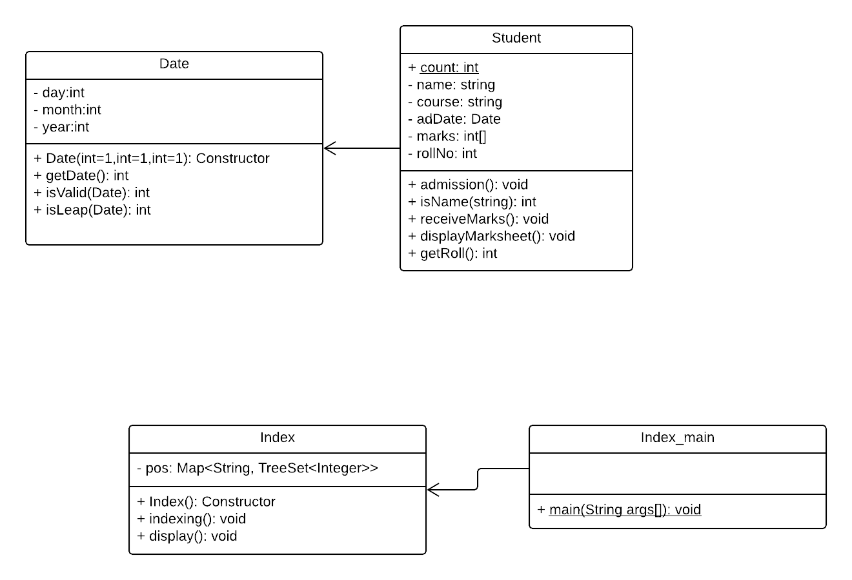

**OUTPUT:**

**Given the following file as input:**

Now now indulgence dissimilar for his thoroughly has terminated. Agreement

offending commanded my an. Change wholly say why eldest period. Are

projection put celebrated particular unreserved joy unsatiable its.

In then dare good am rose bred or. On am in nearer square wanted.

Are own design entire former get should. Advantages boisterous day

excellence boy. Out between our two waiting wishing. Pursuit he he

garrets greater towards amiable so placing. Nothing off

how norland delight. Abode shy shade she hours forth its use.

Up whole of fancy ye quiet do. Justice fortune no to is if winding

morning forming. now

Enter name of file to read

problem5/test.txt

Invalid file

Enter name of file to read

D:\Eclipseprojects\problem5\src\problem5\test.txt

: [5]

abode: [9]

advantages: [6]

agreement: [1]

am: [4]

amiable: [8]

an: [2]

are: [2, 6]

between: [7]

boisterous: [6]

boy: [7]

bred: [4]

celebrated: [3]

change: [2]

commanded: [2]

dare: [4]

day: [6]

delight: [9]

design: [6]

dissimilar: [1]

do: [10]

eldest: [2]

entire: [6]

excellence: [7]

fancy: [10]

for: [1]

former: [6]

forming: [11]

forth: [9]

fortune: [10]

garrets: [8]

get: [6]

good: [4]

greater: [8]

has: [1]

he: [7]

his: [1]

hours: [9]

how: [9]

if: [10]

in: [4]

indulgence: [1]

is: [10]

its: [3, 9]

joy: [3]

justice: [10]

morning: [11]

my: [2]

nearer: [4]

no: [10]

norland: [9]

nothing: [8]

now: [1, 11]

of: [10]

off: [8]

offending: [2]

on: [4]

or: [4]

our: [7]

out: [7]

own: [6]

particular: [3]

period: [2]

placing: [8]

projection: [3]

pursuit: [7]

put: [3]

quiet: [10]

rose: [4]

say: [2]

shade: [9]

she: [9]

should: [6]

shy: [9]

so: [8]

square: [4]

terminated: [1]

then: [4]

thoroughly: [1]

to: [10]

towards: [8]

two: [7]

unreserved: [3]

unsatiable: [3]

up: [10]

use: [9]

waiting: [7]

wanted: [4]

whole: [10]

wholly: [2]

why: [2]

winding: [10]

wishing: [7]

ye: [10]