Pandas Tutorial:

Youtube-https://www.youtube.com/watch?v=txMdrV1Ut64

Matplotlib exercise

Seaborn documentation

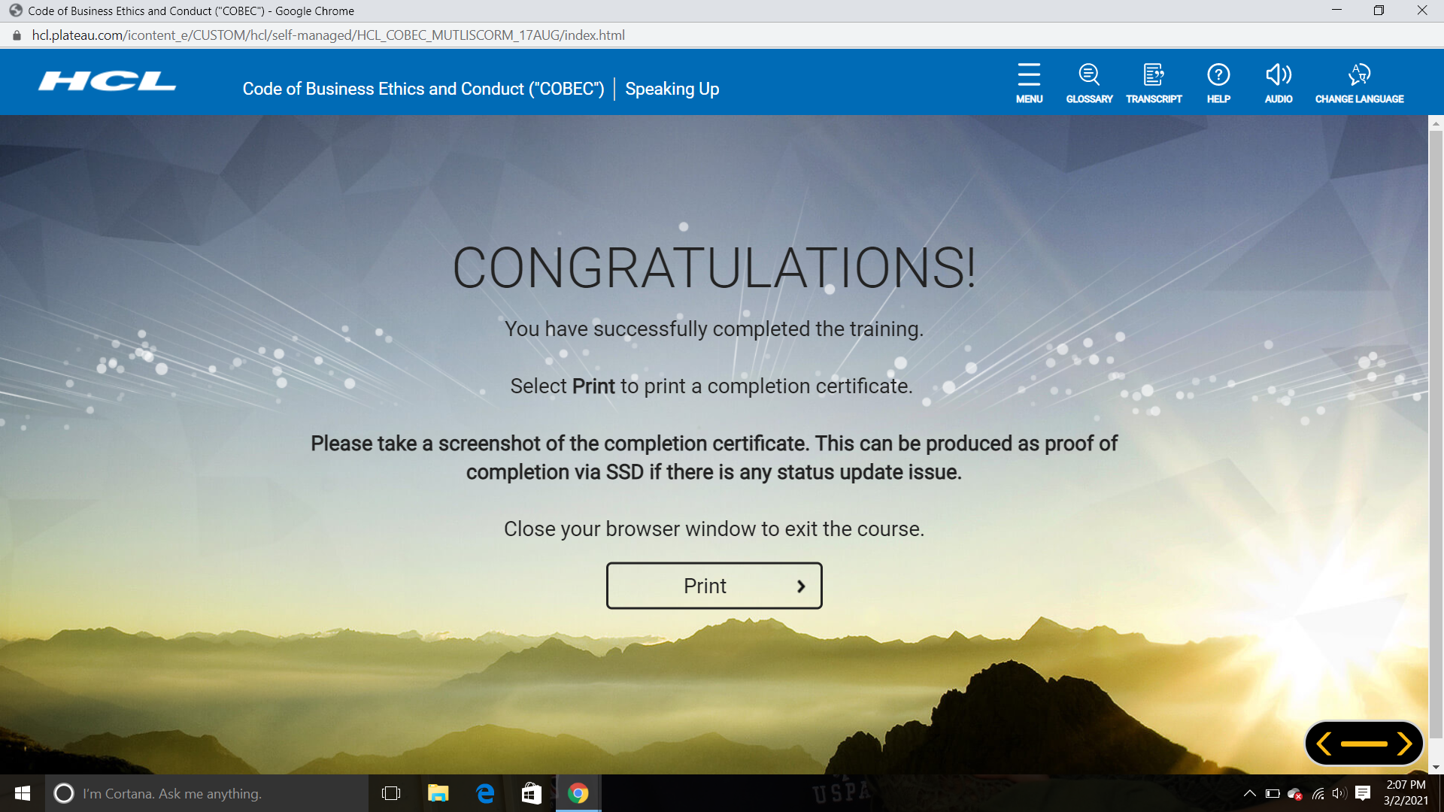

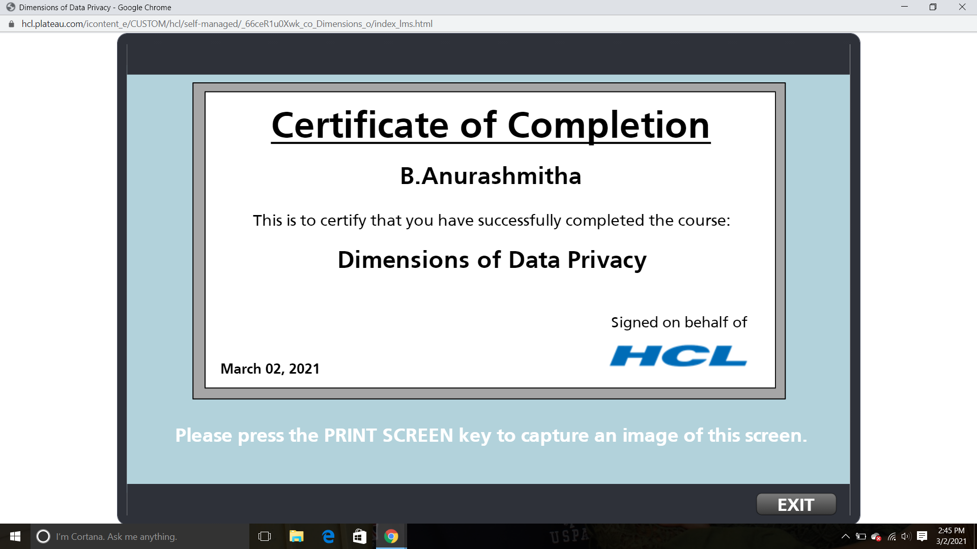

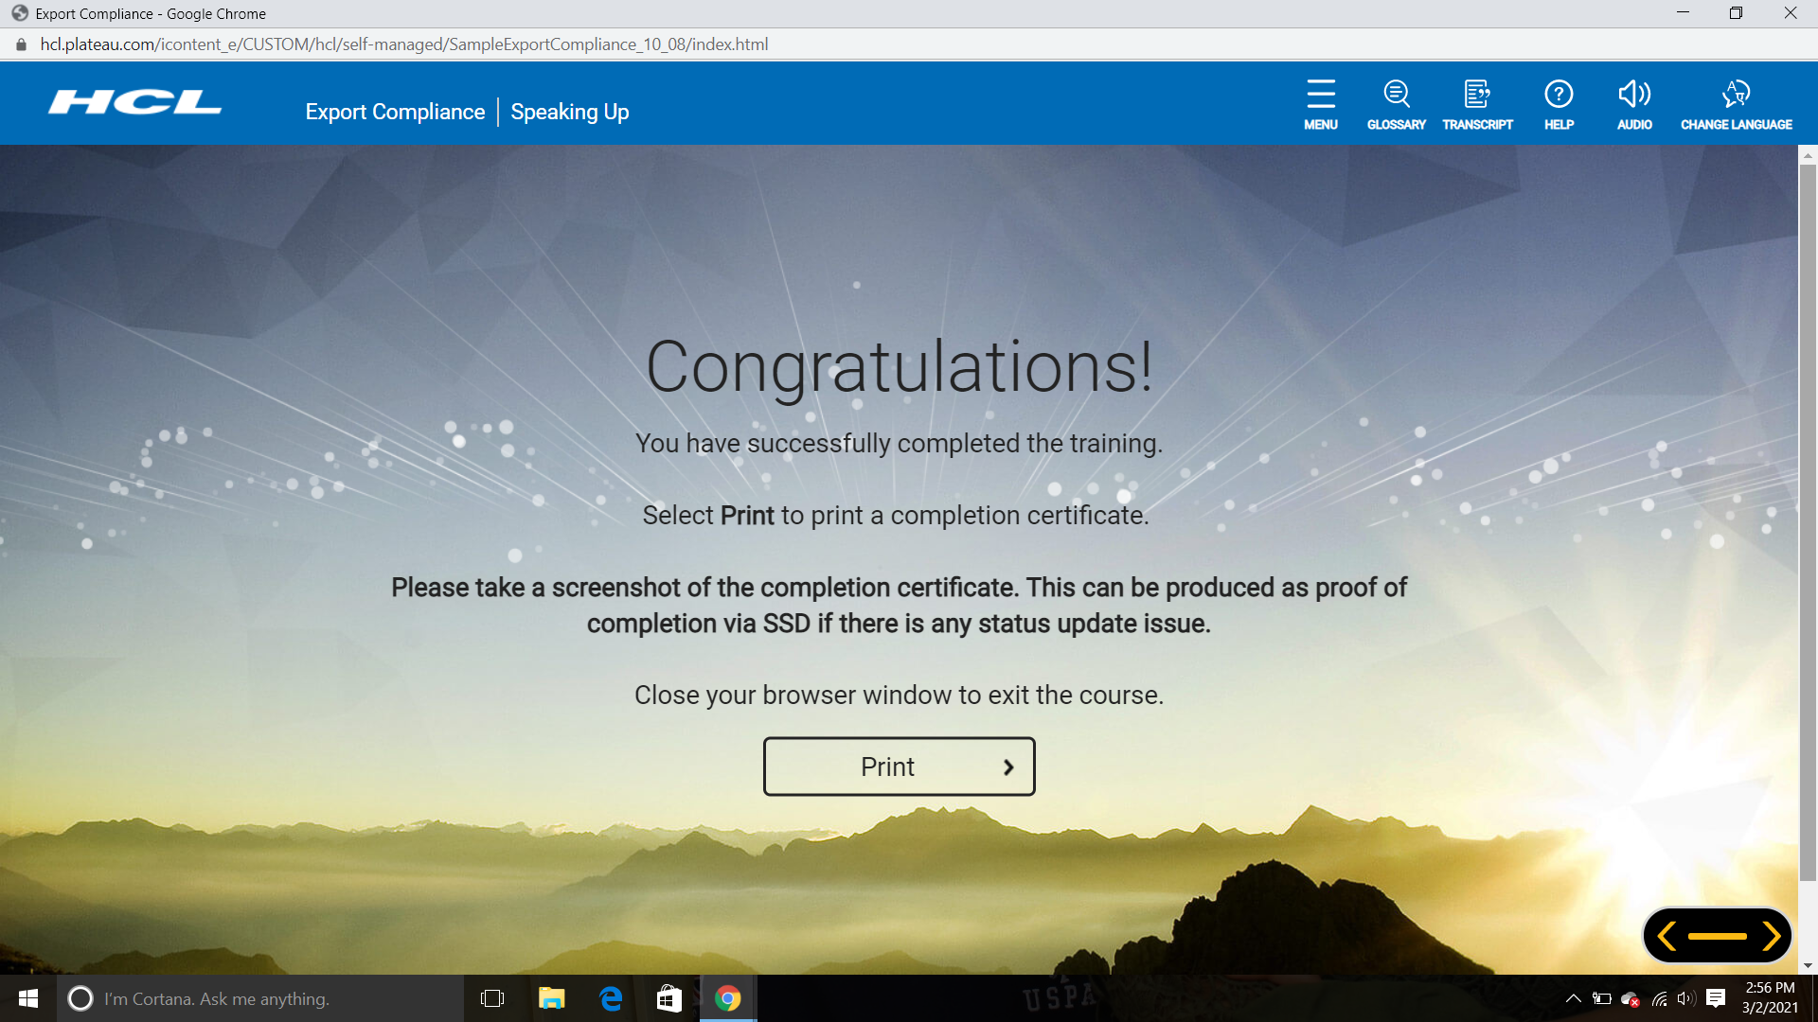

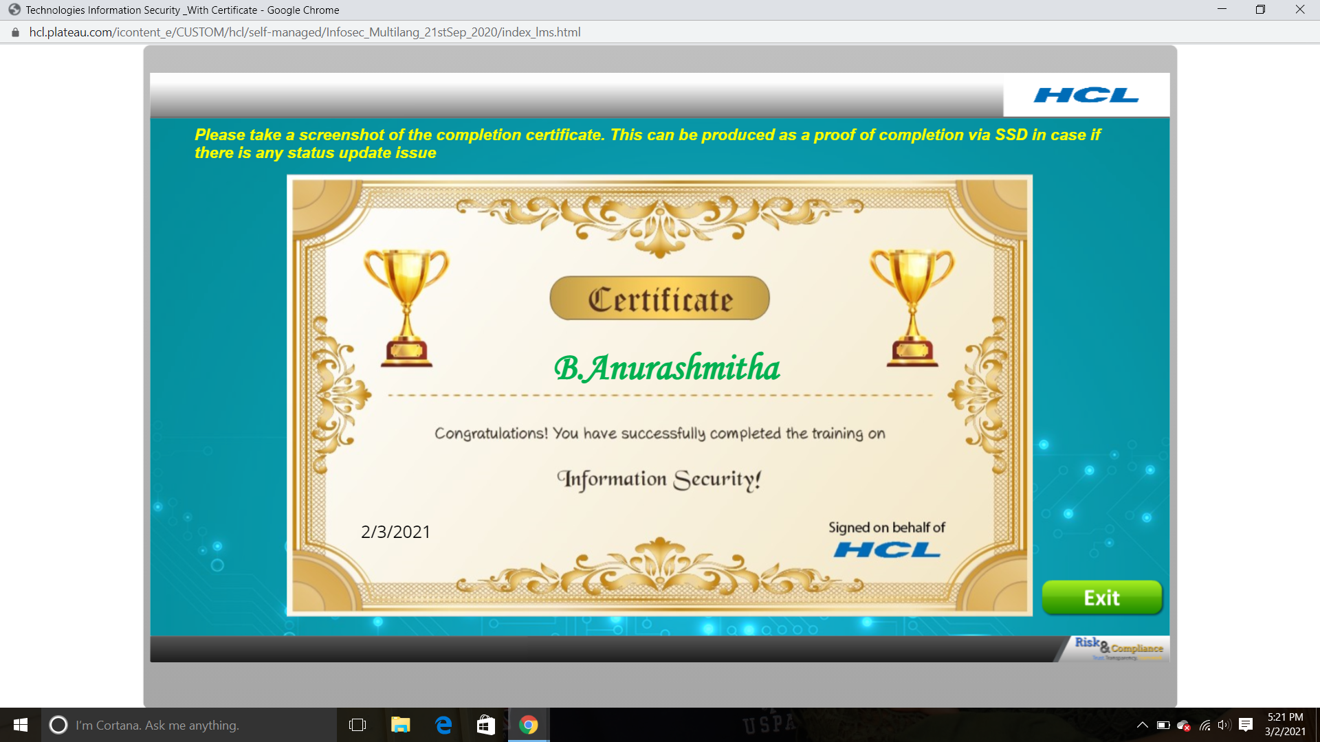

https://www.eclipse.org/downloads/download.php?file=/technology/epp/downloads/release/2020-12/R/eclipse-jee-2020-12-R-win32-x86_64.zip