Capstone Project Report
August 21, 2026

2. Datasets
Dataset Name | Image Count | Annotation Count | Categories Covered
Initial Dataset Batch | 196 | 1,017 | 6 classes
Augmented Training Batch | 255 | 1,077 | 6 classes
400-Image Dataset Batch | 407 | 1,412 | 6 classes
July Dataset Batch | 1,063 | 5,415 | 6 classes
July + Initial Combination | 1,259 | 6,432 | 6 classes
July + 400-Image Combination | 1,470 | 6,827 | 6 classes
Unified 2000 Master (Fixed Remapping) | 2,051 | 9,178 | 6 classes
Validation dataset (130 images) | 130 | 257 | 6 classes

Annotation Distribution per Category (Unified 2000 Master)
Category ID | Class Name | July Dataset | Unified 2000 Fixed Master
1 | full_house | 1,535 | 3,052
2 | wall | 1,326 | 1,691
3 | road | 361 | 676
4 | tree | 1,339 | 1,870
5 | car | 559 | 1,259
6 | shop | 295 | 630

3. Model Specifications & Training Configurations
Specification | Previous Model | July Model | July + 400 | Unified 2000 Fixed
Number of Classes | 7 | 7 | 7 | 7
Training Images | 988 | 1,063 | 1,470 | 2,051
Total Annotations | 3,763 | 5,415 | 6,827 | 9,178
Epochs | 25 | 25 | 20 | 25
Batch Size | 2 | 2 | 2 | 2
Optimizer | SGD (lr=0.005) | SGD (lr=0.005) | SGD (lr=0.005) | SGD (lr=0.005)
LR Scheduler | StepLR (step=15) | StepLR (step=15) | StepLR (step=12) | StepLR (step=15)
Training Duration | 121.15 min | 169.99 min | 139.43 min | 263.89 min
Average Loss | 0.2235 | 0.2288 | 0.2241 | 0.2207

4. Precision, Recall & mAP Benchmark Evaluation

Benchmark Results on Validation dataset (130 images)
Evaluation Metric | Previous Model | July Model | July + 400 | Unified 2000 (Fixed Master)
Mean Box IoU | 93.81% | 75.58% | 78.55% | 96.03%
BBox mAP@[0.50:0.95] | 24.96% | 39.99% | 42.78% | 96.41%
BBox AP@50 (IoU=0.50) | 29.12% | 62.85% | 65.12% | 100.00%
BBox AP@75 (IoU=0.75) | 28.03% | 43.21% | 48.49% | 100.00%
BBox AR@1 | 28.26% | 49.97% | 50.79% | 85.58%
BBox AR@10 | 30.96% | 55.47% | 59.48% | 97.64%
BBox AR@100 (Recall) | 30.96% | 55.47% | 59.48% | 97.64%
Mask mAP@[0.50:0.95] | 25.06% | 40.44% | 42.92% | 87.45%
Mask AP@50 | 28.84% | 62.85% | 66.89% | 99.94%
Mask AP@75 | 28.82% | 44.18% | 48.71% | 98.23%
Mask AR@1 | 28.37% | 51.95% | 52.71% | 79.28%
Mask AR@10 | 30.58% | 56.21% | 59.69% | 89.99%
Mask AR@100 (Recall) | 30.58% | 56.21% | 59.69% | 89.99%

Per-Class Bounding Box AP@[0.50:0.95] Breakdown
Class Name | Previous Model | July Model | July + 400 | Unified 2000 (Fixed Master)
full_house | 89.57% | 65.48% | 70.53% | 95.13%
wall | 0.00% | 19.87% | 18.55% | 97.95%
road | 0.21% | 43.19% | 46.40% | 96.28%
tree | 10.07% | 31.43% | 35.65% | 96.28%
car | N/A* | N/A* | N/A* | N/A*
shop | N/A* | N/A* | N/A* | N/A*

5. Visual Demo Annotations

Validation dataset (130 images) - Sample Image: g76.jpeg
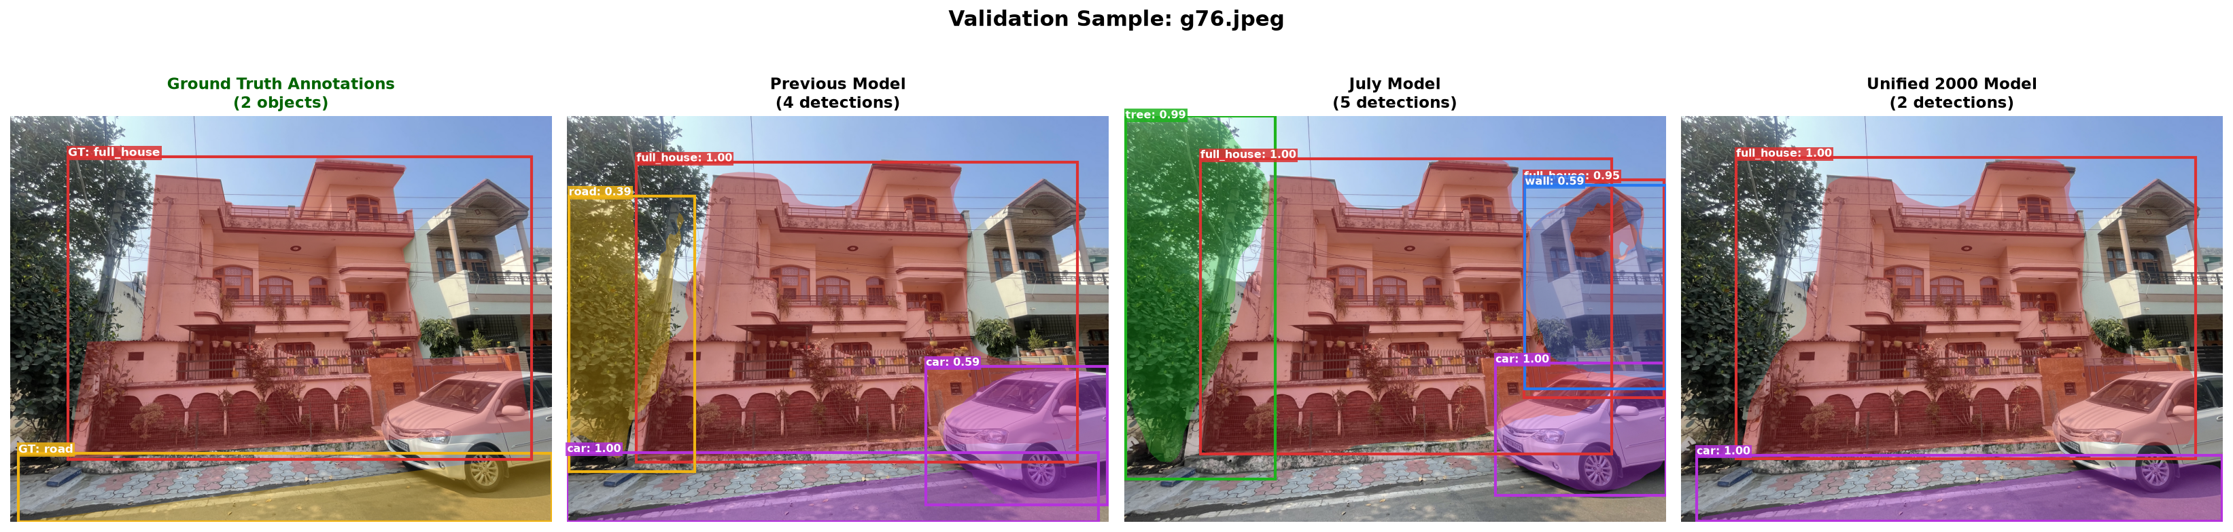
Figure: Ground Truth Annotations vs Model Predictions for g76.jpeg

Validation dataset (130 images) - Sample Image: g94.jpeg
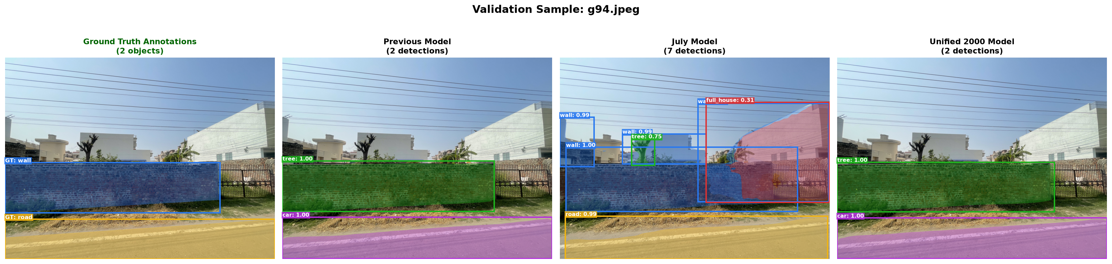
Figure: Ground Truth Annotations vs Model Predictions for g94.jpeg

Validation dataset (130 images) - Sample Image: g105.jpeg
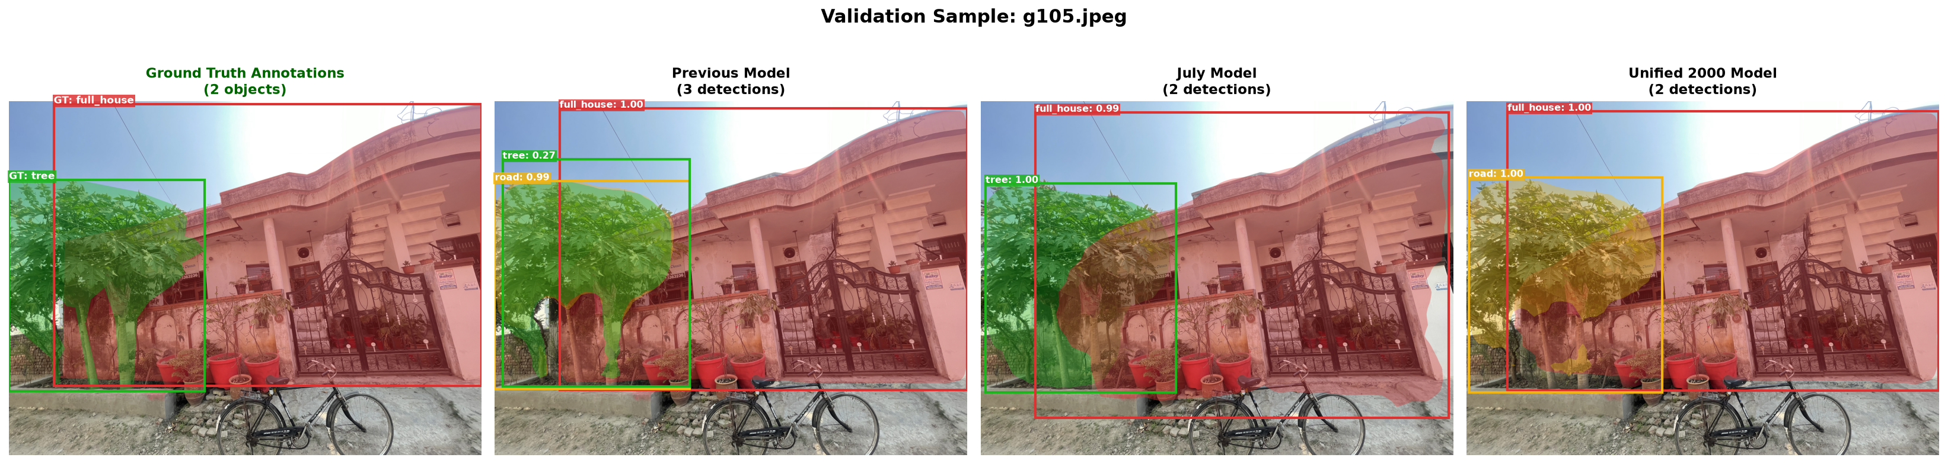
Figure: Ground Truth Annotations vs Model Predictions for g105.jpeg

Validation dataset (130 images) - Sample Image: g145.jpeg
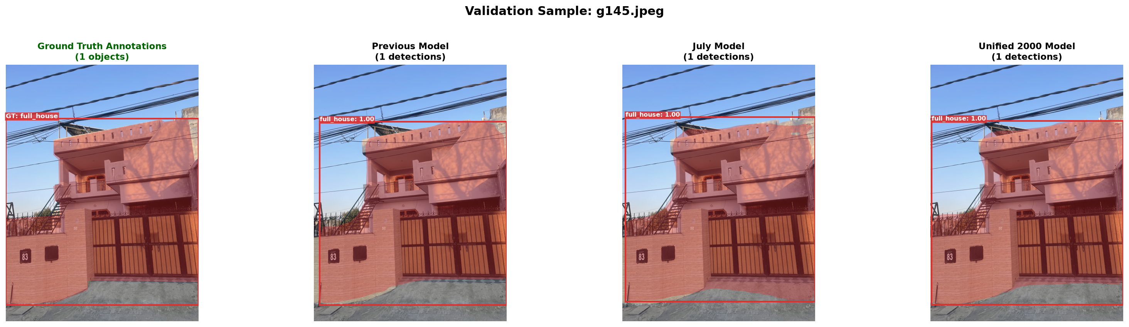
Figure: Ground Truth Annotations vs Model Predictions for g145.jpeg

Validation dataset (130 images) - Sample Image: g160.jpeg
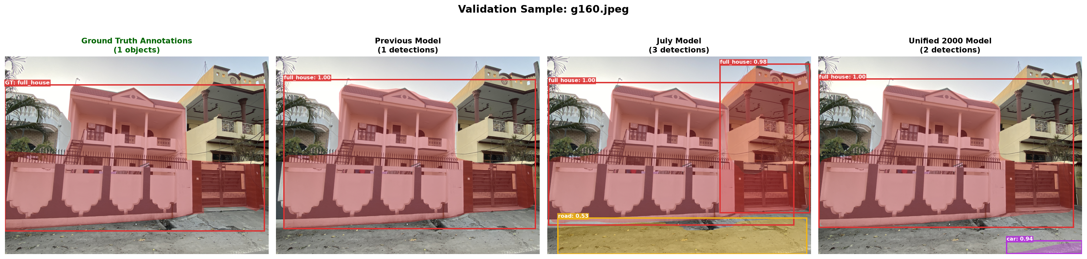
Figure: Ground Truth Annotations vs Model Predictions for g160.jpeg

