Customer Purchase Behavior in Retail using Data Analytics

# 🎯 Project Objective

To analyze customer and sales data from a retail business using Excel, SQL, and Power BI in order to derive actionable insights, optimize inventory, enhance customer satisfaction, and support strategic decision-making.

# 📌 Problem Statement

Retail companies often struggle with managing large volumes of sales, inventory, and customer data. This project aims to leverage Excel, SQL, and Power BI to analyze customer purchase behavior, monitor sales performance, and uncover actionable insights for business growth. The analysis focuses on optimizing inventory levels, improving staff performance, and enhancing the customer experience across different store locations.

# 📊 Key Metrics Summary

Total Revenue: **76,89,116.56**

Total Orders: **1615**

Total Unique Customers: **1445**

Average Order Value: **4,761.06**

Top Performing Product: **Trek Slash 8 27.5 – 2016**

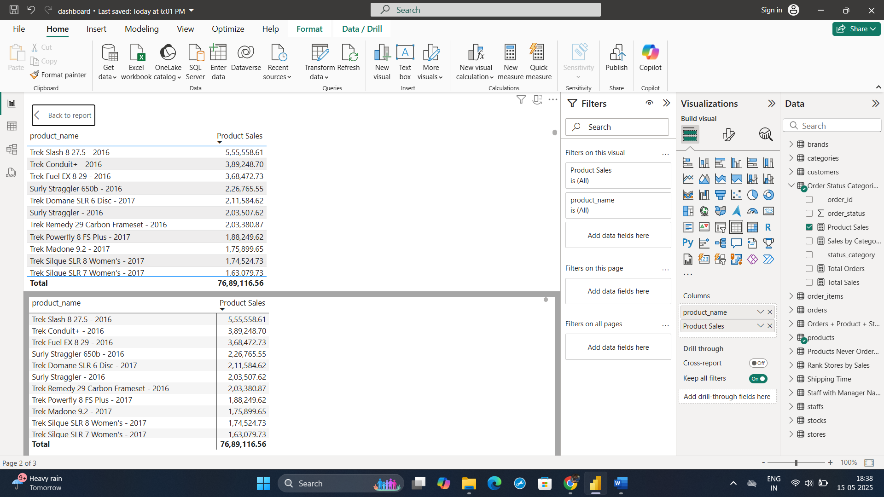

Top Product Category: **Mountain Bikes**

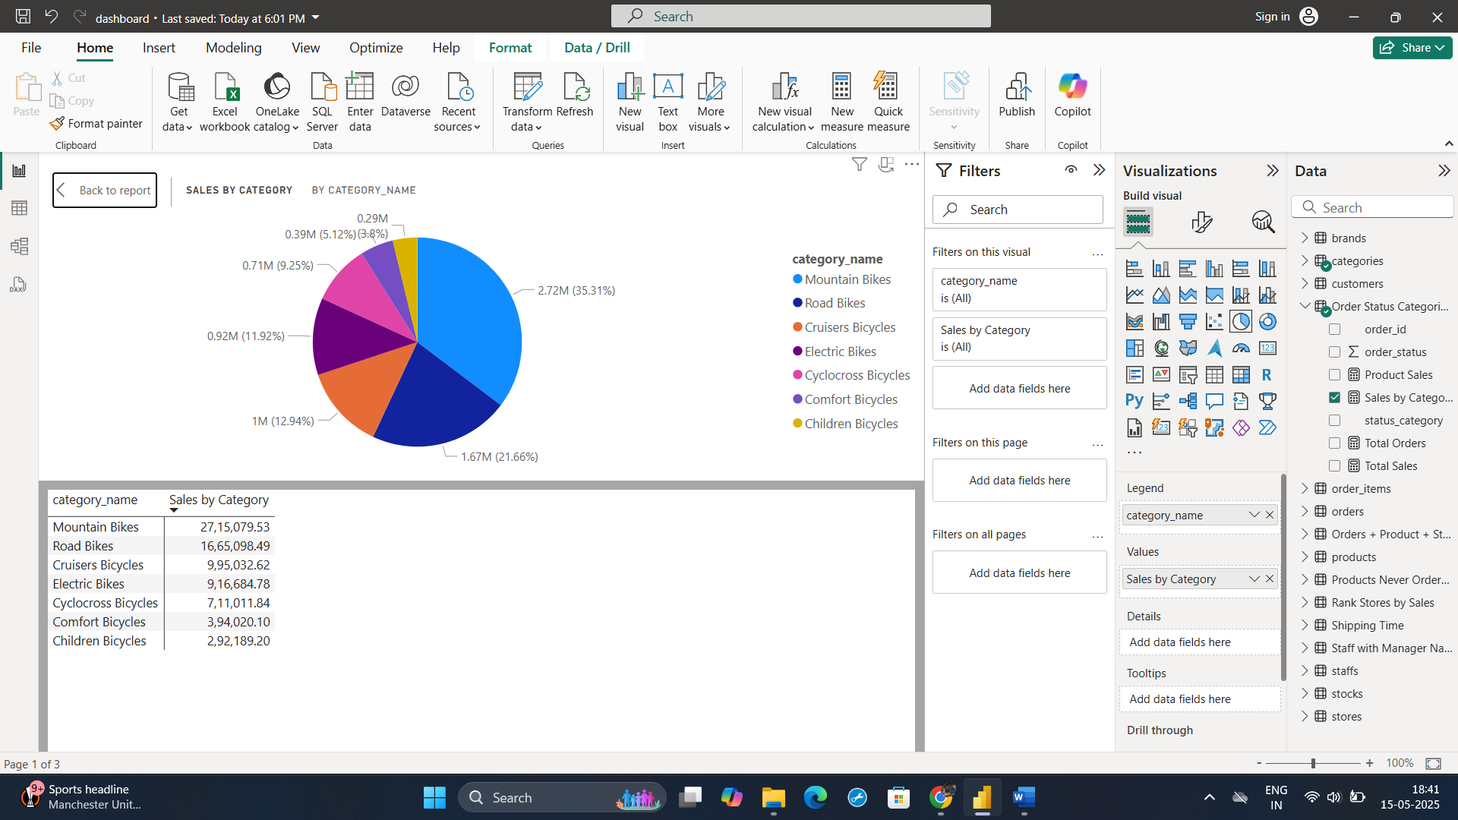

Top Performing Store: **Baldwin Bikes**

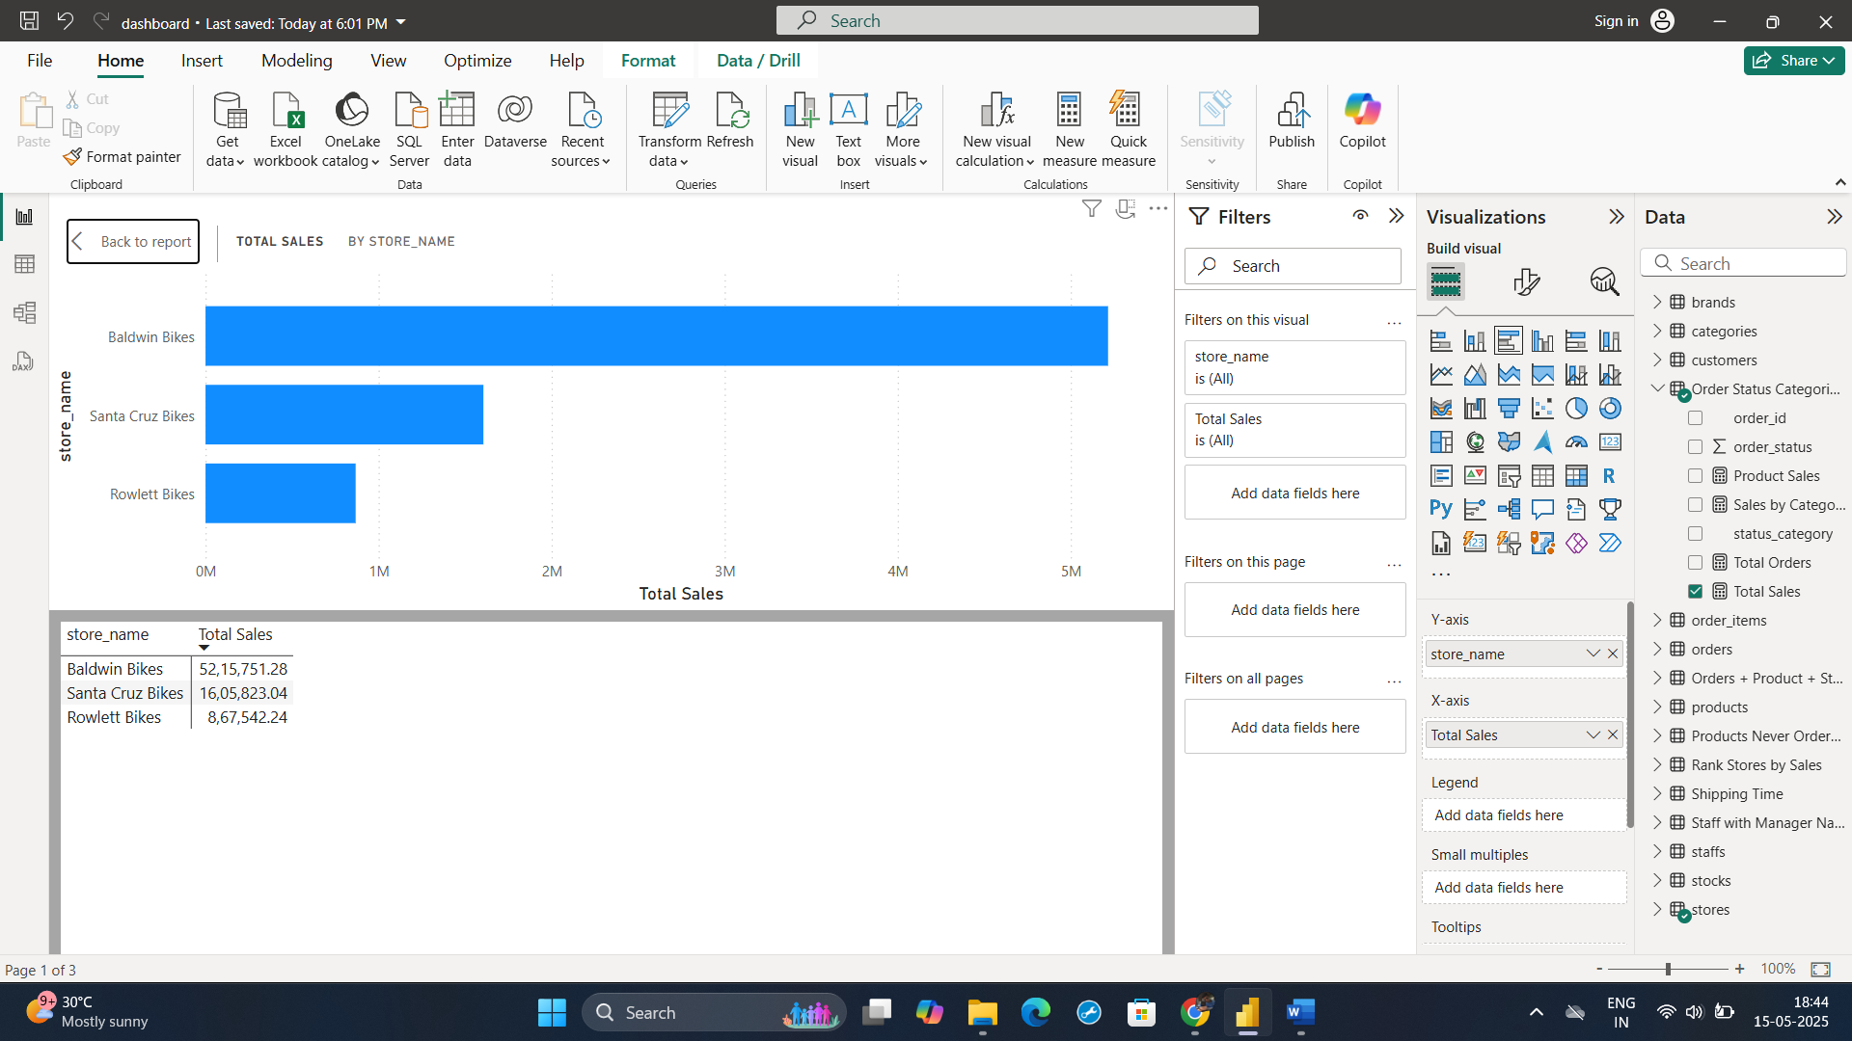

Top Performing Brand**: Trek**

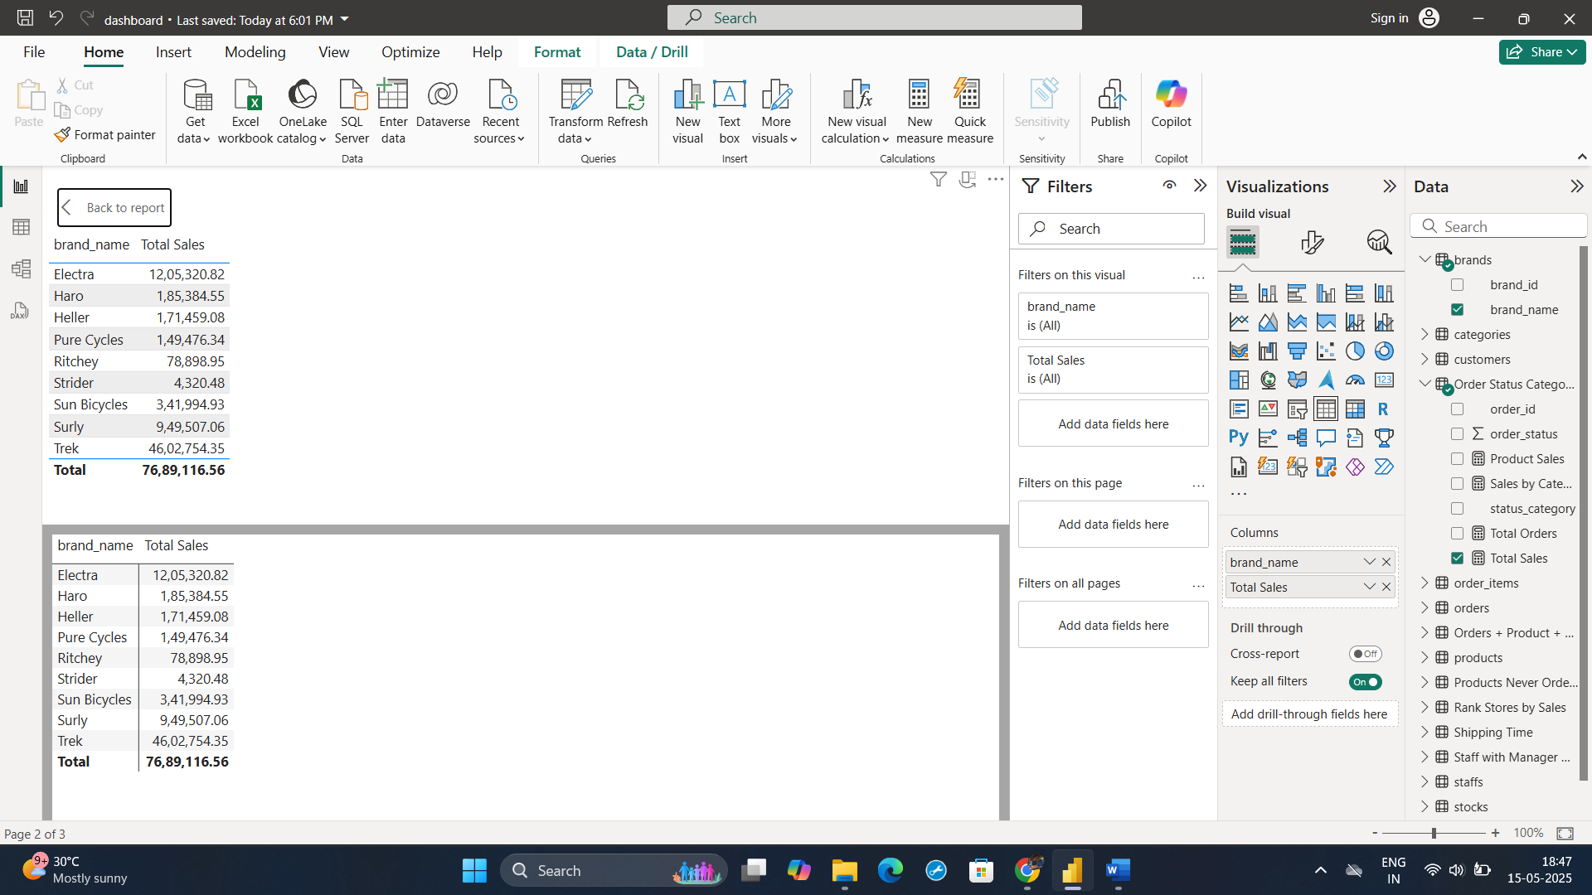

# 🔍 Deep-Dive Insights

## 🧾 Revenue Breakdown

By Category:  
- Mountain Bikes: 27.15 lakh  
- Road Bikes: 16.65 lakh  
- Cruisers Bicycles: 9.95 lakh

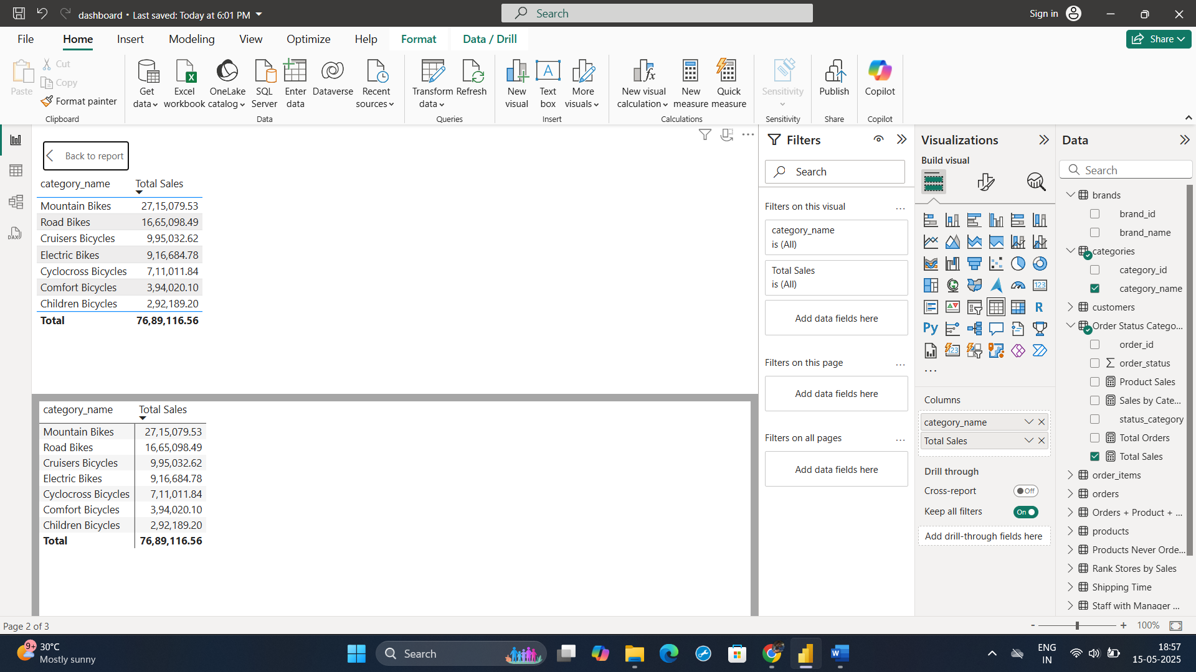

By Brand:  
- Trek: 46.02 lakh  
- Electra: 12.05 lakh  
- Surly: 9.49 lakh

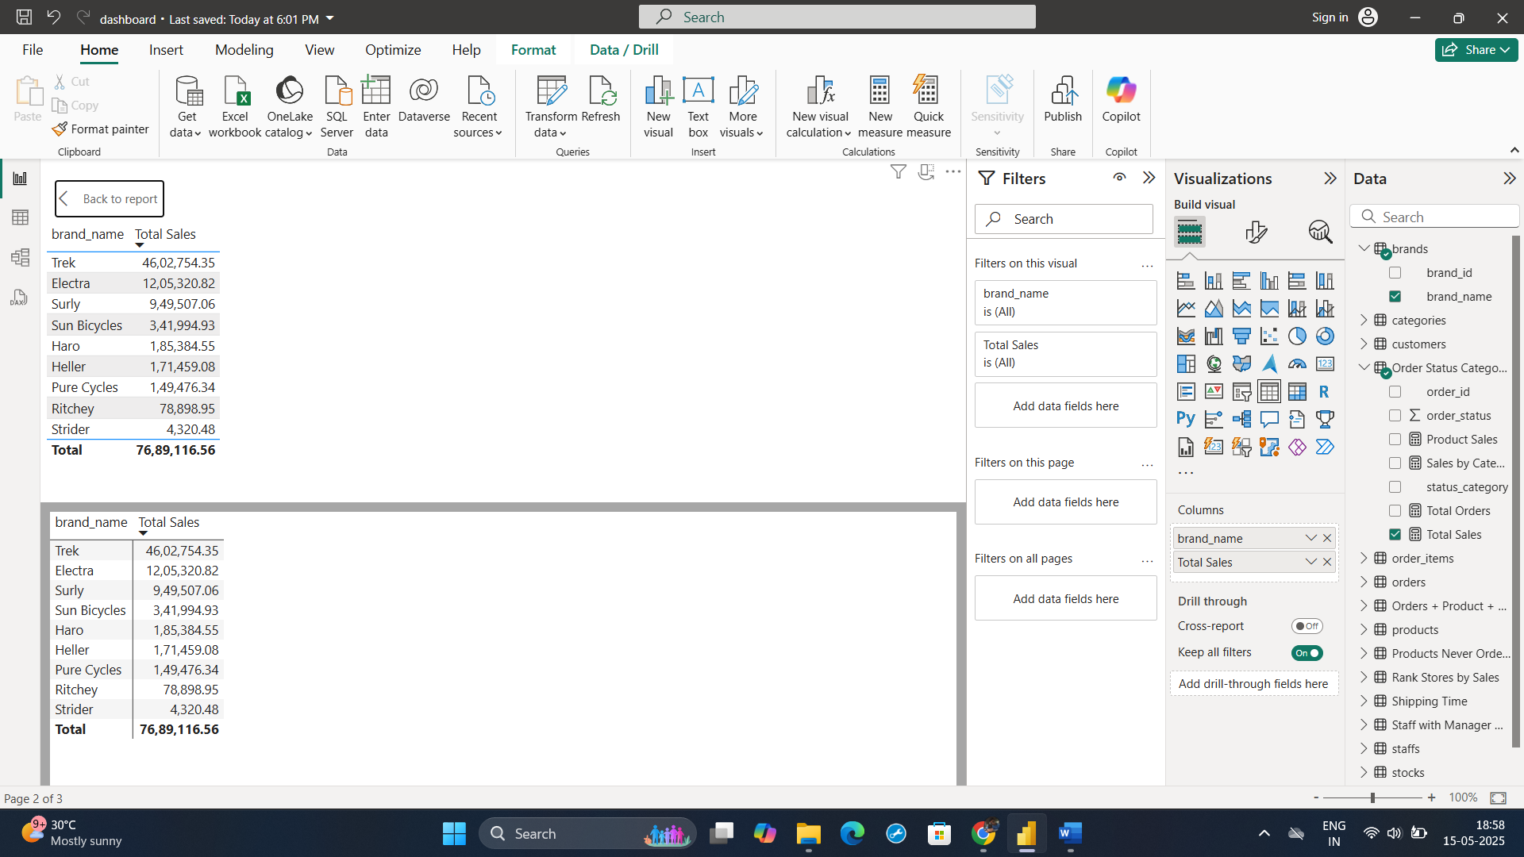

## 👤 Top Customers (by Spend)

Customer ID 94: 34,808  
Customer ID 10: 33,634  
Customer ID 75: 32,803

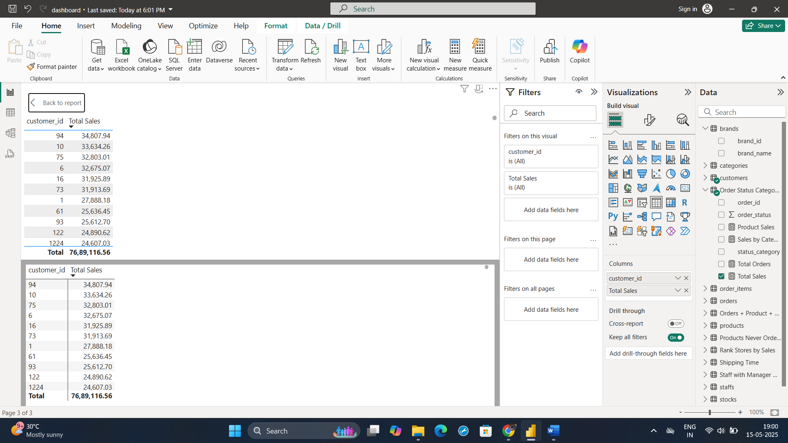

## 🧑‍💼 Top Staff Performance (by Sales)

Marcelene Boyer: 26.24 lakh  
Venita Daniel: 25.91 lakh  
Genna Serrano: 8.53 lakh

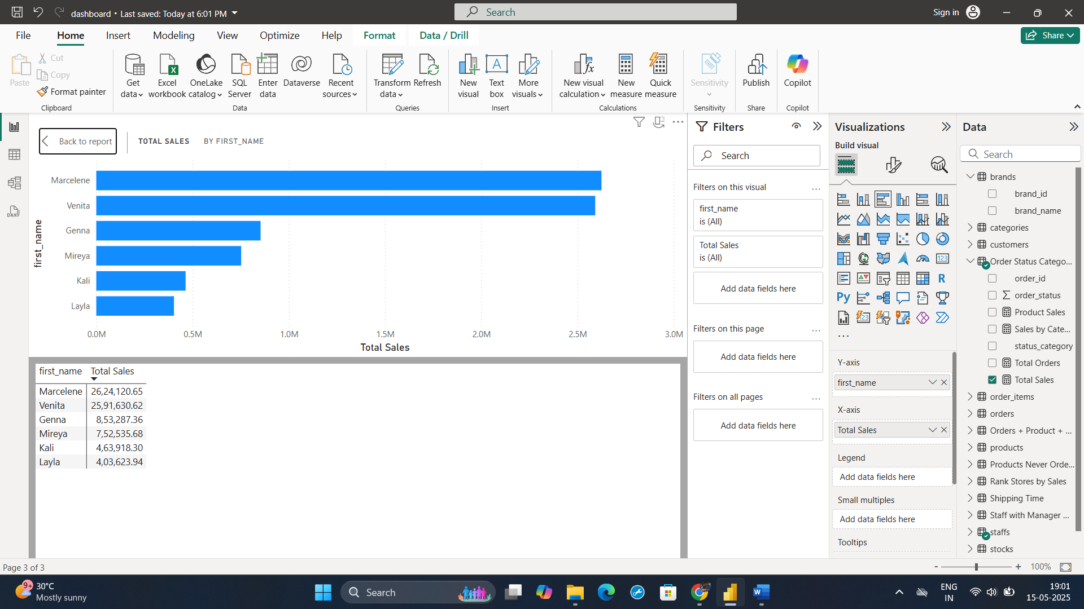

## 🚫 Operational Observations

Unsold Products: 14  
Zero Stock Inventory: 25  
Delayed Orders: 458

# ✅ Recommendations

## 🛍️ Sales Strategy

* - Promote top-performing products like Trek Slash 8 and Mountain Bikes.
* - Run brand-specific campaigns to boost Trek and Electra sales.

## 👥 Customer Retention

* - Reward high-value customers with loyalty perks.
* - Re-engage dormant customers with personalized offers.

## 🧑‍💼 Staff Management

* - Acknowledge top performers with incentives.
* - Provide coaching for underperforming staff.

## 🏪 Inventory Optimization

* - Replenish fast-moving items regularly.
* - Discount or remove unsold products to free up space.

## 🚚 Order Fulfillment

* - Review and optimize shipping for late deliveries.
* - Use alerts for orders at risk of delay.

# 🎓 Tools & Skills Used

Excel: Data cleaning, pivot tables, summary statistics

SQL: Data extraction, transformations, joins, aggregations

Power BI: Visual dashboards, KPIs, interactive filters, DAX calculations