Walmart Superstore Sales Analysis – Full Project Report

# Project Objective

The aim of this project is to analyze Walmart Superstore's sales data using Power BI, to uncover actionable business insights. Through comprehensive dashboards and visual reports, we focused on tracking sales performance, optimizing inventory, identifying regional trends, and analyzing customer behavior to support strategic decision-making.

# Tools & Technologies Used

- Power BI (Data Modeling, KPIs, Dashboards, Drilldowns, Maps)

# Project Requirements & Coverage

1. Sales and Revenue Dashboard – KPI cards, sales trends, sub-category performance.

2. Inventory Management Dashboard – Turnover rate, reorder analysis, low stock alerts.

3. Regional Sales Map – State-wise profit visualized on a filled map.

4. Drill-Down Hierarchies – Category > Sub-Category navigation with bar chart.

# 1. Sales and Revenue Dashboard

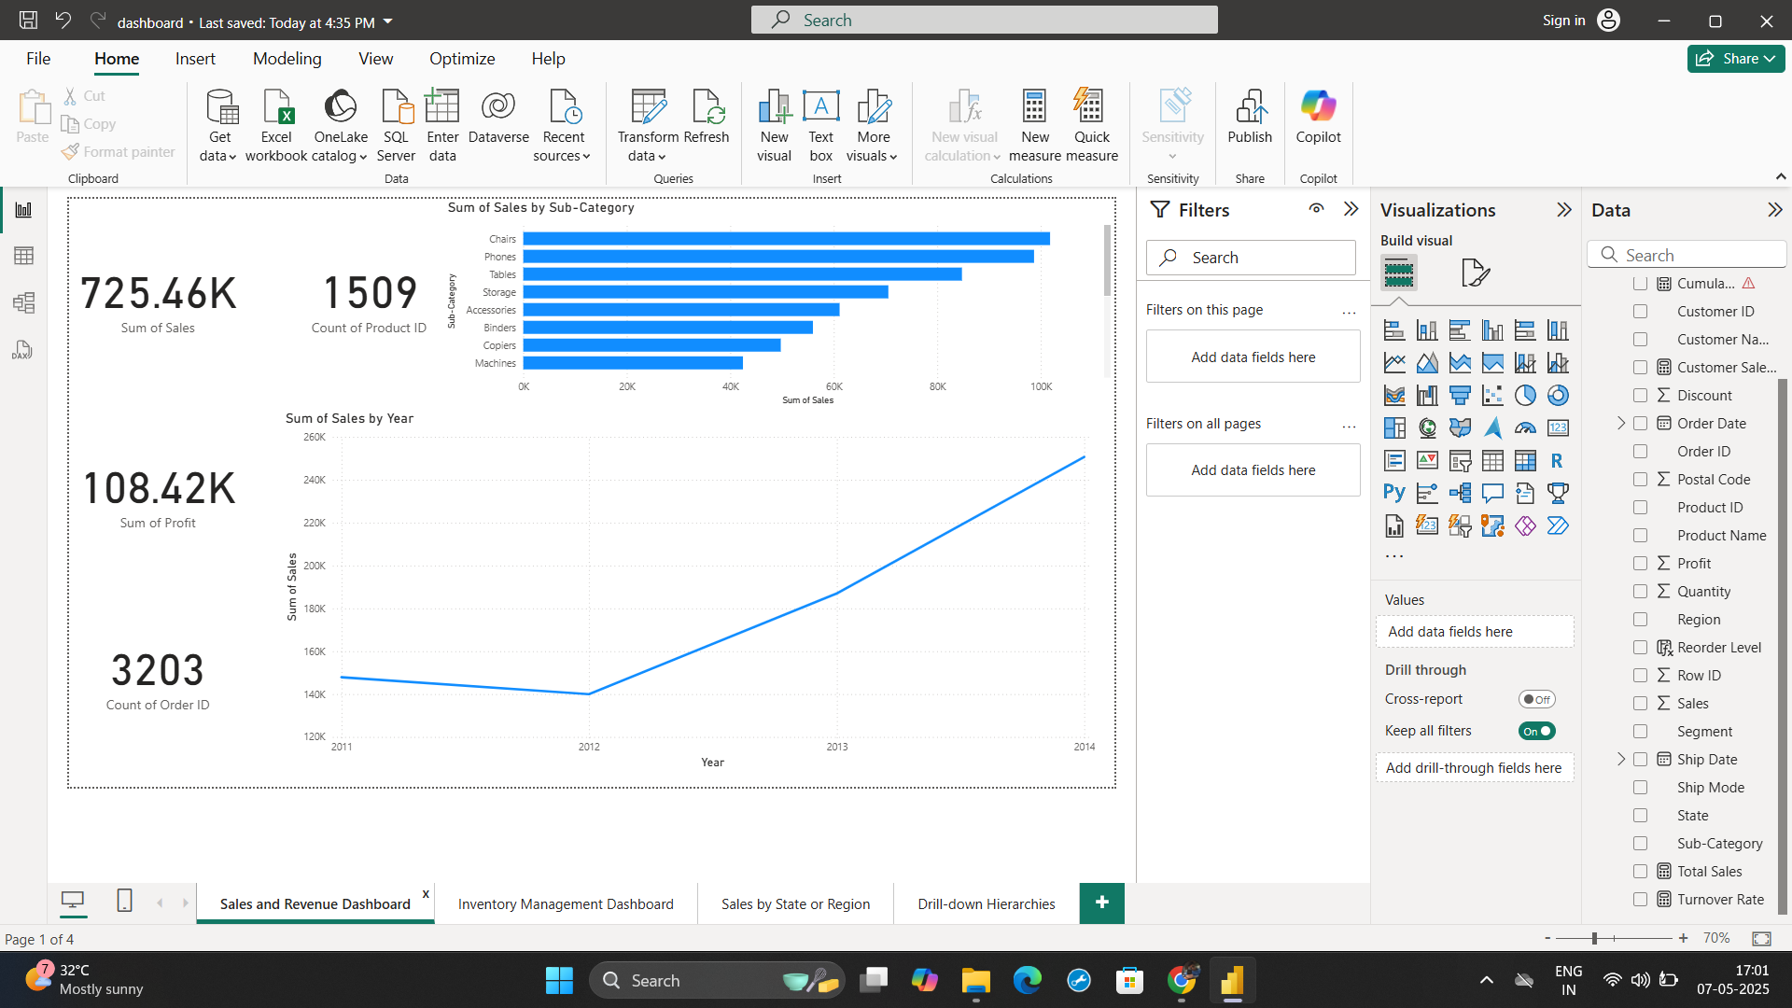

• Total Sales: ₹725.46K | Profit: ₹108.42K | Orders: 3203 | Products: 1509

• Top sub-categories: Chairs, Phones, Tables

• Sales increased significantly from 2012 to 2014.

# 2. Inventory Management Dashboard

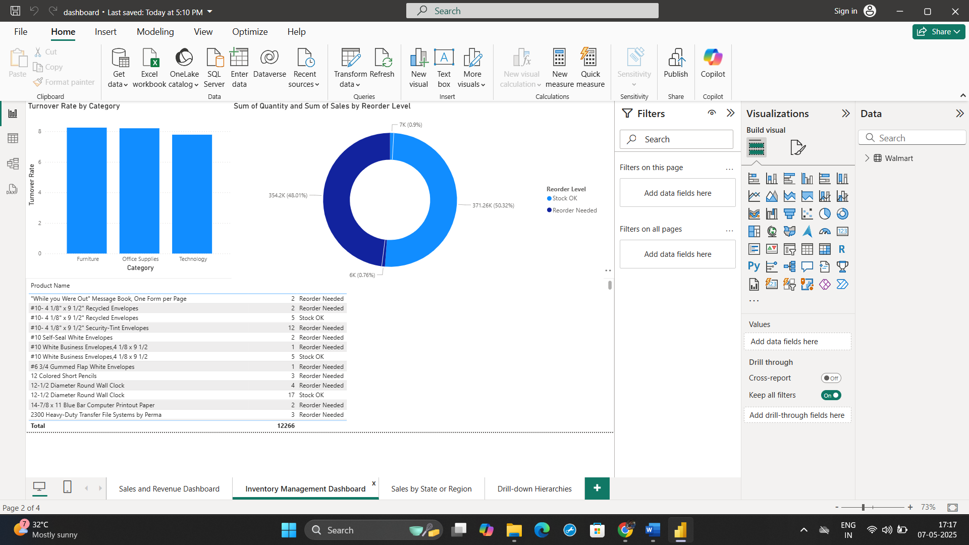

• Highest inventory turnover: Office Supplies > Furniture > Technology

• 50%+ sales are from 'Reorder Needed' items – demand-driven stock.

• Table shows key low-stock products to restock proactively.

# 3. Sales by State or Region

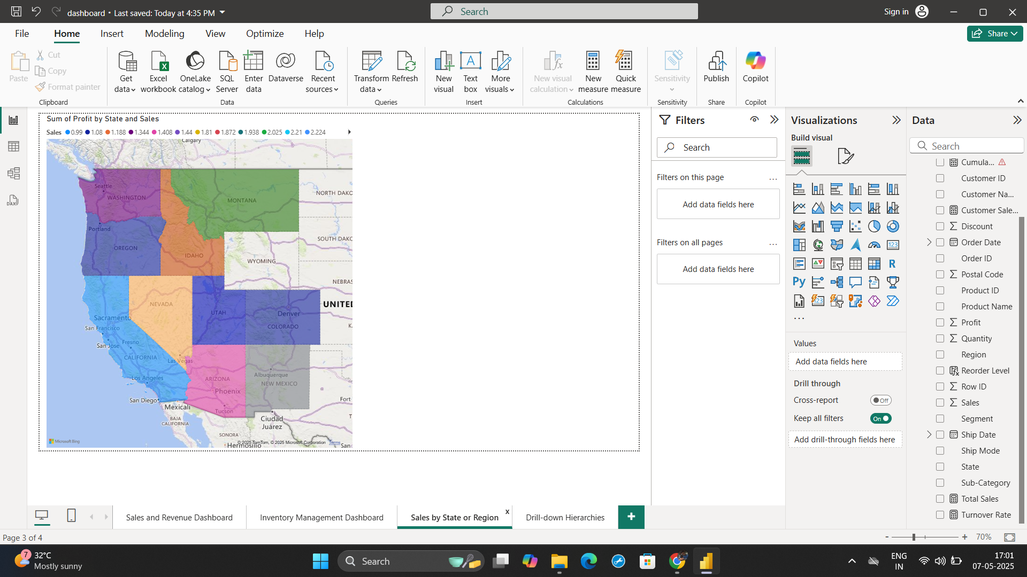

• California, New York, and Washington have high profitability.

• Inner US states have mixed performance – opportunity for marketing strategies.

# 4. Drill-down Hierarchies

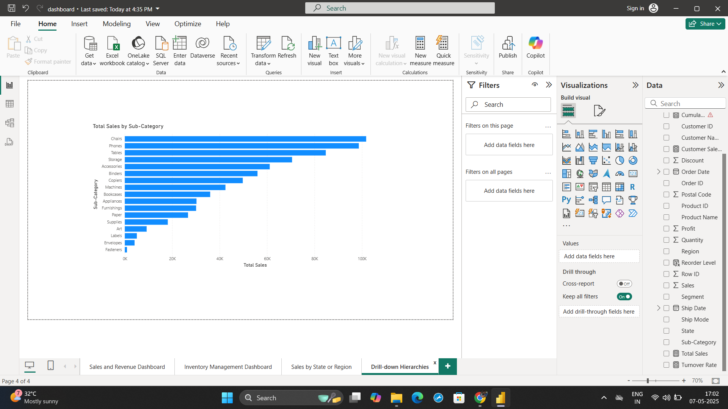

• Category > Sub-category breakdown shows detailed contribution to total sales.

• This allows users to drill deeper into performance segments like Technology > Phones.

# Key Insights

• Chairs and Phones dominate sales volumes.

• 20% of products generate nearly 80% of revenue.

• Strong demand evident in the 'Reorder Needed' status across major products.

• Regional disparities point to growth potential in underperforming states.

# Recommendations

• Focus on stocking fast-moving items in top-performing categories.

• Target underperforming states with marketing or pricing strategies.

• Continue monitoring reorder levels for proactive inventory restocking.

• Consider bundling top products with slow movers for upsell.

# Conclusion

This Power BI-based Walmart Superstore sales analysis provides a comprehensive view into sales drivers, regional opportunities, inventory needs, and customer-focused insights. The dashboards are scalable and can be updated with real-time data for ongoing decision support.