Experimental design An experimental design is a plan for assigning experimental units to treatment levels and the statistical analysis associated with the plan (Kirk, 1995: 1). The design of an experiment involves a number of inter-related activities. 1. Formulation of statistical hypotheses that are germane to the scientific hypothesis. A statistical hypothesis is a statement about: (a) one or more parameters of a population or (b) the functional form of a population. Statistical hypotheses are rarely identical to scientific hypotheses—they are testable formulations of scientific hypotheses. 2. Determination of the treatment levels (independent variable) to be manipulated, the measurement to be recorded (dependent variable), and the extraneous conditions (nuisance variables) that must be controlled. 3. Specification of the number of experimental units required and the population from which they will b

e sampled. 4. Specification of the randomization procedure for assigning the experimental units to the treatment levels

5. Determination of the statistical analysis that will be performed (Kirk, 1995: 1–2). In summary, an experimental design identifies the independent, dependent, and nuisance variables and indicates the way in which the randomization and statistical aspects of an experiment are to be carried out. The primary goal of an experimental design is to establish a causal connection between the independent and dependent variables. A secondary goal is to extract the maximum amount of information with the minimum expenditure of resources



Add a note...

Clipped from: http://www.okstate.edu/ag/agedcm4h/academic/aged5980a/5980/newpage2.htm

|  |
| --- |
| **Research Design in Occupational Education Copyright 1997. James P. Key. Oklahoma State University Except for those materials which are supplied by different departments of the University (ex. IRB, Thesis Handbook) and references used by permission.**  http://www.okstate.edu/ag/agedcm4h/academic/aged5980a/5980/_themes/blends/blesepa.gif |

|  |  |  |  |  |  |  |  |  |  |  |  |  |  |  |  |  |  |  |  |  |  |  |  |  |  |  |
| --- | --- | --- | --- | --- | --- | --- | --- | --- | --- | --- | --- | --- | --- | --- | --- | --- | --- | --- | --- | --- | --- | --- | --- | --- | --- | --- |
|  |  | **MODULE R13**  **EXPERIMENTAL RESEARCH AND DESIGN**      - An attempt by the researcher to maintain control over all factors that may affect the result of an experiment. In doing this, the researcher attempts to determine or predict what may occur.  **Experimental Design** - A blueprint of the procedure that enables the researcher to test his hypothesis by reaching valid conclusions about relationships between independent and dependent variables. It refers to the conceptual framework within which the experiment is conducted.  **Steps involved in conducting an experimental study**   |  |  | | --- | --- | | http://www.okstate.edu/ag/agedcm4h/academic/aged5980a/5980/_themes/blends/blebul1a.gif | Identify and define the problem. |  |  |  | | --- | --- | | http://www.okstate.edu/ag/agedcm4h/academic/aged5980a/5980/_themes/blends/blebul1a.gif | Formulate hypotheses and deduce their consequences. |  |  |  | | --- | --- | | http://www.okstate.edu/ag/agedcm4h/academic/aged5980a/5980/_themes/blends/blebul1a.gif | Construct an experimental design that represents all the elements, conditions, and relations of the consequences. |   1. Select sample of subjects.  2. Group or pair subjects.  3. Identify and control non experimental factors.  4. Select or construct, and validate instruments to measure outcomes.  5. Conduct pilot study.  6. Determine place, time, and duration of the experiment.   |  |  | | --- | --- | | http://www.okstate.edu/ag/agedcm4h/academic/aged5980a/5980/_themes/blends/blebul1a.gif | Conduct the experiment. |  |  |  | | --- | --- | | http://www.okstate.edu/ag/agedcm4h/academic/aged5980a/5980/_themes/blends/blebul1a.gif | Compile raw data and reduce to usable form. |  |  |  | | --- | --- | | http://www.okstate.edu/ag/agedcm4h/academic/aged5980a/5980/_themes/blends/blebul1a.gif | Apply an appropriate test of significance. |     **Essentials of Experimental Research**   |  |  | | --- | --- | | http://www.okstate.edu/ag/agedcm4h/academic/aged5980a/5980/_themes/blends/blebul1a.gif | *Manipulation* of an independent variable. |  |  |  | | --- | --- | | http://www.okstate.edu/ag/agedcm4h/academic/aged5980a/5980/_themes/blends/blebul1a.gif | An attempt is made to hold all other variables except the dependent variable constant - *control*. |  |  |  | | --- | --- | | http://www.okstate.edu/ag/agedcm4h/academic/aged5980a/5980/_themes/blends/blebul1a.gif | Effect is observed of the manipulation of the independent variable on the dependent variable - *observation*. |   Experimental control attempts to predict events that will occur in the experimental setting by neutralizing the effects of other factors.  **Methods of Experimental Control**   |  |  | | --- | --- | | http://www.okstate.edu/ag/agedcm4h/academic/aged5980a/5980/_themes/blends/blebul1a.gif | *Physical Control* |  |  |  | | --- | --- | | http://www.okstate.edu/ag/agedcm4h/academic/aged5980a/5980/_themes/blends/blebul2a.gif | Gives all subjects equal exposure to the independent variable. | | http://www.okstate.edu/ag/agedcm4h/academic/aged5980a/5980/_themes/blends/blebul2a.gif | Controls non experimental variables that affect the dependent variable. | |

|  |  |
| --- | --- |
| http://www.okstate.edu/ag/agedcm4h/academic/aged5980a/5980/_themes/blends/blebul1a.gif | *Selective Control* - Manipulate indirectly by selecting in or out variables that cannot be controlled. |

|  |  |
| --- | --- |
| http://www.okstate.edu/ag/agedcm4h/academic/aged5980a/5980/_themes/blends/blebul1a.gif | *Statistical Control* - Variables not conducive to physical or selective manipulation may be controlled by statistical techniques (example: covariance). |

**Validity of Experimental Design**

|  |  |
| --- | --- |
| http://www.okstate.edu/ag/agedcm4h/academic/aged5980a/5980/_themes/blends/blebul1a.gif | *Internal Validity* asks did the experimental treatment make the difference in this specific instance rather than other extraneous variables? |

|  |  |
| --- | --- |
| http://www.okstate.edu/ag/agedcm4h/academic/aged5980a/5980/_themes/blends/blebul1a.gif | *External Validity* asks to what populations, settings, treatment variables, and measurement variables can this observed effect be generalized? |

**Factors Jeopardizing Internal Validity**

|  |  |
| --- | --- |
| http://www.okstate.edu/ag/agedcm4h/academic/aged5980a/5980/_themes/blends/blebul1a.gif | **History** - The events occurring between the first and second measurements in addition to the experimental variable which might affect the measurement. |

*Example*: Researcher collects gross sales data before and after a 5 day 50% off sale. During the sale a hurricane occurs and results of the study may be affected because of the hurricane, not the sale.

|  |  |
| --- | --- |
| http://www.okstate.edu/ag/agedcm4h/academic/aged5980a/5980/_themes/blends/blebul1a.gif | **Maturation** - The process of maturing which takes place in the individual during the duration of the experiment which is not a result of specific events but of simply growing older, growing more tired, or similar changes. |

*Example*: Subjects become tired after completing a training session, and their responses on the Posttest are affected.

|  |  |
| --- | --- |
| http://www.okstate.edu/ag/agedcm4h/academic/aged5980a/5980/_themes/blends/blebul1a.gif | **Pre-testing** - The effect created on the second measurement by having a measurement before the experiment. |

*Example*: Subjects take a Pretest and think about some of the items. On the Posttest they change to answers they feel are more acceptable. Experimental group learns from the pretest.

|  |  |
| --- | --- |
| http://www.okstate.edu/ag/agedcm4h/academic/aged5980a/5980/_themes/blends/blebul1a.gif | **Measuring Instruments** - Changes in instruments, calibration of instruments, observers, or scorers may cause changes in the measurements. |

*Example*: Interviewers are very careful with their first two or three interviews but on the 4th, 5th, 6th become fatigued and are less careful and make errors.

|  |  |
| --- | --- |
| http://www.okstate.edu/ag/agedcm4h/academic/aged5980a/5980/_themes/blends/blebul1a.gif | **Statistical Regression** - Groups are chosen because of extreme scores of measurements; those scores or measurements tend to move toward the mean with repeated measurements even without an experimental variable. |

*Example*: Managers who are performing poorly are selected for training. Their average Posttest scores will be higher than their Pretest scores because of statistical regression, even if no training were given.

|  |  |
| --- | --- |
| http://www.okstate.edu/ag/agedcm4h/academic/aged5980a/5980/_themes/blends/blebul1a.gif | **Differential Selection** - Different individuals or groups would have different previous knowledge or ability which would affect the final measurement if not taken into account. |

*Example*: A group of subjects who have viewed a TV program is compared with a group which has not. There is no way of knowing that the groups would have been equivalent since they were not randomly assigned to view the TV program.

|  |  |
| --- | --- |
| http://www.okstate.edu/ag/agedcm4h/academic/aged5980a/5980/_themes/blends/blebul1a.gif | **Experimental Mortality** - The loss of subjects from comparison groups could greatly affect the comparisons because of unique characteristics of those subjects. Groups to be compared need to be the same after as before the experiment. |

*Example*: Over a 6 month experiment aimed to change accounting practices, 12 accountants drop out of the experimental group and none drop out of the control group. Not only is there differential loss in the two groups, but the 12 dropouts may be very different from those who remained in the experimental group.

|  |  |
| --- | --- |
| http://www.okstate.edu/ag/agedcm4h/academic/aged5980a/5980/_themes/blends/blebul1a.gif | **Interaction of Factors**, such as Selection Maturation, etc. - Combinations of these factors may interact especially in multiple group comparisons to produce erroneous measurements. |

**Factors Jeopardizing External Validity or Generalizability**

**Pre-Testing** -Individuals who were pretested might be less or more sensitive to the experimental variable or might have "learned" from the pre-test making them unrepresentative of the population who had not been pre-tested.

*Example*: Prior to viewing a film on Environmental Effects of Chemical, a group of subjects is given a 60 item antichemical test. Taking the Pretest may increase the effect of the film. The film may not be effective for a nonpretested group.

**Differential Selection** - The selection of the subjects determines how the findings can be generalized. Subjects selected from a small group or one with particular characteristics would limit generalizability. Randomly chosen subjects from the entire population could be generalized to the entire population.

*Example*: Researcher, requesting permission to conduct experiment, is turned down by 11 corporations, but the 12th corporation grant permission. The 12th corporation is obviously different then the others because they accepted. Thus subjects in the 12th corporation may be more accepting or sensitive to the treatment.

**Experimental Procedures** - The experimental procedures and arrangements have a certain amount of effect on the subjects in the experimental settings. Generalization to persons not in the experimental setting may be precluded.

*Example*: Department heads realize they are being studied, try to guess what the experimenter wants and respond accordingly rather than respond to the treatment.

**Multiple Treatment Interference** - If the subjects are exposed to more than one treatment then the findings could only be generalized to individuals exposed to the same treatments in the same order of presentation.

*Example*: A group of CPA’s is given training in working with managers followed by training in working with comptrollers. Since training effects cannot be deleted, the first training will affect the second.

**Tools of Experimental Design Used to Control Factors Jeopardizing Validity**

|  |  |
| --- | --- |
| http://www.okstate.edu/ag/agedcm4h/academic/aged5980a/5980/_themes/blends/blebul1a.gif | **Pre-Test** - The pre-test, or measurement before the experiment begins, can aid control for differential selection by determining the presence or knowledge of the experimental variable before the experiment begins. It can aid control of experimental mortality because the subjects can be removed from the entire comparison by removing their pre-tests. |

However, pre-tests cause problems by their effect on the second measurement and by causing generalizability problems to a population not pre-tested and those with no experimental arrangements.

|  |  |
| --- | --- |
| http://www.okstate.edu/ag/agedcm4h/academic/aged5980a/5980/_themes/blends/blebul1a.gif | **Control Group** -The use of a matched or similar group which is not exposed to the experimental variable can help reduce the effect of History, Maturation, Instrumentation, and Interaction of Factors. The control group is exposed to all conditions of the experiment except the experimental variable. |

|  |  |
| --- | --- |
| http://www.okstate.edu/ag/agedcm4h/academic/aged5980a/5980/_themes/blends/blebul1a.gif | **Randomization** - Use of random selection procedures for subjects can aid in control of Statistical Regression, Differential Selection, and the Interaction of Factors. It greatly increases generalizability by helping make the groups representative of the populations. |

|  |  |
| --- | --- |
| http://www.okstate.edu/ag/agedcm4h/academic/aged5980a/5980/_themes/blends/blebul1a.gif | **Additional Groups** - The effects of Pre-tests and Experimental Procedures can be partially controlled through the use of groups which were not pre-tested or exposed to experimental arrangements. They would have to be used in conjunction with other pre-tested groups or other factors jeopardizing validity would be present. |

http://www.okstate.edu/ag/agedcm4h/academic/aged5980a/5980/_themes/blends/blesepa.gif

The method by which treatments are applied to subjects using these tools to control factors jeopardizing validity is the essence of experimental design.

**Tools of Control**

|  |  |  |  |  |
| --- | --- | --- | --- | --- |
| **Internal Sources** | Pre-Test/  Post Test | Control Group | Randomization | Additional  Groups |
| History |  | X |  |  |
| Maturation |  | X |  |  |
| Pre-Testing |  |  |  | X |
| Measuring Instrument |  | X |  |  |
| Statistical Regression |  | X | X |  |
| Differential Selection | X |  | X |  |
| Experimental Mortality | X |  |  |  |
| Interaction of Factors |  | X | X |  |
| **External Sources** |  |  |  |  |
| Pre-Testing |  |  |  | X |
| Differential Selection | X |  | X |  |
| Procedures |  |  |  | X |
| Multiple Treatment |  |  |  |  |

http://www.okstate.edu/ag/agedcm4h/academic/aged5980a/5980/_themes/blends/blesepa.gif

http://www.okstate.edu/ag/agedcm4h/academic/aged5980a/5980/_themes/blends/blesepa.gif

There are three basic types of experimental research designs . These include pre-experimental designs, true experimental designs, and quasi-experimental designs.   The degree to which the researcher assigns subjects to conditions and groups distinguishes the type of experimental design. This module will focus on the different types of **true experimental designs**. True experimental designs are **characterized by the random selection of participants and the random assignment of the participants** to groups in the study. The researcher also has **complete control over the extraneous variables**. Therefore, it can be confidently determined that that effect on the dependent variable is directly due to the manipulation of the independent variable. For these reasons, true experimental designs are often considered the best type of research design. There are several types of true experimental designs and they are as follows:

* **Post-test Only Design** – This type of design has two randomly assigned groups: an experimental group and a control group. Neither group is pretested before the implementation of the treatment. The treatment is applied to the experimental group and the post-test is carried out on both groups to assess the effect of the treatment or manipulation. This type of design is common when it is not possible to pretest the subjects.
* **Pretest-Post-test Only Design** - The subjects are again randomly assigned to either the experimental or the control group. Both groups are pretested for the independent variable. The experimental group receives the treatment and both groups are post-tested to examine the effects of manipulating the independent variable on the dependent variable.
* **Solomon Four Group Design** – Subjects are randomly assigned into one of four groups. There are two experimental groups and two control groups. Only two groups are pretested. One pretested group and one unprotested group receive the treatment. All four groups will receive the post-test. The effects of the dependent variable originally observed are then compared to the effects of the independent variable on the dependent variable as seen in the post-test results. This method is really a combination of the previous two methods and is used to eliminate potential sources of error.
* **Factorial Design** – The researcher manipulates two or more independent variables (factors) simultaneously to observe their effects on the dependent variable. This design allows for the testing of two or more hypotheses in a single project. One example would be a researcher who wanted to test two different protocols for burn wounds with the frequency of the care being administered in 2, 4, and 6 hour increments.
* **Randomized Block Design** – This design is used when there are inherent differences between subjects and possible differences in experimental conditions. If there are a large number of experimental groups, the randomized block design may be used to bring some homogeneity to each group. For example, if a researcher wanted to examine the effects of three different kinds of cough medications on children ages 2-16, the research may want to create age groups (blocks) for the children, realizing that the effects of the medication may depend on age. This is a simple method for reducing the variability among treatment groups.
* **Crossover Design (also known as Repeat Measures Design)** – Subjects in this design are exposed to more than one treatment and the subjects are randomly assigned to different orders of the treatment. The groups compared have an equal distribution of characteristics and there is a high level of similarity among subjects that are exposed to different conditions. Crossover designs are excellent research tools, however, there is some concern that the response to the second treatment or condition will be influenced by their experience with the first treatment. In this type of design, the subjects serve as their own control groups.

Once the design has been determined, there are four elements of true experimental research that must be considered:

* **Manipulation:** The researcher will purposefully change or manipulate the independent variable, which is the treatment or condition that will be applied to the experimental groups. It is important to establish clear procedural guidelines for application of the treatment to promote consistency and ensure that the manipulation itself does affect the dependent variable.
* **Control:** Control is used to prevent the influence of outside factors (extraneous variables) from influencing the outcome of the study. This ensures that outcome is caused by the manipulation of the independent variable. Therefore, a critical piece of experimental design is keeping all other potential variables constant. For example, if testing the effects of fertilizer on plant height, all other factors such as sunlight, soil type and water would have to be constant (controlled).
* **Random Assignment:** A key feature of true experimental design is the random assignment of subjects into groups. Participants should have an equal chance of being assigned into any group in the experiment. This further ensures that the outcome of the study is due to the manipulation of the independent variable and is not influenced by the composition of the test groups. Subjects can be randomly assigned in many ways, some of which are relatively easy, including flipping a coin, drawing names, using a random table, or utilizing a computer assisted random sequencing.
* **Random selection:** In addition to randomly assigning the test subjects in groups, it is also important to randomly select the test subjects from a larger target audience. For example, if a researcher wanted to look at the impact of sleep on the test scores of 5th graders in a particular city, a sample of 5th graders would need to be randomly selected from the city’s population in such a way that any 5th grader would have an equal chance of being selected for the study. This ensures that the sample population provides an accurate cross-sectional representation of the larger population including different socioeconomic backgrounds, races, intelligence levels, and so forth.

The following Slideshare Presentation, *Experimental Research Design*, contains a basic overview of experimental research methodology, as well as a more detailed discussion of types of experimental designs.

RESEARCH OBSERVATORY

Four types of experimental design

Repeated measures design (or within-subjects design) requires one group of samples or participants. This same group is exposed to all of the levels of the independent variable of interest.



Add a note...

Clipped from: http://study.com/academy/lesson/within-subject-designs-definition-types-examples.html

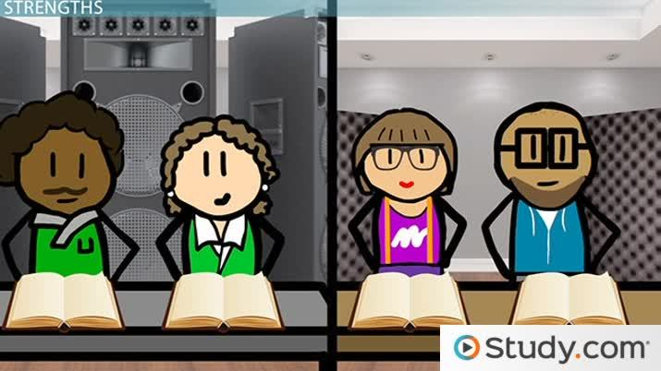

Top of Form

What did you find most helpful about this lesson?

Thank you for your feedback!

Bottom of Form

[Add to](http://study.com/academy/lesson/within-subject-designs-definition-types-examples.html)Add to Add to

Want to watch this again later?

Log in or sign up to add this lesson to a Custom Course.

[Login](http://study.com/academy/login.html) or [Sign up](http://study.com/academy/plans.html)

*Organize and save your favorite lessons with Custom Courses*

[About](http://study.com/academy/lesson/within-subject-designs-definition-types-examples.html#customCourseHelpAbout) [Create](http://study.com/academy/lesson/within-subject-designs-definition-types-examples.html#customCourseHelpCreate) [Edit](http://study.com/academy/lesson/within-subject-designs-definition-types-examples.html#customCourseHelpEdit) [Share](http://study.com/academy/lesson/within-subject-designs-definition-types-examples.html#customCourseHelpShare)

**Custom Courses** are courses that you create from Study.com lessons. Use them just like other courses to track progress, access quizzes and exams, and share content.

Teachers

Organize and share selected lessons with your class. Make planning easier by creating your own custom course.

Students

Add important lessons to your Custom Course, track your progress, and achieve your study goals faster.

[Next: Creating a Custom Course](http://study.com/academy/lesson/within-subject-designs-definition-types-examples.html#customCourseHelpCreate)

**Create a new course** from any lesson page or your dashboard.

From any lesson page:

Click "Add to" located below the video player and follow the prompts to name your course and save your lesson.

From your dashboard:

Click on the "Custom Courses" tab, then click "Create course". Next, go to any lesson page and begin adding lessons.

[Next: Editing a Custom Course](http://study.com/academy/lesson/within-subject-designs-definition-types-examples.html#customCourseHelpEdit)

**Edit** your Custom Course directly from your dashboard.

Personalize:

Name your Custom Course and add an optional description or learning objective.

Organize:

Create chapters to group lesson within your course. Remove and reorder chapters and lessons at any time.

[Next: Sharing a Custom Course](http://study.com/academy/lesson/within-subject-designs-definition-types-examples.html#customCourseHelpShare)

**Share** your Custom Course or assign lessons and chapters.

Teacher Edition:

Share or assign lessons and chapters by clicking the "Teacher" tab on the lesson or chapter page you want to assign. Students' quiz scores and video views will be trackable in your "Teacher" tab.

Premium Edition:

You can share your Custom Course by copying and pasting the course URL. Only Study.com members will be able to access the entire course.

[Got it!](http://study.com/academy/lesson/within-subject-designs-definition-types-examples.html)

[Timeline](http://study.com/academy/lesson/within-subject-designs-definition-types-examples.html)

Autoplay

Autoplay

26,592 views

Instructor: *Natalie Boyd*

Natalie is a teacher and holds an MA in English Education and is in progress on her PhD in psychology.

Within-Subject Design

Emily is a psychologist who is interested in the effects of noise level on concentration. She believes that the noisier a room is, the less people will be able to concentrate.

To test her hypothesis, Emily gathers a bunch of volunteers and gives them a passage to read in a noisy room. Afterwards, she tests their memory of the reading passage. Then, she puts all of the volunteers into a room that's quiet and has them read another passage. Finally, she tests them on the passage they read in the quiet room.

If Emily's hypothesis is correct, her subjects should score better on the passage that they read in the quiet room than in the noisy room.

Emily's study is an example of a **within-subjects design**, which is sometimes called a **repeated measures design**. This type of experimental design is when one set of participants are tested more than once and their scores are compared. It is called 'repeated measures' because the researchers are repeatedly measuring the performance of each participant.

For example, Emily's subjects are given two reading passages and two tests. When she compares their noisy room scores to their quiet room scores, she'll be able to see how much of a difference noise level makes on concentration.

Let's look at the main strength and limitation of a within-subjects design, as well as how to guard against some of the possible problems with a within-subjects design.

Strengths

Imagine for a moment that Emily decides to divide her subjects in half and put half of them in a noisy room and half of them in a quiet room. She'll then compare the results of the noisy group to the results of the quiet group.

This is a different design because each participant is only taking one test, and they are being compared to other people's performance, not their own. But if Emily decides to use this type of design, how does she know that all of the smart people won't end up in the quiet room? Maybe the results will be because her groups are different, not because of the difference in noise level between the two rooms.

The main strength of a repeated measures design is that you are comparing apples to apples. In other words, Emily won't have to worry that all the smart people ended up in one group or the other because everyone is in both groups. By comparing everyone to themselves, she can really see how noise level affects people's concentration.

Limitations

There are some limitations, as well, though. The main problem with repeated measures is that of carryover effects, which are sometimes called testing effects. Think about it like this: if Emily gives everyone the test in a noisy room, and then gives everyone the test in a quiet room, the subjects might do better in the quiet room because they've already taken one test. They are able to practice the skills they needed and therefore do better.

In independent samples design (or between-subjects design), the samples or participants are assigned into equally sized groups and each group receives a different treatment. Each group receives only one treatment, this prevents treatment cross contamination between the groups. Comparison between the groups is then made.



Add a note...

Clipped from: http://study.com/academy/lesson/between-subjects-designs-definition-examples.html

Instructor: *Natalie Boyd*

Natalie is a teacher and holds an MA in English Education and is in progress on her PhD in psychology.

Between-Subjects Design

Lou is a psychologist who is interested in how room temperature affects how people perform on a test. He gathers participants and gives them a basic reading and math test in one of two rooms. One room is set to 50 degrees, and the other is set to 85 degrees. Will the heat or the cold produce better test scores? That's what Lou wants to figure out.

There are many elements of experimental design. One common experimental design method is a **between-subjects design**, which is when two or more separate groups are compared. For example, Lou has two groups of participants, one in the 50 degree room and one in the 85 degree room. He is comparing the scores of the two groups to see if the cold room or the hot room will produce better test scores.

In a between-subjects design, the goal is to see if one treatment is better than the other. For example, it might involve comparing teaching methods or treatments for anxiety or other mental illness. For each subject, one score is gathered. Each subject's score is averaged with the other subjects in their treatment group. Finally, the average scores for each of the groups are compared to see if one treatment is more effective than the other. Let's look closer at the strengths and limitations of between-subjects design and look at the importance and types of equivalent groups.

Strengths & Limitations

So why should Lou go with a between-subjects design for his study, as opposed to another type of experimental design? There are several strengths of a between-subjects design. One major strength is that the scores of the participants are not influenced by other factors. For example, what if Lou decided to use the same participants for both conditions? He gives a person a test in a 50 degree room and then he gives them a similar test in an 85 degree room.

The problem there is that the person might do better in the 85 degree room not because of the heat, but because they've practiced with the first test. Or they might do worse because they are tired from taking the first test. Either way, their scores are being influenced by a factor other than the temperature.

In a between-subjects design, though, each participant is only taking one test, and therefore their test scores aren't being influenced by practice or fatigue. Lou is more likely to be able to see the variability between conditions without all the noise of the other factors. There are some limitations, though. The most major limitation is that of individual differences. What if the people in the 50 degree room are just smarter than the ones in the 85 degree room? In that case, it might appear as though the 50 degree room produces better results. In reality, though, the individual differences of the participants are a major factor in the results.

. In matched pairs design the samples or participants are matched into pairs with most similarity to each other and each member of the pair is randomly assigned to a different experimental condition ensuring that the experimental groups are as equivalent as possible.

A factorial design is used where there are several independent variables and the researcher is interested in their combined effect on the dependent variable (Lewis-Beck 1993, pg 48). All possible combinations of the levels of the independent variables are applied to different experimental groups. This can create a large number of experimental conditions for example if three independent variables are investigated and three levels of each are used this would result in 9 experimental conditions (3 x 3 = 9) excluding any control conditions.

# Quasi-Experimental Design

A quasi-experimental design is one that looks a bit like an experimental design but lacks the key ingredient -- random assignment. My mentor, Don Campbell, often referred to them as "queasy" experiments because they give the experimental purists a queasy feeling. With respect to [internal validity](http://www.socialresearchmethods.net/kb/intval.php), they often appear to be inferior to randomized experiments. But there is something compelling about these designs; taken as a group, they are easily more frequently implemented than their randomized cousins.

I'm not going to try to cover the quasi-experimental designs comprehensively. Instead, I'll present two of the classic quasi-experimental designs in some detail and show how we analyze them. Probably the most commonly used quasi-experimental design (and it may be the most commonly used of all designs) is the[nonequivalent groups design](http://www.socialresearchmethods.net/kb/quasnegd.php). In its simplest form it requires a pretest and posttest for a treated and comparison group. It's identical to the [Analysis of Covariance](http://www.socialresearchmethods.net/kb/expcov.php) design except that the groups are not created through random assignment. You will see that the lack of random assignment, and the potential



Add a note...

Clipped from: http://study.com/academy/lesson/pretest-posttest-design-definition-example.html

Instructor: *Devin Kowalczyk*

Devin has taught Psychology and has a master's degree in Clinical Forensic Psychology, and will earn a PhD in 2015.

Definition

You've probably got some ideas of how experiments should be run. Why don't researchers just look at something, poke it with a stick, and then study the changes? Researchers are always making things super complicated.

I am glad to inform you that there is a methodology very similar to this, most of the time occurring without the stick. A **pretest-posttest design** is usually a quasi-experiment where participants are studied before and after the experimental manipulation. Remember, **quasi-experimental** simply means participants are not randomly assigned. It is possible to have a control group, or a group who doesn't receive the manipulation, but we will not be looking at that in this lesson. In a pretest-posttest design, there is only one group and all of them are in the experimental condition.

The reason you run a pretest-posttest experiment is to see if your manipulation, the thing you're looking at, has caused a change in the participants. Since everyone is being manipulated in the same way, any changes you see across the group of participants is likely from the manipulation. This means you test them before doing the experiment, then you run your experimental manipulation, and then you test them again to see if there are any changes. So how does this really work?

Example 1

Have you ever tried to go about your day when you haven't showered, brushed your teeth, or really cleaned yourself? Let's say you're a researcher who is interested in how much the feeling of being unclean affects judgment and general knowledge. You settle on a pretest-posttest design. You will administer a pretest on general knowledge and judgment, then have your experimental manipulation of the participants not cleaning themselves, then perform a posttest using the same or similar tests.

You collect your participants and give them a series of tests that will measure their judgment and general knowledge. For example, you may look at their ability to discern when it would be a good time to pull out into traffic as a measure of judgment. For general knowledge, you write up a short test about historical, scientific, and literary ideas.

Next, you instruct all of your participants to not shower, brush their teeth, or clean themselves for 36 hours. This is to ensure maximum nasty grossness in your study. After 36 hours, your participants return.

You likely would not give them the exact same tests because there's a**practice effect**, defined as an influence on performance from previous experience. So if you have them do the exact same car driving sequence, they may have learned a pattern or become familiar with the machine. If you give them the exact same general knowledge test, then they may have looked up some of the answers or had a chance to remember more.

Lastly, you will compare the participants' pre- and posttests to see if being dirty affected their judgment or general knowledge. The purpose of this experiment was to demonstrate if there was a change in the participants brought on by your experimental manipulation. If the posttest is significantly different from your pretest, then your manipulation caused some kind of change. Remember, this is a quasi-experimental study since all of the participants went 36 hours without cleaning. This means you don't have randomly assigned experimental and control groups. If you wanted a true experiment, then you would need additional steps to randomly sort your participants.

his is an example of **cross-sectional research**. Cross-sectional research involves using different groups of people who differ in the variable of interest but share other characteristics, such as socioeconomic status, educational background, and ethnicity.

In the example above, the variable of interest was age because you wanted to see if any changes were noticed in groups of different ages. By looking at similar women in different age groups, you can assume that any differences between groups can be attributed to age difference rather than another factor.

Characteristics

|  |
| --- |
|  |

Cross-sectional research studies are based on observations that take place in different groups at one time. This means there is no experimental procedure, so no variables are manipulated by the researcher. Instead of performing an experiment, you would simply record the information that you observe in the groups you are examining. Because of this, a cross-sectional research study can be used to describe the characteristics that exist in a group, but it cannot be used to determine any relationship that may exist. This method is used to gather information only. The information may then be used to develop other methods to investigate the relationship that is observed.

Let's use the previous example to understand how this works. In the cross-sectional study to examine if there are different percentages of women diagnosed with breast cancer at different ages, you find out that the percentages are higher as the age group increases. This information does not tell you why breast cancer diagnosis increases with age, only that it does. If you combine this information with other research, you could use it to develop a hypothesis about why breast cancer diagnosis increases with age. You would then need to use other research methods to test your idea.

Cross-secti

\



Add a note...

Clipped from: http://study.com/academy/lesson/longitudinal-designs-definition-examples.html

Instructor: *Devin Kowalczyk*

Devin has taught Psychology and has a master's degree in Clinical Forensic Psychology, and will earn a PhD in 2015.

Definition

There are a lot of things science can study, and there are a lot of clever ways to study things. For instance, a typical way to study the effects of chemicals on living things is to inject them into rats and see what happens.

But what about people? You can't inject people with chemicals to see how it affects them over a lifetime. More than this, you can't inject rats with human culture. Moving away from injecting chemical stuff into people and rats and into the psychological stuff, how do we study the effects of something like television or the environment on people?

A **longitudinal design** is a research study where a sample of the population is studied at intervals to examine the effects of development. In a longitudinal design, you have a group of people and you study something about them. Then you collect their contact information. After a set amount of time - be it weeks, months or years - the participants are called and asked to return.

Tests are re-administered to see what changes are in the participants. Let's look at some examples, and then we will discuss some benefits and issues with this type of design.

Example One

There is evidence to suggest that there is a link between violence and television, and you, as a researcher, have been hired by a media company to determine whether their new programming decreases violence in the next year. You collect a group of participants to study. Because you want to reduce the amount of interference, you collect a large group of participants from a pool of those who may watch the programming. If the program is meant for three- to seven-year-olds, then you aren't going to collect teenagers.

You have all of your participants. Your next step is to record how violent they are currently. This creates a baseline to compare to later. After testing, you would give each participant (in this case, their parents) a log to keep track of how much they are watching the new programming. This will allow you to run additional statistical tests later. However, that's a bit beyond this lesson.

Every month for 12 months, because that's how long the program is going on, you will have your original participants come in, so you can test how violent they are. As we can see by this line graph, the group watching this program is actually becoming more violent. Whatever this television program is, it is having the opposite effect! From this simple longitudinal study, you can see that this program is not reducing violence in children.

Example Two

Medical issues can also be studied effectively by using longitudinal designs for many reasons. One big one is that there is usually some kind of progression with a disease. Someone doesn't get HIV and then their whole life stops; they have to keep on living. Another big reason that medical issues are easy to study is that they often require return trips to the hospital.

Using HIV as an example, a longitudinal study could be conducted with a group of individuals who have been newly diagnosed with the virus. You could examine several things, such as:

* Energy levels
* Social support
* Life outlook

You could have your participants in every month, every six months or even every year. While it may be a stretch in this example, some studies meet every two to five years. However, when you have longer intervals between meetings, you have an increased chance of losing participants.

**A-B-A Withdrawal Designs**

In the A-B-A withdrawal family of single subject design strategies, A refers to the non-treatment or control phase of the experiment while B refers to the treatment phase of the experiment.

The simplest variant of A-B-A withdrawal designs is the A-B design. In this design type a non-treatment phase is initiated until the behavior in question demonstrates stability. Once the behavior becomes stable, the treatment phase is initiated. The behavior in question, the dependent variable in the experiment, is measured during both phases and the results for the two phases of the experiment are compared.

How could we set our experiment up to find the effectiveness of colored overlays for a reading disabled student using the AB research design? Our first step would be to state our research problem in a manner that includes operational definitions of our experimental variables. We might state our research problem as for a 12 year old student name Billy, as follows: The effect of the use of self-selected colored transparencies on the number of words read correctly in a one minute time period by Billy.

We then do a match to sample with Billy to find which color of transparency he likes the best. That is which of the colors makes reading the easiest for him. We can do this as follows: Prepare two letter sized sheets of white paper with the sentence, **A ≠ this is the letter A.** on one and **B ≠ this is the letter B** on the other sheet. You are going to place colored transparencies over each of the sheets, two at a time and ask the student which one he or she can read best or which one he or she prefers. With the following six different transparencies, yellow, green, red, pink, blue, and clear, we could proceed as follows. Place the yellow and green transparencies on the white sheets before the student and say, ≥Which one can you read best A or B? Which one can you read the easiest? Which one do you like the best?≤ Set the winning color aside (for example yellow) and then proceed in the same manner with the red and pink transparencies. Letπs say that the student preferred pink for our example. Then place the blue and clear transparencies on the sheets and again ask the student which one he prefers. Letπs say the winner was blue. We have now identified three potential preferred transparencies to use with our student, yellow, pink, and blue. So next cover the white sheets with the yellow and pink transparencies and ask the student which one he or she prefers. Letπs say our student prefers pink. Now for our final matching present the sheets covered with the pink and blue transparencies. Whichever color the student selects will be the preferred transparency color for that student. Colored transparencies to use with students in cases such as this can be purchased at a school or office supply business. They can also be purchased on the internet. For example, colored transparencies can be ordered at <http://www.howtolearn.com/filters.html>

Then we have Billy do an oral reading sample for one minute without the colored overlay on his reading selection (or use the clear transparency) until he has established a stable baseline rate (3-5 sessions). We count the number of words Billy reads correctly during the one minute daily timings. Then we use the self selected colored overlay (pink for our example) for Billyπs daily reading assignments for the same number of sessions as the baseline or control condition. In the spreadsheet below we have recorded the session number, the condition (A = baseline, B = colored overlay), and the number of words read correctly in a one period of time. The results are also recorded in a behavioral chart.

he results of a single subject experiment are typically interpreted by referring to the behavioral chart in which the data were graphed. We can see from Billyπs chart that his performance did increase with the use of the colored transparency. He read more words correctly while using the colored overlay than he did under the baseline conditions. Statistics are not generally used to interpret the results of single subject experiments, but we could find the average number of words read under baseline conditions (50.2) and compare that with the average number of words read correctly while using a colored transparency (56.6). It looks like on the average that Billy read 6.4 more words per minute under experimental conditions, an increase of 11%, which would certainly seem like a significant increase and would justify the use of pink transparencies for Billy to use in his reading.

**A-B-A design**

In the ABA design strategy we add another control phase after the end of the experimental phase (using the colored overlays) of the project. So in Billyπs case we would do 5 sessions without the colored overlays, 5 sessions with the colored overlays, and then 5 sessions without the colored overlays. The results for Billy are show in the chart below.

As with the AB design, the ABA design suggests an improvement in the number of words read correctly as an adjunct to using the colored transparency. We can also see that the number of words read correctly is under experimental control. In other words there was not a sustained increase in the number of words read correctly after the use of the colored transparency was discontinued.

**A-B-A-B design**

In some cases the investigator or teacher conducting a single subject research design, is reticent to conclude the experiment in the control condition. This is particularly true if the experiment results in an improvement of the target behavior. This would constitute a problem with the ABA design. To overcome this the investigator introduces an additional treatment phase at the end of the ABA design, which makes it an ABAB design, that is a control condition is followed by an experimental condition, which is followed by an additional control condition and experimental condition. If we subjected our subject Billy to this design we might get the following results.

As we might have expected if the dependent variable is under the control of the experimental condition, our use of the ABAB design shows a significant increase in words read correctly in a one minute time period with the use of the colored transparency. In both baseline conditions, during which the colored transparency was not used the number of words read correctly decreased below the level of the experimental condition.

**Multiple-Baseline Designs**

In the typical single-subject designs we have considered a single subject, one behavior, and a single setting. In a multiple-baseline design, we systematically vary one of the three parameters (subject, behavior, or setting) while keeping the other two parameters constant. In the designs we have considered so far we have kept all three parameters constant. That is we have considered a single behavior for a single subject in a single setting. What if we looked at the number of words read correctly in one minute by three subjects while using their favorite color of transparency. In this design, we do a baseline line condition (that is reading words without using a colored filter) for all three subjects. After 3-5 trials, one of the subjects is subjected to the experimental condition (using a colored overlay) while the other two subjects continue with the baseline condition. After 3-5 more trials, the first subject is returned to the baseline condition while a second student goes into the experimental phase. The third student continues with the baseline condition. After 3-5 more days, the third student starts the experimental phase, while the other two students, return to or continue in the baseline or control situation.

Mrs. Smith is working with three boys with reading problems and as part of her reading program already does daily, one-minute reading sessions on all her students who are attempting to improve their reading skills. Here is a spreadsheet showing the number of words read correctly and experimental condition for a total of 12 sessions, conducted over 16 school days. Each cell shows the studentπs condition (A = baseline or control, B = experimental). This is followed by the words read correctly in a one minute period for each student. These data are followed by a behavioral chart of the data.

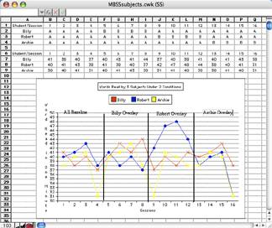

We can see that Billy, showed a slight improvement in number of words read correctly while using the colored overlay. Robert showed a dramatic improvement in number of words read correctly with the colored overlay and probably should continue to use colored overlays in reading. Archie on the other hand showed no improvement as a result of using colored overlays while reading. Archie also showed greater day by day fluctuation in the number of words read correctly. It is doubtful that the use of colored overlays would be at all useful with Archie.

In this multiple baseline study, we have looked at the performance of several subjects on the same behavior (number of words read correctly) and the same setting (in school during the reading instruction period). We could also do a multiple baseline study by looking at several behaviors for one subject in one setting. The third variant of a multiple baseline study could involve a single subject with a single behavior in several settings. For example we could take one minute samples for Billy reading words correctly in his regular classroom, in the resource room, and at home

**Alternating Treatments Design**

The final type of single research designs we will consider is the alternating treatments design. In this design we wish to compare the effect of two treatments on a subject. The subject in an alternating treatments design is given one of two treatments at each experimental session. Which treatment to use during a given session is determined randomly. This could be done by flipping a coin after assigning treatment 1 to heads and treatment 2 to tails. We could use this design with our colored transparencies in reading by considering the use of a clear transparency as treatment 1 and the use of a preferred colored transparency as treatment 2.

If we evaluated Jimmyπs performance in reading words correctly under the two treatment conditions over a 10 session period we might get results such as the following.

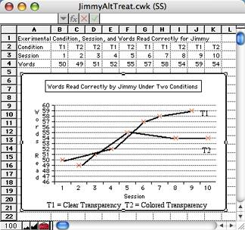

The chart for Jimmyπs data shows the number of word read correctly during a one minute time period while using a clear transparency (T1) and the number of words read correctly while using a colored transparency (T2). For Jimmy we do not see an advantage for his reading with a colored transparency. In fact during sessions 6 through 10 he seemed to be performing slightly better with Treatment 1, the use of clear transparencies. We could make a couple of other observations. 1) There is little overall difference in Jimmy reading behavior as a function of treatment type. 2) there does seem to be a general increase in the number of words read correctly over time, but this is not related the treatment choice.



Add a note...

Clipped from: http://www.winginstitute.org/Graphs/Mindmap/Single-Subject-Design-Examples/



[Previous Page](javascript:javascript:history.go(-1))

There are three commonly employed **single subject** research designs.

1. A-B-A-B Withdrawal (Reversal) Designs
2. Multiple-Baseline Designs
3. Alternating Treatments Design

# ****A-B-A-B Withdrawal (Reversal) Designs****

The A-B-A-B withdrawal procedure uses a baseline (control) phase referred to as the A of the experiment and an intervention (treatment) phase of the experiment known as the B. In the A-B-A design, the baseline is required to establish the student’s pre-intervention performance level. This non-intervention period is initiated until the behavior in question demonstrates stability. The intervention phase B of the study is initiated and data continues to be collected. In the A-B-A design, a third phase is subsequently instituted in which the experimental intervention is withdrawn with a return to the baseline (control) state A. Finally, the B phase is reinstated to demonstrate that the effects are a function of the intervention and not some other variable. This is done to determine if a causal relationship exists between the intervention (B) and improved student performance. Demonstrating the effect across additional participants further strengthens the causal relationship.  
  
  
**Example: A-B-A-B Withdrawal Design**  
A teacher is working to improve a student’s ability to remain in seat during work periods uses an A-B-A-B Design.

* **Phase A**: The teacher records the number of times per day Bob is out of his seat during work periods.
* **Phase B**: The teacher implements reinforcement program for student remaining in seat for a week and counts the frequency of out of seat behavior.
* **Phase A**: The teacher suspends the reinforcement program and the records the number of times Bob is out of his seat.
* **Phase B**: The teacher re-implements reinforcement program for student remaining in seat and counts the frequency of out of seat behavior.

In this experiment the teacher is able to show the reinforcement program is effective in meeting her goals for Bob.

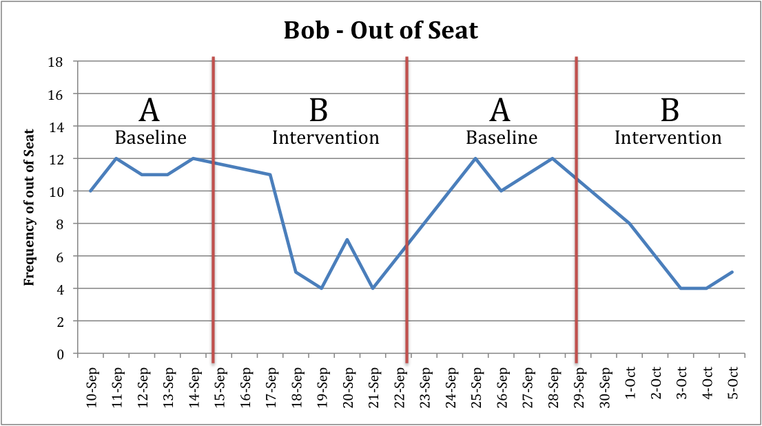

# ****Multiple-Baseline Designs****

The first example looked at the effects of a single targeted student behavior, out of seat, in a single setting.

The second example, a multiple-baseline design, is useful for studying the effects of a teaching practice in which two or more behaviors, people, or settings can be tracked on a single experiment. The multiple-baseline can examine one of these three variables (subject, behavior, or setting) while keeping the other two variables constant. In the A-B-A-B design all three parameters were kept constant, a single behavior for a single subject in a single setting. What if a teacher wants to know the impact of fluency training for three students in her/his classroom? The multiple-baseline design is well suited to answering this type of question. Another advantage of the multiple baseline design is it is not necessary to return a participant to baseline condition.  The multiple baseline design can demonstrate causal relation without having to terminate intervention.  In the case of academic skills this offers the teacher an important tool as it is often the case that once the skill have been learned then a return to baseline will not produce a change in performance.

**Example: Multiple-Baseline:**

A pre-intervention reading fluency baseline is established for all three students (Bill, Gloria, and Bob). The data is usually collected concurrently across all three participants.   
  
After three to five trials and assuming a stable baseline is established, Bill is introduced to the experimental condition, a reading fluency  program. The program is introduced while the other two subjects continue with the baseline condition.  
  
After three to five more trials, Gloria goes into the experimental phase. The third student, Bob, continues with the baseline condition.   
  
After three to five more days, Bob starts the experimental phase while the other two participants continue in the intervention phase.  
  
In this example, the dependent variable is the number of words read correctly during a one-minute time period, and the independent variable is the three students.   
This design allows the teacher to know that the intervention is effective for Bill and Gloria but is not working for Bob.  
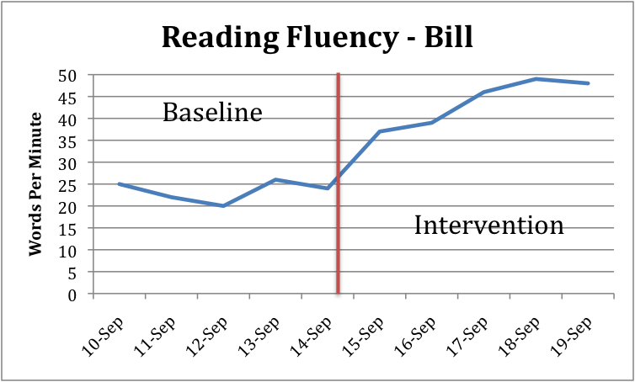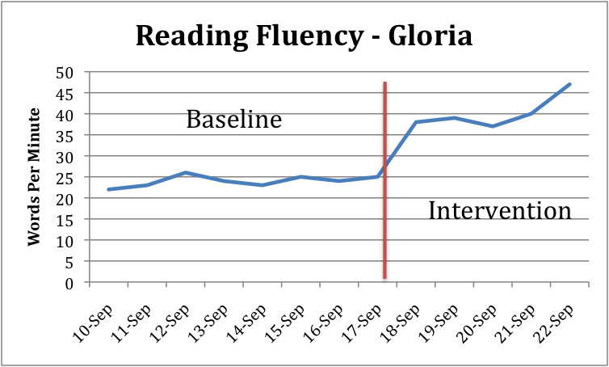

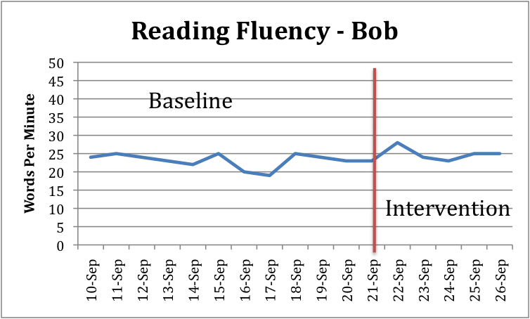

# Alternating Treatment Design

The alternating treatment design is used to compare the effects of two treatments on one subject. Two interventions or practices are introduced and alternated at each of the training sessions. The teacher determines randomly which of the two experimental interventions to select for each session. This design offers the teacher a method for comparison of the two interventions is better suited to improving the student’s performance.   
  
Example: Alternating Treatment Design  
  
A teacher is interested in increasing her student’s rate of reading. She has two fluency programs that she believes may work with Bob. She implements the two different programs on alternate days over 19 days. After the completion of the experiment, she is confident that intervention #1 will achieve better results for improving Bob’s reading skills  
  
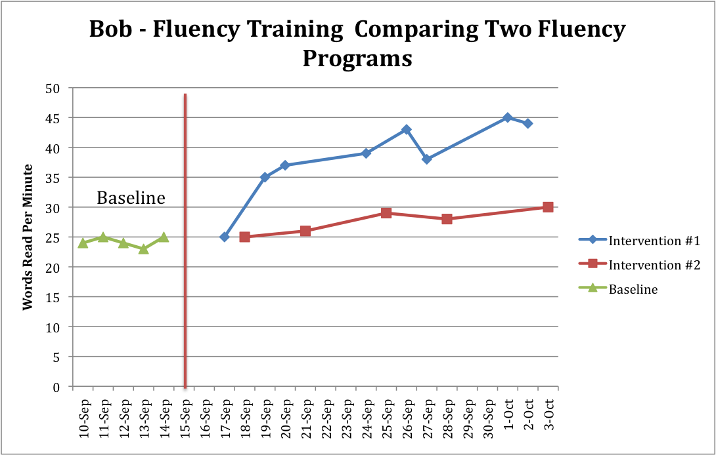

[Please Login to Submit Comments](http://www.winginstitute.org/MemberLogin.aspx?returnurl=/Comment.aspx?id=653)

|  |
| --- |
| **Reviews** |



Add a note...

Clipped from: http://study.com/academy/lesson/ethnographic-design-definition-advantages-disadvantages.html

Instructor: *Natalie Boyd*

Natalie is a teacher and holds an MA in English Education and is in progress on her PhD in psychology.

Qualitative Research

Cal's father was a prosecutor, and when Cal was a kid, he used to sit in the courtroom for hours watching his father work to put criminals away. He began to notice some patterns emerging. Often, the children of incarcerated criminals would themselves end up incarcerated. The family members called to testify in cases were often jaded and looked at cops and lawyers with a skeptical eye.

Now, Cal is all grown up. He's a psychologist, and he's really interested in studying the community that consists of families of incarcerated criminals. Why do they think the way they do? How do they view law enforcement and the legal system? What is different about their community and culture compared to the community and culture of the United States at large?

These are all good questions, and there are many ways that Cal can answer them through research. One way that Cal can approach these questions is by doing **qualitative research**, which involves examining non-numerical data to find answers to his questions. There are many types of qualitative research. Let's look closer at one qualitative research method - ethnography - and its strengths and limitations.

Ethnography

Okay, so Cal wants to examine the families of incarcerated criminals to see what they have in common with each other and what he can figure out about the community that surrounds incarceration. So he begins to hang out in circles where there are many incarcerated criminals. He observes and interviews family members of the incarcerated and makes notes about what he sees. Afterwards, he'll go back through and look for patterns in his notes.

Essentially, Cal is conducting an **ethnographic study**, which is focused on describing a culture's characteristics. It often involves looking at how the culture and beliefs of a community affect the behaviors and thoughts of individuals within that community. For example, perhaps Cal begins to notice that many people in the community he's observing distrust outsiders, particularly if they are involved in law enforcement or the legal system.

How does that affect members of that community? Perhaps children who grow up with an incarcerated parent, raised within the community of suspicion, end up being more than usually suspicious of cops. As a result, they do not turn to the police for help, instead learning to defend themselves. So Cal notices that there is a higher rate of vigilante justice among children of incarcerated criminals.

In general, ethnography is not interested in any given individual and their subjective observations and responses. Instead, it is focused on the community and what patterns are prevalent within the community.

Ethnographic research is often done in the field. That is, the researchers usually go into the community they are studying. They might spend hours and hours over months or even years talking to people in the community. Observations, interviews and documents can all be a good source of information for ethnographic researchers.

The biggest challenge that faces those who do ethnographic research is the balance between getting close to their subjects and maintaining distance. In order to get the community to open up and because they are spending so much time within the community, ethnographers have to become very close to their subjects, sometimes even becoming a part of the community that they are studying. But they also have to maintain a certain amount of distance in order to be able to take a clear-headed, scientific view of their research.

Strengths and Limitations

Ethnography is particularly good at examining complex cultural phenomena. This is one of its biggest strengths. For example, Cal notices that there is a higher prevalence of vigilante justice among children of incarcerated criminals. That same observation could come from many other types of research; a researcher might notice that when he looks at crime rates, for example.

But Cal is in a unique position to answer not just 'what' (the vigilante justice) but 'why' it happens. Crunching numbers and examining crime rates won't tell you why children of incarcerated criminals lean more towards vigilante justice, but Cal's ethnographic research can.



Add a note...

Clipped from: https://www.spotless.co.uk/insights/ethnography-when-and-how/

### Ethnography can help investigate very complicated or critical design challenges. A good researcher is essential when observing and/or interacting with target audiences in their real-life environment.

#### *Definition of ethnography*

Ethnography is a qualitative research method where **researchers observe and/or interact with a study’s participants in their real-life environment.** Ethnography was popularised by anthropology, but is used across a wide range of social sciences.

Within the field of usability and user-centred design, ethnography is used to support a **designer’s deeper understanding of the design problem**– including the relevant domain, audience(s), processes, goals and context(s) of use.

The aim of an ethnographic study within a usability project is to get ‘under the skin’ of a design problem (and all its associated issues). It is hoped that by achieving this, a designer will be able to truly understand the problem and therefore design a far better solution.

#### *Methods associated with ethnography*

Anthropological ethnographers often live amongst a group/society for a year or more, in order to learn about them. This fully immersive, long-term ‘live and work’ approach to ethnography has not proven popular within the field of usability.

Part of the reason may involve cost, but it is also the case that anthropologists and usability practitioners are interested in different things. Anthropologists use ethnography in an attempt to fully understand as much as possible about an entire society. Usability practitioners are usually only interested in learning information that will support their reasoning on a specific design problem.

We would argue that deep, immersive ‘live and work’ ethnography is rarely required within the field of user-centred design. However, **short ethnographic studies can be very useful for user-centred projects**. For example: in order to understand the way in which a Merchant Bank trades and operates, a usability consultant might conduct an ethnographic study by working and socialising with its employees for a month.

Individual methods which are available within an ethnographic study include: participant observation, interviews and surveys. All of these ethnographic methods can be very valuable in gaining a deeper understanding of a design problem. Usability practitioners often make use of these in order to develop their understanding of the relevant domain, audience(s), processes, goals and context(s) of use.

#### *When to use ethnography*

Ethnography is most useful in the early stages of a user-centred design project. This is because ethnography focuses on developing an understanding of the design problem. Therefore, it makes more sense to**conduct ethnographic studies at the beginning of a project** in order to support future design decisions (which will happen later in the user-centred design process).

Ethnographic methods (such as participant observation) could also be used to evaluate an existing design – but their true value comes from developing an early understanding of the relevant domain, audience(s), processes, goals and context(s) of use.

We would normally recommend that **ethnographic methods are used for very complex and/or critical design problems**. More complex design problems (in terms of their domain, audience(s), processes, goals and/or context(s) of use) are likely to need the deeper understanding which ethnographic studies can bring. Equally, highly critical systems (where failure or error can lead to disaster) could also justify significant ethnographic research.

For example: An insurance company wanted to re-design their system dealing with the processing of insurance claims. This system had evolved over many years and actually represented a patchwork of previous systems. The ‘claim processing’ supported by this ‘system of systems’ is itself a highly complex process. In this example, ethnographic research should probably be considered.

#### *Advantages of ethnography*

One of the main advantages associated with ethnographic research is that**ethnography can help identify and analyse unexpected issues**. When conducting other types of studies, which are not based on in-situ observation or interaction, it can very easy to miss unexpected issues. This can happen either because questions are not asked, or respondents neglect to mention something. An ethnographic researcher’s in-situ presence helps mitigate this risk because the issues will (hopefully) become directly apparent to the researcher.

Ethnography’s other main benefit is generally considered to be its ability to deliver a detailed and faithful representation of users’ behaviours and attitudes. Because of its subjective nature, an ethnographic study (with a skilled researcher) can be very useful in**uncovering and analysing relevant user attitudes and emotions.**

#### *Disadvantages of ethnography*

One of the main criticisms levelled at ethnographic studies is the amount of time they take to conduct. As discussed above, **ethnographic studies do not always require a long period of time**, but this consideration is nonetheless valid. Because of its richer output, an ethnographic study will tend to take longer to generate and analyse its data than many other methods.

During previous ethnographic studies, we have found that it is possible that**subjects may not act naturally during a short study**. Longer studies normally counter-act this because the subjects grow to trust the researcher and/or get tired of any pretence.

For example: During the first week of an ethnographic study into an insurance claim processing system, all the subjects were observed to be following the strictest interpretation of the correct procedures. As time progressed, however, it became increasingly apparent that almost all employees had ‘work-arounds’ and ‘short cuts’ which were liberally used in order to speed things up. These behaviours were very instructive in helping to re-design the process flow. Had the researcher not stayed in-situ long enough to observe these, they may have gone unrecorded.

#### *Risks associated with ethnography*

As stated above, ethnographic studies consist of the researcher observing and/or interacting with subjects within the environment which the (future) design is intended to support. The two main potential weaknesses with ethnographic studies are:

**Researcher**  
Ethnographic researchers need to be very highly-skilled to avoid all the potential pitfalls of an ethnographic study. Some of these include the detail & completeness of observations, as well as potential bias (and mistakes) in data collection or analysis.

**Subjects**  
It is essential that any studies’ subjects are as true a representation of the larger user audience as possible (assuming that the study has been designed this way). It is also vital that the subjects are open and honest with the researcher. Of course, both of these issues are related to the quality of the researcher themselves and their role in the study’s design.

As we can see from the above, most of the risks associated with ethnographic studies relate to the researcher, either directly or indirectly. This, of course, means that the**choice of ethnographic researcher is critical to a study’s success**. We recommend choosing a researcher with a proven background of past involvement in successful projects across varying domains.

#### *Conclusion*

We would generally recommend that an ethnographic approach may be suitable for the early stages of a user-centred project that deals with a particularly complicated or critical design challenge. This is because ethnographic methods allow a particularly deep understanding of a design problem’s domain, audience(s), processes, goals and context(s) of use. These ethnographic methods can also be very useful in discovering and exploring previously unknown issues.

Perhaps the most critical decision within an ethnographic study is the choice of ethnographic researcher. This individual will design, conduct and analyse the study’s findings – so it is essential that they have the skill and experience to make sure the study is representative, accurate and fair.

[back to top](https://www.spotless.co.uk/insights/ethnography-when-and-how)



Add a note...

Clipped from: http://www.psych2go.net/research-methods-part-4-the-correlational-design/

A correlational design is part of the non-experimental research design. The reason it is non-experimental is because it does not involve manipulating the variable of interest. The correlational design simply aims to determine the relationship between two variables, as well as how strongly these variables relate to one another.

How a study goes about conducting a correlational research is beyond the scope of this article. Instead, this article primarily focuses on the purpose of a correlational design, the types of relationships that exist for a correlational design and the limitations or problems that are typically associated with it.

The purpose of a correlational design is to describe the relationship that exists between two variables and the strength of this relationship. Let’s first talk about the four possible types of relationships:  
Positive  
Negative  
Curvilinear  
No Relationship.

**1. Positive Relationship.**

[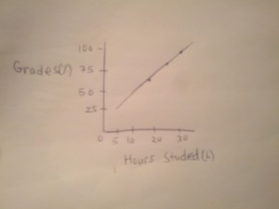](http://www.psych2go.net/wp-content/uploads/2014/09/2014-09-05-00.27.21.jpg)

A positive relationship is when two variables increases or decreases together. For example, the relationship between the number of hours studied and the resulted grades. The more hours studied, the higher the grade and the less hours studied the lower the grade.

Practice question: Think of some things that may have a positive relationship.

**2. Negative Relationship.**

[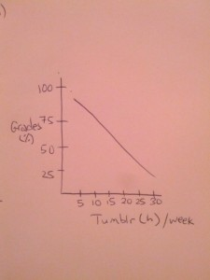](http://www.psych2go.net/wp-content/uploads/2014/09/2014-09-05-00.42.57.jpg)

A negative relationship is when one variable increases the other decreases or vice versa. For example, the more time spent on Tumblr the lower the grades or the less time spent on tumblr, the higher the grade.

Practice question: Think of some things that you know that may share a negative relationship.

**3. Curvilinear Relationship**

[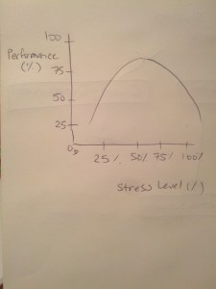](http://www.psych2go.net/wp-content/uploads/2014/09/2014-09-05-00.54.15.jpg)

A curvilinear Relationship is a type of relationship between two variables in which as one variable increases, so does the other variable. However, this works only only up to a certain point. This means that as one variable continues to increase, the other decreases. If you were to graph this kind of curvilinear relationship, you will come up with the shape of an inverted-U. For example: as stress increases, performance also increases but only until a certain point – at some point, performance will start to decrease. The other possibility is when one variable increases, the other starts decreasing but only until a certain point before it begins rising, the non-inverted-U curve.

Practice Question: Can you think of any other things that may share a curvilinear relationship?

**4. No Relationship (Flat)**

[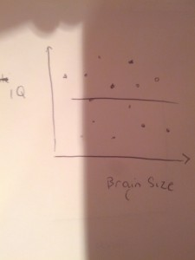](http://www.psych2go.net/wp-content/uploads/2014/09/2014-09-05-01.01.26.jpg)

A no relationship is when there is no pattern between the two variables. For example, the relationship between a person’s brain size and his/her IQ point. As shown in the diagram, the points are scattered everywhere, making it hard to see an existing relationship. This is in fact quite common, because it’s actually very hard to find relationships between things.

Practice question: Can you think of some things that don’t share a relationship?

**The Pearson Coefficient r : describes the the strength that exists between two variables for linear type relationships.**

It varies between +1 and -1. +1 means a very strong positive relationship whereas a -1 means a very strong negative relationship. However, this is actually very rare to see. Most relationships are not this strong and perfect.

r = 0 would mean a no relationship.

**Possible Exam questions:**

1. What’s the purpose of a correlational design?

2. What does a Pearson Coefficient r of .33 mean?

3. Which of these examples describe a positive relationship?  They’d probably trick you with the wording of the examples they give you, so be very careful with that. The key to determining a positive relationship is to look for two variables that are increasing or decreasing together.

**Limitations of Correlational Designs**

When you read studies and you recognize that the study is based on a correlational design (with no variable manipulation), there are generally three things to consider:

**1. No cause-and-effect can be determined.** This means that just because two variables share a relationship does not necessarily mean that one causes the other. For example, just because a correlational study determines that the amount of time studied and grades are related does not mean that time spent studying contributed to higher grades.

**2. There could be other variables mediating the relationship.** Using the same example above, it can not be concluded for certain that studying more made the difference in the grades. Perhaps, people who study more are also receiving more help from teachers or tutors or are just inherently more student type to begin with. There are so many possibilities that cannot be ruled out when using a correlational design. As such, an experimental design is needed in order to determine a cause-and-effect relationship.

**3. The direction of the effects cannot be determined.** This does not refer to whether the relationship is positive or negative. It refers to the idea that a correlational design cannot conclude which variable is causing the change in the other variable. It could be that studying more can possibly lead to higher grades, or higher grades can lead to studying more. Furthermore, there is also a possibility that these effects have a bidirectional meaning in which they contribute to one another. However, none of this can be fully concluded with just a correlational design. An experimental design is needed to determine the direction.

Hence, when reading studies either on this website or anywhere on the web, be sure to ask yourself if the research or study is based on correlation. If so, be sure to apply the above understanding to make your own conclusions.

Final comment:

Through my experiences as a psychology student, I have noticed that a lot of findings are generally best taken as correlational. Even if an experimental design is used to arrive at a cause-and-effect finding, there is still potential limitations with that design making you best take the finding as a correlational basis.

**Potential exam questions:**

1. What are the three weaknesses of correlational design?

2. Here is an example: What if someone asks you to identify the type of design used (correlational, experimental, quasi?), and what limitations you should be weary of for such design. In fact, you might even have to apply the variables used in the study as part of your answer. This cannot conclude whether x is causing y, or if y is causing x or if another variableyis mediating the effects.

**You can listen to our audio version here:**

Edited by [Tammy Cheng](https://www.facebook.com/tammarella)