What Indian Job Postings Say About Pay, Skills and Careers
Salary estimation with calibrated ranges, skill pay associations and pay disclosure from Naukri postings
Course: 23CSE452 Business Analytics (Units 1, 2 and 3)
Programme: B.Tech Computer Science, Amrita School of Computing
Group number: 03
Member | Register number
V Kireeti | CB.SC.U4CSE23057
R Anusanth | CB.SC.U4CSE23235
Mithresh M | CB.SC.U4CSE23039
Ravula Akshith | CB.SC.U4CSE23648
Rishinath | CB.SC.U4CSE23741

Guide: Ms. Rohini
Academic year: 2026 Submission date: 10-11-2026

Declaration and acknowledgement
We declare that this report describes work done by our team for the course named on the cover page. The analysis, code, figures and dashboard were produced by the team members listed in Section 8.2. Data, ideas, figures and code that come from other sources are cited in the text and listed in the references. The report has not been submitted for any other course or degree.
Signatures of team members:
Name | Register number | Signature | Date
V Kireeti | CB.SC.U4CSE23057
R Anusanth | CB.SC.U4CSE23235
Mithresh M | CB.SC.U4CSE23039
Ravula Akshith | CB.SC.U4CSE23648
Rishinath | CB.SC.U4CSE23741

Acknowledgement. We thank our guide for direction during the project, the course faculty for the review sessions that shaped the scope, and the people who maintain the open software packages listed in the references. We also thank our teammates for the time they put into data collection, cleaning, analysis and review.

Abstract
Job boards show what employers ask for, and sometimes what they pay, but few studies turn this into numbers that a job seeker, a recruiter or a training institute can act on in India. We collected 14,085 full-text postings from the Naukri job board. Of these, 10,780 map to one of ten business and technology roles, and 1,358 state a usable yearly salary range. We estimate pay for employers the model has not seen, and we return an 80% range whose coverage we check by role. We then test which skills go with higher pay, whether a description identifies its role, whether it predicts that the employer states pay, and which skills would move a posting toward another role. Google Trends data for 20 skills shows how search interest differs from employer demand. A tuned gradient-boosting model reaches R² 0.767 and a mean error of ₹3.8 lakh on 257 unseen-employer postings (role median: 0.335 and ₹5.6 lakh), and its 80% range held 83.3% of stated salaries. Experience carries most of the signal. Of 170 skills, 17 show a pay association that survives false-discovery control, and their ranking is unstable across employer halves. Only 12.9% of postings state pay, and the description predicts that with ROC-AUC 0.87. The work is delivered as four notebooks and a five-section dashboard.
Keywords: job postings, salary estimation, conformal prediction, text mining, time series, pay transparency, India.
Executive summary
Problem. A person deciding whether an offer is fair, a recruiter setting a salary band and a trainer choosing what to teach all rely on job postings, yet about nine in ten postings on the board we studied do not state a salary. Where a salary is stated it is a range, and skills lists mix useful tools with filler.
What we did. We studied 14,085 postings for ten roles. We built a salary estimate with an 80% range, tested which skills are linked to pay, checked whether a description identifies the role, and checked who states pay at all. We also compared employer demand for 20 skills with five years of Google search interest. All results are available in an interactive dashboard.
Main evidence. For employers the model had not seen, the typical error was ₹3.8 lakh against ₹5.6 lakh for guessing the role median, and 60% of estimates were within 30% of the stated salary. The 80% range held for 83% of postings, but only 59% for Software Engineer and 64% for Data Scientist. Experience is the strongest input. Only 17 of 170 skills show a clear pay association, and Python and SQL, the two most requested skills, show none. Only 12.9% of postings state pay, mostly from the same few employers. Search interest for Python and SQL fell by about a third and a half over five years while a quarter of postings still ask for them.
Value and actions. A job seeker can compare an offer with a range and similar postings, a recruiter can benchmark a role with a stated reliability, and a trainer gets a short list of skills that separate neighbouring roles. Negotiate from the range, treat Python and SQL as entry requirements, report how many postings stand behind any benchmark, and collect postings again over time before relying on skill pay figures.

Table of contents
Declaration and acknowledgement 2
Abstract 3
Executive summary 3
Table of contents 4
List of figures 4
List of tables 4
List of abbreviations 4
1. Introduction, Business Objectives and Literature Review 7
1.1 Context and scope 7
1.2 Related analytics work and research gap 8
2. Dataset Collection, Validation and Preparation 9
2.1 Provenance, coverage and challenges 9
2.2 Data quality, privacy and ethics 10
2.3 Transformations and usable dataset 10
3. Exploratory Data Analysis and Visualization (Unit 1) 11
4. Feature Engineering and Predictive Modelling (Unit 2) 12
5. Advanced Analytics (Unit 3): Two Selected Methods 14
5.1 Method 1: Text mining 14
5.2 Method 2: Time-series analysis 16
6. Comparative Analysis and Business Impact 17
6.1 Comparison of the two Unit 3 methods 17
6.2 Comparison with existing studies 17
6.3 KPI-based business impact and scenarios 18
7. Interactive Application, Figure Index and Reproducibility 18
7.1 Dashboard 18
7.2 Figure index and reproduction map 19
7.3 Code and environment 19
8. End-to-End Validation, Traceability and Contributions 20
8.1 Completion and validity 20
8.2 Project tracking and individual work 20
8.3 AI use and originality declarations 21
9. Conclusion, Recommendations and Roadmap 22
References 22
Appendix A: Data validation records 24
Appendix B: Additional analysis 24
Appendix C: Implementation, configuration and dashboard guide 24
Appendix D: Tracking evidence, contribution records, declaration and similarity report 24

List of figures
Figure 1. End-to-end workflow connecting the units and the application. Tool: Python (Matplotlib) 8
Figure 2. Salary midpoint by role. Boxes show the middle half; whiskers and dots show spread and outliers 11
Figure 3. Predicted against stated salary on the 257 test postings (left) and 80% ranges for a sample, so 13
Figure 4. Skill pay associations from double machine learning, with 95% intervals. Filled points survive 14
Figure 5. Employer demand against five-year change in search interest for 20 skills, coloured by pay asso 17
Figure 6. Dashboard Overview filtered to Data Analyst postings asking for 2 to 5 years: 33 postings, medi 19
List of tables
Table 1. Business objectives, KPIs and success criteria. 7
Table 2. Record counts through preparation. 9
Table 3. Sample of the final salary table (title and company omitted). 9
Table 4. Mapping of the final fields to the units and methods. 10
Table 5. Models on the same folds and the held-out test. 12
Table 6. Predicting whether a posting states pay (five-fold cross-validation by company, 10,780 postings 15
Table 7. Current findings against existing studies. 17
Table 8. Sensitivity of range reliability by role. 18
Table 9. Objective-to-evidence traceability matrix. 20
Table 10. Individual contributions. 21
Table 11. Prioritised recommendations. 22
Table 12. Supplementary results. 24

List of abbreviations
CV: cross-validation
DiD: difference-in-differences
DML: double machine learning
EDA: exploratory data analysis
FDR: false-discovery rate
KPI: key performance indicator
LDA: latent Dirichlet allocation
MAE: mean absolute error
MASE: mean absolute scaled error
MAPE: mean absolute percentage error
NMF: non-negative matrix factorisation
NMI: normalised mutual information
ROC-AUC: area under the receiver operating characteristic curve
STL: seasonal and trend decomposition using loess
SVD: singular value decomposition
TF-IDF: term frequency, inverse document frequency

1. Introduction, Business Objectives and Literature Review
1.1 Context and scope
Many Indian job seekers use Naukri to compare roles, and recruiters use it to see what rivals ask for. The board therefore holds a large record of requested skills and, for some postings, salaries. Three groups use this record. Job seekers and students want to know what an offer should pay and which skills to learn. Recruiters and human resources teams want a market benchmark for a role. Training institutes want to teach skills that employers ask for and that pay. The business problem is that most postings state no salary, the stated salary is a wide range, and skills lists do not say which skills matter for pay.
The scope is ten roles (Software Engineer, Data Analyst, Data Scientist, Data Engineer, DevOps and Cloud Engineer, Business Analyst, Product Manager, Project Manager, Digital Marketing and Graphic Designer) on one job board, with the salaries stated yearly in rupees. Search interest comes from Google Trends for India. The overall objective is to turn postings into decision support for the three groups above. The analytical questions and their measurable targets are in Table 1.
Table 1. Business objectives, KPIs and success criteria.
Business objective | KPI / unit | Baseline / target | Relevant unit or method
O1. Estimate pay for employers not seen in training | R² on log salary; mean error in ₹ lakh | Baseline: role median (R² 0.335, ₹5.6 lakh). Target: clearly better on both | Unit 2
O2. Give a range that holds | Share of stated salaries inside the 80% range (%) | Target 80%, with coverage reported by role | Unit 2
O3. Find skills that go with pay | Skills with a pay association after false-discovery control (count of 170) | Baseline: skills found by chance at p < 0.05 (about 8.5 of 170) | Unit 3, text mining
O4. Tell whether a description identifies its role | Accuracy and macro-F1 on unseen companies | Baseline: largest role, 19.8% accuracy | Unit 3, text mining
O5. Find out who states pay | F1 and ROC-AUC for stating pay | Baseline: always "does not state" (F1 0, AUC 0.5) | Unit 3, text mining
O6. Compare employer demand with search interest | Skills rising or declining; forecast error (MASE) | Baseline: naive forecast (MASE 1.035) | Unit 3, time series

Figure 1 shows how the units connect. Raw postings are cleaned once in Section 2. The cleaned data feeds the exploratory analysis (Unit 1), the salary model (Unit 2) and the two Unit 3 methods, text mining and time series. Their outputs are joined in Section 6 and shown together in the dashboard in Section 7.
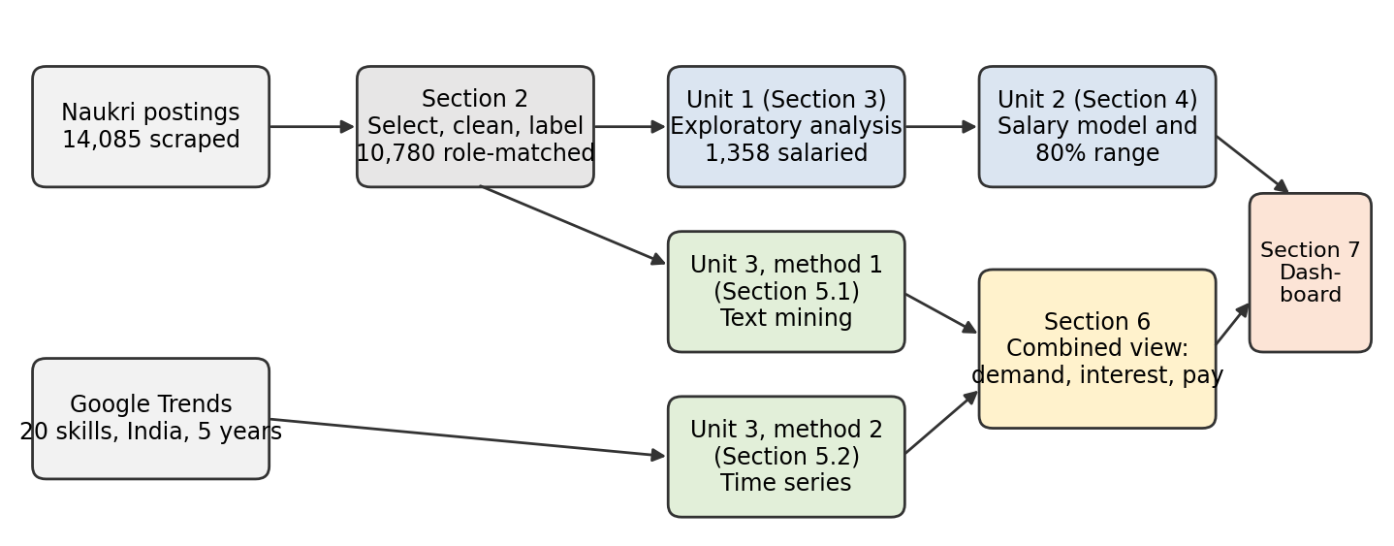
Figure 1. End-to-end workflow connecting the units and the application. Tool: Python (Matplotlib). Source: figure drawn for this report.
1.2 Related analytics work and research gap
Bana trained a language model on the text of postings from a US aggregator and reported that the words explain a large share of salary variation, much more than titles and locations alone [2]. The summary we read does not define the metric, so we use it as context, not as a number to match. Deming and Kahn linked skill requirements in US postings to wages within occupations and firms [10]. Ao and co-authors compared ways of finding skills in a UK set of over one million advertisements by how much wage variation each explains, and found that topic modelling explained more than keyword dictionaries [1].
Batra, Michaud and Mongey studied how little wage information US online postings carry: about 14% contain any wage, the range averages about 28% of its midpoint, and high-wage firms disclose less [3]. Hazell and Taska used posted wages to study how rigid pay is for new hires [13]. For India we found a framework for mining skills from computer-science advertisements that reports no quantitative results [24].
These studies leave three needs unmet for our setting. First, none gives a salary estimate with a stated range checked on employers not used in training, for an Indian board. Second, the pay-transparency studies describe who discloses but, in the sources we read, do not ask whether the wording of a posting predicts disclosure. Third, skill-and-wage studies report coefficients without checking how stable they are on a second set of employers. Regression with employer-grouped validation, conformal ranges [22], and a stability test address these. The numerical comparison with these studies is in Section 6.2.
2. Dataset Collection, Validation and Preparation
2.1 Provenance, coverage and challenges
The postings come from the Naukri job board [18], collected with a commercial scraper (an Apify actor named thirdwatch/naukri-jobs-scraper) in a single snapshot. Each posting has a title, company, locations, work mode, experience range, employer-tagged skills, industry, the full description, and sometimes a salary range. Search interest comes from the Google Trends service [11], queried through the pytrends package for 20 skills in India over five years of weekly data, in batches of five terms with a shared anchor term (SQL) so that batches can be placed on one scale. No synthetic data was used.
The scrape returned 14,085 postings and 63 columns, of which we kept 28. The unit of observation is one posting. Table 2 shows the counts through preparation and Table 3 a sample of the final salary table.
Table 2. Record counts through preparation.
Step | Postings | Note
Scraped | 14,085 | 63 columns, unique job id
Mapped to one of ten roles from the title | 11,589 | 2,401 matched no role, 63 matched two, 32 hit an exclusion rule
State a salary (role-matched, salary notebook) | 1,457 | 12.6% of role-matched postings
Final salary table (Units 1 and 2) | 1,358 | 1,017 employers; screens in Section 2.3
Text-mining corpus, distinct descriptions (Unit 3) | 10,780 | Descriptions of at least 50 characters, identical ones kept once
State a salary in the text-mining corpus | 1,389 | 12.9%; 1,348 after screens, from 1,016 employers

Table 3. Sample of the final salary table (title and company omitted).
Role | City | Work mode | Years asked | Skills tagged (first three) | Stated range (₹ lakh) | Split
Software Engineer | Pune | Hybrid | 5-10 | microsoft fabric, azure data factory, databricks unified data analytics platform | 15-27.5 | train
Data Scientist | Hyderabad | Work from office | 6-11 | machine learning, large language model, python | 13-20 | train
Data Engineer | Mumbai | Hybrid | 5-10 | snowflake, sql, data build tool | 15-30 | train

Collection had four practical limits. Runs were merged and repeated job ids removed. About 88% of postings carry no salary, which sets the size of every pay result. Some ranges are open-ended (starting at 0) or look monthly. Search interest is an index scaled to the largest term in each request, so batches were rescaled with the shared anchor. The collection was a single snapshot, so the results describe one point in time.
2.2 Data quality, privacy and ethics
Quality checks. Missing salary is the main gap (87.9% of raw postings). We also found repeated descriptions (790 in the role-matched set), repeated title-company-range rows (9), open-ended ranges starting at 0 (dropped) and midpoints under ₹100,000 a year that look monthly (32 dropped). Role sizes are uneven: Digital Marketing has 370 salaried postings and Data Scientist 72.
Privacy and bias. The data is public advertising text. Recruiter names, emails, links and logos were dropped at the first step, so no personal data about individuals is analysed. Company names appear only in local dashboard files, and the raw postings are kept locally and not redistributed, in line with the data minimisation expected under India's Digital Personal Data Protection Act, 2023 [12]. Only about one posting in eight states pay, mostly from a minority of employers, so pay results describe postings that disclose.
2.3 Transformations and usable dataset
Descriptions were lower-cased, links and addresses removed and whitespace collapsed, with no stemming. Seniority came from title keywords, city from the first listed location grouped into hubs, and experience from the midpoint of the stated range. Skills are the 200 most common employer tags; a posting asks for a skill if it was tagged or named in the text. The salary target is the log of the midpoint of the stated range. Model-specific steps such as the vocabulary, SVD and encoders were fitted on training postings only, and every split keeps each employer in one part (1,101 training and 257 test postings).
Table 4. Mapping of the final fields to the units and methods.
Variable | Type / meaning | Origin / preparation | Used in
role | Category, 10 levels | Title rules, one role per posting | U1, U2, U3 M1
experience (min, max, midpoint) | Years, number | Parsed from the stated range | U1, U2, U3 M1
seniority | Entry, Mid, Senior | Title keywords | U1, U2, U3 M1
city, work mode, industry | Category | First listed city grouped to hubs; board fields | U1, U2, U3 M1
skill tags | List of text | Employer tags, 200 most common used | U2, U3 M1
description | Text | Cleaned; TF-IDF, 50-component SVD, topics | U2, U3 M1
salary min, max | Rupees per year | Stated yearly range; screens in Section 2.2 | U1, U2
states pay | Yes or no | Salary field holds a yearly range | U3 M1
weekly search interest | Index 0-100 | Google Trends, rescaled with SQL anchor | U3 M2

3. Exploratory Data Analysis and Visualization (Unit 1)
The questions behind this section are: how is pay spread, what separates high from low pay, who states a salary, and is there enough text to learn from? All figures come from the notebook career_market_intelligence.ipynb (Python, Matplotlib and Seaborn) [14].
Salary is strongly right-skewed (skewness 1.72) and close to symmetric on the log scale (−0.04), so the models predict log salary. The median midpoint is ₹9.0 lakh against a mean of ₹12.3 lakh, and the middle 90% run from about ₹2.4 to ₹32.5 lakh. The log histogram has two humps, near ₹4 to 5 lakh and ₹20 lakh, which correspond to the lower-paid marketing and design roles and the technical and management roles. In the right panel the stated maximum is typically 1.67 times the minimum, so a single number hides a wide range.
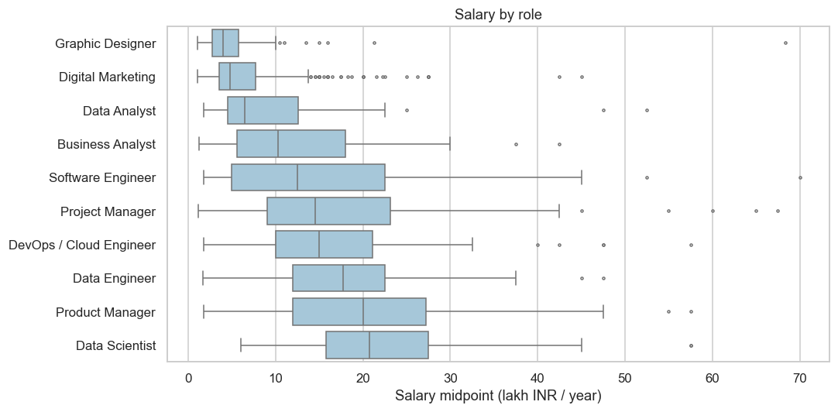
Figure 2. Salary midpoint by role. Boxes show the middle half; whiskers and dots show spread and outliers. Source: career_market_intelligence.ipynb, cell eda_role.
Role separates pay more than any other field in the table. Median pay is ₹4.0 lakh for Graphic Designers and ₹4.75 lakh for Digital Marketing, against ₹20.8 lakh for Data Scientists and ₹20.0 lakh for Product Managers, about a five-fold spread. The boxes overlap, so role alone cannot give a salary. Experience is the strongest single signal: the correlation of log salary with the experience midpoint is 0.71. Median pay rises from ₹3.4 lakh (Entry) to ₹6.2 lakh (Mid) and ₹13.0 lakh (Senior).
About one posting in eight states a yearly range (12.6% of role-matched postings). The rate runs from 5.5% for Software Engineer to 18.7% for Digital Marketing. On experience and company rating, postings that state pay look like those that do not (mean experience 6.1 against 6.0 years, rating 3.55 for both), which is reassuring but incomplete. The 1,358 postings come from 1,017 employers; the largest has 16 postings (1.2%) and 84% appear once, so we group all validation by employer.
4. Feature Engineering and Predictive Modelling (Unit 2)
Target and predictors. The target is the log of the midpoint of the stated yearly range. Predictors are experience (midpoint, square and span), role, seniority, city group, work mode, industry, company attributes, education, the 60 most common skill tags and a 50-component truncated SVD of the TF-IDF description. Text is reduced to 50 components so that 1,101 training rows are not swamped by thousands of word columns.
Protocol and leakage audit. The 257 test postings (204 companies) were set aside before any model was fitted and used once. Models are compared by five-fold cross-validation grouped by company on the 1,101 training postings. Encoders, the vocabulary and the SVD are fitted inside each training fold. We checked that no employer is in both parts, that salary amounts quoted in the text are not driving the result (removing pay amounts from the text changed R² by 0.002), and that the target does not enter any feature. A randomised search over XGBoost settings (20 draws) used the training postings only [7].
Table 5. Models on the same folds and the held-out test.
Model | Validation scheme | Test metrics | Interpretability / bias evidence
Global median (baseline) | 5-fold CV by company | CV R² −0.007; mean error ₹7.8 lakh | No inputs; sets the floor
Role median (baseline) | 5-fold CV by company; test | CV R² 0.372; test R² 0.335, error ₹5.6 lakh, 36.6% within 30% | Shows how little role alone explains
Ridge | 5-fold CV by company | CV R² 0.671; error ₹4.6 lakh | Coefficients; close to boosted models
Random forest | 5-fold CV by company | CV R² 0.671; error ₹4.5 lakh | Importance by group
Stacking (Ridge, forest, XGBoost) | 5-fold CV by company | CV R² 0.704; error ₹4.2 lakh | Hard to explain; tied with XGBoost
XGBoost, tuned (selected) | 5-fold CV; held-out test | CV R² 0.696; test R² 0.767, error ₹3.8 lakh, 59.9% within 30% | Permutation importance, error by role

Stacking and XGBoost differ by 0.009 in R², far inside the fold-to-fold spread of about 0.05, so neither is a clear winner. Ridge is only 0.03 behind, which says the signal is mostly additive. We selected XGBoost because it is a single model, nearly as accurate as the stack, and supports the explanations below. Tuning did not help (R² 0.695 to 0.696), so the limit is the information in the postings, not the settings.
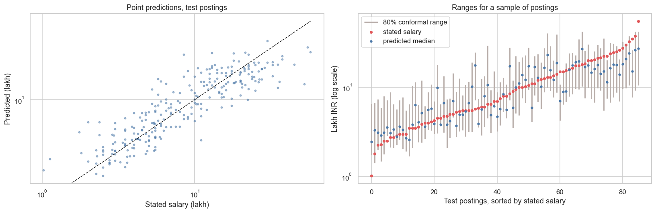
Figure 3. Predicted against stated salary on the 257 test postings (left) and 80% ranges for a sample, sorted by stated salary (right). Source: career_market_intelligence.ipynb, cell eval_plot.
On unseen employers the tuned model reaches test R² 0.767 and a mean error of ₹3.8 lakh, against 0.335 and ₹5.6 lakh for the role median, and 59.9% of estimates fall within 30% of the stated salary (36.6% for the role median). The 80% range uses conformalized quantile regression [22]: quantile models at the 10th and 90th percentiles are fitted on a proper training part, and a calibration part, separate by employer, widens them. The range held 83.3% of test salaries, against 70.4% for the uncalibrated bands.
What the model uses. Removing experience lowers cross-validated R² by 0.109 and removing the description by 0.023; removing any other group costs 0.006 or less. Shuffling a group on the test postings gives the same order (experience 0.61, description 0.23). This does not mean role and seniority carry no information. Each alone explains much of the variation (role 40%, experience 51%), but the description names the role with about 90% accuracy and seniority moves with experience, so once those inputs are present the others add little.
Subgroup check. The overall figure hides differences. Coverage is 58.8% for Software Engineer (17 test postings), 63.6% for Data Scientist (11), 72.2% for Product Manager (18) and 75.0% for Business Analyst (16), against 96.9% for Graphic Designer (32). By experience it is 76.1% for 5 to 8 years and 78.7% for 8 to 12 years. The guarantee of conformal prediction holds over all postings together, not within each role, and the small roles have too few test postings to say more. We report this as a limit and recommend that users of the range read it with the role-level figure. For business use, the model beats the role median clearly for every role in typical error, so it meets O1, and it meets O2 overall but not for the four roles above.
5. Advanced Analytics (Unit 3): Two Selected Methods
We chose text mining and time-series analysis. Text mining suits the problem because pay, role and disclosure all depend on what a posting says. Time series suits the question of how skill demand compares with public interest over time. Both are presented with the same structure.
5.1 Method 1: Text mining
Business question and inputs. Which skills go with higher pay, can a description identify its role, who states pay, and which skills would move a posting toward another role? The input is the 10,780 role-matched postings with distinct descriptions; the pay questions use the 1,348 that state a salary after screens. The notebook is text_mining.ipynb.
Algorithms and settings. Skills were found from employer tags and whole-word matching in the text. Topics came from LDA and NMF (K = 8, chosen by held-out perplexity) [5]. Posting clusters used K-means. Skill bundles came from Louvain community detection on a co-occurrence network built from lift [6]. Pay associations were estimated three ways for 170 skills with at least 25 salaried postings: least squares with company-clustered errors, a joint ridge regression with company bootstrap, and double machine learning with five-fold cross-fitting [8], using role, experience, seniority, city, work mode and industry as controls, and Benjamini-Hochberg false-discovery control at 10% [4]. Role fit compared ten models under company-grouped cross-validation. Disclosure classification compared seven models, with salary amounts removed from the text, and ranked words by weighted log-odds [17]. Skill recourse used a multinomial logistic regression on the 200 skill indicators and added, one at a time, the skill that most raised the target role's lead, limited to skills at least 10% of the target role's postings ask for [25].
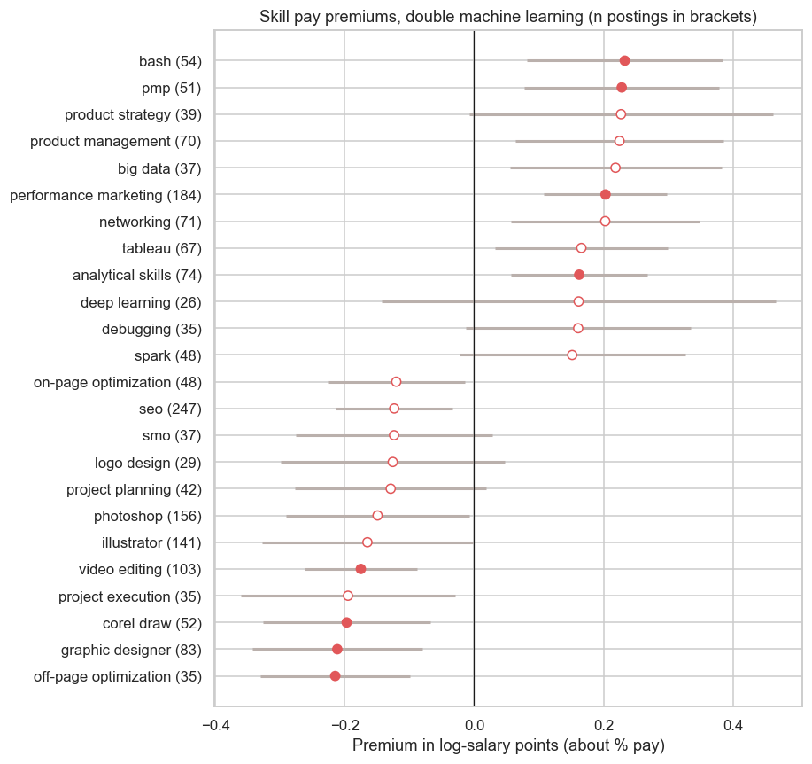
Figure 4. Skill pay associations from double machine learning, with 95% intervals. Filled points survive false-discovery control. Source: text_mining.ipynb, cell forest.
Pay associations. Of 170 skills, 32 have p < 0.05 by least squares, about 8.5 expected by chance, and 15 survive correction; double machine learning gives 31 and 8, and 17 skills are clear in at least one estimator. The largest positive double-ML values are bash (+26%), product management (+25%), networking (+23%), performance marketing (+23%) and analytical skills (+18%); the largest negative are off-page optimisation (−19%), graphic designer (−19%), CorelDraw (−18%) and video editing (−16%). Python (+8%) and SQL (+4%) are not distinguishable from zero. However, estimating on a random 80% of companies and again on the rest gives a rank agreement of only about 0.28, so exact percentages are unreliable. Adding skills to the salary model lifted held-out R² by 0.01 or less (Section 4).
Role and disclosure classification. On 2,064 test postings from unseen companies a linear model reads the role from the description with accuracy 0.897 and macro-F1 0.881 (largest-role guess: 0.198 and 0.033). Removing the title's own words leaves it at 0.896 and 0.881, so the model is not copying the title; reading only the first 500 characters lowers cross-validated macro-F1 to 0.839. Skills alone place 90.3% of postings in the right role. Only 12.9% of postings state pay, so always answering "does not state" is 87.1% accurate and useless. Table 6 gives the models.
Table 6. Predicting whether a posting states pay (five-fold cross-validation by company, 10,780 postings).
Model for "states pay" | ROC-AUC | Precision | Recall | F1
Logistic regression, words and attributes | 0.882 | 0.415 | 0.688 | 0.518
Logistic regression, words | 0.871 | 0.440 | 0.629 | 0.518
Linear SVM, words | 0.863 | 0.435 | 0.598 | 0.504
MLP on 100 SVD components | 0.851 | 0.404 | 0.623 | 0.490
Complement naive Bayes, words | 0.839 | 0.399 | 0.546 | 0.461
XGBoost, posting attributes | 0.819 | 0.351 | 0.575 | 0.435
Logistic regression, role only | 0.593 | 0.157 | 0.649 | 0.253
Always "does not state" | 0.500 | 0 | 0 | 0

The words predict disclosure well (F1 0.52, and 0.552 with ROC-AUC 0.871 on 2,064 held-out postings), and the posting attributes add almost nothing. Compressing the words by SVD first does not help. Reading only 500 characters lowers F1 to 0.42, because the cues sit in the closing boilerplate. The pattern is mostly an employer habit: 76.5% of postings come from companies that never state a salary, and 85.5% of the postings that do come from companies that state one in at least half of their postings. Inside a role, employers that stay silent point to 3.6% lower pay, with an interval from −7.2% to +2.4%, which includes zero.
Skill recourse. Across all 90 role moves, a posting reaches the target role within five added skills in 48.1% of cases and within ten in 84.3%, with a median of five. The baseline that adds the target role's most common missing skills reaches 29.2% and 61.7%. A flip only means the classifier reads the posting as the target role.
5.2 Method 2: Time-series analysis
Business question and inputs. Which skills are people searching for more or less, and do skills that employers still ask for show falling interest? The input is weekly Google Trends interest for India for 20 skills over five years (261 weeks), rescaled with the SQL anchor. The notebook is method2_time_series.ipynb. Anchor agreement across batches was high (minimum correlation 0.999), and a repeat pull with plain-word queries gave the same class for 13 of 20 skills.
Algorithms and settings. Weekly series were smoothed with an eight-week average. Each skill is labelled rising, stable or declining from the five-year change (cut-off 10%), and the label is confirmed with a Mann-Kendall trend test [16]. Forecasts used a naive baseline, exponential smoothing, ARIMA and Holt-Winters, scored by rolling-origin backtests with MAPE and MASE [15], with conformal intervals. Seasonality used STL decomposition [9], computed with statsmodels [23]. To test whether code skills lost interest after AI coding assistants appeared, five code skills were compared with seven tool and platform skills around November 2022 by interrupted time series and by a difference-in-differences whose p-value comes from all 792 ways of choosing five treated skills out of twelve.
Results. Of 20 skills, 3 are rising (Deep Learning, Google Cloud, Machine Learning), 5 stable and 12 declining, and six have trends too small to judge. Python fell 34% and SQL 56% in five years. No forecasting method beats the naive forecast on 98 rolling windows (median MASE 1.035 naive, 1.076 smoothing, 1.126 ARIMA, 1.115 Holt-Winters), so forecasts are given with intervals and not as point claims.
After the release, code skills lost about 0.32 log points (roughly 27%) more search interest than the control skills, and only 3 of 792 groupings give a gap that low or lower (p = 0.005). No skill drops sharply at the release. Instead the code skills were rising before and bend downward afterward, and the gap is largest in 2025, so the date is wrong for the release itself. The test cannot separate AI assistants from other causes. Limits: Google Trends is a sample and measures attention, not hiring; the original pulls were not kept, so validation was repeated on fresh pulls.
6. Comparative Analysis and Business Impact
6.1 Comparison of the two Unit 3 methods
Text mining works on what postings say (10,780 descriptions, 1,348 with salary) and gives pay associations, classifiers and skill moves; time series works on 20 weekly search series and gives trend labels, forecasts with intervals and a break test. The methods complement each other. Python and SQL are asked for in about a quarter of postings each, while their search interest fell 34% and 56%. This fits skills that have become assumed knowledge, and neither carries a clear pay premium. Machine Learning is the only skill high on both demand (12.6% of postings) and rising interest (+40%), with a pay association of +21% in the 20-skill analysis and +14% in the 170-skill analysis, where it is not clear after correction. Figure 5 shows the combined view.
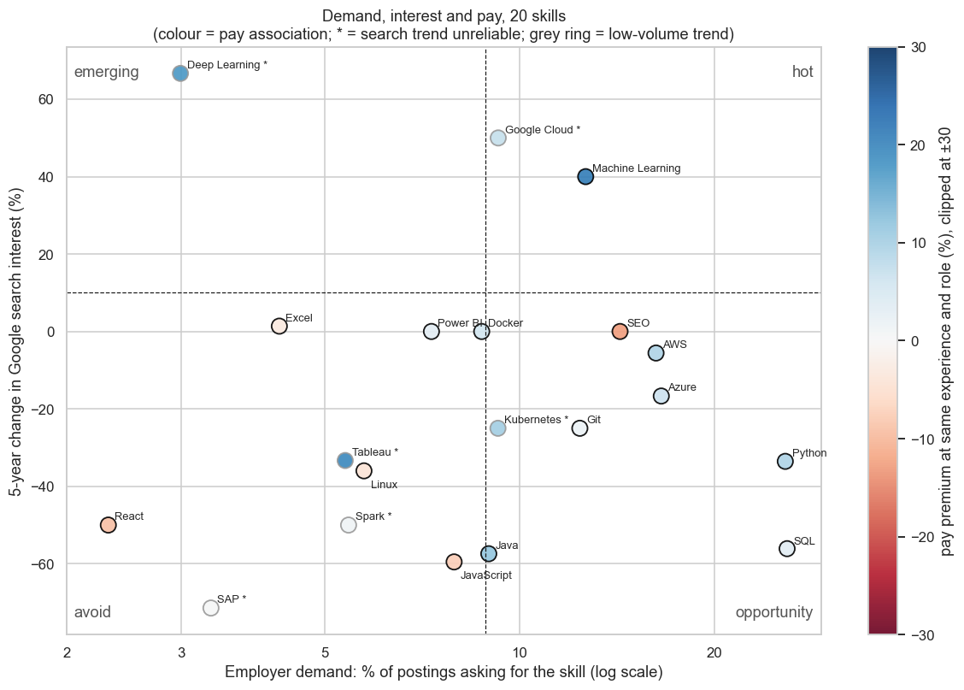
Figure 5. Employer demand against five-year change in search interest for 20 skills, coloured by pay association. Source: combined_insight.ipynb, cell plot.
By the fixed quadrant rule, one skill is hot, seven are in the opportunity quadrant (high demand, flat or falling interest), six are avoid and six have a trend too small to place.
6.2 Comparison with existing studies
Table 7. Current findings against existing studies.
Criterion | Batra et al. [3] | Ao et al. [1] | Bana [2] | Current project
Data and setting | US, all online job posts | UK, over 1 million advertisements | US aggregator, about 1 million postings | India, one board, 14,085 postings, 1,358 with salary
Methods and validation | Descriptive statistics of disclosure | Wage regressions; skill methods judged by variation explained | Fine-tuned language model; 80/20 split | Boosted model, employer-grouped CV; conformal range; stability tests
Comparable findings | About 14% state any wage; range 28% of midpoint; firm concentration | Dictionaries about 20%, topic model about 45% of wage variation | Text explains "87%" (metric not defined in the source we read) | 12.9% state pay; range 50% of midpoint; 76.5% of postings from never-disclosers; R² 0.767 test
Limits | No study of wording | Different metric from ours | Not comparable to our R² | Small test set; one snapshot

Our disclosure share (12.9%) is close to the US 14%, and disclosure is concentrated in few employers in both. Our stated ranges are wider: the median top-to-bottom ratio is 1.67, a span of 50% of the midpoint, against 28% in the US data. Like Ao et al., we find that text measures capture more than a skill list: topic shares alone explain R² 0.36 of log salary and the 50-component text summary 0.52, while adding skills to experience and role lifts R² by about 0.01. A numerical comparison with the language-model result is not valid, because its metric is undefined in the summary we read and the data differ in size by about three orders of magnitude. The project adds a role-level check of the salary range for an Indian board, a disclosure classifier and a stability test of skill premiums. It does not claim better accuracy than the other studies.
6.3 KPI-based business impact and scenarios
Measured outcomes. For the 257 unseen-employer postings the model's mean error was ₹3.77 lakh against ₹5.60 lakh for the role median, which is ₹1.83 lakh (33%) lower per posting, and the 80% range held 83.3% of the time. These are measured on held-out data.
Table 8. Sensitivity of range reliability by role.
Scenario | Assumption | Coverage of the 80% range | Reading
Best | Roles like Graphic Designer (32 test postings) | 96.9% | Range is wider than needed
Base | All roles together (257 postings) | 83.3% (95% interval 78.2% to 87.3%) | Close to target
Worst | Roles like Software Engineer (17 postings) | 58.8% | Range too narrow; widen it by hand

7. Interactive Application, Figure Index and Reproducibility
7.1 Dashboard
The dashboard is a Next.js application [19] with Observable Plot charts [20]. It runs locally from the repository folder named frontend, with these commands: `cd frontend`, `npm install`, `npm run dev`, then open http://localhost:3100. A hosted copy is at https://career-market-intelligence.vercel.app. A production build uses `npm run build` and `npm start`. Notebooks write JSON files with the final aggregates (for example salary.json, textmining.json, trends.json, gap.json, dataset.json, switch.json), and the application reads them, so the pages and the notebooks cannot disagree.
A top bar has five sections and a filter strip (role, city, experience, work mode) that carries across pages. Overview shows KPIs and pay by role, experience and city for the selection. Pay has the estimator with its 80% range, an offer check and range reliability. Skills has the demand, interest and pay map, pay associations and a skill planner. Careers has the skill-recourse tool. Data and method has the dataset, who states pay and the method notes. KPIs, pay charts, the dataset table, the offer check and the recourse search are computed in the browser from the filter; model comparisons, premiums, topics and trends come from the notebooks and are marked as not filtered.
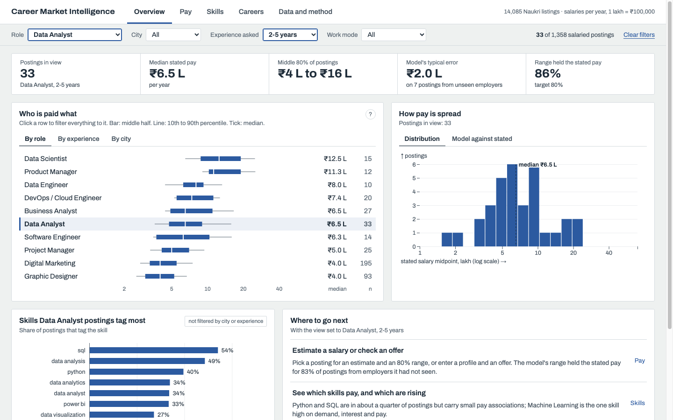
Figure 6. Dashboard Overview filtered to Data Analyst postings asking for 2 to 5 years: 33 postings, median ₹6.5 lakh. Source: frontend application, route /?role=Data Analyst&band=2-5 years.
Tests and limitations. A scripted browser session of about 40 steps (filters, tabs, estimator, offer check, skill lookup, recourse, dataset search) ran with no console errors, and the build and type check pass. Phone layout was not tested on a device. The dashboard files contain scraped titles and company names, so the application is for local use only.
7.2 Figure index and reproduction map
Every figure comes from the notebook named in its caption, in the cell named there. Appendix A lists all figures with their sections. The traceability matrix in Section 8.1 links each objective to its figure or file.
7.3 Code and environment
The repository is https://github.com/anusanth26/Career-Market-Intelligence. Folders are data, notebooks, scripts, reports, frontend and config, and the README files describe the tree. Dependencies are in requirements.txt (pandas, scikit-learn, xgboost, statsmodels, networkx, pytrends and others) [21], with Python 3.10 and Node.js 22. To reproduce, install the requirements, run the notebooks in the order career_market_intelligence, text_mining, method2_time_series, combined_insight (each writes the JSON the dashboard reads), then start the dashboard. No keys are stored in the repository. The raw postings and Trends pulls are not distributed because the board's terms may restrict copying. Seeds are fixed at 42 and splits group by employer.
8. End-to-End Validation, Traceability and Contributions
8.1 Completion and validity
Unit 1 is covered by Section 3 (descriptive statistics, distributions, segment comparisons and the disclosure anomaly), Unit 2 by Section 4 (baselines, four models, leakage audit, explanation and subgroup checks), Unit 3 by Section 5 (text mining and time series), and the application by Section 7 (screenshots and a scripted test). Notebooks execute in order with no errors.
Threats to validity. One board and one snapshot limit generalisation and rule out claims about change over time. Only 12.9% of postings state pay, so pay results describe disclosing postings. Role labels come from title rules. Test sets are small (257 postings, 11 to 33 per role). Skill premiums are associations and their ranking is unstable. Whole-word skill matching misses implied skills, and two notebooks differ for a few skills because their alias lists differ (Machine Learning +21% against +14%). Google Trends is a sample of attention, and the raw data cannot be shared.
Table 9. Objective-to-evidence traceability matrix.
Objective / KPI | Analysis / method | Result / metric | Figure / artifact | Recommendation
O1 Estimate pay | Section 4 | Test R² 0.767; error ₹3.8 L vs ₹5.6 L | Table 5; Fig. 3 | R1, R2
O2 Range that holds | Section 4 | 83.3% at an 80% target; 59% to 97% by role | Fig. 3 | R2
O3 Skills and pay | Section 5.1 | 17 of 170 clear; rank agreement 0.28 | Fig. 4 | R3
O4 Role from text | Section 5.1 | Accuracy 0.897; macro-F1 0.881 | textmining.json | R4
O5 Who states pay | Section 5.1 | F1 0.518; AUC 0.871; 76.5% from never-disclosers | Table 6 | R5
O6 Demand and interest | Section 5.2, 6.1 | 3 rising, 12 declining; no method beats naive | Fig. 5 | R3, R6

8.2 Project tracking and individual work
Work was tracked through the repository's issue tracker at https://github.com/anusanth26/Career-Market-Intelligence/issues (27 issues, all closed) and through pull requests and commits. The project board is at https://github.com/users/anusanth26/projects/1. Individual marks can vary with participation and the explanation each member gives. Table 10 lists each member's main work with a link to it.
Table 10. Individual contributions.
Team member / register no. | Assigned work | Evidence link / artifact
V Kireeti, CB.SC.U4CSE23057 | Text mining: skill extraction, LDA and NMF topics, K-means clusters, Louvain skill bundles, skill pay associations (least squares, ridge, double machine learning, false-discovery control, placebo and stability tests), role fit, pay disclosure and skill recourse | Text mining notebook
R Anusanth, CB.SC.U4CSE23235 | Time series: Google Trends collection in batches with anchor rescaling, trend labels with Mann-Kendall test, naive, smoothing, ARIMA and Holt-Winters forecasts with rolling-origin backtest, STL seasonality, conformal intervals and break test | Time series notebook
Mithresh M, CB.SC.U4CSE23039 | Combined view: employer demand from the postings joined with search interest and pay association, quadrant rule and skill gap table. Salary modelling, second part: stacking, tuned XGBoost with randomised search, held-out test evaluation (R², mean error, share within 30%), permutation importance, conformal 80% range and coverage by role | Combined insight notebook, Career market intelligence notebook
Ravula Akshith, CB.SC.U4CSE23648 | Salary modelling, first part: baselines (global and role median), Ridge and random forest, employer-grouped 5-fold cross-validation and the model comparison table | Career market intelligence notebook
Rishinath, CB.SC.U4CSE23741 | Data preparation and features: merging runs, removing repeated postings, salary screens, role mapping, experience, seniority, city and skill features, text SVD and the leakage audit; also the dashboard application and the Careers page | Frontend, Careers page, Career market intelligence notebook

Technical detail of the dashboard and Careers work (Rishinath). The dashboard is a Next.js 16 application on React 19 and TypeScript, using Observable Plot and d3 for charts and TanStack Table for the dataset view. A shared filter state (role, city, experience, work mode) is kept in the web address, so every page reads the same selection. The pages read JSON files that the notebooks export, from the career_market_intelligence notebook (salary.json, dataset.json, calculator.json) and the text-mining notebook (switch.json). The Careers page runs the skill search in the browser: it adds, one at a time, the skill that most raises the target role's score, limited to skills at least 10% of the target role's postings ask for. The finished application was checked with a scripted browser session of about 40 steps.
8.3 AI use and originality declarations
We used an AI assistant as a tool during this project. It helped write and debug notebook code, build the dashboard, draw figures and draft and format this report.
The team chose the problem, the roles and skills to study and the data sources. We collected the Naukri postings and Google Trends data, decided which models and tests to run, and checked the results against the notebooks. All members have read the report and take responsibility for what it says.
9. Conclusion, Recommendations and Roadmap
The objectives were met as shown in Table 9. The salary model beat the role median on unseen employers (O1), its 80% range held overall but not for the smallest roles (O2), most skill premiums did not survive checking (O3), the description identifies the role and predicts disclosure (O4, O5), and search interest differs from demand (O6).
Table 11. Prioritised recommendations.
No. | Recommendation | Expected KPI effect | Stakeholder | Feasibility
R1 | Negotiate from a range and compare with similar postings, not with one number | Offer placed against the 80% range and similar postings | Job seekers | High; in the dashboard now
R2 | Read the range with its role-level coverage; widen it for Software Engineer, Data Scientist and Product Manager | Fewer under-covered benchmarks | Recruiters, HR | High
R3 | Treat Python and SQL as entry requirements and add Machine Learning or cloud skills for data roles; do not choose skills by search interest | Skill plans linked to demand and pay evidence | Students, trainers | Medium; premiums are weak
R4 | Put the role's own content in the first lines of a description | Keeps role signal; first 500 characters score lower | Recruiters | High
R5 | State a salary range in the posting, and report how many postings stand behind any benchmark | Higher disclosure share | Recruiters, analysts | Medium
R6 | Collect postings repeatedly before relying on skill pay figures | Stable premiums | Project team | Medium

Roadmap. Next month: show range reliability by role beside every estimate, with the benchmark sample size. In three to six months: repeat the collection monthly, re-estimate skill premiums and add a second board. In six to twelve months: extract skills with a trained model, model both ends of the range, and test the skill advice against real career moves. Success checks are coverage within five points of 80% for each role with enough postings and a premium rank agreement above 0.5 on held-out employers.
References
[1] Ao, Horvath, Sheng, Song, and Sun. 2022. Skill requirements in job advertisements: a comparison of skill-categorization methods based on explanatory power in wage regressions. arXiv:2207.12834. https://arxiv.org/abs/2207.12834
[2] Sarah Bana. 2022. work2vec: Using Language Models to Understand Wage Premia. Preliminary paper, AEA Annual Meeting 2022. https://www.aeaweb.org/conference/2022/preliminary/paper/6yd4YYky
[3] Honey Batra, Amanda Michaud, and Simon Mongey. 2023. Online Job Posts Contain Very Little Wage Information. NBER Working Paper 31984. https://www.nber.org/papers/w31984
[4] Yoav Benjamini and Yosef Hochberg. 1995. Controlling the False Discovery Rate: A Practical and Powerful Approach to Multiple Testing. Journal of the Royal Statistical Society: Series B 57, 1 (1995), 289-300.
[5] David M. Blei, Andrew Y. Ng, and Michael I. Jordan. 2003. Latent Dirichlet Allocation. Journal of Machine Learning Research 3 (2003), 993-1022.
[6] Vincent D. Blondel, Jean-Loup Guillaume, Renaud Lambiotte, and Etienne Lefebvre. 2008. Fast unfolding of communities in large networks. Journal of Statistical Mechanics: Theory and Experiment 2008, 10 (2008), P10008.
[7] Tianqi Chen and Carlos Guestrin. 2016. XGBoost: A Scalable Tree Boosting System. In Proceedings of the 22nd ACM SIGKDD International Conference on Knowledge Discovery and Data Mining (KDD '16). ACM, New York, NY, USA, 785-794.
[8] Victor Chernozhukov, Denis Chetverikov, Mert Demirer, Esther Duflo, Christian Hansen, Whitney Newey, and James Robins. 2018. Double/debiased machine learning for treatment and structural parameters. The Econometrics Journal 21, 1 (2018), C1-C68. https://arxiv.org/abs/1608.00060
[9] Robert B. Cleveland, William S. Cleveland, Jean E. McRae, and Irma Terpenning. 1990. STL: A Seasonal-Trend Decomposition Procedure Based on Loess. Journal of Official Statistics 6, 1 (1990), 3-73.
[10] David Deming and Lisa B. Kahn. 2018. Skill Requirements across Firms and Labor Markets: Evidence from Job Postings for Professionals. Journal of Labor Economics 36, S1 (2018), S337-S369.
[11] Google LLC. Google Trends. Retrieved from https://trends.google.com
[12] Government of India. 2023. The Digital Personal Data Protection Act, 2023 (Act No. 22 of 2023). Ministry of Law and Justice, New Delhi.
[13] Jonathon Hazell and Bledi Taska. 2025. Downward Rigidity in the Wage for New Hires. American Economic Review 115, 12 (2025).
[14] John D. Hunter. 2007. Matplotlib: A 2D graphics environment. Computing in Science and Engineering 9, 3 (2007), 90-95.
[15] Rob J. Hyndman and Anne B. Koehler. 2006. Another look at measures of forecast accuracy. International Journal of Forecasting 22, 4 (2006), 679-688.
[16] Henry B. Mann. 1945. Nonparametric tests against trend. Econometrica 13, 3 (1945), 245-259.
[17] Burt L. Monroe, Michael P. Colaresi, and Kevin M. Quinn. 2008. Fightin' Words: Lexical Feature Selection and Evaluation for Identifying the Content of Political Conflict. Political Analysis 16, 4 (2008), 372-403.
[18] Info Edge (India) Ltd. Naukri.com job portal. Retrieved from https://www.naukri.com
[19] Vercel Inc. Next.js, the React framework. Retrieved from https://nextjs.org
[20] Observable Inc. Observable Plot. Retrieved from https://observablehq.com/plot
[21] Fabian Pedregosa, Gael Varoquaux, Alexandre Gramfort, Vincent Michel, Bertrand Thirion, Olivier Grisel, Mathieu Blondel, Peter Prettenhofer, Ron Weiss, Vincent Dubourg, Jake Vanderplas, Alexandre Passos, David Cournapeau, Matthieu Brucher, Matthieu Perrot, and Edouard Duchesnay. 2011. Scikit-learn: Machine Learning in Python. Journal of Machine Learning Research 12 (2011), 2825-2830.
[22] Yaniv Romano, Evan Patterson, and Emmanuel Candes. 2019. Conformalized Quantile Regression. In Advances in Neural Information Processing Systems 32 (NeurIPS 2019). https://arxiv.org/abs/1905.03222
[23] Skipper Seabold and Josef Perktold. 2010. Statsmodels: Econometric and Statistical Modeling with Python. In Proceedings of the 9th Python in Science Conference. 92-96.
[24] Singh, Kanaujia, and Singh. 2025. Data to Decisions: A Computational Framework to Identify Skill Requirements from Advertorial Data. arXiv:2503.17424. https://arxiv.org/abs/2503.17424
[25] Berk Ustun, Alexander Spangher, and Yang Liu. 2019. Actionable Recourse in Linear Classification. In Proceedings of the Conference on Fairness, Accountability, and Transparency (FAT* '19). ACM, New York, NY, USA, 10-19. https://arxiv.org/abs/1809.06514
Appendix A: Data validation records
Validation records: 14,085 unique job ids; 1,709 postings (12.1%) with a yearly salary range; 11,972 marked not disclosed, 352 unpaid and 52 with a monthly amount; 790 repeated descriptions removed from the text corpus; 32 implausible and 9 repeated salary rows removed. Raw files are held locally and are not included.
Appendix B: Additional analysis
Table 12. Supplementary results.
Check | Result
Salary model without text / with 50-component text summary | CV R² 0.673 / 0.696
Text limited to first 500 characters | CV R² 0.677
Pay amounts removed from the text | CV R² 0.694
Learning curve, training share 20% to 100% | CV R² about 0.62 rising to 0.70
Role fit, macro-F1 by split ratio 80/20, 70/30, 60/40 | 0.88 to 0.89, stable
Disclosure, ROC-AUC by split ratio 80/20 to 50/50 | 0.859 to 0.866
Pay-premium stability, rank agreement on held-out companies | About 0.28 at 80/20, 70/30 and 60/40
Search-interest forecasts, share of 80% conformal intervals that held | Naive 86.4%, smoothing 87.5%, ARIMA 89.5%, Holt-Winters 78.6%

Appendix C: Implementation, configuration and dashboard guide
Install with `pip install -r requirements.txt` for the notebooks and `cd frontend && npm install` for the dashboard. Run the four notebooks in order, then `npm run dev` in the frontend folder and open http://localhost:3100. Set role, city, experience and work mode in the filter strip; open Pay for the estimator and offer check, Skills for the demand map and skill lookup, Careers for the recourse tool, and Data and method for the dataset. Role rules are in config/roles.json and tracked skills in config/review2_skills.json.
Appendix D: Tracking evidence, contribution records, declaration and similarity report
Issue tracker: https://github.com/anusanth26/Career-Market-Intelligence/issues. Project board: https://github.com/users/anusanth26/projects/1. Commit history is available from the repository.

