CSP554 — Stock Market Data Pipeline
Phase 1 Documentation

What is Phase 1?
Phase 1 sets up the data collection and streaming layer for the pipeline. It has two parts:
- Download 5 years of stock data for AAPL, GOOGL, MSFT, TSLA, AMZN and save as CSV files
- Set up Apache Kafka so the data can be streamed record by record to Phase 2

The pipeline flow:
CSV Files -> Kafka Producer -> Kafka Topic -> Phase 2 Consumer

What We Did
Part | Task | Who
Part A | Downloaded 5 CSV files (~6,285 rows total) | Muthu
Part B | Set up Kafka using Docker (docker-compose.yml) | Muthu
Part C | Created Kafka topic: stock-market-data | Anusha
Part D | Wrote and tested producer.py — sends all records to Kafka | Anusha

How to Run Phase 1

Before you start — install these once
pip3 install kafka-python pandas --break-system-packages
Also install Docker Desktop from docker.com/products/docker-desktop and make sure it is open (whale icon in menu bar).

Step 1 — Go to the project folder
cd Desktop/stock-pipeline

Step 2 — Start Kafka
docker compose up -d
Check it is running:
docker ps
You should see 2 containers (kafka and zookeeper) both showing status Up.

Step 3 — Create the Kafka topic
docker exec -it kafka kafka-topics --create --topic stock-market-data --bootstrap-server localhost:9092 --partitions 1 --replication-factor 1
You should see: Created topic stock-market-data

Step 4 — Open 2 terminal windows side by side

TERMINAL 1 — paste this and press Enter (it will just wait, that is normal):
docker exec -it kafka kafka-console-consumer --topic stock-market-data --bootstrap-server localhost:9092 --from-beginning

TERMINAL 2 — paste these and press Enter:
cd Desktop/stock-pipeline
python3 producer/producer.py

You will see Terminal 2 counting up:
Sent 100 records (current: AAPL)
Sent 200 records (current: AAPL)
...

Switch to Terminal 1 — you will see JSON data flowing in:
{"symbol": "AAPL", "date": "2020-01-02", "open": 71.41, "close": 72.40, ...}

When you see JSON in Terminal 1 — Phase 1 is complete.

Step 5 — Shut down when done
Press Ctrl + C in Terminal 1 to stop it, then run:
docker compose down

Snapshots:

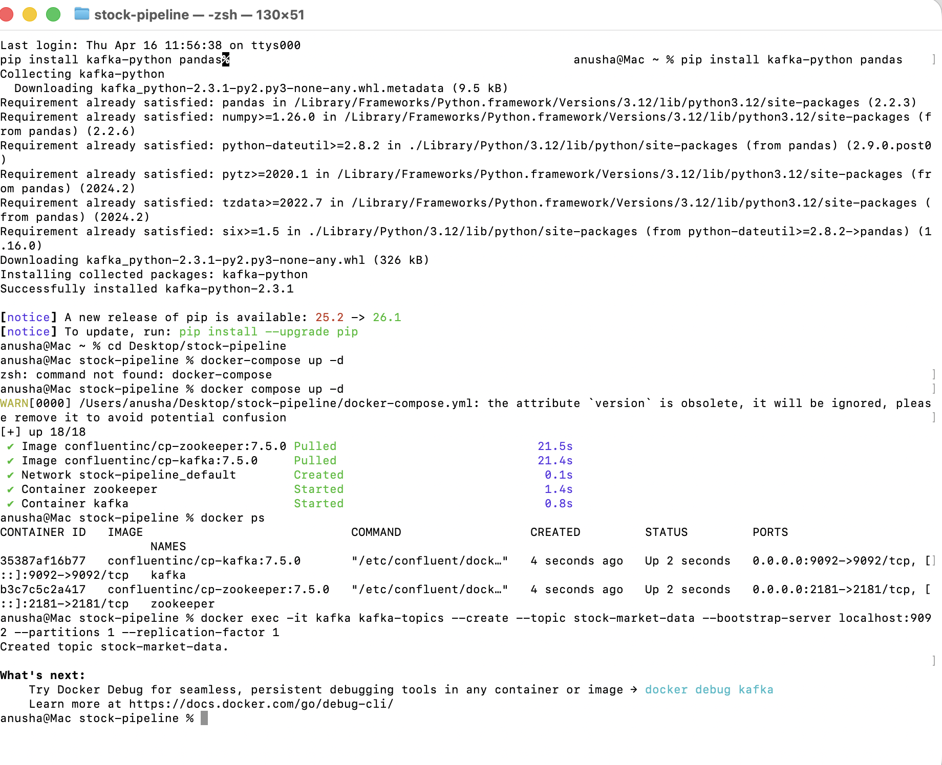
Terminal 1:
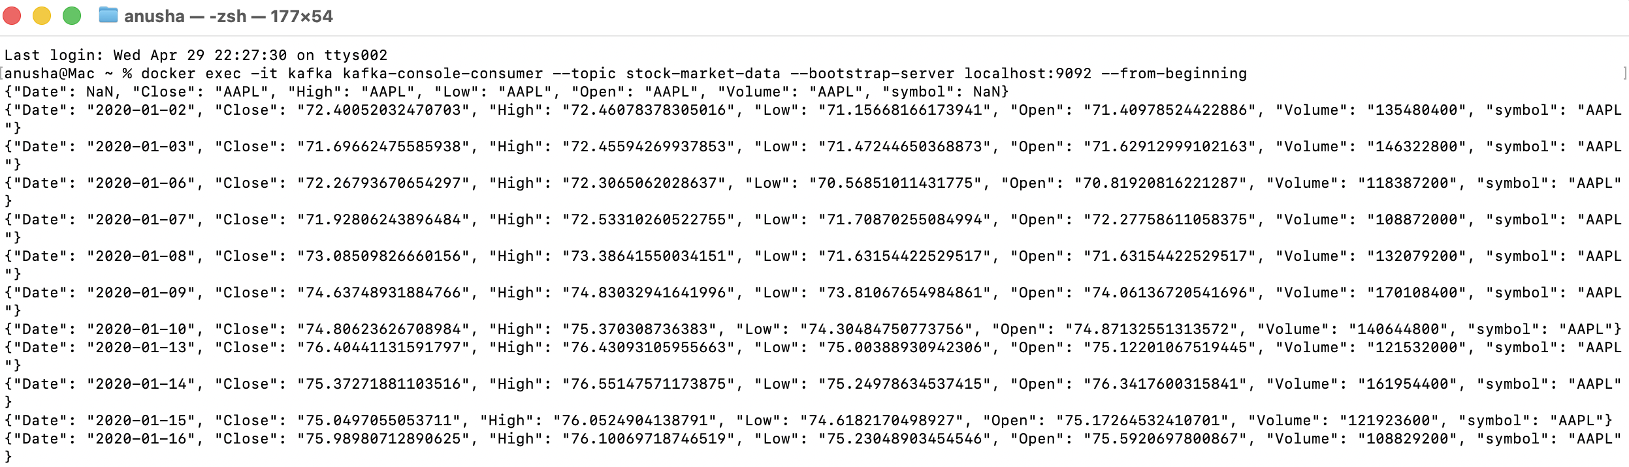

Terminal 2:
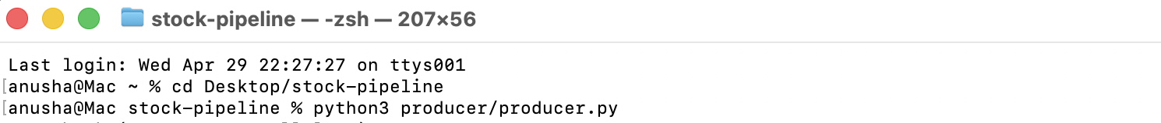
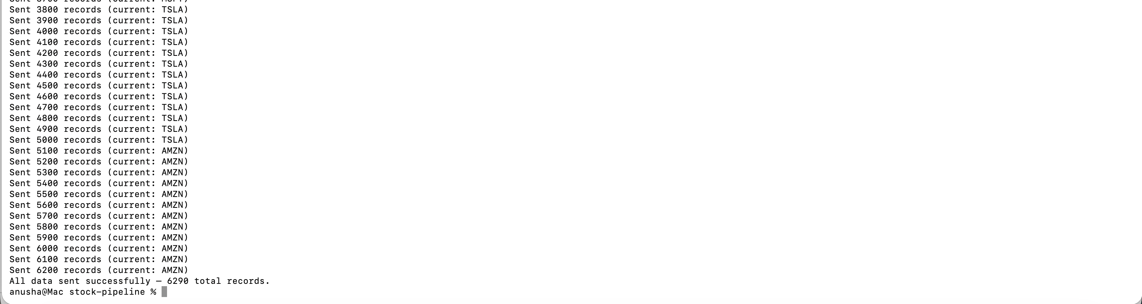

Shut down:
