Good afternoon mam.
My project focuses on analyzing the used bike resale market, which is growing quickly because many people prefer affordable transportation options.
In online marketplaces, we see thousands of used bikes listed with different prices. These prices vary depending on factors like the bike’s age, usage, engine capacity, ownership history, and location.
In this project, I use Exploratory Data Analysis to study a used bike dataset and understand how these factors affect pricing.
Since real-world data is often incomplete or inconsistent, an important part of my work was cleaning and preparing the data before analysis.
Finally, by studying past bike listings, my project helps identify market trends and provides useful insights into how used bike pricing works.
Business Problem (in your words)
“The used bike resale market has inconsistent pricing. Buyers often don’t know if a bike is fairly priced, and sellers rely on guesswork, which can lead to incorrect pricing and slower sales. There is no standard, data-driven way to understand what factors influence bike prices.”
Problem Statement (your project focus)
This project analyzes real-world used bike data to identify the key factors affecting resale prices. By cleaning the data and performing exploratory data analysis, I studied relationships between price, model year, kilometers run, engine capacity, ownership, and location to provide insights into pricing patterns.
Optional Viva Line to Connect Them
“So, my business problem is addressed through this analysis — the EDA provides clear insights that explain why bike prices vary and helps buyers and sellers make better decisions.”
Objectives
The main objectives of my project are to clean and preprocess used bike data, analyze price and ownership trends, study how factors like model year, kilometers run, and engine capacity influence prices, identify regional and ownership-based variations, and finally, provide actionable insights to help buyers, sellers, and platforms make better pricing decisions.

Clean and preprocess real-world used bike listing data
Answer:
“I cleaned the dataset by removing bicycle entries, special characters in numeric columns, and duplicates. I converted Price and KMs Run to numeric types and handled missing values using median, mode, or placeholders. I also standardized text in columns like ‘No of Owners’. This made the dataset consistent and ready for analysis.”
Where:
- Data cleaning and preprocessing section in your code.
2️⃣ Analyze price distribution and ownership trends using univariate analysis
Answer:
“I performed univariate analysis to understand individual patterns. For example, most bikes are single-owner, and the price distribution is right-skewed, showing that most bikes are priced below ₹2 lakh. I also looked at popular colors and top bike models.”
Where:
- sns.histplot(df["Price"]),
- df["No of Owners"].value_counts(),
- df["Color"].value_counts(),
- df["Bike Name"].value_counts().
Study relationships between price and factors such as kilometers run, model year, and engine capacity
Answer:
“I analyzed how price depends on key factors. I found that:
- Kilometers run: More used bikes generally have slightly lower prices, but the relation is weak.
- Model year: Newer bikes have higher prices, showing a strong positive relationship.
- Engine capacity (CC): Bikes with higher engine capacity have higher prices, while smaller engine bikes are cheaper.”
Where in your project:
- Correlation: df[["Price", "KMs Run", "Model Year"]].corr()
- Scatter plot: Price vs KMs Run
- Boxplot: Price vs Engine CC
- Median price by Model Year: df.groupby("Model Year")["Price"].median()

Generate actionable insights that support buyers, sellers, and business platforms
- Answer:
- “Based on my analysis, buyers can know typical price ranges for different models, sellers can price their bikes more competitively, and platforms can highlight fair prices. Insights like newer bikes costing more, lower mileage bikes being priced higher, and engine CC affecting price help make data-driven decisions.”
WEB SCRAPING
Web scraping is the process of automatically collecting data from websites.
“I collected used bike data from an online platform using web scraping. I used Python Requests to get the webpage and BeautifulSoup to extract the bike details into a structured format. Here’s a simple example of how I did it:
import requests
from bs4 import BeautifulSoup

# Send HTTP request to the webpage
url = "https://www.example.com/used-bikes"
response = requests.get(url)

# Parse the HTML content
soup = BeautifulSoup(response.text, "html.parser")

# Extract bike details (example: bike names and prices)
bike_names = [name.text for name in soup.find_all("h2", class_="bike-name")]
prices = [price.text for price in soup.find_all("span", class_="bike-price")]

# Combine into a dataset
import pandas as pd
df = pd.DataFrame({"Bike Name": bike_names, "Price": prices})
print(df.head())

First, I fetched the page using Requests, then parsed the HTML using BeautifulSoup. I used .find_all() to get the bike names and prices, and finally saved everything into a Pandas DataFrame for analysis.

DATASET OVERVIEW
“The dataset has 2027 used bike listings with 8 features like bike name, price, model year, location, kilometers run, engine capacity, color, and ownership. It contains both numerical and categorical data, with model years from 1980 to 2026. Some values were missing or inconsistent, so I preprocessed the data before analysis.”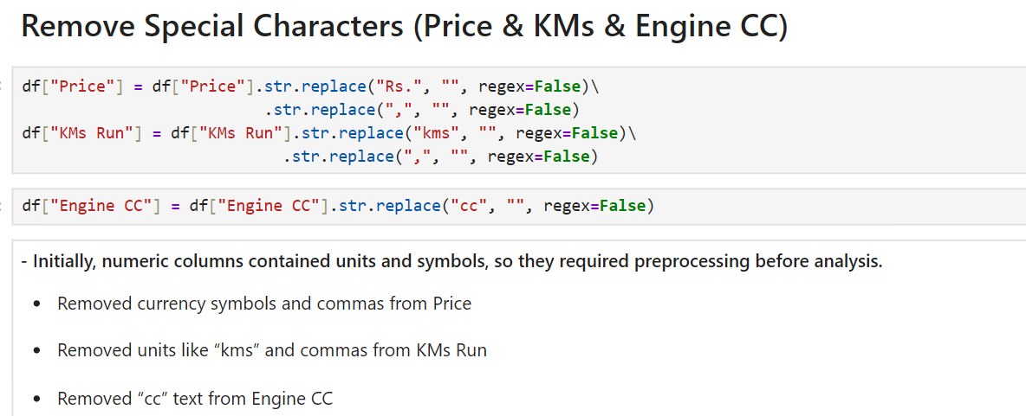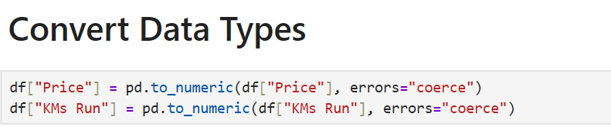
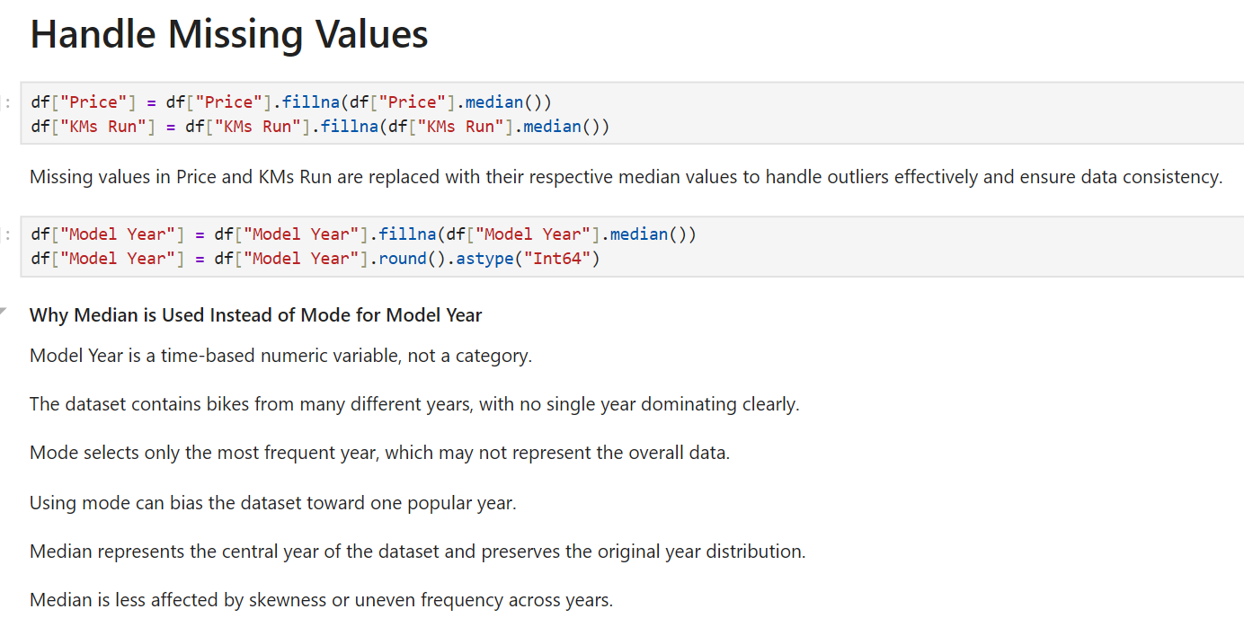
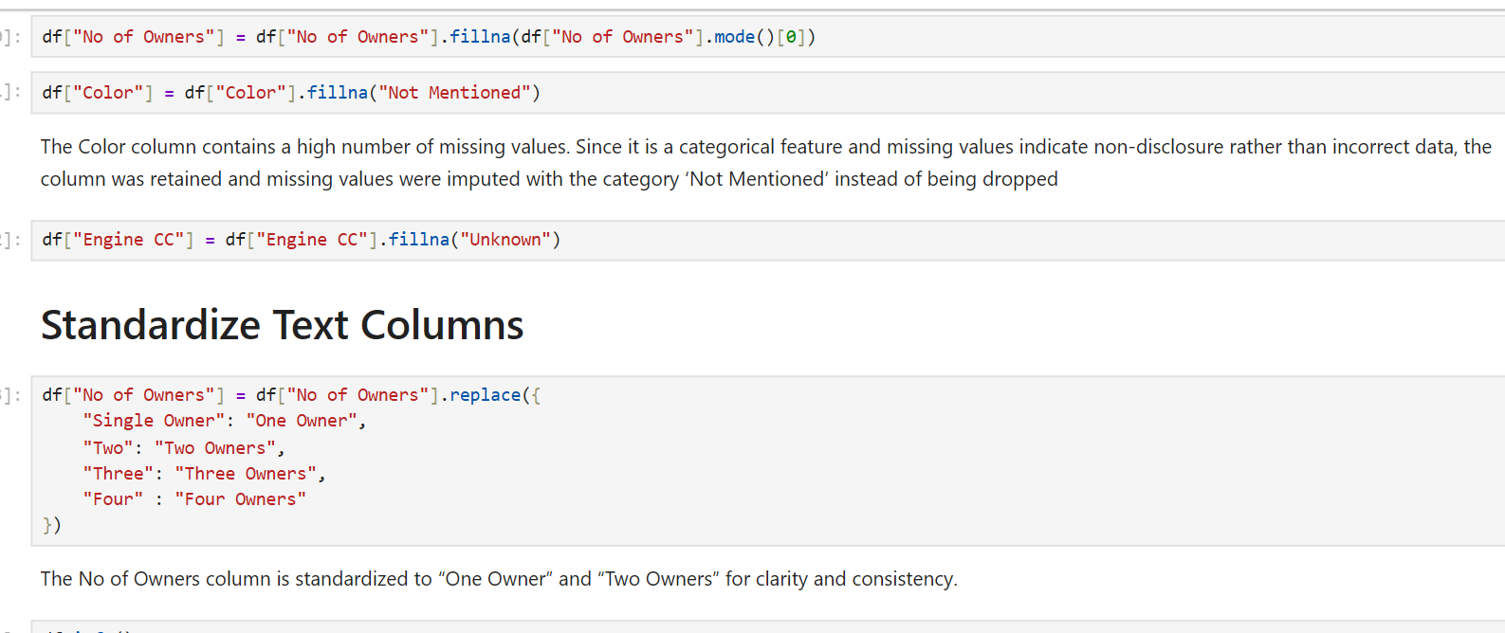

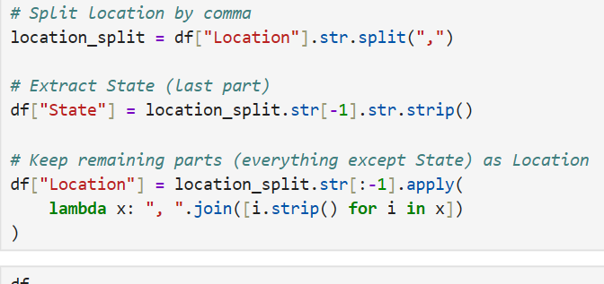

NON-VISUALIZATION — Univariate Analysis (Speaking Style)
Writing
First, I performed univariate analysis to understand ownership distribution and regional listings.
I found that about 95 percent of bikes are single-owner vehicles, while multi-owner bikes are very rare. This indicates that most used bikes in the market are relatively lightly used, which is attractive for resale.
Next, I analyzed the state-wise distribution of listings. Maharashtra has the highest number of bike listings, followed by Karnataka and Tamil Nadu. This shows that used bike activity is concentrated in a few major states with strong resale markets.

NON-VISUALIZATION — Bivariate Analysis (Speaking Style)
Writing
In bivariate analysis, I studied the relationship between price, kilometers run, and model year using correlation.
Price shows a moderate positive correlation with model year, meaning newer bikes generally have higher resale prices.
There is a weak negative correlation between price and kilometers run, which suggests that higher mileage slightly reduces bike value, but the impact is not very strong.
I also performed median price analysis by model year. Older bikes show highly variable prices because their value depends on rarity and condition. However, recent bikes from 2016 onward show a clear upward trend in median prices.
I used median instead of mean to reduce the effect of outliers and represent typical market prices more accurately.
Additionally, I analyzed median kilometers run by state. The results show noticeable regional differences in bike usage, which can influence resale value and condition.

NON-VISUALIZATION — Multivariate Analysis (Speaking Style)
Writing
For multivariate analysis, I examined how price varies across both state and ownership categories.
The results show that single-owner bikes generally have higher median prices compared to multi-owner bikes. This reflects buyer preference for bikes with fewer ownership transfers.
Some state–ownership combinations show NaN values, which simply indicate that there were no listings available for those combinations, not missing data.
Overall, this analysis highlights how both geographical location and ownership history influence resale pricing.

🎤 VISUALIZATION — Univariate Analysis (Speaking Style)
Writing
I then used visualizations to better understand data distribution.
The price histogram shows that most bikes are priced below two lakh rupees. A few expensive bikes create a long right tail, resulting in a right-skewed distribution.
A bar chart of state listings confirms that Maharashtra has the highest number of listings, followed by Karnataka and Tamil Nadu, showing concentration in major markets.
Color analysis reveals that black is the most common bike color, while red, blue, and white are moderately popular. Less frequent colors include grey, orange, green, and yellow.
When analyzing bike models, Royal Enfield Classic 350 appears most frequently, followed by other popular commuter and mid-range bikes, indicating strong resale demand for these models.

🎤 VISUALIZATION — Bivariate Analysis (Speaking Style)
Writing
The scatter plot between price and kilometers run shows a negative relationship. Bikes with lower mileage tend to have higher prices, while prices gradually decrease as usage increases. A few outliers are present with unusually high prices or mileage.
A box plot comparing price distributions across major states shows that prices vary significantly by region. States like Karnataka display wider price ranges and extreme outliers, suggesting a diverse market. Other states show more stable pricing around the median.
A stacked bar chart of ownership by state shows that one-owner bikes dominate across all regions. Multi-owner bikes are rare, reinforcing the trend that most resale bikes are lightly used.
Finally, the engine capacity box plot demonstrates that higher CC bikes generally have higher median prices and wider price ranges. Lower CC bikes show tighter and more affordable price distributions. This confirms a positive relationship between engine capacity and price.

🎤 VISUALIZATION — Multivariate Analysis (Speaking Style)
Writing
The correlation heatmap summarizes relationships among key numerical variables.
It shows a moderate positive relationship between price and model year, meaning newer bikes tend to cost more.
Kilometers run has only a weak negative relationship with price, suggesting that model year influences price more strongly than usage.
Overall, the heatmap confirms that resale price is affected by multiple factors, but model year plays a more significant role than mileage.

ANALYSIS RESULTS — Viva Speaking Style
Writing
From univariate analysis, I observed that most bikes are priced below two lakh rupees, and the distribution is right-skewed due to a few premium bikes.
There is a moderate positive relationship between price and model year, meaning newer bikes generally have higher prices.
Price shows a weak negative relationship with kilometers run, suggesting that higher usage slightly reduces value.
Royal Enfield models are the most frequently listed bikes, and black is the most common color.
State-wise analysis shows that Maharashtra, Karnataka, and Tamil Nadu have the highest number of listings.
Engine capacity also affects price, with higher CC bikes having higher median prices.
Overall, bike price is influenced more by model year and engine capacity than by mileage.

🎤 CONCLUSION — Viva Speaking Style
Writing
In conclusion, most used bikes fall into the affordable segment below two lakh rupees.
Newer models and higher engine capacity generally increase resale value.
Most bikes are sold by their first owner, indicating relatively low usage.
Geographical differences exist, with some states showing wider price ranges.
Overall, bike pricing depends on multiple factors, including model year, engine capacity, ownership, and location.

🎤 EXPERIENCES & CHALLENGES — Viva Speaking Style
Writing
Through this project, I gained practical experience in web scraping using Python and handling real-world messy datasets.
I improved my skills in data cleaning, preprocessing, and exploratory analysis.
One major challenge was scraping dynamic web pages and dealing with inconsistent data formats.
Handling missing values and special characters in numeric columns required careful preprocessing.
Ensuring accuracy while managing duplicates and maintaining efficiency was also challenging.

