**A Mini Project Report**

**On**

# TELEPHONE DIRECTORY

Submitted to

### COMPUTER SCIENCE & ENGINEERING

### 

### 20CSE104 DATA STRUCTURES

### Assignment 2

**Submitted By**

### J.ANUSHA - (21691A0508)

**K.DEEPIKA - (21691A0531)**

### K.DEEPIKA - (21691A0530)

**Under the Guidance of Dr. R. Nidhya Ph.D, Professor**

**Department of Computer Science & Engineering.**



**MADANAPALLE INSTITUTE OF TECHNOLGY & SCIENCE (UGC – AUTONOMOUS)**

**(Affiliated to JNTUA, Anantapuram) Accredited by NBA, Approved by AICTE, New Delhi)**

**AN ISO 9001:2008 Certified Institution**

**P. B. No: 14, Angallu, Madanapalle – 517325 2022-2023**



**DEPARTMENT OF COMPUTER SCIENCE & TECHNOLOGY**

This is to certify that the mini project work entitled **“TELEPHONE DIRECTORY”** is a work carried out by

### J.ANUSHA - (21691A0508)

**K.DEEPIKA - (21691A0531)**

### K.DEEPIKA - (21691A0530)

And submitted as Assignment 2 for the subject **20CSE104 Data Structures.**

Guide

**Dr. R. Nidhya Ph.D,**

**Professor,**

**Department of CS­­­­­E.**

## LIST OF CONTENTS

|  |  |  |
| --- | --- | --- |
| S.NO | TITLE | PAGE NO |
| 1 | ABSTRACT | 4 |
| 2 | PROCEDURE | 4 |
| 3 | SOURCE CODE | 5-8 |
| 4 | RESULTS | 9-10 |
| 5 | CONCLUSION | 11 |

# ABSTRACT

The main purpose of designing the project is to make the TELEPHONE DIRECTORY.

It is easy,efficient ,user friendly to friendly to provide brief description about the telephonedirectory to the users.

This telephone directory application is very simple mini project in c that can help youUnderstand the basic concepts of functions and data structure.The application will teach you how to add,list,modify or edit,search and delete contacts

This project is aimed at storing,searching and modifying the contacts easily.

For this application we use the concept of linked list.

We are determined to design a system which is intented in saving name and number of

desired persons.the main objective of telephone directory is to add,search,edit and delete various contacts.

**PROCEDURE**

In telephone directory first we need to note down the requirements for our project

According to the requiremennts we need to take our functions and etc..

In this we have different functions like

* Insert()
* Delete()
* Display()
* Search()

1. Insert()-used to insert the contacts details
2. Delete()-used to delete contact details
3. Display()-used to display all the contacts
4. Search()-used to search a contact from the contacts

In the main() function we call all the functions

Before declaring and defining the we need to create a node using a structure

In node we have name ,mobile no. and mail address and a pointer to connect to next node .

In the insert function we ask the user to enter the details and store them in nodes

In the delete function we ask the to enter the contact that they need to delete and we go to that contact node and delete that node

In the search function we ask the user to enter the name of contact they want to search and we give that details of that contact

In the display function we print all the contacts

**SOURCE CODE**

#include <stdio.h>

#include <stdlib.h>

#include <string.h>

#include <conio.h>

#include <ctype.h>

typedef struct list add;

struct list

{

char name[40];

char num[20];

char gmail[40];

add* next;

};

int i=1,size=0;

void Insert(add** head)

{

add* temp=(add*)malloc(sizeof(add));

printf("\n\n\n\t\tContact name : ");

gets(temp->name);

system("cls");

printf("\n\n\n\t\tContact Name : ");

gets(temp->name);

system("cls");

printf("\n\n\n\t\t\tMobile Number : ");

gets(temp->num);

system("cls");

printf("\n\n\n\t\t\tGmail id : ");

gets(temp->gmail);

system("cls");

temp->next = NULL;

size++;

if(size == 20)

{

system("cls");

printf("\n\n\n\t\t\tPhone Memory is full!!!");

printf("\n\t\tIf you want to add more contact,You have to delete some contact from your list...\n\n\n");

return;

}

else

{

if(*head == NULL)

{

*head = temp;

system("cls");

printf("\n\n\t\t\t\t\tDone!!!\n\n");

return;

}

else

{

add* p = *head;

while(p->next != NULL)

{

p = p->next;

}

p->next = temp;

system("cls");

printf("\n\t\t\t\t\tDone!!!\n\n");

}

return;

}

}

void Search(add*head)

{

char ch[40];

printf("\n\n\n\t\tContact name : ");

gets(ch);

system("cls");

printf("\n\n\n\t\tContact name : ");

gets(ch);

system("cls");

if(head == NULL)

{

system("cls");

printf("\n\n\n\t\tNo Contact exists in this Phone Book List!!!\n\n");

return;

}

else

{

add*p = head;

while(p != NULL)

{

if(strcmp((p->name),ch) == 0)

{

system("cls");

printf("\n\t\t\t%s",p->name);

printf("\n\t\t-------------------------");

printf("\n\t\tNumber : %s",p->num);

printf("\n\t\tGmail ID : %s",p->gmail);

return;

}

p = p->next;

}

system("cls");

printf("\n\n\n\t\tThis Contact is not exists in the list! ");

}

}

void Delete(add** head)

{

char ch[40];

printf("\n\t\tContact name : ");

gets(ch);

system("cls");

printf("\n\t\tContact name : ");

gets(ch);

system("cls");

if(*head == NULL)

{

system("cls");

printf("\n\t\t\t\t\tNo Contact exists in this Phone Book List!\n\n");

return;

}

else

{

if(strcmp(((*head)->name),ch) == 0)

{

add*p=*head;

*head = (*head)->next;

free(p);

printf("\n\t\t\t\t\tDone!!!\n\n\n\n");

return;

}

else

{

add*p = *head;

while(p->next != NULL)

{

if(strcmp((p->next->name),ch) == 0)

{

p->next = p->next->next;

size--;

return;

}

p = p->next;

}

system("cls");

printf("\n\t\t\t\t\tInvalid Contact!!!\n\n");

}

}

}

void Display(add* head)

{

if(head == NULL)

{

system("cls");

printf("\n\n\n\t\tNo Contact exists in this Phone Book List!");

return;

}

else

{

add*p = head;

while(p != NULL)

{

printf("\n\t\t\t\t%d.%c%s",i,32,p->name);

printf("\n\t\t\t-------------------------");

printf("\n\t\t\tNumber : %s",p->num);

printf("\n\t\t\tGmail ID : %s",p->gmail);

p = p->next;

i++;

}

i=1;

return;

}

}

int main()

{

add* head=NULL;

system("cls"); printf("\n\t\t****************************************************************|\n\n\n");

printf("\n\t\t| !!!!!!!!!!!!!!!!!!!!!!!!!!!! |");

printf("\n\t\t|!!!!!!!!!!!!!!!!!!! WELCOME TO OUR PHONE BOOK !!!!!!!!!!!!!!!!!|");

printf("\n\t\t| !!!!!!!!!!!!!!!!!!!!!!!!!!!! |"); printf("\n\t\t****************************************************************|\n\n\n");

while(1)

{

printf("\n\n\t\t\t\t\t\tMenu");

printf("\n\t\t\t-------------------------------------------------");

printf("\n\t\t\t1)Create A Contact\t\t2)Remove A Contact");

printf("\n\t\t\t3)Show The Contact List\t\t4)Find A Contact");

printf("\n\t\t\t-1)Quit");

int ch;

scanf("%d",&ch);

if(ch == -1)

{

break;

}

else

{

switch(ch)

{

case 1 :system("cls");

system("color 5f");

Insert(&head);

break;

case 2 :system("cls");

system("color 4f");

Delete(&head);

break;

case 3 :system("cls");

system("color 8f ");

Display(head);

break;

case 4 :system("cls");

system("color 8b");

Search(head);

break;

default :printf("\n\t\tInvalid Choice!Try again!!!");

break;

}

}}

return 0;

**RESULTS**

Main menu

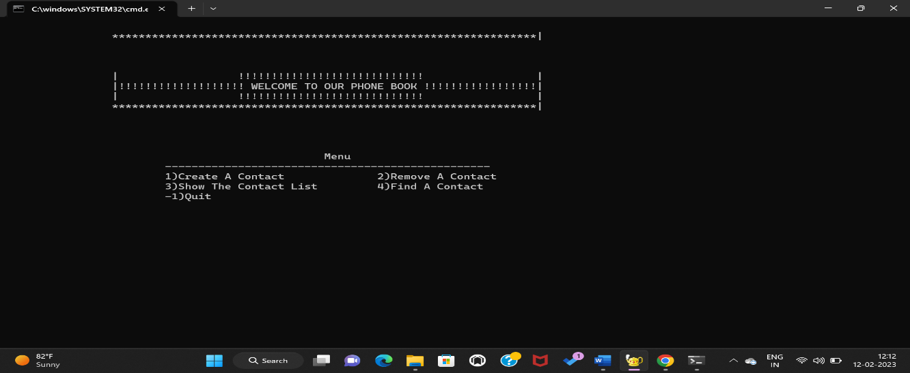

Inserting a contact

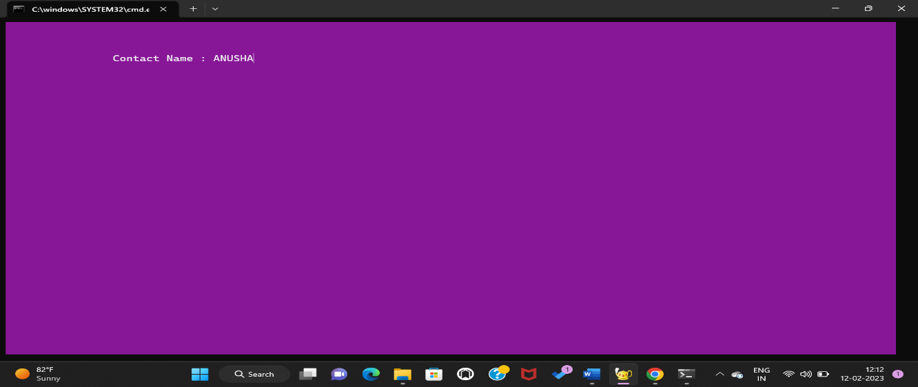

Deleting a contact

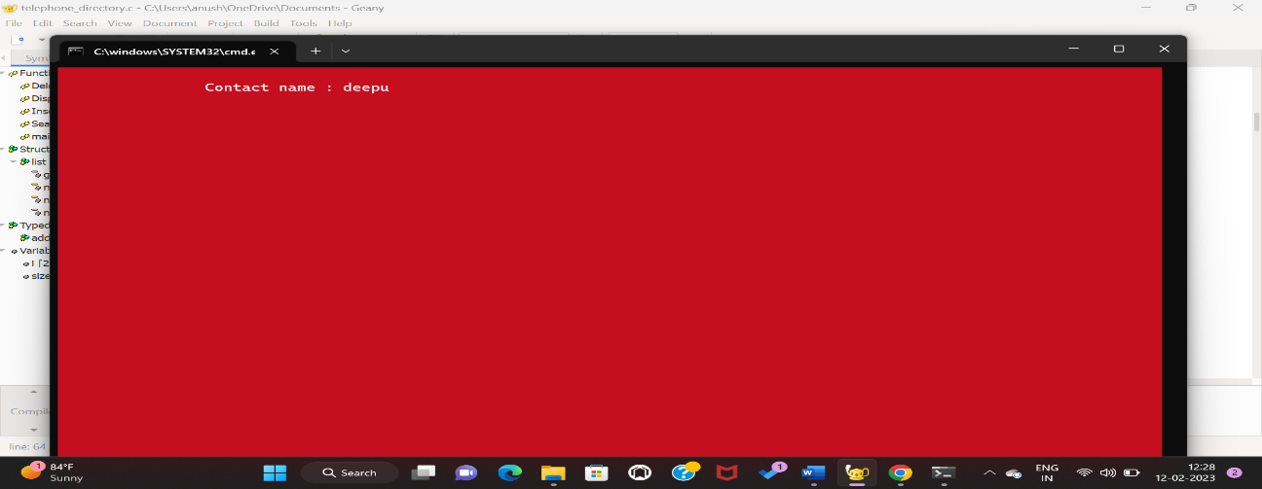

Displaying all contacts

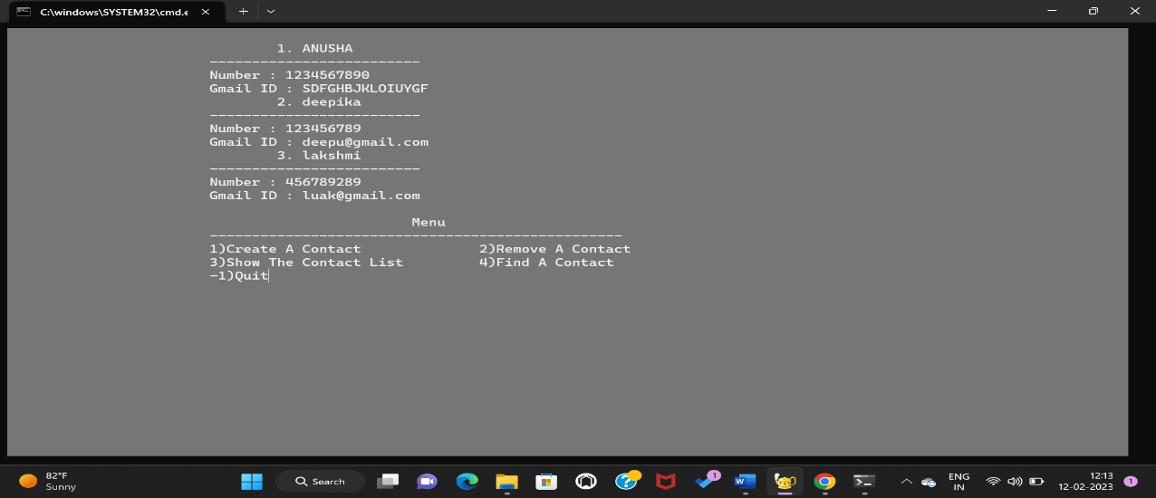

Searching a contact

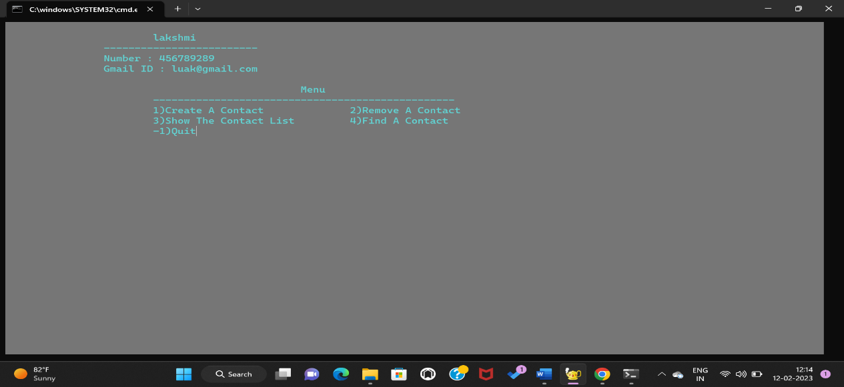

Existing from program

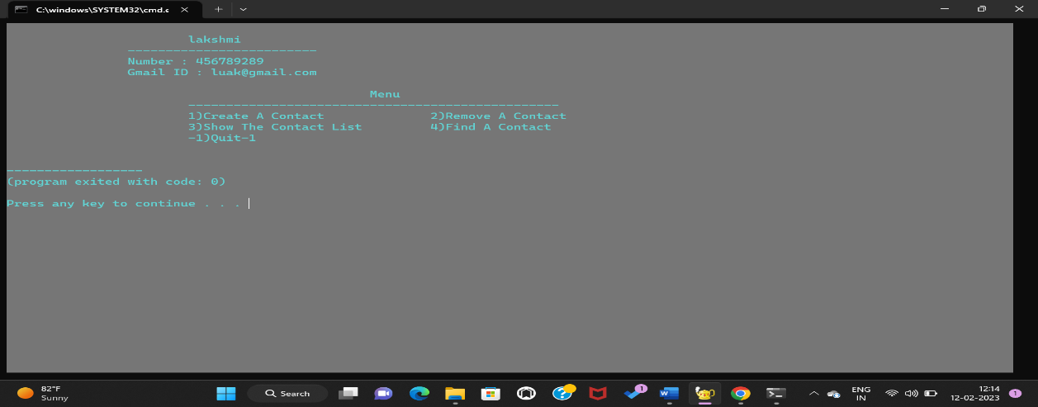

**CONCLUSION**

In conclusion, the telephone directory project has been a successful endeavor in creating an organized and comprehensive database of phone numbers and contact information. With the increasing use of technology, having an updated and accessible telephone directory has become a necessity for both personal and professional purposes.

The project has been designed to meet the needs of its users by providing them with accurate and relevant information in a user-friendly format. The use of the latest technology has allowed for the creation of a database that can be easily updated, searched and accessed from a wide range of devices.

The feedback from the users of the telephone directory has been overwhelmingly positive, with many praising its simplicity, efficiency and ease of use. The project team is committed to continuously improving the telephone directory and adding new features to meet the changing needs of its users.

Overall, the telephone directory project has been a success and has made a significant impact in improving the accessibility and organization of telephone numbers and contact information. The project team is confident that the telephone directory will continue to be a valuable resource for years to come.