APIGEE Learning GUIDE
Contents
1. Understanding API and API Management concepts 5
1.1 What is an API 5
1.2 What is API Management 5
1.3 What are API management tools 5
1.4 Benefits of API Management 6
1.5 API Monitoring Tools 7
1.6 Related products and services 7
2. Understanding APIGEE Concepts 7
2.1 What is Apigee 7
2.2 What does Apigee provide 8
2.3 Who Uses Apigee 8
2.4 Key Benefits of Apigee 8
2.5 Apigee technical features overview 9
2.6 Apigee Terminology: Key Concepts 9
2.6.1 API Proxy 9
2.6.2 Target Endpoint 9
2.6.3 Proxy Endpoint 9
2.6.4 Policies 10
2.6.5 Flow Variables 10
2.6.6 Shared Flows 10
2.6.7 Developer Portal 10
2.6.8 Analytics & Monitoring 10
2.6.9 Apigee X vs. Apigee Edge 10
2.6.10 Key Takeaways 10
3. Apigee Edge Concepts 10
3.1 What is Apigee Edge 11
3.1.1 Key Uses of Apigee Edge 11
3.1.2 Apigee Edge Editions 11
3.1.3 APIGEE Basic terminology 11
3.2 Development tools 13
3.2.1 Use the Edge UI 13
3.2.2 Use the Edge API 15
3.2.3 Understand the Edge API base path 15
3.2.4 Apigee Edge API vs. Apigee Edge UI 15
3.2.5 Key Takeaways 16
3.3 Debugging and testing 16
3.4 Components of Apigee Edge 17
3.4.1 Edge API runtime 18
3.4.2 Edge monitoring & analytics 18
3.4.3 Edge developer ecosystem 19
3.4.4 Monetization 21
3.5 Build your first API proxy 21
Further Reading 31
4. Restful Services Reference 37
4.1 Quick Guide to Understanding RESTful Services 38
4.1.1 What is REST? 38
4.1.2 Key Features of REST: 38
4.1.3 HTTP Methods: 38
4.1.4 RESTful Resource URIs: 38
4.1.5 RESTful Response Status Codes: 38
4.1.6 Data Formats: 39
4.1.7 How REST Works: 39
4.1.8 Common Usage Scenarios: 39
4.1.9 Advantages of REST: 39
4.1.10 Disadvantages of REST: 39
4.1.11 Getting Started with REST: 40
5. JavaScript Reference 40
5.1 Quick Guide to Understand JavaScript 40
5.1.1 What is JavaScript? 40
5.1.2 Key Features of JavaScript: 40
5.1.3 Basic Syntax: 40
5.1.4 Control Structures: 41
5.1.5 Asynchronous JavaScript: 41
5.1.6 Common Usage Scenarios: 42
5.1.7 Advantages of JavaScript: 42
5.1.8 Disadvantages of JavaScript: 42
5.1.9 Getting Started with JavaScript: 42
6. SOAP Services Reference 42
6.1 Quick Guide to Understanding SOAP Services 42
6.1.1 What is SOAP? 43
6.1.2 Key Features of SOAP: 43
6.1.3 SOAP Message Structure: 43
6.1.4 How SOAP Works: 43
6.1.5 Web Services Description Language (WSDL): 43
6.1.6 Common Usage Scenarios: 44
6.1.7 Advantages of SOAP: 44
6.1.8 Disadvantages of SOAP: 44
6.1.9 Getting Started with SOAP: 44
6.1.10 Resources: 44
7. APIGEE Best Practices Guidelines 44
7.1 Naming Conventions 45
7.2 Indicative Prefix Reference Table 46
7.3 DO's 48
7.4 Dont's 49

Understanding API and API Management concepts

What is an API

APIs–Application Programming Interfaces–are the building blocks of modern technology and business infrastructure. At its most basic level, an API is a piece of software that allows two applications to talk to each other. APIs connect apps to apps, apps to servers, and apps and servers to consumers.

As apps, software, and the cloud have proliferated to dominate the modern technology and business landscape, the number of APIs that companies use and manage have skyrocketed.
The design, development, testing, deployment, governance, security, monitoring, and monetization of APIs have become an important part of the software development lifecycle (SDLC), and a large and growing sector of the technology ecosystem.
API management is the set of software and processes that support all stages of an API’s - and an API consumer’s - life cycle.

What is API Management

API management is the process of developing, designing, monitoring, testing, securing, and analysing APIs for organizations. API management platforms provide a robust set of software and processes with this functionality, hosted on premises, in the cloud, or a hybrid environment.

API management enables organizations to make both their public and private APIs consumable and scalable. A full-lifecycle API management platform offers these benefits by including functionality for developers to easily discover and use APIs, while also enabling organizations to control access, analyse usage, and enforce security & governance policies of APIs.

In effect, API management platforms are used to govern an enterprise’s entire API ecosystem, managing the API lifecycle from beginning to end.

What are API management tools

A full featured API management platform typically includes the following tools:
Developer portals: A site where developers can find the information and credentials required to use APIs in their client apps. A developer portal can provide interactive documentation, developer-facing analytics, monetization information, app approval status, and other tools and services for developers.
Design and development: A developer experience and set of tools for designing and building API products, and for enabling APIs to be used by existing systems.
Testing: Allows for a wide range of testing, from mock testing to functional testing, performance and security testing of APIs.
API gateways: An API gateway performs mediation and enforcement of API calls at runtime.
Analytics and monitoring: Operational metrics, such as usage over time, allow developers to increase speed of API deployment and reliability. Monetization and business metrics, such as the revenue driven through a particular API, let organizations measure the business health of their API ecosystem.
Policy management: Policies define the operation of an API, including how often it caches data, how it translates protocols, and quotas for its use. Managing these policies is an important facet of maintaining an API.
Security and governance: APIs require consistent standards for authorization, authentication, abuse prevention, and connecting identity to client and developer credentials.

Benefits of API Management
API management platforms help organizations treat APIs as products, ensuring security, performance, and continuous improvement based on user feedback. Key benefits include:
- Enhanced Security & Privacy: Integrated identity and access management, encryption key management, and governance policies.
- Anomaly Detection: AI-powered tools predict traffic patterns and detect anomalies in real time.
- Global Accessibility: Cloud-hosted API catalogue enable seamless access for developers worldwide.
- Improved Performance & Reliability: Integration with CDNs and cloud services enhances API responsiveness.
- Legacy System Integration: Acts as an abstraction layer to connect old systems with modern cloud-native technologies.
These features collectively optimize API usability, security, and scalability.

API Monitoring Tools
API monitoring tools analyse API performance, usage, and security to ensure optimal functionality and a seamless user experience. Key functions include:
- Traffic Analysis: Tracks API usage, success rates, and sources of traffic (e.g., bots, browsers, devices).
- API Tracing & Observability: Helps troubleshoot API flows, providing real-time visibility into execution and latency.
- Performance Analysis: Measures API response times, error rates, and latency across different geographies.
- Availability & Performance Monitoring: Detects outages, generates alerts, and reduces issue resolution times.
- Developer Engagement: Analyses how developers interact with APIs, including traffic generation and documentation usage.
- Security Health Monitoring: Scans for risks, anomalies, and compliance violations, ensuring API security and integrity.
These tools help API managers and developers optimize performance, detect issues proactively, and enhance API security.

Related products and services

Google offers a full-service API management platform that enables businesses to grow, monitor, analyse, scale, and secure their API ecosystems with APIGEE
Apigee can be used with a variety of other Google Cloud products and services to expand the utility of APIs, such as Cloud Armor and Service Mesh.

Understanding APIGEE Concepts

What is Apigee
Apigee is Google Cloud's native API management platform that can be used to build, manage, and secure APIs — for any use case, environment, or scale. Apigee offers high performance API proxies to create a consistent, reliable interface for your backend services. The proxy layer gives you granular control over security, rate limiting, quotas, analytics, and more for all of your services.
Apigee supports REST, gRPC, SOAP, and GraphQL, providing the flexibility to implement any API architectural style.

What does Apigee provide
Apigee provides an API proxy layer that sits between your backend services and internal or external clients that want to use your services. Apigee provides a rich array of policies that allow you to add security, traffic management, data mediation, extensions, and other features to the API proxy layer for a robust, enterprise-grade API management solution.
You can also add custom code, conditional logic, fault handling, rate limiting, caching, and many other actions. Because the policies and actions are implemented on Apigee, in the API proxy layer, your underlying backend services can remain unchanged.

Who Uses Apigee
Apigee serves two main user groups:
- API Producers – Developers who create and manage APIs for backend services.
  - Challenges:
    - Security: Protect APIs from unauthorized access.
    - Discoverability: Ensure APIs are easy to find and use.
    - Measurability: Monitor traffic, set quotas, and track API usage.
- API Consumers – Client developers who use APIs in their applications.
  - Challenges:
    - Flexibility: Adapt to different API technologies.
    - Ease of Use: APIs should be well-designed and documented.
    - Reliability: Depend on consistent API interfaces for seamless functionality.

Key Benefits of Apigee
- API Discoverability: Provides a developer portal for API documentation and updates.
- API Insights: Offers security, monitoring, and analytics to track API performance.
- API Reliability: Uses proxies to manage security, traffic, and backend changes without disrupting consumers.
Apigee simplifies API management, ensuring security, usability, and performance for both API producers and consumers.

Apigee technical features overview
The following table lists the Apigee API management products that are compared in this topic:
Difference Between Apigee and Apigee Hybrid:
Feature | Apigee (Apigee X & Apigee Edge) | Apigee Hybrid
Deployment | Fully managed on Google Cloud | Hybrid model: Control plane in Google Cloud, runtime in customer’s environment
Infrastructure | Google manages all infrastructure, scaling, and maintenance | Requires Kubernetes (GKE, OpenShift, or on-prem K8s) for API runtime
Security & Compliance | Google ensures security, data handling, and compliance | Users control data residency, security, and compliance
Customization & Control | Limited control over runtime | More control over networking, security, and runtime
Latency & Performance | APIs run on Google Cloud, optimized with Google’s global network | APIs run closer to customers for reduced latency and on-prem connectivity
Best Use Case | Fully cloud-based API management with minimal operational overhead | Enterprises needing data control, compliance, and hybrid cloud strategy

Apigee Terminology: Key Concepts
Understanding Apigee’s core terminology is essential for managing and optimizing APIs. Below are key terms:

API Proxy
An API proxy acts as an intermediary between the client and backend service, enabling security, traffic management, and analytics without modifying the backend.

Target Endpoint
The backend service or application that an API proxy routes requests to.

Proxy Endpoint
The entry point for API requests, handling security, policies, and transformations before forwarding to the target endpoint.

Policies
Predefined rules that modify API behaviour, including:
- Security Policies (OAuth 2.0, API Key validation)
- Traffic Policies (Rate limiting, caching)
- Mediation Policies (JSON-to-XML conversion)

Flow Variables
Dynamic data stored during API execution, used for routing, logging, or response transformation.

Shared Flows
Reusable logic that can be applied across multiple API proxies for common tasks like authentication or error handling.

Developer Portal
A self-service API hub where developers can discover, test, and subscribe to APIs.

Analytics & Monitoring
Tools for tracking API usage, latency, errors, and security events to optimize performance.

Apigee X vs. Apigee Edge
- Apigee X – Cloud-native API management on Google Cloud.
- Apigee Edge – Legacy API management solution supporting hybrid and on-premises deployments.

Key Takeaways
- Use Apigee X if you want a fully managed API gateway with minimal setup.
- Use Apigee Hybrid if you need on-premises control, compliance, and hybrid cloud flexibility.

Apigee Edge Concepts

3.1 What is Apigee Edge
Apigee Edge is a full lifecycle API management platform that helps businesses secure, analyse, and scale their APIs. It acts as an API gateway, allowing organizations to expose backend services securely while adding features like traffic control, authentication, analytics, and monetization.

Key Uses of Apigee Edge
- API Gateway & Security
  - Acts as a proxy between clients and backend services.
  - Supports OAuth 2.0, API keys, JWT, and traffic throttling to secure APIs.
- Traffic Management
  - Implements rate limiting, quotas, and caching for performance optimization.
  - Balances API loads to prevent downtime.
- API Analytics & Monitoring
  - Tracks latency, error rates, API usage, and developer engagement.
  - Uses AI-powered anomaly detection to improve reliability.
- Developer Engagement
  - Provides a developer portal for API discovery, documentation, and subscription.
  - Supports API monetization by offering tiered API access.
- API Mediation & Transformation
  - Converts data formats (e.g., JSON to XML).
  - Enables backend orchestration for multiple services.
- Hybrid & Multi-Cloud Support
  - Can be deployed on-premises, in private clouds, or Google Cloud.
  - Apigee Edge for Private Cloud supports on-prem API gateway deployment.

Apigee Edge Editions
- Apigee Edge (Public Cloud) – Fully hosted by Google.
- Apigee Edge for Private Cloud – Installed in an enterprise’s data centre.
For more details: https://docs.apigee.com/api-platform/get-started/what-apigee-edge

APIGEE Basic terminology

There are several concepts that are common ideas with a unique meaning in Apigee.
Term | Definition
API | An application programming interface—an interface that makes it easy for one application to consume capabilities or data from another application.  By defining stable, simplified entry points to application logic and data, APIs enable developers to easily access, and reuse application logic built by other developers. In the case of Web APIs, that logic and data is exposed over the network.
API proxy | An API Proxy in Apigee Edge acts as a facade for APIs, HTTP services, or applications like Node.js. It is configured using policies, code, and resources provided by Apigee Edge.  Key benefits of API proxies:  ✅ Decouples APIs from backend services, allowing seamless backend changes without affecting developers.  ✅ Customizable API interfaces, enabling different versions for various developer needs.  ✅ Configurable via UI, text editor, or IDE, providing flexibility in implementation.
API base path and resources | APIs defined by network addresses and URIs. An API is made up of a base path and a set of API resources. Every API proxy defines a base path and, optionally, multiple API resource paths. You can think of an API simply as a set of URIs, all of which share a common base path.  To make it easier to manage your APIs, Apigee augments these raw URIs with display names and descriptions. Edge enables you to attach policies and code to URIs, enabling fine-grained control and management of the behaviour of your APIs.
API product | A collection of API resources (URIs) combined with a quota, or service plan, which is published to app developers at design time. API products can in turn be bundled into API packages for monetization.  An API key is bound to one or more API products, enforcing a binding between an app and the bundle of URIs that the app is permitted to consume.
API package | A collection of API products that are presented to developers as a bundle and typically associated with a rate plan defined in monetization.
app | An abbreviation of application. The term app has come to refer to mobile applications that consume APIs. Developers implement apps in a variety of programming languages and using various technologies and platforms. Developers who want to consume APIs register apps in an API provider's organization on Apigee Edge.  When the app is registered, Apigee generates an API key and secret that identify the app. The developer embeds the API key in the app, which presents the key when making requests. API Services implements security around the API key through direct API key validation or through OAuth.
environment | A runtime execution context for API proxies. An API proxy must be deployed to an environment before the API it exposes is accessible over the network. By default, organizations are provisioned with two environments: test and prod.  - The test environment is typically used for deploying API proxies during development.  - The prod environment is typically used for promoting API proxies from the test environment after they have been fully developed and tested.
organization | A container for all the objects in an Apigee Edge account, including API proxies, API products, API packages, apps, and developers.  A user account is required for each organization for which you are a member. (Most users will have an account in only one organization.)
policy | A processing step that executes as an atomic, reusable unit of logic within an API proxy processing flow.  Typical policy-based functionality includes transforming message formats, enforcing access control, calling remote services for additional information, masking sensitive data from external users, examining message content for potential threats, caching common responses to improve performance, and so on.  Policies may be conditionally executed based on the content or context of a request or response message. For example, a transformation policy may be executed to customize a response format if the request message was sent from a smartphone.
API resource path | A RESTful concept, a resource path is a uniform resource identifier (URI) that identifies the network path to a given resource.
version | The version of the developer-facing API interface.  For example, pivotaltracker.com/services/v3, or api.enterprise.apigee.com/v1.  This term is distinguished from revision, which is the numbered, version-controlled package of configuration and policies bundled into an API Proxy. API interfaces have versions; API proxies have revisions.
revision | A numbered, version-controlled package of configuration and policies bundled into an API Proxy. This term is distinguished from version, which is the developer-facing API interface. See version above.

Development tools

Use the Edge UI
The Apigee Edge UI is a browser-based tool you can use to create, configure, and manage API proxies and API products. A subset of tasks can only be accomplished using the API, too.
The following table describes how to access the Edge UI:
Product | UI Name | Access URL
Edge | Edge UI | To access the Edge UI, use the following URL:  https://apigee.com/edge  For a tutorial on using the Edge UI, see Build your first API proxy.
Edge for Private Cloud | Classic Edge UI | To access the Edge UI for Edge for Private Cloud, use the following URL:  http://ms-ip:9000  Where ms-ip is the IP address or DNS name of the Management Server node.
Using the Edge UI, you can:
- Create API proxies by editing code and tracing request flows through your proxies.
- Create API products that bundle proxies for exposure to client requests.
- Manage developers and developer apps.
- Configure your test and production environments.
- Implement JavaScript and Node.js applications.
The following image shows the API proxy editor in the UI that you can use to create and configure an API proxy:
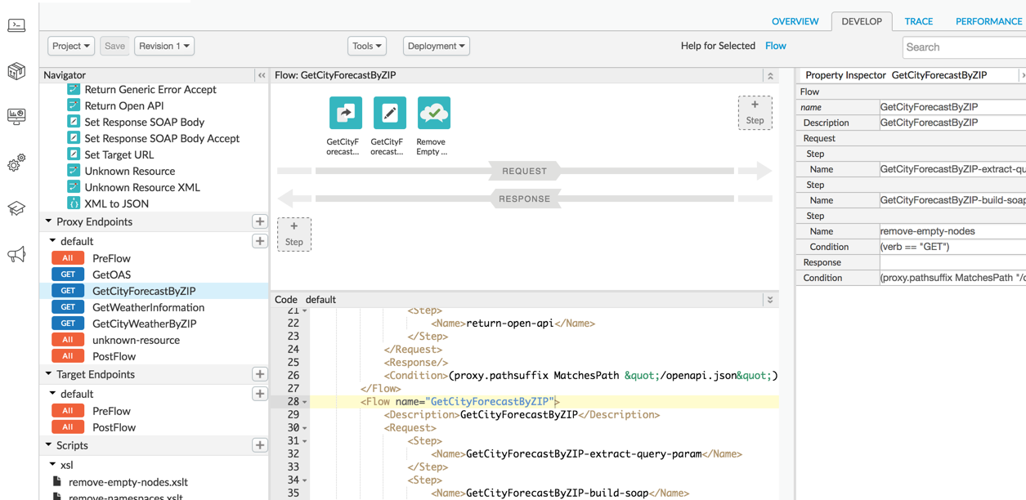

Use the Edge API
You can use Edge API to manage your API resources. The APIs also provide access to low-level capabilities that are not exposed by the UI.
The API endpoints often take data containing configuration information and require you to pass authentication information, such as username and password, to access them. Following RESTful principles, you can call HTTP GET, POST, PUT, and DELETE methods on any of the API resources.

Understand the Edge API base path
The path you'll use in API requests concatenates the following:
- A base path that includes your organization name. For example: https://api.enterprise.apigee.com/v1/organizations/org_name
- An endpoint that points to the Edge resource you're accessing.
For example, if your organization name is Api builders, then every call you make to the API will use the following base path:
https://api.enterprise.apigee.com/v1/organizations/apibuilders
To retrieve a list of API proxies in your organization, you would call GET on:
https://api.enterprise.apigee.com/v1/organizations/apibuilders/apis
Many resources are scoped by environment. Two environments are provided by default: test and prod. For example, caches are scoped by environment. A shared cache called "mycache" is included by default in every environment.
You can list caches by calling GET on the cache resource as follows:
https://api.enterprise.apigee.com/v1/organizations/apibuilders/environments/test/caches
https://api.enterprise.apigee.com/v1/organizations/apibuilders/environments/prod/caches

Apigee Edge API vs. Apigee Edge UI

Feature | Apigee Edge API | Apigee Edge UI
Definition | A RESTful API that allows programmatic access to Apigee Edge features | A web-based user interface for managing APIs, policies, and analytics
Access Method | Accessed via HTTP requests (e.g., using cURL, Postman, or automation scripts) | Accessed through a browser (Apigee Management Console)
Use Cases | Automate API proxy creation, deployment, security settings, and monitoring | Manually create and configure API proxies, policies, and analytics reports
Flexibility | Allows CI/CD integration and scripting for large-scale API management | Ideal for interactive, visual configuration and monitoring
Best For | Developers, DevOps, and automation tasks | API managers, analysts, and non-technical users
Example Usage | Deploy an API proxy using POST /v1/organizations/{org}/apis | Create an API proxy using "Create Proxy" in the UI

Key Takeaways
- Use Apigee Edge API for automation, scripting, and CI/CD.
- Use Apigee Edge UI for interactive, manual API management.

Debugging and testing
Apigee provides a trace tool that lets you debug end-to-end request and response flows. The trace results display request and response headers and payloads, policy execution, variable values, and any errors that may have occurred during the flow.
Key data points for use in troubleshooting:
- Timestamps: Use timestamps to see how long each step takes to execute. Comparing timestamps helps you isolate the policies that are taking the longest to execute that are slowing down your API calls.
- Base path: By verifying the base path, you can ensure that a policy is routing the message to correct server.
- Results of policy execution: These results let you see if the message is being altered as expected, such as if the message is being transformed from XML to JSON, or if the message is being cached.
The following figure shows trace results:
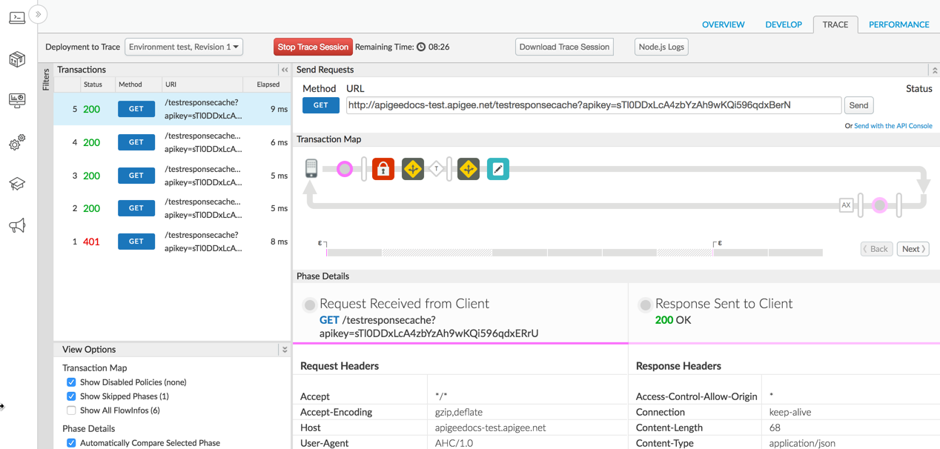
Each Trace session is broken down into the following major steps:
- Original request received from client: Displays the verb and URI path of the request from the client app, headers, body data, and query parameters.
- Request sent to your backend service: Displays the request message sent to the backend service by the API proxy.
- Response returned by the backend service: Displays the response headers and payload returned by the backend service.
- Final response sent to client: The response message returned to the requesting client app once the response flow has executed.
For more details reference: https://docs.apigee.com/api-platform/fundamentals/developing-apigee-edge

Components of Apigee Edge
Apigee Edge consists of API runtime, monitoring and analytics, and developer services that together provide a comprehensive infrastructure for API creation, security, management, and operations.
The following figure shows Edge services:
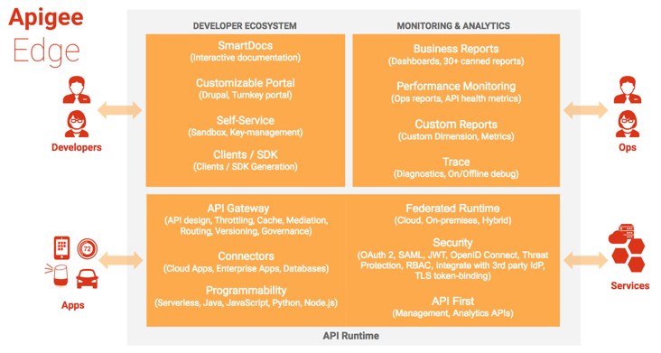

Edge API runtime
Apigee Edge API Services are all about creating and consuming APIs, whether you're building API proxies as a service provider or using APIs, SDKs, and other convenience services as an app developer.
The API management server provides tools for adding and configuring your API proxies, setting up API products, and managing app developers and client apps. It offloads many common management concerns from your backend services. When you add an API proxy, you can apply policies to the API proxy for adding security, rate-limiting, mediation, caching, and so on. You can also customize the behaviour of your API proxy by applying custom scripts, making calls out to third-party APIs and services, and so on. See Understanding APIs and API proxies for more.
If you're a Node.js developer, you can seamlessly add your Node.js modules to Edge to create APIs and API mashups, all the while leveraging the benefits Edge provides, from message transformation to security to analytics.

Edge monitoring & analytics
Apigee Edge API Analytics provides powerful tools to see short- and long-term usage trends of your APIs. You can segment your audience by top developers and apps, understand usage by API method to know where to invest, and create custom reports on business- or operational-level information.
As data passes through Edge, several default types of information are collected including URL, IP, user ID for API call information, latency, error data, and so on. You can create policies to add other information, such as headers, query parameters, and portions of a request or response extracted from XML or JSON. This information is collected asynchronously from the actual request/response flow and therefore has no effect on API performance.
The management UI lets you view multiple metrics and dimensions in a browser, as shown in the following figure:
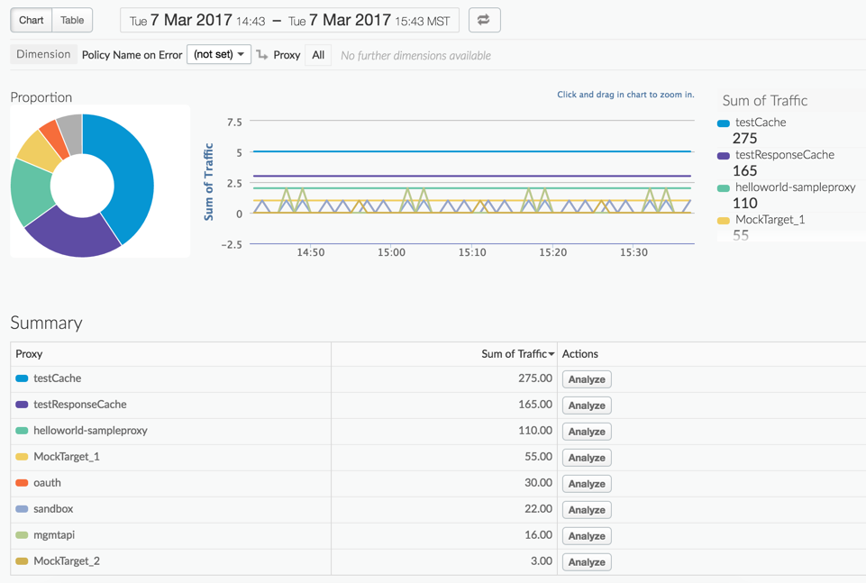
However, you can also access and control the Analytics Service by a command-line interface or through RESTful APIs. See API Analytics overview for more.

Edge developer ecosystem
Apigee Edge provides developer services that enable you to:
- Manage the community of app developers that are using your services.
- Work with internal and external developers and formalize the relationships with financial models.
- Onboard developers and create a developer portal. App developers connect to your portal to access API documentation to learn more about your publicly available API products and manage API keys.
Every Edge customer can create their own developer portal, either in the cloud or on-premises with Apigee Edge for Private Cloud.
Apigee Edge enables you to create two types of portals:
- Integrated portal which can be instantly provisioned. See Build your integrated portal.

- Drupal-based portal. See Build a Drupal-based portal.
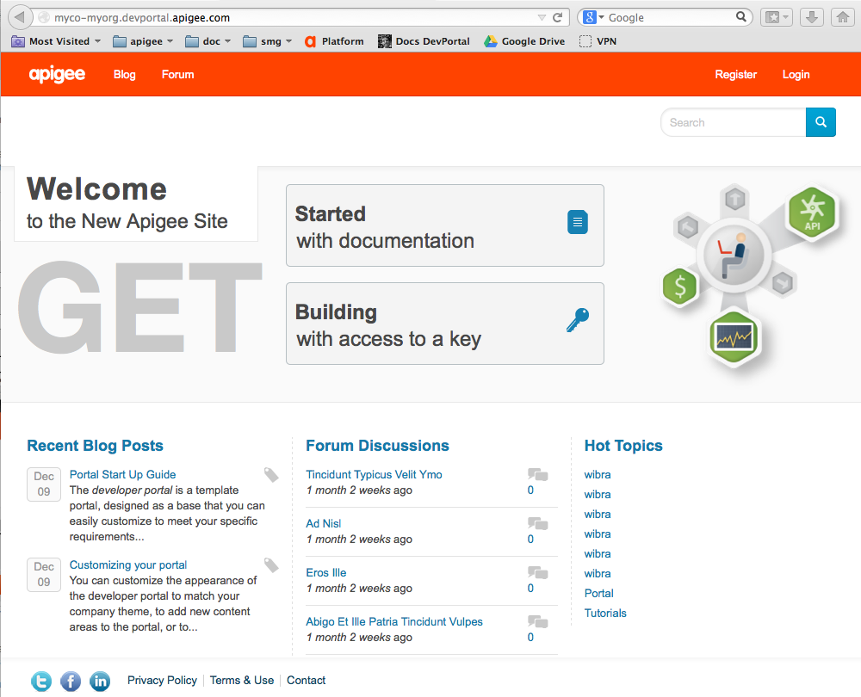

Monetization
Monetization capabilities provide the financial infrastructure and relationships to turn your developer community into an actual channel for your digital assets. With monetization, you can create a variety of rate plans that charge developers for the use of your API products or let you pay developers in revenue-sharing scenarios.
Plans include pre-paid plans, post-paid plans, fixed-fee plans, variable rate plans, "freemium" plans, plans tailored to specific developers, plans covering groups of developers, and more. In addition, monetization includes reporting and billing facilities.
For more information, see Monetization overview.
Reference : https://docs.apigee.com/api-platform/get-started/what-apigee-edge

Build your first API proxy

An API proxy is your interface to developers that want to use your backend services. Rather than having them consume those services directly, they access an Edge API proxy that you create. With a proxy, you can provide value-added features such as:
- Security | - Rate limiting | - Quotas | - Caching & persistence
- Analytics | - Transformations | - CORS | - Fault handling
- And so much more...

To build and deploy your first API proxy:
- Create an API proxy using the Edge management UI. You'll connect your proxy to a mock endpoint so you can see how it works.
- Test your new proxy to make sure you're on track.
- Change your target endpoint so your policy has more interesting data to play with.
- Add a policy to convert the response from XML to JSON. Policies are at the heart of your proxy's request-response flow.

- Create an API proxy
This section explains how to create a simple API proxy.
EdgeClassic Edge (Private Cloud)
To create an API proxy using the Edge UI:
- Sign in to apigee.com/edge.
- Click API Proxies in the main window:
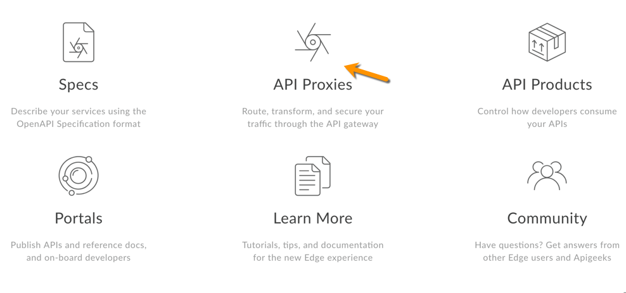
- Click +Proxy.

Apigee walks you through the process of creating a new proxy. First, select the type of proxy:
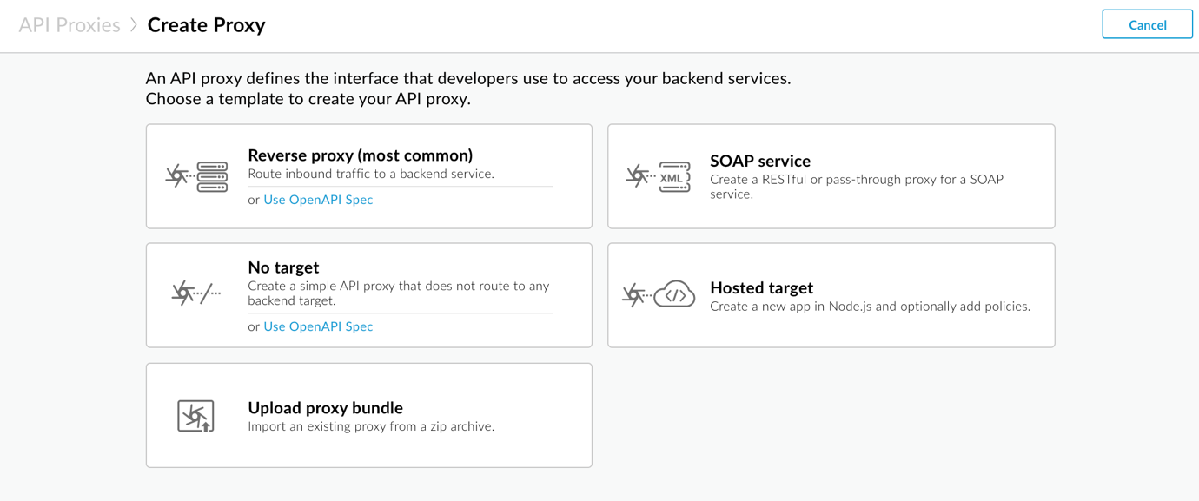
- Click Reverse proxy (most common).
Apigee displays the Proxy details page.
- Configure your proxy details, as follows:
  - Name: Enter getstarted. If a proxy already exists with this name, then use a different name.
  - Base path: Ensure this is set to /getstarted.
The base path is part of the URL used to make requests to your API. Edge uses the URL to match and route incoming requests to the proper API proxy.
  - Description (Optional): Enter a description for your new API proxy, such as Get started proxy.
  - Target (Existing API): Enter https://mocktarget.apigee.net. This defines the target URL that Apigee Edge invokes on a request to the API proxy.
The mock target service is hosted at Apigee and returns simple data. It requires no API key or access token.
Your proxy's details should look like the following:
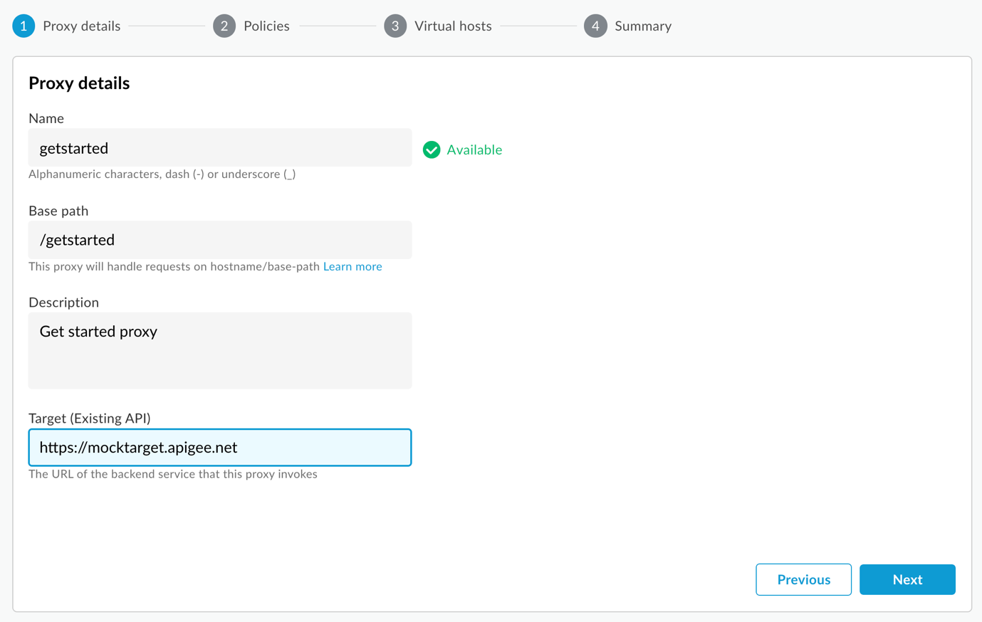
- Click Next.
- On the Common policies page, under Security: Authorization ensure that Pass through (no authorization) is selected and click Next.
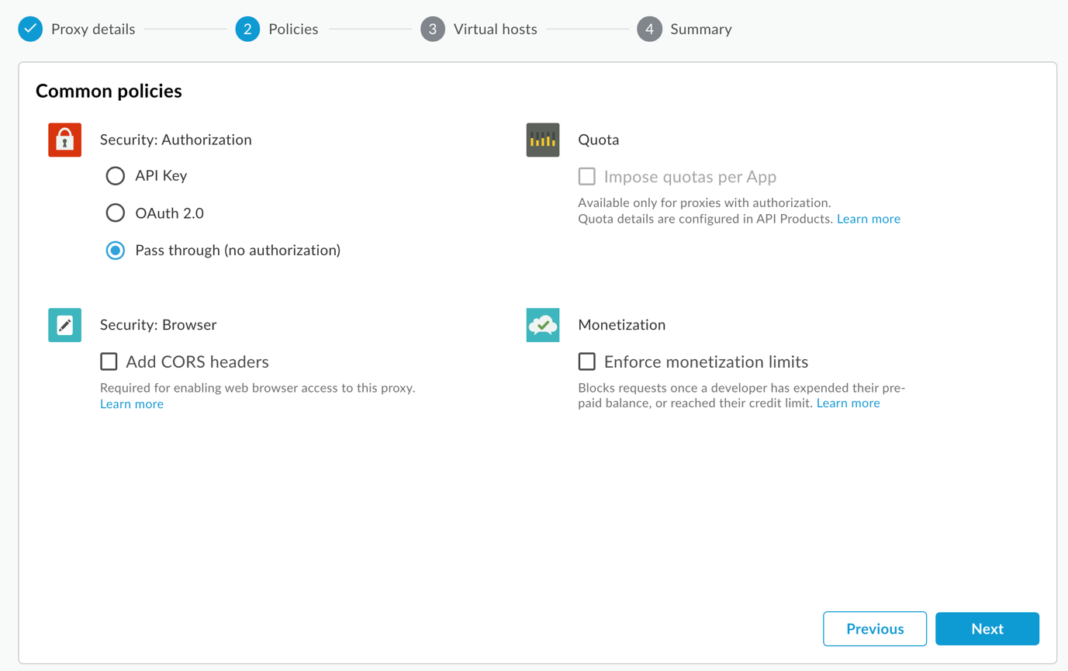
- On the Virtual hosts page, select default and secure, and click Next.
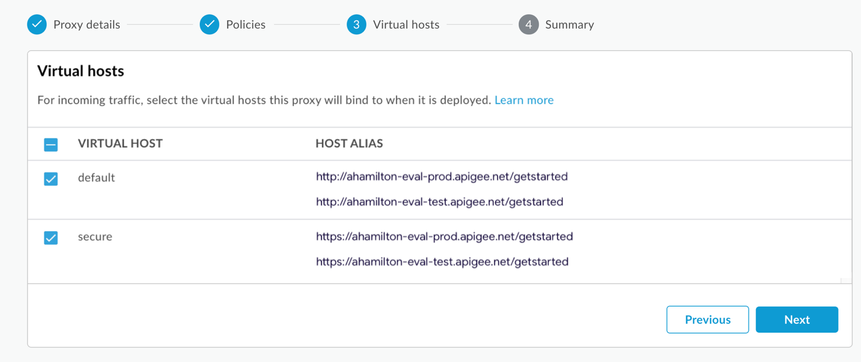
- On the Summary page, make sure the Test environment is selected under Optional Deployment and click Create and deploy:
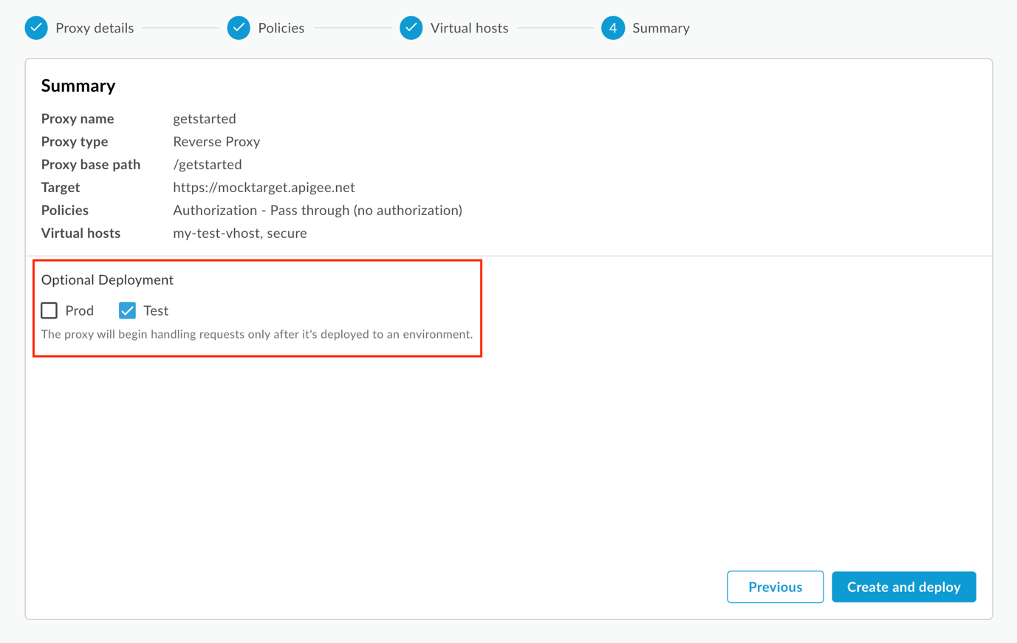
Apigee creates your new API proxy and deploys it to your test environment:
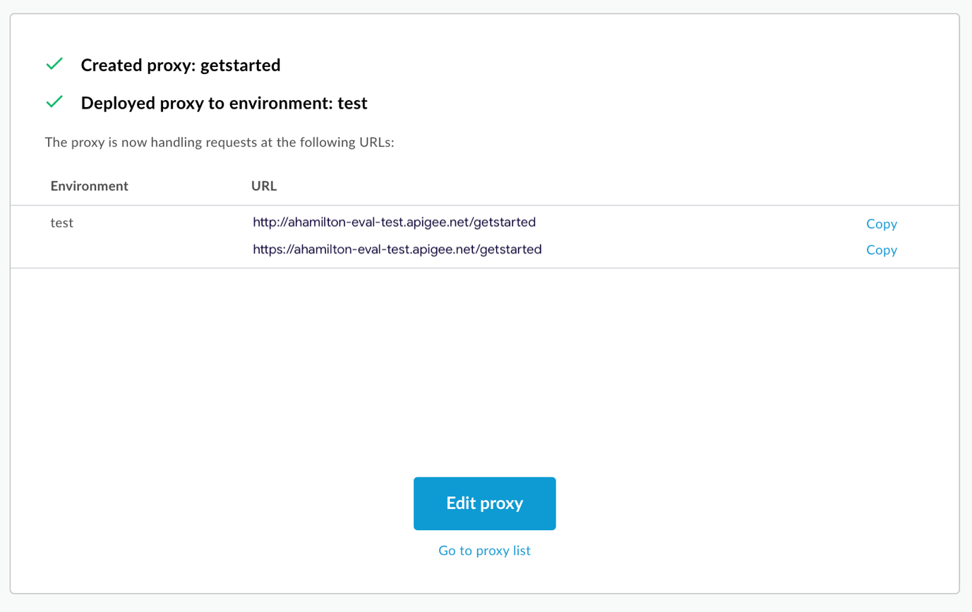
- Click Edit proxy to display the Overview page for the API proxy:
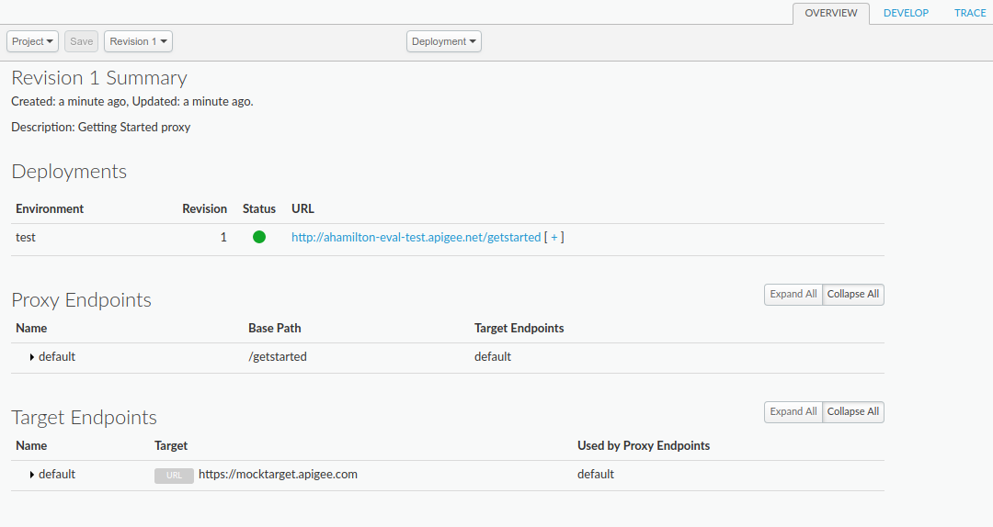
Note that if you expand the [ + ], the UI lists both HTTP and HTTPS URLs for the test environment:

As a result, you can send requests to either, but this tutorial uses HTTPS.

To test your new proxy:
- In a terminal window, execute the following curl command:
curl https://org_name-test.apigee.net/getstarted
Where:
  - org_name is the organization name that Apigee assigned to you when you created your Apigee account.
  - -test is the environment. You deployed your new proxy to the "test" environment in Step 1: Create an API proxy.
  - /getstarted is the Proxy Base Path.
For example:
curl https://ahamilton-eval-test.apigee.net/getstarted
Alternatively, you can navigate to "https://org_name-test.apigee.net/getstarted" in a browser.
You should receive the following response:
Hello, Guest!

- Change your target endpoint

To change your proxy's target endpoint:
- Sign in to the Edge UI.
- Select Develop > API Proxies.
- Select your getstarted proxy from the list to display the API proxy details. If you don't see your proxy in the list, be sure that you selected the right organization, as described in Switching between organizations.
- Click the Develop tab:

This takes you to the API Proxy Editor. The Proxy Editor lets you see the structure of your API proxy and configure its flow. (Don't panic. Other tutorials will cover the concept of flows.)
- In the Navigator pane, select Target Endpoints > default:
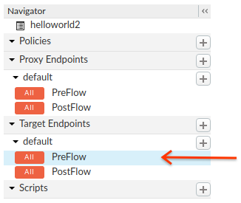
Edge displays the endpoint settings in the Code pane:
<TargetEndpoint name="default">
<Description/>
<FaultRules/>
<PreFlow name="PreFlow">
<Request/>
<Response/>
</PreFlow>
<PostFlow name="PostFlow">
<Request/>
<Response/>
</PostFlow>
<Flows/>
<HTTPTargetConnection>
<Properties/>
<URL>https://mocktarget.apigee.net</URL>
</HTTPTargetConnection>
</TargetEndpoint>
The target endpoint is defined by the <HTTPTargetConnection> element.
- Change the URL to "https://mocktarget.apigee.net/xml". (Append "/xml" to the existing URL.)
The new URL returns a small block of XML in the body of the response.
Your endpoint configuration should now look like the following:
...
<HTTPTargetConnection>
<Properties/>
<URL>https://mocktarget.apigee.net/xml</URL>
</HTTPTargetConnection>
...
- To save your changes to the proxy configuration, click the Save button.
Edge saves your changes and automatically deploys them.
If there is an error, Edge will save your changes but not deploy the proxy. In this case:
  - Fix your proxy configuration. Edge may provide syntax guidance as a pop-up.
  - Manually deploy your changes to the test environment by clicking Deployment > test if Edge does not automatically deploy it.
You can check if your proxy was deployed successfully by selecting the Deployment drop-down above the Flow editor. A green button indicates that the proxy was deployed to that environment successfully:
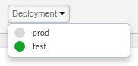
- Test your changes by sending a request to your proxy,
For example:
curl https://org_name-test.apigee.net/getstarted

TIP: Use an XML prettifier such as xmllint (if available) to make your output look better in a terminal. For example:

curl https://ahamilton-eval-test.apigee.net/getstarted | xmllint --format -
This time, the mocktarget endpoint returns XML in the body of the response:
<?xml version="1.0" encoding="UTF-8"?>
<root>
<city>San Jose</city>
<firstName>John</firstName>
<lastName>Doe</lastName>
<state>CA</state>
</root>

- Add a policy
Now that you've changed your target endpoint, you're ready to add a policy to your proxy.
A policy is an Edge component that you can attach to different points in the message flow through your API proxies. Policies can transform message formats, enforce access control, call remote services, authorize users, examine message content for potential threats, and do much more.
In this tutorial, you're going to add the XMLtoJSON policy to your proxy. This policy converts the payload of an XML message to JSON. It also changes the response's Content-Type header.

Further Reading
To add the XML to JSON policy to your proxy:
- Open the Edge UI in a browser and log in.
- Click API Proxies in the main window and select a proxy. For this example, select the proxy that you created in Step 1: Create an API proxy.
- Click the Develop tab:

Edge displays the API Proxy Editor.
- In the Navigator pane, click Proxy Endpoints > default > PreFlow:
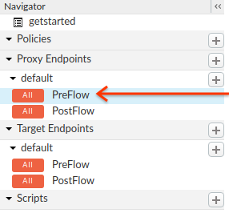
Edge displays the Flow editor:
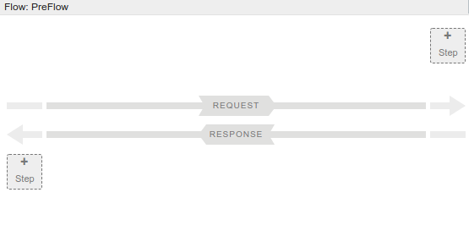
In addition, Edge displays the default Proxy Endpoint configuration in the Code pane:
<?xml version="1.0" encoding="UTF-8" standalone="yes"?>
<ProxyEndpoint name="default">
<Description/>
<FaultRules/>
<PreFlow name="PreFlow">
<Request/>
<Response/>
</PreFlow>
<PostFlow name="PostFlow">
<Request/>
<Response/>
</PostFlow>
<Flows/>
<HTTPProxyConnection>
<BasePath>/getstarted</BasePath>
<Properties/>
<VirtualHost>default</VirtualHost>
<VirtualHost>secure</VirtualHost>
</HTTPProxyConnection>
<RouteRule name="default">
<TargetEndpoint>default</TargetEndpoint>
</RouteRule>
</ProxyEndpoint>
- To add a policy to your proxy, click the + Step button in the response PreFlow (the bottom half of the Flow editor):
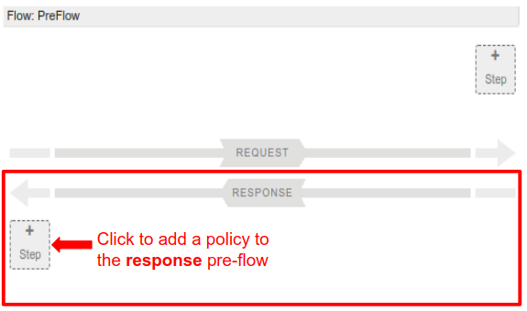
Edge displays a categorized list of policies in the Add dialog box that you can add to your flow:
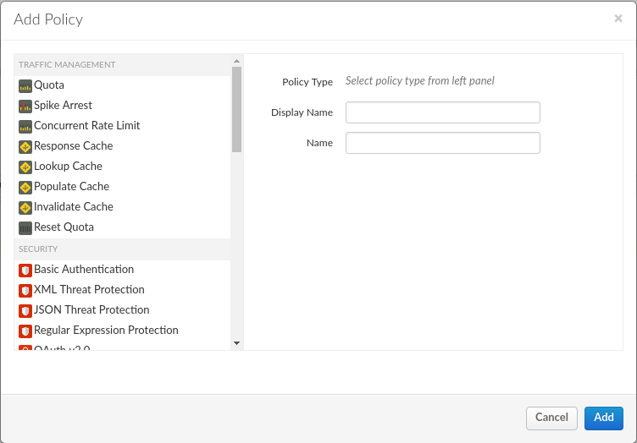
- Scroll down and select the XML to JSON policy in the Mediation category.TIP: The API Proxy Editor also supports drag & drop. For example, after you have added one or more policies to the proxy, you can then drag them from the Navigator into place in the Flow editor:
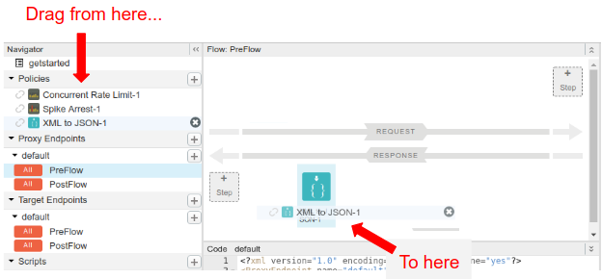
- Leave the default names and click Add.
Edge attaches the new policy to the PreFlow of the response:
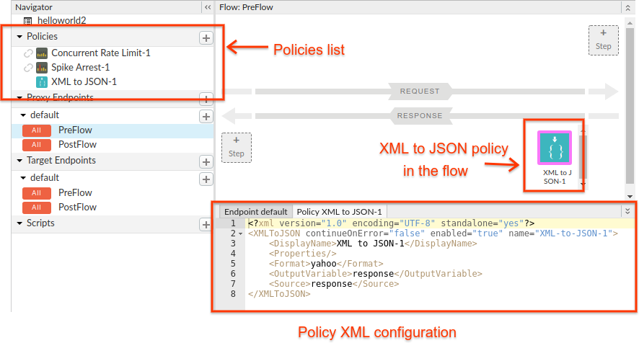
Note that when you click Add, Edge does the following:
  - Adds the new policy under Policies in the Navigator pane.
  - Adds the XML to JSON policy in the Flow pane.
  - Displays the policy's configuration XML in the Code pane.
- Click Save to save the current revision with your changes.
Now try it out! In a terminal window, execute the following curl command:
curl https://org_name-test.apigee.net/getstarted
Where:
- org_name is the organization name that Apigee assigned to you when you created your Apigee account.
- -test is the environment. You deployed your new proxy to the "test" environment in Step 1: Create an API proxy.
- /getstarted is the Proxy Base Path.
TIP: Use a JSON prettifier such as the json.tool Python library to make your output look better in a terminal. For example:
curl https://ahamilton-eval-test.apigee.net/getstarted | python -m json.tool
Alternatively, you can open the same URL in a browser.
You should receive the following response:
{
"root": {
"city": "San Jose",
"firstName": "John",
"lastName": "Doe",
"state": "CA"
}
}
You've successfully added the XML to JSON policy to your new proxy!
If the body of the response doesn't look like this, check that:
- Your target endpoint is "https://mocktarget.apigee.net/xml", as described in Step 3: Change your target endpoint:
  - If you get "Hello, Guest!" as a response, then you need to append "/xml" to the end of the target endpoint.
  - If you get a 404, then check that you are accessing "apigee.net" and not "apigee.com".
- The latest revision of your proxy is deployed. Try re-deploying your API proxy as described in Deploying and undeploying an API proxy.
To see the HTTP request and response headers, enable verbosity in curl with the -vs option (v makes the response verbose, but s suppresses some of the less interesting details). For example:
curl -vs https://ahamilton-eval-test.apigee.net/getstarted | python -m json.tool
You should get a response that looks like the following. Note that the Content-Type header in the response is "application/json". The XML to JSON policy changes the header before sending the response back.
* Trying 10.20.30.40...
* TCP_NODELAY set
* Connected to ahamilton-eval-test.apigee.net (10.20.30.40) port 443 (#0)
...
> GET /getstarted HTTP/1.1
> Host: ahamilton-eval-test.apigee.net
> User-Agent: curl/7.58.0
> Accept: */*
>
< HTTP/1.1 200 OK
< Date: Fri, 25 May 2018 16:20:00 GMT
< Content-Type: application/json;charset=UTF-8
< Content-Length: 77
< Connection: keep-alive
< X-Powered-By: Apigee
< Access-Control-Allow-Origin: *
...
{ [77 bytes data]
{
"root": {
"city": "San Jose",
"firstName": "John",
"lastName": "Doe",
"state": "CA"
}
}

Reference : https://docs.apigee.com/api-platform/get-started/get-started

Further Exploration
- Add some protection:
  - Secure your API proxy against traffic spikes or malicious attacks with the Spike Arrest policy
  - Control developer access to your API with an API key
  - Authorize access with OAuth
- See what's out there:
  - Grab some code — it's just sitting there in GitHub (maybe there's something you can steal)
  - Import and deploy sample proxies
  - Check out the proxy cookbook
  - And many more...
- More resources:
  - 4-Minute Videos for Developers
  - Apigee API Management trial video series
  - Coursera Apigee courses
  - More tutorials

Restful Services Reference

Quick Guide to Understanding RESTful Services
REST (Representational State Transfer) is an architectural style for designing networked applications. It relies on a stateless, client-server, cacheable communications protocol — the HTTP protocol is typically used. Here’s a quick guide to get you started:

What is REST?
RESTful services use standard HTTP methods and are based on resources (like users, orders, etc.) which are identified by URIs. They provide a lightweight alternative to mechanisms like SOAP for web services.

Key Features of REST:
- Stateless: Each request from a client to server must contain all the information the server needs to fulfil that request.
- Cacheable: Responses must define themselves as cacheable or not, to prevent clients from reusing stale data.
- Uniform Interface: Resources are manipulated through a fixed set of operations.
- Client-Server Architecture: The client and server are separate entities.
- Layered System: The architecture allows for intermediary servers to improve system scalability.

HTTP Methods:
REST uses standard HTTP methods to perform CRUD (Create, Read, Update, Delete) operations:
- GET: Retrieve data from the server.
- POST: Submit data to be processed to the server.
- PUT: Update existing data on the server.
- DELETE: Remove data from the server.

RESTful Resource URIs:
Resources in a RESTful service are identified by URIs (Uniform Resource Identifiers). Examples:
- GET /users: Retrieve a list of users.
- GET /users/{id}: Retrieve a specific user by ID.
- POST /users: Create a new user.
- PUT /users/{id}: Update an existing user by ID.
- DELETE /users/{id}: Delete a user by ID.

RESTful Response Status Codes:
RESTful services use standard HTTP status codes to indicate the result of an operation:
- 200 OK: The request was successful.
- 201 Created: A new resource was created.
- 204 No Content: The request was successful but there is no content to send.
- 400 Bad Request: The request could not be understood or was missing required parameters.
- 401 Unauthorized: Authentication failed, or user does not have permissions for the requested operation.
- 404 Not Found: The requested resource could not be found.
- 500 Internal Server Error: An error occurred on the server.

Data Formats:
RESTful services typically use JSON or XML to format data. JSON is more common due to its simplicity and efficiency.
Example JSON Response:
{
"id": 1,
"name": "John Doe",
"email": "[john.doe@example.com](mailto:john.doe@example.com)"
}

How REST Works:
- Client sends a request: The client application sends an HTTP request to a RESTful web service.
- Server processes the request: The server processes the request and sends back an HTTP response.
- Client receives the response: The client application receives the response and processes it accordingly.

Common Usage Scenarios:
- Web and Mobile Applications: REST is widely used in web and mobile applications for its simplicity and performance.
- Microservices: RESTful APIs are often used for communication between microservices.
- Public APIs: Many companies provide public APIs using REST (e.g., Twitter, Google Maps).

Advantages of REST:
- Simplicity: RESTful APIs are easy to understand and use.
- Performance: Lightweight and fast due to stateless nature and efficient data formats like JSON.
- Scalability: Supports layered architecture, enabling scalability.

Disadvantages of REST:
- Statelessness: Each request must contain all information, which can lead to overhead.
- Lack of Standards: REST is more of an architectural style and doesn’t have a strict standard, which can lead to inconsistencies.

Getting Started with REST:
- Learn HTTP: Understanding HTTP methods, status codes, and headers is crucial.
- Understand JSON: Familiarize yourself with JSON for data interchange.
- Use REST Tools: Tools like Postman can help test and develop RESTful services.
- Experiment with APIs: Practice by accessing public REST APIs and creating your own.

JavaScript Reference

Quick Guide to Understand JavaScript

JavaScript is a versatile, high-level programming language primarily used for creating dynamic content on websites. Here’s a quick guide to get you started:

What is JavaScript?
JavaScript is a lightweight, interpreted programming language with first-class functions. It is best known as the scripting language for web pages but is also used in many non-browser environments such as Node.js.

Key Features of JavaScript:
- Interpreted Language: JavaScript is executed line by line in the browser.
- Dynamic Typing: Variables can hold any data type and can be changed dynamically.
- Object-Oriented: Supports object-oriented programming with prototypes.
- Event-Driven: Can execute code in response to events like user actions.
- Functional: Functions are first-class citizens and can be passed as arguments.

Basic Syntax:
JavaScript syntax is the set of rules that define a correctly structured JavaScript program.
Variables:
let name = "John";
const age = 30;
var isActive = true;
Data Types:
- String: "Hello, World!"
- Number: 42
- Boolean: true or false
- Array: [1, 2, 3, 4, 5]
- Object: { name: "John", age: 30 }
Functions:
function greet(name) {
return `Hello, ${name}!`;
}
console.log(greet("Alice")); // Outputs: Hello, Alice!

Control Structures:
Conditional Statements:
if (age > 18) {
console.log("Adult");
} else {
console.log("Minor");
}
Loops:
for (let i = 0; i < 5; i++) {
console.log(i);
}
let i = 0;
while (i < 5) {
console.log(i);
i++;
}

Asynchronous JavaScript:
JavaScript supports asynchronous operations to handle tasks like data fetching without blocking the main thread.
Callbacks:
function fetchData(callback) {
setTimeout(() => {
callback("Data fetched");
}, 1000);
}
fetchData(function(result) {
console.log(result);
});
Promises:
const promise = new Promise((resolve, reject) => {
setTimeout(() => {
resolve("Data fetched");
}, 1000);
});
promise.then(result => {
console.log(result);
});
Async/Await:
async function fetchData() {
const result = await new Promise((resolve) => {
setTimeout(() => {
resolve("Data fetched");
}, 1000);
});
console.log(result);
}
fetchData();

Common Usage Scenarios:
- Web Development: Creating interactive websites.
- Server-Side Development: Using Node.js for server-side scripting.
- Mobile App Development: Using frameworks like React Native.

Advantages of JavaScript:
- Interactivity: Enhances user interaction on websites.
- Speed: Runs immediately within the client-side browser.
- Versatility: Can be used across various platforms and environments.
- Rich Ecosystem: Abundance of libraries and frameworks (React, Angular, Vue.js).

Disadvantages of JavaScript:
- Security Issues: Can be exploited for malicious purposes.
- Browser Dependency: Different browsers may interpret JavaScript differently.
- Performance: Can be slower than compiled languages.

Getting Started with JavaScript:
- Learn the Basics: Familiarize yourself with the syntax and basic concepts.
- Practice Coding: Build small projects to practice and understand concepts.
- Use Tools: Utilize tools like browser developer tools for debugging.
- Explore Frameworks: Learn popular frameworks like React or Vue.js for advanced development.

SOAP Services Reference

Quick Guide to Understanding SOAP Services
SOAP (Simple Object Access Protocol) is a protocol for exchanging structured information in the implementation of web services in computer networks. Here’s a quick guide to get you started:

What is SOAP?
SOAP is a messaging protocol that allows programs running on different operating systems to communicate using HTTP and XML. It is highly extensible and allows for secure communication.

Key Features of SOAP:
- Protocol Independence: SOAP can be used over various transport protocols such as HTTP, SMTP, TCP, etc.
- Language and Platform Independent: SOAP allows different programming languages and platforms to interoperate.
- Extensibility: It provides the flexibility to add new features without affecting the core protocol.
- Security: SOAP supports Web Services Security (WS-Security) for secure message transmission.

SOAP Message Structure:
A SOAP message is an XML document with the following elements:
- Envelope: The root element that defines the XML document as a SOAP message.
- Header (optional): Contains application-specific information like authentication, payment, etc.
- Body: Contains the actual SOAP message intended for the recipient.
- Fault (optional): Used for reporting errors.
Example SOAP Message:
<soapenv:Envelope xmlns:soapenv="[http://schemas.xmlsoap.org/soap/envelope/](http://schemas.xmlsoap.org/soap/envelope/)" xmlns:ex="[http://example.com/](http://example.com/)">
<soapenv:Header/>
<soapenv:Body>
<ex:GetPrice>
<ex:Item>12345</ex:Item>
</ex:GetPrice>
</soapenv:Body>
</soapenv:Envelope>

How SOAP Works:
- Client sends a request: The client application sends a SOAP request to the server.
- Server processes the request: The server processes the request and sends back a SOAP response.
- Client receives the response: The client application receives the response and processes it.

Web Services Description Language (WSDL):
WSDL is an XML-based language used for describing the functionalities offered by a SOAP service. It defines:
- Operations: The actions available via the service.
- Messages: The data exchanged between the client and the server.
- Types: The data types used by the web service.
- Binding: The protocol and data format for each operation.
- Service: The endpoint where the service can be accessed.

Common Usage Scenarios:
- Enterprise Applications: SOAP is often used in enterprise applications requiring complex transactions, reliability, and security.
- Distributed Computing: When systems need to interact over a network in a platform-independent manner.
- API Integration: Integrating disparate systems within an organization or with external partners.

Advantages of SOAP:
- Robust Error Handling: With the Fault element, SOAP provides detailed error information.
- Asynchronous Processing: Can handle both synchronous and asynchronous operations.
- Formal Contracts: The WSDL provides a formal contract between the client and server.

Disadvantages of SOAP:
- Complexity: SOAP can be more complex and harder to implement compared to REST.
- Performance: SOAP messages can be heavier and slower due to their XML format.
- Firewall Issues: SOAP often uses HTTP, but strict firewalls might block non-HTTP traffic.

Getting Started with SOAP:
- Learn XML: Understanding XML is crucial since SOAP messages are XML-based.
- Understand WSDL: Familiarize yourself with writing and reading WSDL files.
- Use SOAP Tools: Utilize tools like SoapUI for testing and developing SOAP services.
- Experiment with APIs: Practice by accessing public SOAP APIs and creating your own.

Resources:
- W3C SOAP Specification: W3C SOAP 1.2
- SOAP Tutorials: TutorialsPoint, W3Schools
- Tools: SoapUI, Postman (for SOAP testing)

APIGEE Best Practices Guidelines

Source : https://docs.apigee.com/api-services/content/best-practices-api-proxy-design-and-development

Naming Conventions

- The Policy name attribute and the XML policy file name and DisplayName must be identical.
- The Script and Service Callout policy name attribute and the name of the resource file should be identical. E.g., for JsCommonValidations service callout, resource should be JsCommonValidations.js
- Name policies according to their function, for example AssignMessageAuthHeader , ExtractVariableLoginRequest
- Use indicative prefix while naming the policies such as "AssignMessage" while using AssignMessage policy. refer to Indicative Prefix Reference Table below.
- Run the https://github.com/apigeecs/bundle-linter and fix the comments accordingly. Bundle linter will give you suggestions on indicative prefixes
- Use proper extensions for resource files, .js for JavaScript, .py for python, and .jar for Java JAR files.
- Variable names should be consistent. If you choose a style, such as camelCase or under_score, use it throughout the API proxy. camelCase is being used widely. Stick to camelCase
- Use variable prefixes, where possible, to organize variables based on their purpose, for example, Consumer.username and Consumer.password.
- Use double quotes "" for javascript literals - Eg context.setVariable("isValidationError", true);

Indicative Prefix Reference Table

S.No | Policy Name | Indicative Prefix
1 | Quota | Quota
2 | Spike Arrest | SpikeArrest
3 | Concurrent Rate Limit | ConcurrentRateLimit
4 | Response Cache | ResponseCache
5 | Lookup Cache | Lookup
6 | Populate Cache | Populate
7 | Invalidate Cache | Invalidate
8 | Reset Quota | ResetQuota
9 | Basic Authentication | BasicAuth
10 | XML Threat Protection | XMLThreat
11 | JSON Threat Protection | JSONThreat
12 | Regular Expression Protection | RegExProtection
13 | OAuth v2.0 | OAuthv2
14 | Get OAuth v2.0 Info | GetOAuthv2
15 | Set OAuth v2.0 Info | SetOAuthv2
16 | Delete OAuth v2.0 Info | DeleteOAuthv2
17 | OAuth v1.0a | OAuthv1
18 | Get OAuth v1.0a Info | GetOAuthv1
19 | Delete OAuth v1.0 Info | DeleteOAuthv1
20 | Verify API Key | VerifyAPIKey
21 | Access Control | AccessControl
22 | Generate SAML Assertion | GenerateSAML
23 | Validate SAML Assertion | ValidateSAML
24 | Generate JWT | GenerateJWT
25 | Verify JWT | VerifyJWT
26 | Decode JWT | DecodeJWT
27 | JSON to XML | JSONtoXML
28 | XML to JSON | XMLtoJSON
29 | Raise Fault | RaiseFault
30 | XSL Transform | XSLTransform
31 | SOAP Message Validation | SOAPValidation
32 | Assign Message | Assign
33 | Extract Variables | Extract
34 | Access Entity | AccessEntity
35 | Key Value Map Operations | KVM
36 | Java Callout | Java
37 | Python | Script
38 | JavaScript | Js
39 | Service Callout | Callout
40 | Flow Callout | FlowCallout
41 | Statistics Collector | Statistics
42 | Message Logging | Logging
43 | Extension Callout | Extension

DO's

- Remember to clean up after yourself once the ticket is closed (Non-Prod). Delete the unused sandbox proxies, KVM / Cache / Products / App / Key store entries to avoid confusion and performance issues.
- Clean up unused policies and resources (JavaScript, Java, XSLT, etc.) from API proxies, especially large resources that have the potential to slow down import and deploy procedures.
- Adhere to Naming Conventions strictly.
- Use consistent indentation, spacing, vertical alignment, etc
- Each Proxy must be a new repository in Github so multiple proxies can be deployed at the same time through Jenkins job
- Document the Apps / Products / Proxies / Cache Store / KVM / Keystore basically all the configuration that was created as part of development in Confluence
- Remember to import the YAML into Spec and do initial create of the proxy to avoid mismatch between YAML and proxy specs
- Always create Keystore references and use the same in code or virtual hosts. This will make sure code or virtual host remains unchanged while changing the certificates or deleting and creating new keystores. Apigee strongly recommends that you use references to keystores and truststores in a virtual host and do not use names directly.
- Create 2 different KVMs for maintaining secrets and config, eg : GeneralConfig and GeneralSecrets
- Create the KVMs that store the username and passwords as encrypted
- Add hostname and hosturls to config KVM
- Create Github repos as private
- Use built-in policies first and foremost (when possible). Apigee policies are hardened, optimized, and supported. For example, use the standard AssignMessage and ExtractVariables policies instead of JavaScript (when possible) to create payloads, extract information from payloads (XPath, JSONPath), etc.
- JavaScript is preferred over Python and Java. However, if performance is the primary requirement, Java should be used over JavaScript.
- Junits are mandatory for javascript

Dont's

- Avoid using the term 'API' for Proxy Names. Proxy is a collection of API end points. Eg, AuthenticationAPI
- Avoid spelling mistakes everywhere especially in Proxy names, if this is missed in peer review, then a lot of reworks involved. Eg, SunConnection
- Avoid mixing single and double quotes. As a standard practice use double quotes ""
  - context.setVariable("isValidationError", true);
  - context.setVariable('err.message', errorMsg);
  - context.setVariable('err.phrase', 'Bad Request');
- Avoid hard coding host name and host url in config.json. Move it KVM.
  - "tokens": [{"xpath": "/ServiceCallout/HTTPTargetConnection/URL", "value": "https://xxxx-testing.abc.co.uk/abc/create}]
- Do not use Python unless absolutely required. Python scripts can introduce performance bottlenecks for simple executions, as it is interpreted at runtime.
- Do not commit manifest folder and manifest.xml in github
- Do not commit association.json when in github
- {ProxyName}.xml commit only the Proxy Name and Description. Nothing else is required

